OCR A-Level Computer Science

Programming Project

Candidate Name: Nathan Wise

Candidate Number: 7172

Centre Number: 16802

CONTENTS

**Analysis** **10**

Project Proposal 10

Problem Identification 10

Solution 10

Application of Computational Thinking & Methods 10

Decomposition 11

Abstraction 11

Pattern Recognition 11

Visualisation 11

Thinking Ahead 11

Thinking Logically 12

Thinking Procedurally 12

Thinking Concurrently 12

Existing Solutions 12

Drones 12

User Reviews 13

GoPro 14

User Reviews 14

Bluetooth Remote Control 15

User Reviews 15

Conclusion 16

Stakeholders 17

Gathering Data 18

Survey - General Audience 18

Survey Template 18

Survey Results 20

How often do you take photos? 20

Have you ever struggled with taking a long-distance photo of yourself before? 20

What Mobile OS do you use? 21

Would you use this if you had access to it? If no or maybe, then why not? 21

Which feature is most appealing to you? 22

What other feature would you like to be included outside of the ones listed above? 23

Which alternate solution would you choose over this to take photos? Why? 23

Conclusion 24

Essential Features 24

Requirements 25

Software 25

IDEs - Pycharm and Android Studio 25

GitKraken 25

Libraries, Frameworks and APIs 26

React Native 26

Face Detection 26

Video Streaming 27

PIL 27

RPI Controller Libraries 28

Hardware 28

Raspberry Pi 28

RPI Camera and Mini Pan-tilt Camera Mount 28

3D Printer 29

WiFi Dongle / Ethernet 29

PC Hardware Requirements 29

Limitations 30

Programming Complexity 30

Time Constraint 30

Stakeholders 30

Video Feed 30

Power 31

Development Methodology (SDLC) 31

Comparison Table 31

Evaluation 32

Success Criteria 33

**Design** **35**

Decomposition Diagram 35

Usability Features 36

Simplistic GUI 36

Button Icons 36

Text 36

Error Tolerant 36

GUI Styling 36

GUI Design Reference Table 37

Navigation Diagram 38

Main System Flowchart 39

Main System Pseudocode 40

Class Diagram 41

Module 1 - Main Interface 43

Justification 43

Flowcharts 43

Connect GUI 43

Pseudocode 44

Connect GUI 44

Variable Table 45

GUI Design 47

Splash Screen 47

RPI Connect Screen 48

Main GUI Screen 49

Stakeholder Feedback 50

Test Plan - White Box 50

Post Development Test Plan - Black Box 53

Module 2 - Camera Rotation 56

Justification 56

Flowcharts 56

Rotation GUI 56

Pitch Yaw GUI 57

Face Detect Algorithm 58

Pseudocode 59

Rotation GUI 59

Face Detect Algorithm 61

Variable Table 61

Data Structures 63

Test Plan - White Box 64

Post Development Test Plan - Black Box 65

Module 3 - Take Photo 69

Justification 69

Flowcharts 69

Take Photo Algorithm 69

Pseudocode 71

Take Photo Algorithm 71

Variable Table 71

Data Structures 72

Test Plan - White Box 72

Post Development Test Plan - Black Box 73

Module 4 - Sub Menu 75

Justification 75

Flowcharts 75

Share Media Algorithm 75

About Algorithm 76

Pseudocode 77

Share Media Algorithm 77

About Algorithm 78

Variable Table 78

GUI Design 79

About GUI 79

Test Plan - White Box 80

Post Development Test Plan - Black Box 82

**Development** **85**

Codeblock Referencing 85

Pre-module Scripting 85

Mono-servo Test Script 85

Dual-servo Test Script 87

Raspbian 90

Flask Server Test Script 91

Servo Flask Server Test Script 93

Pre-module Setup 96

Git Repository 96

Trello 96

Module 1 - Main Interface 99

RPI Camera 99

RPI Git Setup 100

1.4 - Live Video Feed 101

RPI Web Server Setup 101

Live Video Feed 104

Final touches 109

1.1 - Connect GUI 110

Setup 110

Initial Design 110

1.2 - Button to next Activity 114

Revised Font System 116

1.3 - Main GUI 117

Webview Functionality Programming 117

GUI 131

Connect Bug 134

Splash Screen 135

Module Evaluation 138

Issues 138

Module 2 - Camera Rotation 139

2.1 - Rotate Camera 139

Snackbar Implementation 139

Bottom Navbar Click Listener 140

Rotation Menu 143

2.3 - Detect Faces 161

Setup 161

2.3 Evaluation 170

Module Evaluation 171

Issues 171

Module 3 - Take Photo 172

3.1 - Regular Photo 172

Sending the Request 172

Snackbar Anchor 173

3.3 - RPI Take Photo, 3.4 - RPI Send Photo, 3.5 - Autosave Image 175

HTTP Requests 175

Take Photo 175

Multiple Photos 179

Unique File Name 185

Android App Compatibility 189

Photo Taking Error Fix - Backend 190

Download Manager 194

Double Photo Take Request Bug 197

3.2 - Timed Shot 199

Backend 199

Frontend 200

Module Evaluation 205

Issues 206

Module 4 - Sub Menu 207

4.1 - Sub menu interface 207

Navigation Drawer 207

Action Bar 208

Item Functionality 211

4.2 - Share Media 212

Persistent Storage for Image URIs 212

Share Media Intent 214

4.3 - Open Photo Gallery 216

Intents 216

4.4 - About Page 217

Activity Initialisation 217

Dynamic Information 219

Theming 223

Module Evaluation 226

Issues 227

Testing **227**

Overall Evaluation 228

Remedial Action 229

Code Structure 229

Connect GUI Bug 251

Menu GUI Styling 255

Share Menu Image Preview 257

White Box Testing 257

Module 1 257

Test Scenarios and Cases 258

Identified Issues 261

Remedial Action 261

Issue 1 261

Module 2 261

Test Scenarios and Cases 262

Identified Issues 264

Remedial Action 265

Issue 1 265

Issue 1.1 269

Issue 2 271

Module 3 272

Test Scenarios and Cases 272

Identified Issues 273

Remedial Action 274

Issue 1 274

Issue 2 274

Module 4 276

Test Scenarios and Cases 276

Identified Issues 278

Remedial Action 278

Issue 1 278

Issue 2 279

White Box Evaluation 281

Black Box Testing 282

Module 1 282

Test Scenarios and Cases 282

Identified Issues 284

Feedback 284

Remedial Action 284

Issue 1 284

Issue 2 288

Issue 3, Feedback 1 289

Feedback 2 289

Feedback 3 294

Module 2 295

Test Scenarios and Cases 295

Identified Issues 299

Feedback 299

Remedial Action 299

Issue 1, Issue 2, Feedback 3 299

Feedback 1 305

Feedback 2 305

Feedback 5 305

Feedback 6 314

Feedback 4 317

Module 3 331

Test Scenarios and Cases 331

Identified Issues 332

Remedial Action 332

Issue 2 332

Issue 1 333

Module 4 338

Test Scenarios and Cases 338

Black Box Evaluation 339

**Project Evaluation** **342**

Success Criteria 342

Module 1 References 343

1.1 - Connect GUI 343

1.2 - Connect to RPI 345

1.3 - Main GUI 345

1.4 - Live Camera Feed 346

Module 2 References 347

2.1 - Rotate Camera 347

2.2 - Modify Servo Rotation 348

2.3 - Detect Faces 348

2.4 - Centre on Face 349

Module 3 References 349

3.1 - Regular Photo 349

3.2 - Timed Shot 349

3.3 - RPI Take Photo 350

3.4 - RPI Send Photo 350

3.5 - Autosave Image 351

Module 4 References 351

4.1 - Sub menu interface 351

4.2 - Share Media 351

4.3 - Open Photo Gallery 352

4.4 - About page 352

Overview 352

Usability 353

Simplistic GUI 353

Button icons 354

Text 354

Error Tolerance 355

GUI Styling 356

Overview 357

Stakeholders 357

Questionnaire 358

Individual Feedback 358

Feedback Overview 359

Future Improvements 359

Limitations 359

Power 359

Connecting to RPI 360

App Request Retries 360

Frontend Photo Requests 360

Public Access 360

One user 361

Frontend 361

GPIO Wires 361

Icon 361

Maintenance 361

Software Updates 362

Hardware 362

Dependencies 362

Modularity 363

Styling 363

Product Photos 363

**Final code** **365**

Backend - RCCamBackend 365

app.py 365

camera.py 365

servo.py 369

face_detect.xml 373

Frontend - RCCamFrontend 373

activities 398

About.kt 398

Connect.kt 398

Main.kt 399

Splashscreen.kt 405

utils 405

Address.kt 406

PublicFunctions.kt 407

views 407

IncrementableTextView.kt 408

drawable 408

ic_baseline_info_24.xml 410

ic_baseline_share_24.xml 410

ic_face_detection.xml 411

ic_rotate.xml 411

ic_round_photo_library_24.xml 411

ic_shutter.xml 411

layout 412

activity_about.xml 412

activity_connect.xml 414

activity_main.xml 415

activity_splash_screen.xml 416

dialogue_rotation.xml 417

dialogue_timed.xml 418

textview_incrementable.xml 419

menu 419

action_bar.xml 419

bottom_navigation.xml 420

values 420

attr.xml 420

colors.xml 420

dimens.xml 421

strings.xml 421

styles.xml 422

**References** **422**

Analysis 424

# Analysis

## Project Proposal

### Problem Identification

Taking a photo is usually a simple, menial task if you want to take a photo of *something*. However, if you wish to take a photo of yourself you may run into some issues. The main issue is that you are not only limited in the distance away from yourself that the photo can be due to your arm length but you also may have trouble taking the photo at a high quality. There are 3 key steps in taking a decent picture: focussing the camera, positioning the camera and pressing a button to take the picture. This process is the same for all types of cameras and becomes increasingly difficult based on how you want to take the photo.

There is a present struggle using these steps when wanting to take a photo involving yourself. It becomes difficult to focus the camera to make sure the photo isn’t unintentionally blurred, to hold it in the correct position and to press the button to take the photo. This becomes arduous if you want a photo of yourself that is further away than you can hold the camera as you’ll now need another person to take the photo for you.

Some digital cameras come with rotatable screens and the shutter-release button on top to help you orient the camera correctly and take a photo. Mobile phones also aim to help mitigate this problem with lower quality cameras built above the screen so that you can take a photo while seeing yourself. However, that reduces the quality and focussing using that method is also difficult as you need to tap the screen before taking the photo. These are both solutions to helping take a photo but don’t aid in all 3 of the key steps.

A more desirable solution than the current methods would be a form of hardware that aims to help in all 3 of the key steps. It would provide a way to easily focus the camera, to position the camera and to take a photo; all while allowing for photos where the user is at a moderate distance from the camera.

### Solution

My idea for a solution to this issue is a mobile app that connects to a form of custom made hardware. The user will be able to control a camera in the hardware using the mobile app. This app will give them the ability to rotate the camera on multiple axes to target the positioning key step. It will also let the user take a photo from the app itself to allow for freedom of movement away from the hardware itself whilst also still being able to take a photo. The reasoning behind a mobile app is that it allows for wider availability of the software due to many people owning a mobile phone, and for a more cost-effective solution in comparison with a custom made remote control for the camera device.

## Application of Computational Thinking & Methods

Throughout my project, I will utilise computational thinking and methods. Some of them will be listed below and coupled with information on how they will be used.

### Decomposition

In my coursework, I will employ decomposition during the design period of the project. It will allow me to divide the project into its features which will make it more manageable. Allowing me to focus on these sections, will aid me in following my development methodology as I’ll be able to develop and test these independently of the whole project. Without this, it would become increasingly time-consuming to continue developing the project due to the high level of complexity present. It will additionally help me manage my project as I can use the resulting decomposition diagram that I will create to construct checklists of requirements and issues.

### Abstraction

I will plan on using abstraction to hide a wide range of data from the user that they otherwise wouldn’t need to view. This unnecessary data may range from the mathematical outputs of the processes run by the facial recognition algorithm to the connection information between the hardware and the mobile phone. I mustn’t overwhelm the user with information that isn’t relevant to them. The user should only see a fairly minimalistic representation of the software to ensure that it is user friendly to the point where anybody could use it with relative ease.

### Pattern Recognition

Pattern recognition will be involved as an available option within the software. This will be used in the form of facial recognition and the user will be able to use this to automatically align the camera to centre a person’s face. This will allow them to easily centre the camera on them without having to manually rotate the camera to achieve this.

### Visualisation

Visualisation will be used within my program, alongside the pattern recognition. This is a computational method that aims to help users understand data by representing it graphically. I will use it in conjunction with the data from the facial recognition to help display the bounding box of any faces the camera can see. This will allow the user to see what the computer essentially sees. I may also include data visualisation for network-related data such as a graph showing the ping between the hardware and the user’s phone over time.

### Thinking Ahead

I will adopt thinking ahead to plan my development ahead of time. It will be used within the design portion of my project and will force me to consider what potential inputs, outputs and functions the finished project may have. This strategy will also aim to alleviate the software of any redundancy. I will not only identify IO and functions but will also identify any preconditions for the software.

To help reduce development time and reduce redundancy, I will utilise reusable components within my project. This will range from classes and subroutines to external frameworks and libraries. The external libraries will have already been tested by experienced developers which means that there is a greatly reduced likelihood of running into issues with their code.

### Thinking Logically

During development and design, I will utilise thinking logically. In the design aspect of the coursework, I will plan my development with pseudocode and flowcharts. Doing so will help me when it comes to development as I will have the basic structure of portions of my code laid out already for me. I will continue to think logically throughout the development of my coursework as well when programming.

### Thinking Procedurally

When designing my project, thinking procedurally will be used. I will construct a decomposition diagram to simplify my problem into manageable sub-problems. These will consist of their own, unique subroutines and classes which may interact with other sub-problems. My software will use a lot of subroutines and events. I am using events since the order of my program is deterministic however the timing of occurrences within the program such as communication with the RPI isn’t deterministic.

### Thinking Concurrently

Thinking concurrently is defined as determining where concurrency needs to occur within a program. This is where multiple sets of code are seemingly run at the same time within the program. In my project, I will use multiple threads to allow my mobile phones software to display the camera feed, run facial recognition and allow user inputs. Not only will this allow the software to function as intended but it will also provide increased performance.

## Existing Solutions

I investigated to see what solutions already existed so that I could build on the issues they had to improve my project. It is vital to do this during development to avoid creating an identical product and to also give insight into the features these products have that give them value. I looked at their available features, user reviews and then constructed a conclusion.

### Drones

This encompasses a wide variety of this product as they all can be used to solve the task that my product aims to solve. A drone is a remote-controlled, small, aircraft that you can pilot with your phone or provided controller which each have a live camera feed. The drone allows you to get a wide variety of angles from otherwise to get locations with a standalone camera alone as well as most having a relatively decent flight time of half an hour - plenty of time to take photos. Additionally, some drones allow for timed shots which is a feature where a photo is taken after X amount of time. This allows you to take a photo while giving you time to put the controller away so that it isn’t present in the picture.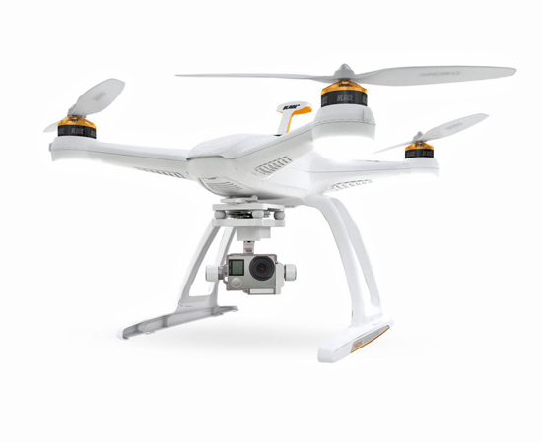

#### User Reviews

After searching for a photography based drone, I came across the DJI Inspire 2 for professional use and the DJI Mavic Mini for novices. For customer reviews, I went to Amazon as they had the most data to work with customer wise and to tech websites for more specific information. I read through a lot of the reviews for both the products and was surprised by the lack of reviews for the DJI Inspire 2.

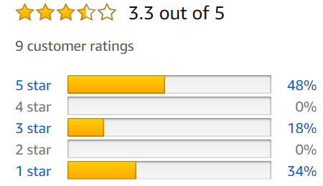

The main problem I gathered with the DJI Inspire 2 was the immense pricing. This drone costs a total of around £3500 but, for its quality, seems to be a worthwhile investment. The only other issues I could see were specific minor hardware issues and other than that the product seems to be decent for most people.

It is stated to be a reliable drone which comes with a detachable and upgradeable camera. A feature which a lot of drones don’t seem to have the option for but is praised for this drone.

The DJI Mavic Mini on the other hand had a vast amount of positive reviews. This drone from DJI is targeted towards hobbyists with a remarkable price of only £370. Despite the low pricing, it comes with a variety of features such as a 3-axis gimbal, a distance of 2km and a flying app for mobile devices. 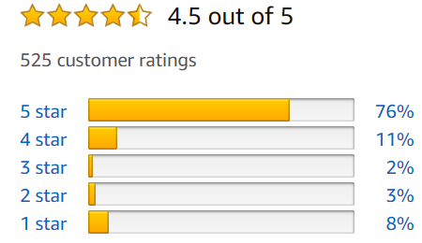

In terms of positives for the camera, it is mentioned that the camera's 3-axis gimbal helps a lot in taking photos and is highly commended. The only issue camera wise is the fact that the image files are in the JPEG format but that hasn’t caused any major concern.

|  |  |
| --- | --- |
| **Positives** | **Negatives** |
| Stable when taking photos | Expensive |
| Can get a range of angles + distances | Requires a pilot to fly it - difficult if you are alone |
| Can take photos in places people can’t access | Most aren’t usable in wind and rain |
| Multi-axis rotation using joystick design | Are banned in some places |
| Mobile app: live video stream and share media button | Specific Hardware Issues at times |
| Timed shots |  |
| Live Camera Feed |  |
| Upgradeable Cameras |  |

### GoPro

A GoPro is a portable, compact action camera that can be used in a variety of extreme conditions. They come with a range of add-ons to help in specific situations such as a wrist mount, an underwater case and protective lenses. They are suitable for taking photos in a range of climates and weathers but all together are lacking in the main functionality of long-distance photo taking. There is an extension pole addon that allows you to get an extended distance but is fairly limited.

#### User Reviews

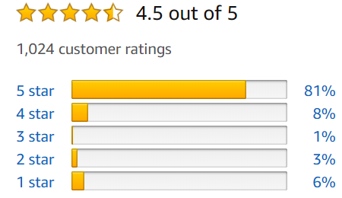Many varieties of GoPro cameras exist. After researching, I found that one of the most popular is the GoPro HERO8. For customer reviews, I went to Amazon due to the extremely large quantity of reviews posted for this camera. I also decided to gather information on an extension pole and found the GoPro El Grande extension pole which also had a relatively large amount of reviews on Amazon.

The GoPro HERO8 is highly rated due to its high quality and useful features that come with the camera. One major feature I have seen mentioned is HyperSmooth 2.0. This is a form of stabilisation developed by the company and is useful for action cameras during videos. The quality of the camera itself is also highly praised in reviews.

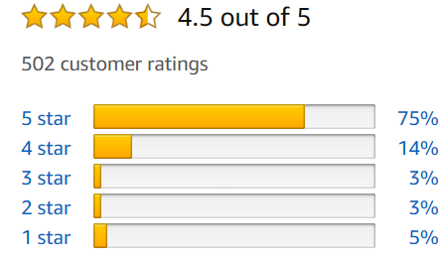

However, the camera comes with a few issues such as a poorly designed battery cover, difficult to export images/video and the low battery life.

The GoPro El Grande (extension pole), is also rated highly due to its high-quality production. Reviews state that the pole is extremely durable and fit for purpose. The pole comes with a ball head which means that you can easily adjust the angle the camera sits on which users agree is useful.

However, some users had issues with the fact that the pole didn’t come with a lanyard which helps with portability and that there is no way to take photos without another device to interact with the GoPro. This pole is purely made for taking videos.

|  |  |
| --- | --- |
| **Positives** | **Negatives** |
| User friendly | Expensive |
| Portable | Hard to keep stable |
| Can be used in extreme conditions | Can’t take long-distance photos without addon |
| The extension pole is relatively limited with an additional 97cm length | Requires you to hold it (unless you use a camera mount) |
| Voice control | Poor battery life |
| Live Camera Feed |  |
| Video Stabilisation |  |

### Bluetooth Remote Control

A Bluetooth remote control is a device that connects via Bluetooth to your phone and allows you to activate the camera shutter by pressing a button on it. They are small devices which are extremely cheap and can connect to multiple phone operating systems. However, they are limited to where you place and angle your phone - providing no way to control the camera's rotation externally and solely rely on the stability of your phone's physical location. This means that it can be difficult without something to prop your phone up and for some planning on angling the phone before you’re even in the shot. Additionally, it provides no means of a live camera feed without you sacrificing quality by using the camera built into the screen of your phone.

#### User Reviews

Multiple versions of Bluetooth Remote controllers exist on the market. Despite this, most of the Bluetooth remote shutter controllers appear to be very similar in appearance - a small rounded controller with two buttons (one for IOS and one for Android OS). Due to this, I used the Ailun Bluetooth Remote shutters customer reviews as they had the most reviews on Amazon out of all the Bluetooth remote controllers.

This cheap £6 device has relatively good reviews with most boasting that simplicity, low cost and portability won them over with this device. Most users found that the device was decent for the price and the positives mostly outweighed the negatives.

There were only a few negatives for this product. Some users mentioned that the quality of the products materials is cheap and plasticky. There are also a few mentions of issues with stable connections between the device and the phone. A final issue is a lack of compatibility between certain phones which, for those that are affected, is a major issue.

|  |  |
| --- | --- |
| **Positives** | **Negatives** |
| Extremely Cheap | Needs a safe spot to put the phone |
| User friendly | Difficult to get good camera angles - requires you to position your phone |
| Portable | Have to hold the remote to take the photo - might be visible in the photo |
| Simplistic Design | Isn’t compatible with some devices |
| Works for multiple phone operating systems | Connection issues |

### Conclusion

From researching these products, I have gathered that portability for my hardware is a necessity for a remote-controlled camera. It allows you to easily transport the device to multiple locations without it becoming a burden. The “Bluetooth Remote Control” and the “GoPro” each solve this with physically small designs that allow you to carry them both easily within your pocket or backpack. Each “Drone” attempts to solve it with different solutions such as a physically small design, foldable wings to compact the drone or a strap to allow you to carry the drone on your back (for larger drones). I will ensure that my project follows what these products accomplished by also being portable through physical size.

Another prevalent feature was “multi-axis camera rotation”. This feature allowed for a greater variety of shots and was present in all of the existing solutions. The “Drone” solved this best, by providing servos to remotely rotate the camera on different axis as opposed to relying on the user to rotate the camera manually. I will make sure to include this feature as it is vital to follow the camera position key step remotely.

*Other inclusions are:*

|  |  |  |
| --- | --- | --- |
| **Feature** | **Origin** | **Reasoning** |
| Live Camera Feed | Drone, GoPro | Allows the user to see what the camera sees in real-time |
| Share Media Button | Drone controller | A convenient way of sharing images taken |
| Simplistic Design | Bluetooth Remote Control | Means that the software is more user friendly and therefore anybody can use it without struggles |
| Stability | GoPro | The camera will need a stand-in order to be stable. Otherwise, the photo will be blurred. |
| Timed Shots | GoPro, Drone | Allows a photo to be taken X seconds later |

## Stakeholders

The stakeholders for this project are going to primarily consist of people interested in photography and mechanics. My solution revolves around photography so feedback from this sector of people would be heavily valued as they can give insight into whether this could have helped a previous situation they’ve been in. Another stakeholder for my project is going to be regular people who are interested in photography as this could help them in taking stable shots since they don’t need to hold this camera.

|  |  |  |  |
| --- | --- | --- | --- |
| **Name** | **Occupation** | **Involvement** | **Justification** |
| Mr Zerouala | Sixth Form Student | General audience | As for most products, you will have an audience of the general public who aren’t necessarily interested in the product but can provide useful insight into improving it. Mr Zerouala is an example of a general audience and would therefore be helpful in the success of this project. |
| Mr Martin | Sixth Form Student | Interested in Photography | The last stakeholder I contacted was Mr Martin. He is a sixth form student who has an interest in photography - specifically mentioning to me that he has a folder dedicated to photos he’s taken on his regular walks with his dog. |
| Mr Davies | College Student | Interested in Photography | Mr Davis is a college student who is focusing on an artistic medium. He is a good candidate for a stakeholder in this project as his interest in photography would massively help with changes to the camera. |
| Mr Dorrell | Sixth Form Student | Interested in Engineering | To account for the hardware side of my coursework, I need to have stakeholders who have an interest in mechanics or engineering. They will be vital in identifying improvements for the pan-tilt aspects as well as the design of the prototype. |
| Mr Horn | College Student | Interested in Engineering | Mr Horn is a college student who is studying under a form of engineering. This would mean that he’s a decent stakeholder as my coursework involves a hardware aspect through the RPI and mount. |

### Gathering Data

During the project’s development, I will continually contact my stakeholders. This will allow me to question them on the current state of the project. I will allow them to use the hardware and software for some time and then ask for any feedback. Utilising the opinions of my stakeholders will support my future decisions on changes to specific features and additions of features. Without feedback, I would be reliant on my own opinions instead of the people my project is targeted for.

I will initially contact them and send them a survey to fill out. This will allow me to get their initial opinions on the features the project should have and to get any other useful information from them. I will be utilising Google Forms as it allows me to easily create surveys that I can share to my stakeholders.

## Survey - General Audience

I wanted to survey to get opinionated information from my stakeholders and the general public so that I can formulate any decisions made in the design section based on the feedback received. Due to the recent outbreak, I created a digital survey using Google Forms to gather my information instead of a physical survey. This survey was shared on various sites to quickly gather data as well as with my ‘General Audience’ stakeholders. However, this means that although I will have a large quantity of data, I may receive valuable responses due to it being open to the public.

### Survey Template

|  |
| --- |
| 1. **How often do you take photos?**   *I asked this question to understand if the survey applies to the user and therefore whether I should consider their later responses*   * Always * Often * Sometimes * Rarely * Never  1. **Have you ever struggled with taking a long-distance photo of yourself before?**   *Asking this allowed me to see if other people have experienced this problem*   * Yes * No * Maybe  1. **What Mobile OS do you use?**   *The answers to this question will help me to choose a mobile platform to develop for*   * IOS * Android * Other...  1. **Would you use this if you had access to it?**   *This allows me to gauge whether this product would be useful*   * Yes * No * Maybe  1. **If no or maybe, then why not? (Optional)**   *If the users said it wouldn’t be useful then this question provides insight into the reason why and allows me to potentially solve the reason why*  <Long answer text>   1. **Which feature is most appealing to you?**   *The results of this will aid me in deciding priority for each feature*   * Face Tracking * Axis Camera Rotation * Delayed Photo Taking [Pressing the button to take a photo 3 seconds later] * Ability to share photos within the app * Live Camera feed  1. **What other feature would you like to be included outside of the ones listed above? (Optional)**   *This section allows the user to give feedback on whether there was a feature that I could include that wasn’t mentioned before*  <Long answer text>   1. **Which alternate solution would you choose over this?**   *This allows me to see which of the alternate solutions other people believe are the best*   * Drone * GoPro * Bluetooth Remote Control * Other...  1. **Why?**   *This gets the user to explain why the alternate solution is better which in turn helps improve my own*  <Long answer text>   1. **Additional Feedback (Optional)**   *Any additional feedback they may have which they didn’t have the option before of saying*  <Long answer text> |

### Survey Results

After waiting for my stakeholders to return the survey, I finally got the results and compiled them into pie charts for readability. A small issue which may be present in some of the answers is the fact that I didn’t target the survey towards a large group of people but I will still continue to take into account the results and will tailor the product based on these.

#### How often do you take photos?

This question was an attempt at discovering whether or not the current stakeholders would utilise the product. The results were fairly expected due two of the stakeholders being interested in photography and with everybody else less interested.

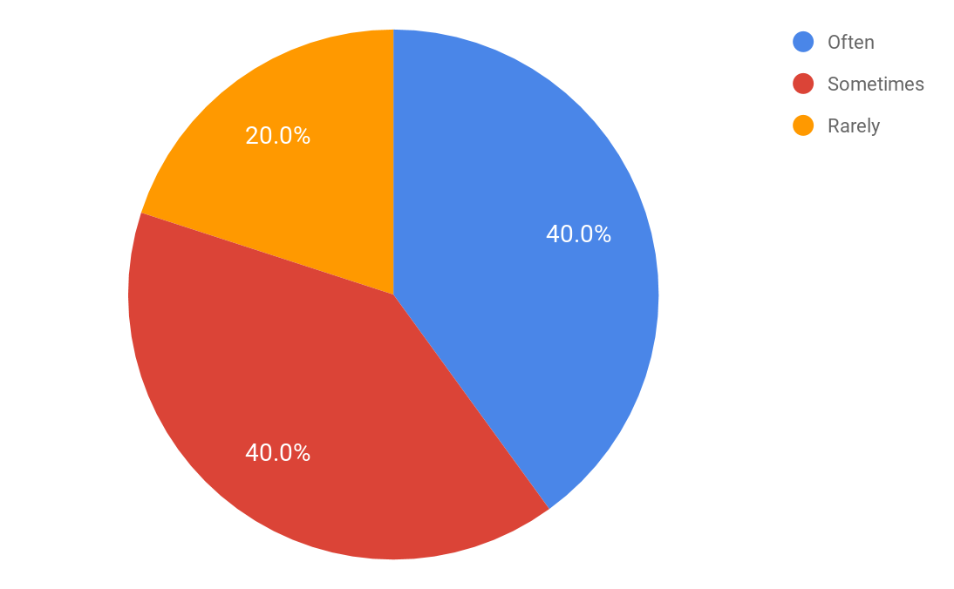

#### Have you ever struggled with taking a long-distance photo of yourself before?

Again, this was also an attempt to hone in on whether the current stakeholders would utilise the product. However, this also gives insight into whether there is a problem to be solved or whether I am wasting my time solving something meaningless. Despite having 2 “No”s, the vast majority of people have. Therefore, I still believe that this problem exists.

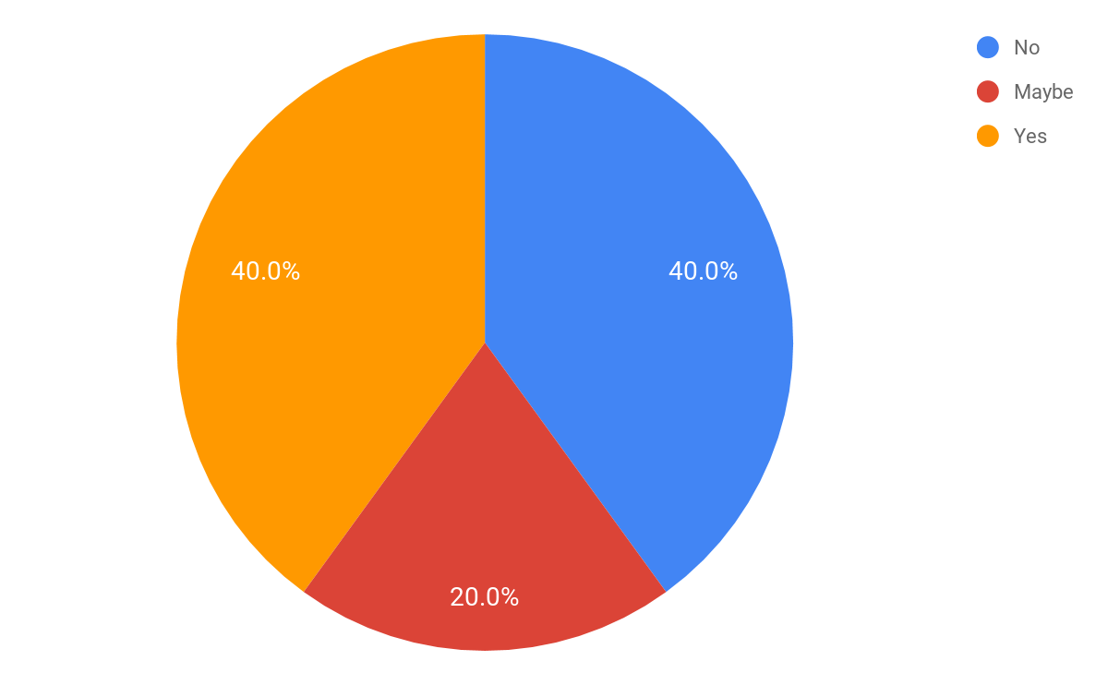

#### What Mobile OS do you use?

Before reading the results for this question, I expected the majority to use an IOS smartphone. Despite this, it turns out that the majority of my stakeholders use Android. Due to this, I will be pursuing Android development instead of IOS. It would be wise to develop for both platforms due to the nature of this split. However, due to time constraints for this project as well being a singular developer, I will only be producing software for Android.

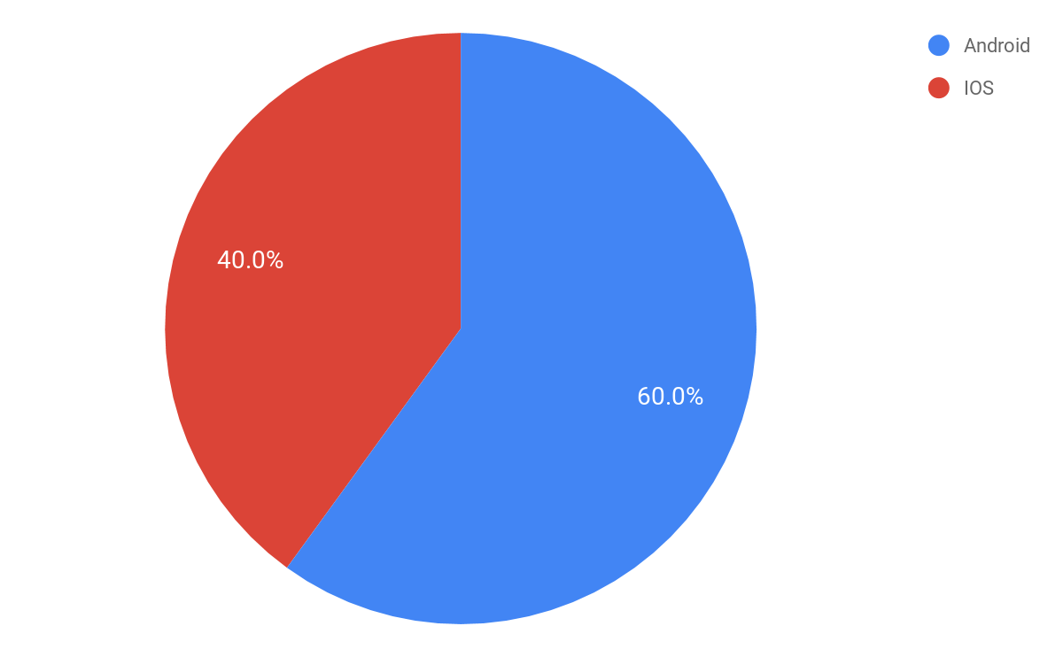

#### Would you use this if you had access to it? If no or maybe, then why not?

Once again this was to gather whether the stakeholders would utilise the product if money wasn’t a concern but also was an attempt at helping me gauge whether the product is useful in general. Considering the high combination of ‘Yes’ and ‘Maybe’, I gather that this product in their eyes is seemingly useful.

For the ‘No’ and ‘Maybe’ responses, I asked them for their reasoning behind why they believed they wouldn’t use the product for certain. The main reason was the fact that you could easily get a friend to help take the picture. This is a valid point however there are some issues with it involving lack of overall control. The other response is the fact that you’d never need to use it since you are very rarely put in this situation.

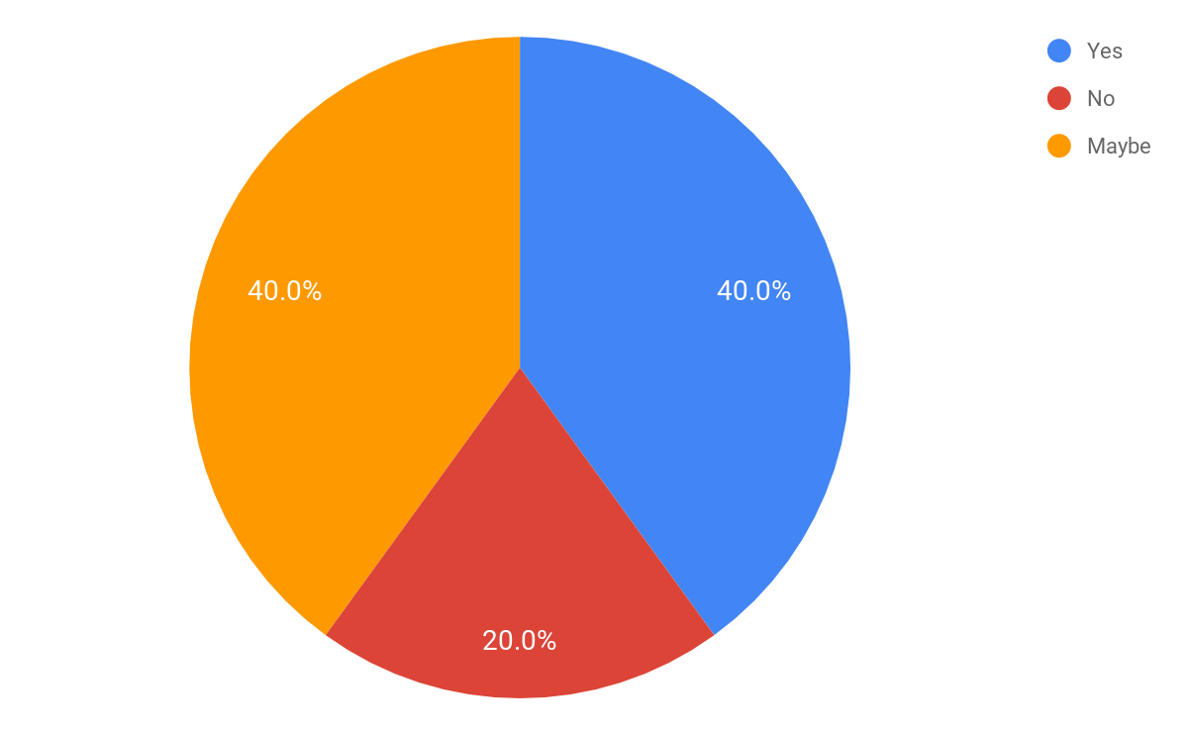

#### Which feature is most appealing to you?

The results for this question have fairly well split all things considered. All options outside of being able to ‘Share Photos’ were selected by at least one stakeholder. This was expected to be the case due to that being an extremely minor feature which, in comparison to the others, isn’t appealing as such but more so just a quality of life feature.

An interesting point to bring up is the fact that ‘Face Tracking’, a feature where the camera centres itself to a face, seems to be as appealing to the respondents as the ‘Axis Camera Rotation’ and the ‘Delayed Photo Taking’. This feature, which I thought was going to be a small side feature, is one that people seem to want as much as the other features to the project.

It didn’t surprise me that the ‘Live Camera Feed’ received the highest amount of votes. However, I did expect it to garner slightly more votes than it got since it is fairly important to the project. I suspect that people based their vote on which unique feature they would want to appear within the project, rather than which feature they would want the most for this project if they were to use it.

Due to not being voted for, ‘Share Media’ will be placed in a lower priority category for development. This means that this feature will be a much lower priority in comparison to ‘Axis Camera Rotation’ for example.

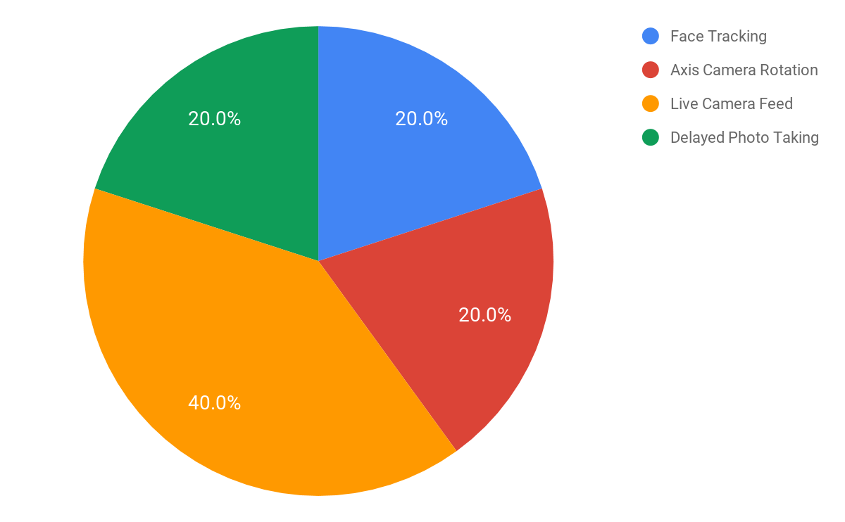

#### What other feature would you like to be included outside of the ones listed above?

As expected, I only got a few responses to this question due to it being open-ended. Outside of the ‘N/A’ answers, I got two responses. One person suggested being able to easily share images taken over Airplay and Google Drive. Considering I won’t be using IOS, Airplay will not be implemented. However, Google Drive may be implemented within the Share Media button. The other response I got was suggesting to make the device easily portable. I completely agree with this as I’ve discussed it countless times within analysis and this will be a main priority for the end product.

#### Which alternate solution would you choose over this to take photos? Why?

The idea of this question was for the stakeholders to potentially bring out any features or ideas I missed within the products listed below which may be able to be integrated into my project. Generally speaking, this question wasn’t as helpful to me as I expected answer wise.

The main point that seemed to be brought up through the respondents who chose either ‘None’ or ‘Another Person takes the photo’ was that the solution to the problem I am solving is simpler with allowing another person to just take the photo. Generally speaking, this is a good solution since it costs no money to ask people to simply take a photo. However, I want to bring up some points. Doing so gives you limited control over how the photo will turn out, people may not always be present to help and giving your phone to a stranger presents a potential trust problem.

Outside of that, the respondents who voted for ‘Bluetooth Remote Control’ seemed to favour the ease of use for the product. The simple design and lack of features get the job done and this simple approach should be incorporated into my software. Overwhelming the user is a bad idea as it can unnecessarily complicate the software and users are more drawn to simplism.

One respondent who voted for the ‘Drone’, brought up the fact that using a drone allows you to capture long-distance images from a variety of angles. However, transporting the drone itself is an issue that they would face. My software will already be able to take photos from a relatively decent distance with a variety of angles thanks to the multi-axis camera rotation. Portability however will need to be taken into consideration as the product will be redundant if it isn’t.

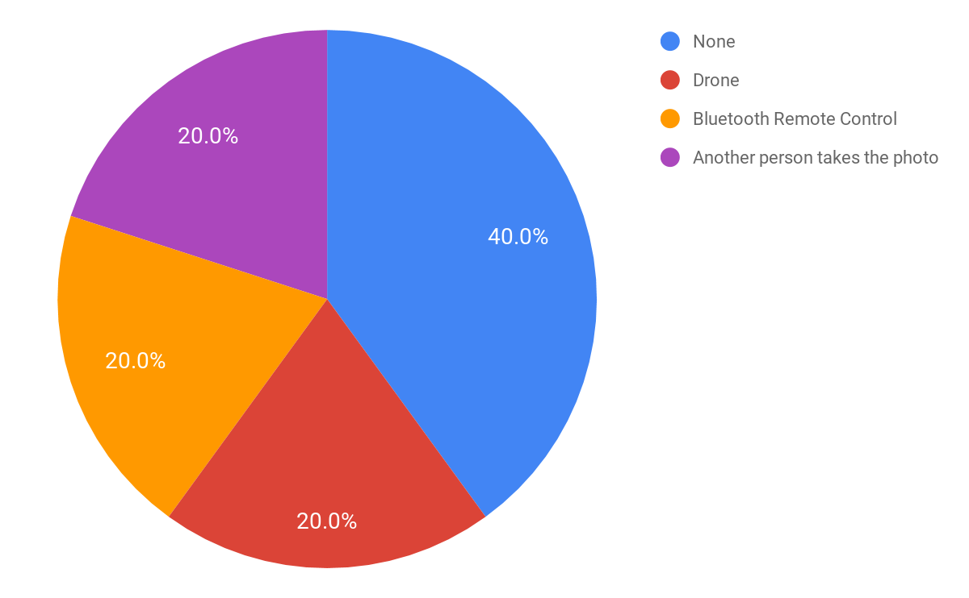

## Conclusion

In conclusion, I will be developing mobile software for the Android platform. This is due to the marginally larger audience for Android and developing both would be time-consuming and a waste of effort due to there being no monetary benefit in doing so - the product is coursework and won’t be sold. Features in a high priority queue will be ‘Face Tracking’, ‘Multi-Axis Rotation’ and ‘Live Camera Feed’. ‘Delayed Photo Taking’ will be placed in a lower priority queue due to it not being the main feature and a smaller % of people wanting it. ‘Share Media’ will follow a similar fate instead of being outright removed due to it being a minor quality of life feature. I will also need to ensure that my end product is portable.

## Essential Features

Drawing from my Stakeholder feedback and initial solution analysis, I will compile a list of essential features for my end product.

|  |  |
| --- | --- |
| **Feature** | **Purpose** |
| Live Camera Feed | In order for the user to easily see what the camera can, a live video feed to the Android app needs to be established. |
| Multi-Axis Rotation | So that the user has control over the camera, it will have multi-axis rotation whereby the user can easily modify the rotation from the Android app. |
| Face Tracking | The app will allow the user to easily centre the camera on their face (or the centre of multiple faces). |
| Delayed Photo Taking | The user will be able to make the camera wait before taking a photo. This will allow them to hide their phone for example when trying to take a photo. |
| Share Media | This will allow the user to easily share photos they have taken without having to open a photo gallery app. |
| Take Photo | The RPI will take a photo and send it to the user via the Android app when they press the button. |
| Simplistic Design | For usability sake, the Android app will need to have a simplistic design. This means that anybody who has never seen the app before should be able to use it with relative ease. |
| Portability | The hardware itself will need to be portable - light weight and small volume wise. |

## Requirements

To develop my project, several software and hardware requirements must be fulfilled. Each of these is a necessity for the project and are listed below.

### Software

#### IDEs - Pycharm and Android Studio

Jetbrains is a company that produces professional software tailored to software developers. For my project to function, I need to use a combination of Python and Kotlin.

From my survey results, I concluded that I should use Android over IOS due to the larger audience. Programming for the Android OS is also a cheaper alternative to IOS due to the overpricing of Apple products. I need to use Kotlin as the Python alternative for Android development is extremely limited and in its early conceptualisation.

To aid me in programming, I have opted for using Android Studio as it is the official IDE for developing Android software. This will not only support me heavily with its features such as auto-completion and an advanced debugger but will also mean that it will be easy to pick up due to being based on IntelliJ - a Java IDE built by Jetbrains that I’ve used in the past.

For the majority of the backend, I will be using Python. I have more experience with Python which means I will be able to develop the majority of the robotics and other content a lot quicker. I will be using the professional edition of the Pycharm IDE to develop this side. Due to this also being built by Jetbrains, it is visually similar to Android Studio. I am familiar with this IDE and its features which, in my opinion, are better than other IDEs available.

#### GitKraken

Recently, I have been using Git to help with the development side of my projects. It allows me to host remote or local repositories and track my development progress through commits and branches. If something major goes wrong with my code, I can revert any commits that led up to that issue.

GitKraken is software that makes the process of using Git extremely simple by providing a well designed GUI that shows a timeline of commits on all branches, merges and other useful information. GitKraken also comes with Glo Boards which act as a sticky board for certain topics. This will be useful in tracking progress for portions of code - whether they are in progress, high priority, completed or need to be done.

### Libraries, Frameworks and APIs

#### React Native

When searching around for easier ways to develop Android Apps, other than using Android Studios standard library, I came across two existing frameworks. Flutter and React Native. They both allow for easier development of Android Apps. Flutter uses the Dart language which is developed by Google specifically for applications and React Native uses Javascript. If I decide on using a framework to help speed up development, I will use React Native as Javascript is extremely simple to use compared to an entirely new language.

Using React Native comes with benefits outside of simply speeding up development. It allows me to develop not only for Android but also for IOS with the same code. This means that I can target both platforms with only one code for both.

However, using this may add unnecessary complexity to the project and will need to be evaluated before continuing forth with it.

#### Face Detection

My project will include face tracking as a minor feature where, when selected, the RPI will automatically modify the servos rotations to centre the camera on a person's face or at a point in between multiple peoples faces. To achieve this, I will need to include a facial recognition algorithm in my software. This will be on the RPI as it should have better hardware than a phone, will make it easier to program and won’t require networking for that section of code - the fewer requests the better.

Since programming a facial recognition algorithm from scratch with a standard library is extremely difficult, I will be looking to use a library that will make it easier. I could potentially use OpenCV to streamline this process. OpenCV is a library that’s focussed on “real-time computer vision”. It is one of the more popular choices for facial recognition which means that there is a decent amount of support readily available.

#### Video Streaming

A major feature within my project is the ability for you to see a live camera feed directly from the RPI on your mobile device. I have done a lot of research on this as it is one of the most complicated section of my entire project. There is very little information on this so I have scraped together what little information there is and stored links on my desktop. There are multiple approaches to streaming video and I believe that the easiest way to be able to output it on an Android app is either to use MJEG or a Web View.

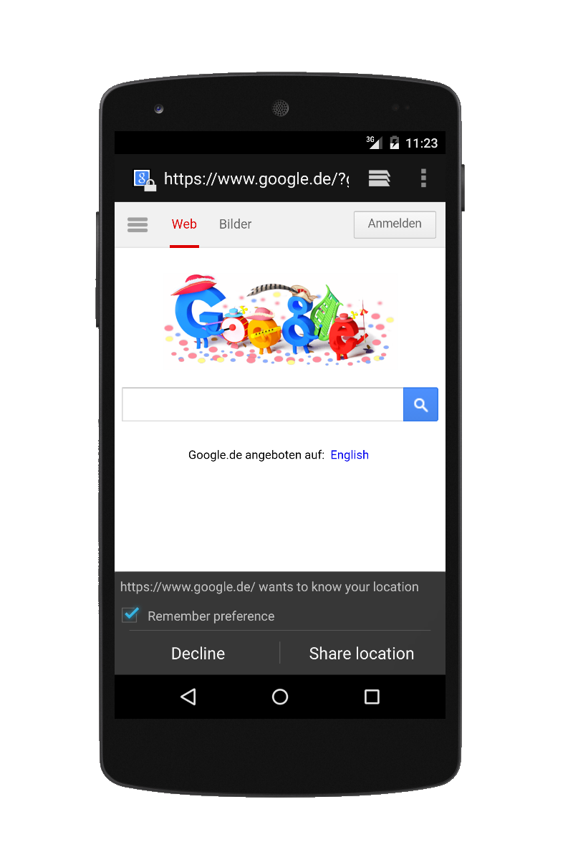

MJEG, or ‘Motion JPEG’, is a form of compression for videos where each frame of the video is turned into a JPEG image. This means that theoretically, I could compress the video in real-time and then send each JPEG to the mobile device. When the software receives a new image it will update the current image to be replaced by that. The logic behind it is fairly simple but figuring out how to execute that as code may not be so simple.

The other potential approach is a component within Android studio called ‘Web View’. This component allows you to connect to a website and in that space view the resulting webpage. This means that you can easily make a browser or show a website after clicking on a link. I could use this to stream videos. There are two approaches to this. Either turn the RPI into a web server and stream the video on an HTML page or find a pre-existing streaming website and stream through there. Either way is possible however, I would prefer not to do the former as it requires a lot more knowledge of networking than I am comfortable with. However, libraries exist which help with this such as Flask for Python.

#### PIL

PIL, also known as the Python Imaging Library, allows you to interact with images within your code. This will most likely be used when video streaming and when taking photos. Without PIL, the modification of images would be very difficult. The only downside from using PIL is the added dependency to the project.

#### RPI Controller Libraries

For the RPI to control the camera it will have as well as the servos, I will need to get two libraries. The first being ‘picamera’ which gives you functionality for the camera. This allows me to take pictures, stream video and add effects. This library alone will aid massively in controlling the camera.

The second library I’ll need is ‘RPI.GPIO’. This library allows me to control the GPIO header on the RPI. The GPIO header is a section of hardware that allows you to add connections to it. Each pin corresponds to a different function ranging from 5V power output to a ground pin. I will use the GPIO header to control the servos for the camera rotation. They will each be connected to the GPIO header by 3 M/F jumper cables.

### Hardware

#### Raspberry Pi

For me to be able to control the movement of the camera, to power the camera and to be able to relay data between the phone I need a form of hardware. Multiple options can accomplish this. Arduino, RPI or connect the camera to a laptop. For obvious portable reasons, I’m not choosing to go with the laptop. It would mean that it would be tedious to move around and is also expensive to purchase a laptop just for this. An Arduino is a good idea due to size but takes longer to load scripts onto, isn’t that powerful computational wise and requires a lot of knowledge on electronics. Using an Arduino would require me to learn a lot which, for a project of this calibre, isn’t something I want to add to the list.

A Raspberry Pi is, quite literally, a remarkably small computer which I will run off of the Raspbian OS - a modified version of Debian (a Linux distribution). This means that I can hook up the RPI to a monitor, plug in a mouse and keyboard and code on the RPI itself. This makes life a lot easier and the RPI itself is only 6cm by 9cm by 3cm. I will be going with the Generation 3B version of the RPI due to the increased power compared to the previous versions. This is necessary for the facial recognition that the RPI will have to process.

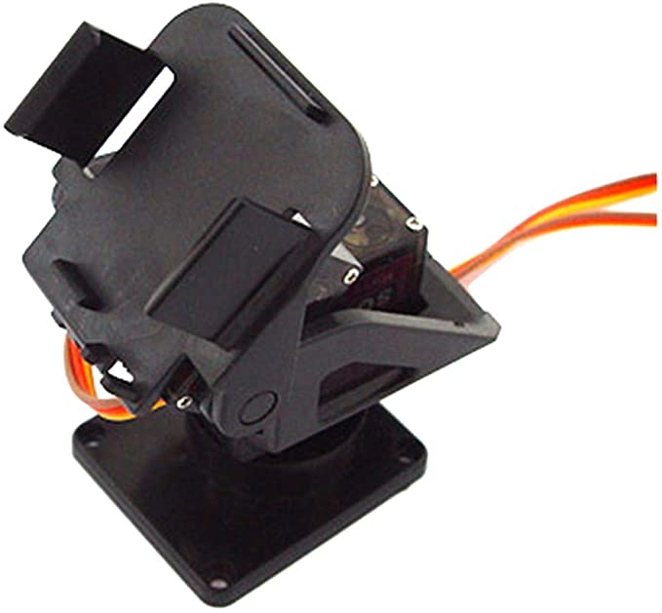

#### RPI Camera and Mini Pan-tilt Camera Mount

There are a variety of cameras I could choose to work with the RPI. Each has a varying degree of quality and accompanying price. To decide on a camera, I had to first find a mount that fulfilled the requirements I had since I don’t want to have to design and 3D print my parts - that would add an unnecessary amount of effort which should be spent elsewhere. After searching around, I found a supposedly pre-assembled (it wasn’t pre-assembled and had no instructions on how to build it) mount with 2 axes of rotation. It is also stated to be very small and would support a 28*28 camera which I presumed meant 28mm^2.

After finding this, I searched around for a camera. Eventually, I settled on a standard RPI camera module as it had roughly the same measurements as the mount supported. The RPI camera module supported 1080p at a decent 30fps and was fairly cheap.

#### 3D Printer

My current RP case doesn’t include a space to screw in the PT camera mount, as expected. So, to compact everything into a single unit - the camera mount and the RPI - I may need to design a custom-built case. If I do this, I will use an Ender 3 pro to print it out. This is one of the cheapest 3D printers and I have ready access to it. This will take up additional time during the project and may not end up being a requirement.

#### WiFi Dongle / Ethernet

The RPI 3 model B comes with a built-in WiFi adapter and Bluetooth adapter to connect you to the internet or Bluetooth compatible devices. However, the built-in WiFi adapter may not be decent enough for a constant video stream. If this is the case during development, then I’ll either need to connect a better WiFi dongle to the RPI or connect the RPI straight to Ethernet. Hopefully, the RPIs built-in WiFi adapter is decent enough for this project.

#### PC Hardware Requirements

The APIs and Frameworks I will be using have mentioned no minimum hardware specifications. The programs for developing however do. The desktop PC I will be developing on has the following specifications:

|  |
| --- |
| **Custom Built Desktop PC**  **OS ~** 64-bit Windows 10  **Processor ~** 3.6 GHz Intel Core i5 8600k  **Main Memory ~** 4x 4GB DDR4 Corsair Vengeance  **Graphics ~** 6 GB Nvidia Geforce GTX 1060  **Storage ~** 500 GB M.2 SSD, 2TB Seagate Firecuda SSHD, 1TB Seagate Firecuda SSHD  **Monitor**  **Resolution ~** 1920x1080 60 Hz |

To run all of the necessary software, my computer needs to meet at least the bare minimum specs. The requirements for the software are listed below:

|  |
| --- |
| **Pycharm** **OS ~** 64-bit versions of Microsoft® Windows® 8, 10  **Main Memory** **~** 8 GB RAM recommended  **Storage** **~** 2.5 GB storage space  **Resolution ~** 1280 x 800 minimum screen resolution  **Python** **~** Python 3.5 or newer |

|  |
| --- |
| **Android Studio - for Windows OS**  **OS ~** 64/32-bit versions of Microsoft® Windows® 7, 8, 10  **Main Memory ~** 8 GB RAM recommended; plus 1 GB for the Android Emulator  **Storage ~** 4 GB storage space recommended  **Resolution** **~** 1280 x 800 minimum screen resolution |

## Limitations

When developing the proposed solution, there will be a few limitations. These have been compiled and listed below.

### Programming Complexity

The project’s frontend will be programmed in Kotlin within the Android Studio IDE. Due to my limited exposure to this programming language, it may be difficult for me to program certain parts of it and as a result, I may need to resort to the language’s documentation or example code online. This will take up time when developing the project so I must ensure that I don’t try to continue with any aspects of the project which seem to be a lot more difficult than anticipated.

### Time Constraint

The coursework project will have a deadline and I will need to have finished the project at a reasonable stage by this point. To successfully do this, I will have to be relatively strict with personal deadlines for each portion of the project.

### Stakeholders

Due to current events, it may be difficult to find appropriate stakeholders for my project; especially since my project is hardware-based. This may mean that I have to find only stakeholders I am legally allowed to interact with.

### Video Feed

As a result of deciding to use a live video feed from the RPI, there may be limitations with the resolution and FPS of the video feed itself. The RPI may not be able to transfer high resolutions or a high FPS. This will depend on how quickly it can send the frames over WiFi using its built-in WiFi dongle.

### Power

The RPI can be run off of power sources other than the mains but for development, I will only be using the mains to develop for it. This means that I won’t know how decent the battery life will have when attached to a power bank and this could severely impact the final product.

## Development Methodology (SDLC)

When I come to develop the software, I will need to follow a certain development methodology. I have created a list of common development methodologies to compare so that I can come to a conclusion on which to use.

### Comparison Table

|  |  |  |
| --- | --- | --- |
| **Methodology** | **Advantages** | **Disadvantages** |
| Waterfall | * Clear requirements * Detailed documentation helps new developers * Easy to measure progress * Easy to calculate release date | * Requirements can’t change * Low flexibility * The client only can see the end product * The need for strict management |
| Spiral | * Incomplete versions of software available early on in development * Handles risk analysis well * Flexibility in requirements * Suitable for high-risk projects | * Unrealistic for small projects - the number of prototypes * Complex SDLC to follow * Time management is difficult * Hard to calculate end product release date |
| Agile | * Satisfied clients - get to see new features quickly * Easy when resolving client feedback * Flexibility in requirements | * Consistent interactions required between client and developer * Difficult to estimate the effort required and therefore end product release date * Risk of the ever-lasting project due to unstable requirements |
| Extreme Programming | * Faster software development due to regular testing * Code is simplistic and can be improved upon later * Massive time savings | * Lower code quality * Difficult for geographically separated teams due to constant feedback and meetings required * Lack of documentation created |
| RAD | * Reduced development time * Heavily encourages client feedback * Flexibility in requirements | * Client involvement during development is a necessity * Only implementable for projects that can be modularised * Can be difficult to set up for |

### Evaluation

For my project, I will be using the waterfall methodology. My requirements for the project have already been established and the success criteria that will be built around them should be fairly stable. Also, for waterfall, the client is only supposed to see the end product which will make changes at the end be a lot longer but will be more manageable documentation and time wise.

The features of the waterfall SDLC that attracted me are the high quality documentation which this coursework will be built around and the idea of clear, stable requirements. This should mean that from a documentation perspective, the development journey will be easy to follow.

## Success Criteria

|  |  |  |  |
| --- | --- | --- | --- |
| **Module** | **Criteria** | **Justification** | **Priority** |
| **Main Interface** | 1.1 - Connect GUI | The interface provides an easy way for the user to connect to the RPI without having to set up the software to only be able to connect to a single RPI. | **High** |
| 1.2 - Connect to RPI | Allows the user to connect to the RPI so that the app can send requests and receive data such as the live video feed and images. | **High** |
| 1.3 - Main GUI | This interface appears after the Connect GUI screen and will allow the user to interact with the camera. It will have buttons for taking photos, rotating the camera, centring the camera on a face and accessing the submenu. | **High** |
| 1.4 - Live Camera Feed | The main portion of the screen will display a live camera feed from the RPIs camera. | **High** |
| **Camera Rotation** | 2.1 - Rotate Camera | This brings up a menu which allows the user to input values which will increment or decrement the rotation of the camera mount by sending a request to the RPI. The menu will be accessed via a button to the right of the ‘Take Photo’ button. | **High** |
| 2.2 - Modify Servo Rotation | For the camera device to be rotated from a distance, the RPI needs to be able to change the rotation of the servos. In turn, this will change the rotation the camera is facing as the servos control the camera mount. | **High** |
| 2.3 - Detect Faces | Facial recognition will be a minor feature on the app. The RPI will detect faces and then modify the servo rotation to centre the camera on any detected faces. | **Medium** |
| 2.4 - Centre on Face | The button sends a request to the RPI to centre the camera on a face or the average position using the location of multiple faces. | **Medium** |
| **Take Photo** | 3.1 - Regular Photo | When the user presses the take photo button, it will request for the RPI to take a photo. | **High** |
| 3.2 - Timed Shot | By pressing and holding the take photo button, you can take a timed shot. The number of seconds you hold the button down for will be counted after releasing and then a photo will be taken. | **Low** |
| 3.3 - RPI Take Photo | The user needs to be able to request for the RPI to take a photo. This is vital as the majority of the project relies on this feature to function. | **High** |
| 3.4 - RPI Send Photo | Once the RPI has taken the photo, it will be sent to the user’s phone. This will be a high priority as is vital to the project. | **High** |
| 3.5 - Autosave Image | If the RPI fails to send the user the photo through either connection means, full storage or another factor - the image should still be persistent somewhere. The RPI will save the images taken to local storage. This way the user can access any and all images taken from the RPI. | **Medium** |
| **Submenu** | 4.1 - Sub menu interface | The button to access the submenu will be located in the top left. This will avoid interference with the main interface that will be used more often | **Medium** |
| 4.2 - Share Media | This brings up the generic share menu built into a lot of android apps. Using this will share the most recent photo taken. | **Low** |
| 4.3 - Open Photo Gallery | Opens the Android photo gallery on the user’s phone; means that I don’t have to implement a custom-built photo gallery into the app. | **Medium** |
| 4.4 - About page | Brings up a page which shows information ranging from the connection information to the RPI to my contact details for feedback. | **Low** |

# Design

## Decomposition Diagram

As I stated I would previously in the Analysis section, I have created a Decomposition Diagram to better help me understand the general flow of my program and its structure. I have used the success criteria to guide this as it already shows the modules and their criteria. The decomposition diagram can be viewed as a visual representation of the success criteria with the added benefit of the programs general structure included.

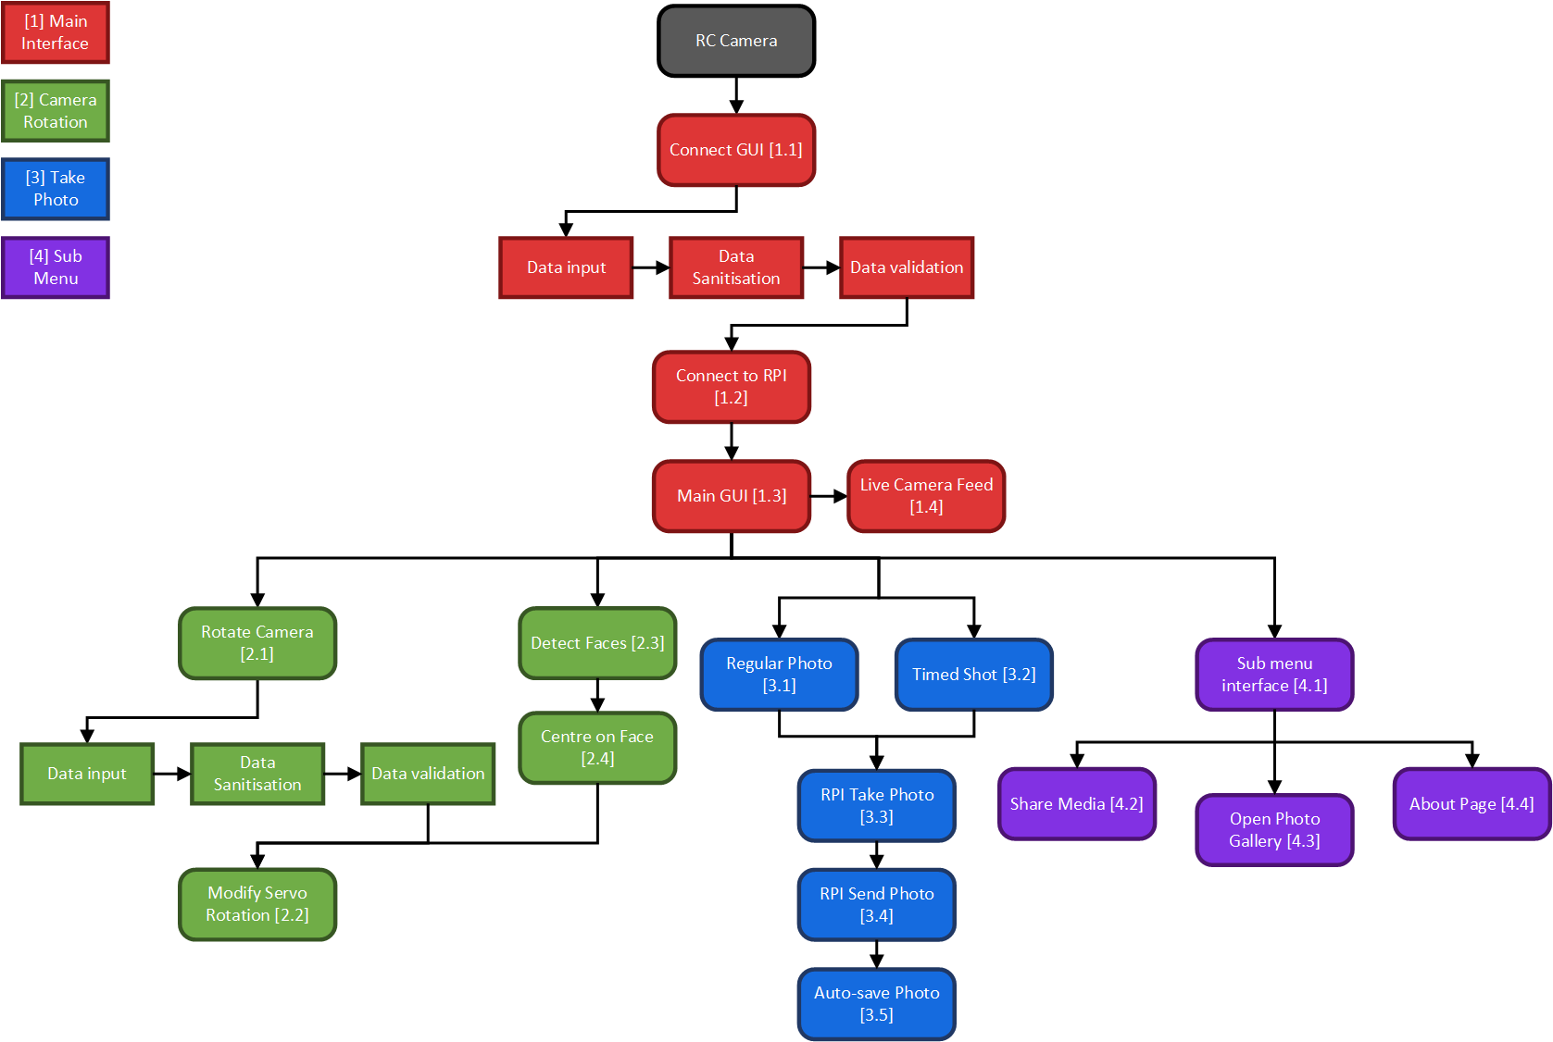

## Usability Features

When developing this project, usability should be a heavy influence on the frontend interface. I have identified some key factors that should be considered during development to allow the user to have a better experience.

### Simplistic GUI

In order to make navigation and performing tasks easier, the GUI needs to be able to be easily interpreted and understood. This includes minimising the amount of clutter present on the screen and for the key portions of the GUI to stand out. This should also include integrating the existing Android backwards navigation feature into the app since the user will be acclimated to this already.

### Button Icons

For the majority of buttons - where appropriate - I should use icons instead of text. This will reduce clutter and will be more pleasing on the eye. However, the function of the buttons should still be understood. This means that I should attempt to use familiar icons where possible; a cog for a settings button for example. There should also be an alternative way of displaying the buttons function - potentially being able to press and hold on the button for a short description of the button could be possible.

### Text

Any and all text within the app should not only be grammatically correct but should also be short. It is more convenient for the user to read a small bit of text in comparison to paragraphs worth. The styling for text should also be consistent based on its purpose. For example, titles may have one style and descriptive text another. Additionally, these text styles should all be easily readable with high contrasting colours when compared to the background.

### Error Tolerant

In situations where an error may arise, the program should have code to remedy these without human intervention. This means that instead of having an error simply appearing on screen, the program should go out of it’s way to fix these without the need to have an error. For example, in situations where only numerical values are accepted, the program could remove all instances of non-numerical values as soon as they are typed in. The alternative, non-error tolerant version would simply have a text input and would inform the user that numerical values are only allowed. This would reduce the efficiency of the program since the user would manually have to go and remove each instance of this which would become increasingly frustrating.

### GUI Styling

When styling the GUI, the theming should be consistent across all instances. This increases a users familiarity with the program and would mean that, if they encounter a new part of the GUI, they will be less intimidated. The styling should also be modern and appealing to the user. Some common examples of a modern GUI is minimalistic design.

## GUI Design Reference Table

My project will consist of software for a Raspberry Pi 3 and for an Android App. The user will be presented with the Android App as the front-end and so I have decided to create some GUI designs for each screen. These will heavily influence my end products GUI and I will consult the Photography stakeholders on these designs. I will be asking the Photography stakeholders due to the fact that their interest is the closest I have to ‘Graphic Design’.

When explaining design choices for the GUIs, I will be referencing specific colours, fonts and icons. These will be listed in the table below. I will add them to the table below as I design each GUI.

|  |  |  |
| --- | --- | --- |
| **Section** | **Reference Name** | **Reference Definition** |
| **Colour** | Raspberry Red | #BB1142 |
| Leaf Green | #75A928 |
| Black | #000000 |
| White | #FFFFFF |
| Grey | #404040 |
| Midnight Blue | #2E325E |
| Navy | #393E75 |
| Space Blue | #474B7A |
| Slate Blue | #6D6994 |
| **Font** | Main | Agency FB |
| Alternate | Gill Sans MT |
| **Icon** | RCPIC Logo |  |
| Shutter Button |  |
| Face Tracking Button |  |
| Rotate Axis Button |  |
| Submenu Button |  |
| Open Photo Gallery Button |  |
| Share Button |  |
| About Page Button |  |
| Back Button |  |

## Navigation Diagram

In order to better visualise the project’s Android app structure as a whole, I decided to make a navigation diagram. This shows a generalised flow of the program from each GUI page. I decided to include the GUI prototype designs from earlier in order to get a better sense of how it might look.

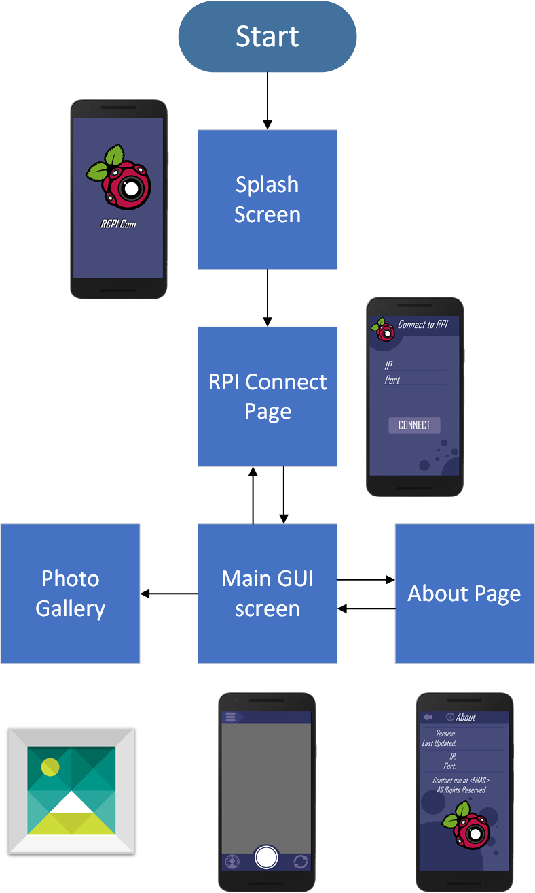

## Main System Flowchart

The flowchart below showcases how the flow of the program generally works. The subroutines below will have individual flow charts created within the rest of the design section.

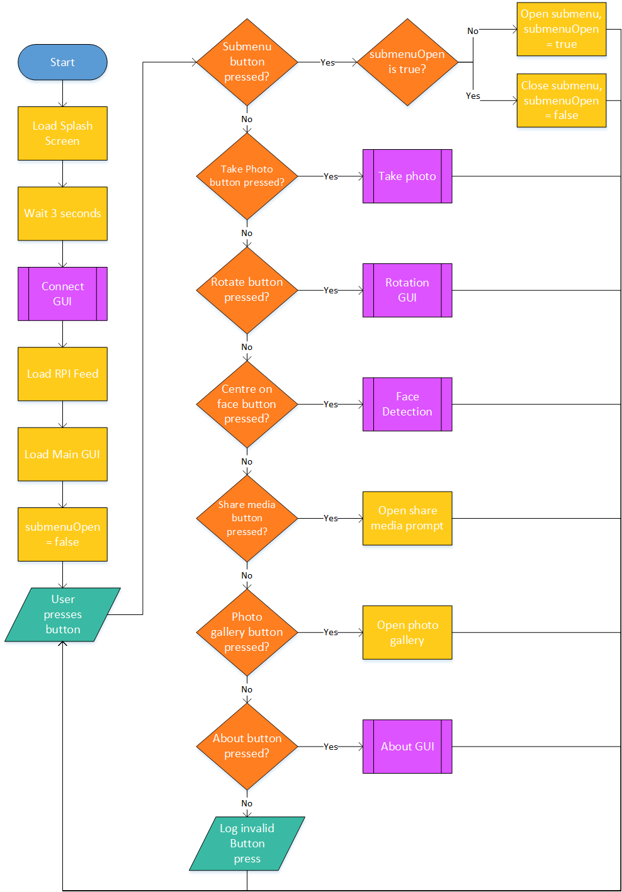

## Main System Pseudocode

|  |
| --- |
| START  Load Splash Screen  Wait 3 seconds  Run on_create method of a ConnectGUI instance  Load the RPI feed  Load the Main GUI  submenuOpen = False  WHILE DO  IF user presses button THEN  IF button is Submenu THEN  IF submenuOpen is True THEN  Close submenu  submenuOpen = False  ELSE THEN  Open submenu  submenuOpen = True  ENDIF  ELSE IF button is Take Photo THEN  TakePhoto()  ELSE IF button is Rotate THEN  Run on_create method of a RotationGUI instance  ELSE IF button is Centre on Face THEN  FaceDetect()  ELSE IF button is Share Media THEN  ShareMedia()  ELSE IF button is Photo Gallery THEN  Open photo gallery  ELSE IF button is About THEN  About()  ELSE THEN  LOG "Invalid Button Press"  ENDIF  ENDIF  ENDWHILE  END |

## Class Diagram

Before working on my individual modules, I have decided to create a class diagram to represent the connections between classes that I will develop. When creating the class diagram, I used the [following website](https://creately.com/blog/diagrams/class-diagram-relationships/) as a reference.

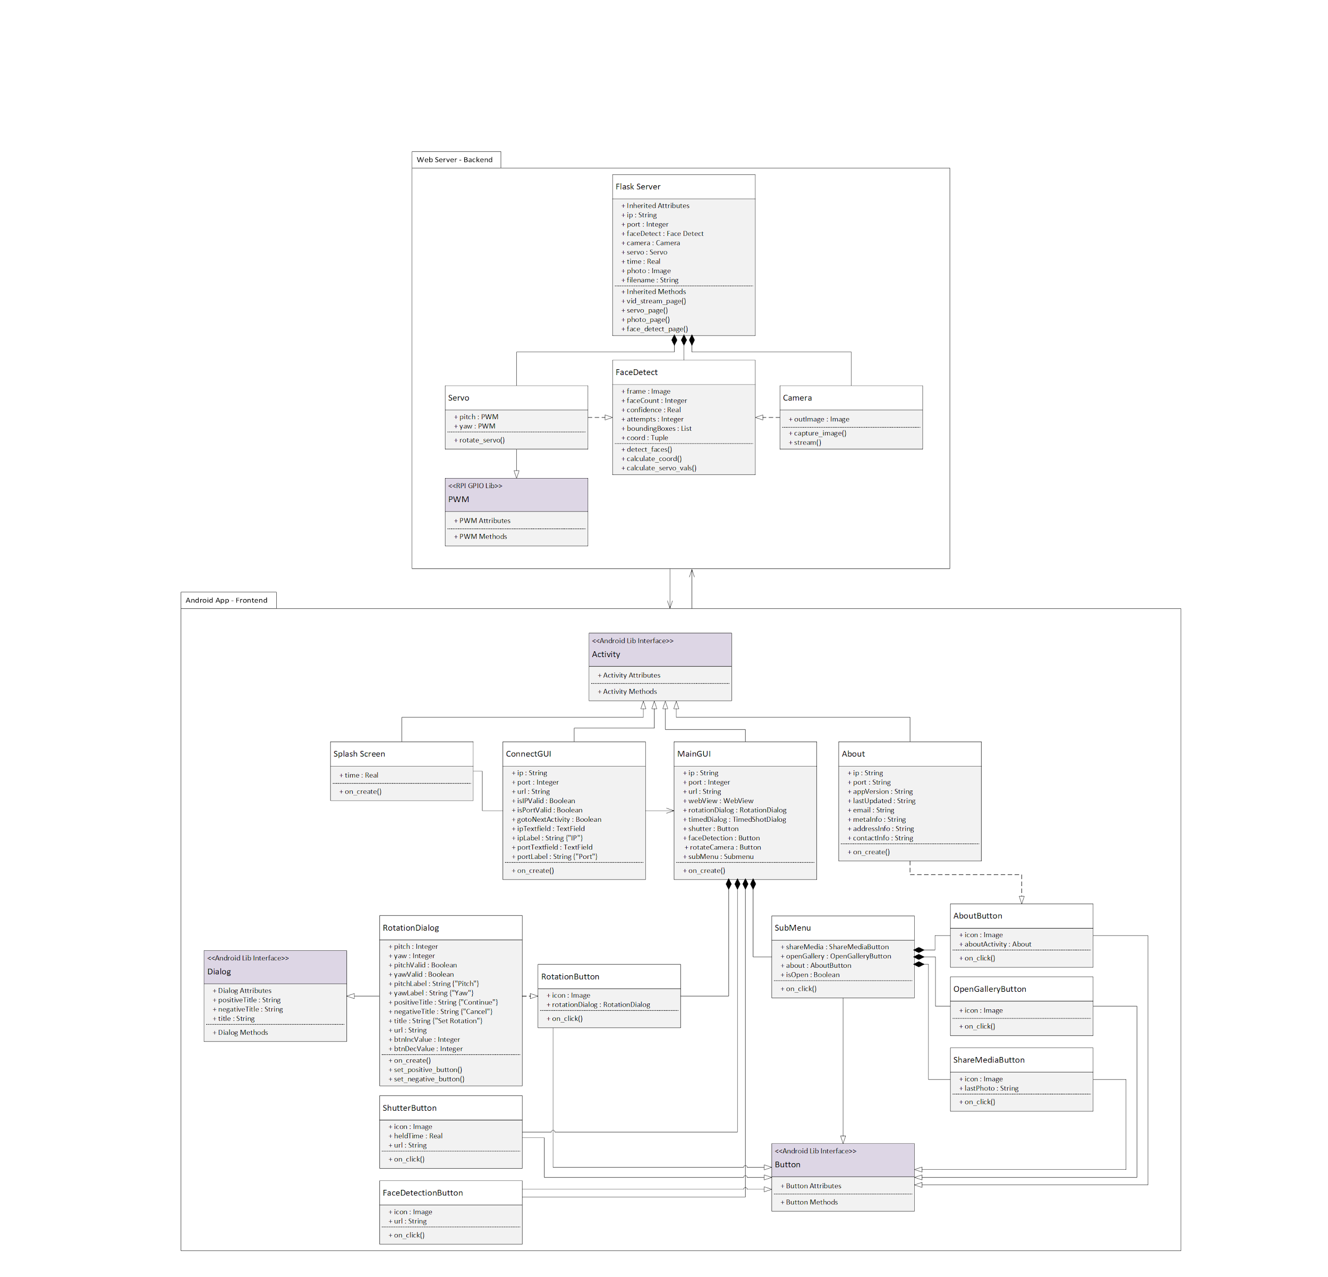

## Module 1 - Main Interface

### Justification

The Main interface module contains both the logic for connecting to the RPI, as well as the GUI the user will be using to interact with the RPI. Previously, they were in separate modules (RPI Connection module and the Main Interface module) but due to their small sizes and similarities, they were combined into one.

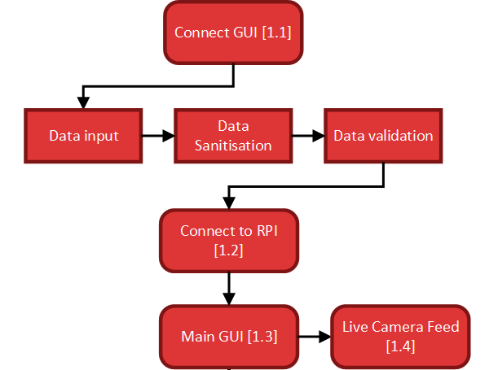

### Flowcharts

#### Connect GUI

The Connect GUI allows the user to establish a connection with the RPI. This means that it requires the user to enter a valid IP and Port value which will be used together to try to connect when the user hits the confirm button. Before a connection is attempted - the algorithm will check whether the IP and Port are valid and if they aren’t will notify the user.

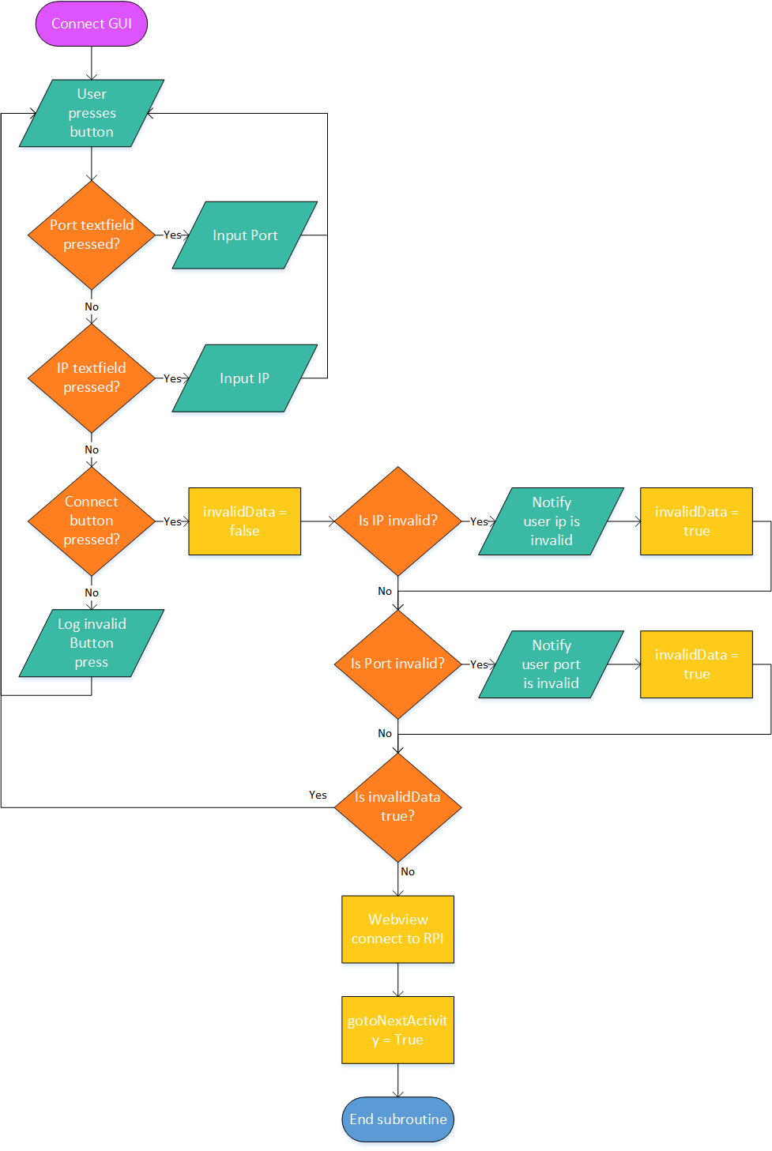

### Pseudocode

#### Connect GUI

|  |
| --- |
| CLASS ConnectGUI INHERITS Activity  ATTRIBUTES  ip <String>  port <Integer>  url <String>    SUBROUTINE on_create  WHILE DO  IF user presses button THEN  IF button is Port Textfield THEN  INPUT port  ELSE IF button is IP Textfield THEN  INPUT ip  ELSE IF button is Connect THEN  invalidData = False  IF ip is invalid THEN  OUTPUT "IP is invalid"  invalidData = True  IF port is invalid THEN  OUTPUT "Port is invalid"  invalidData = True  IF invalidData is False THEN  url = "{ip}:{port}"  Connect Webview to url  gotoNextActivity = True  ELSE THEN  LOG "Invalid Button Press"  ENDIF  ENDIF  ENDWHILE  ENDSUBROUTINE  ENDCLASS |

### Variable Table

|  |  |  |  |  |  |
| --- | --- | --- | --- | --- | --- |
| **Class** | **Variable** | **Data Type** | **Constant** | **Validation** | **Justification** |
| Connect GUI | ip | String | False | Must have the correct formatting for an IP address. 4 integers between 0 and 255, each separated by a “.”  Type Check  Format Check  Presence Check | This is the string data from the IP text field. It needs to be a string as periods are separating the numbers. It needs to have validation for the formatting of a correct local IPv4 address; the RPI will be connected to using this. This variable is modified by the user and therefore cannot be constant. |
| port | Integer | False | Must be a number between 0 and 65535 - valid port numbers.  Type Check  Presence Check | This is the integer data from the port text field. This can be an integer as Kotlin’s integers are 32bit signed and the maximum port value is within that. This variable is modified by the user and therefore cannot be constant. |
| url | String | False | None | This will be the concatenation of IP and port if gotoNextActivity is True. It will be used to see if the web server is able to be connected to. |
| isIPValid | Boolean | False | Must be either True or False. If True then the textfield IP input is valid. | After validation checks are done on the ip string, this flag will show whether it was valid or not. |
| isPortValid | Boolean | False | Must be either True or False. If True then the textfield Port input is valid. | After validation checks are done on the port integer, this flag will show whether it was valid or not. |
| gotoNextActivity | Boolean | False | Must be either True or False dependent on the textIPValid and textPortValid flags. If both are True, this will be True. | After any checks are done, this flag will determine whether or not the program will continue to the Main GUI or stay. If the user failed to input valid data then this will be False. |
| ipLabel | String | True | None | This will hold the string for the name of the label above the IP textfield. |
| portLabel | String | True | None | This will hold the string for the name of the label above the Port textfield. |
| Main GUI | ip | String | False | None | This will hold the ip value from the connect activity. |
| port | Integer | False | None | This will hold the port value from the connect activity. |
| url | String | True | None | This will be the following text which will be used with a format method to insert the ip and port into.  The Kotlin equivalent of "http://{}:{}/".format(ip, port) |

### GUI Design

#### Splash Screen

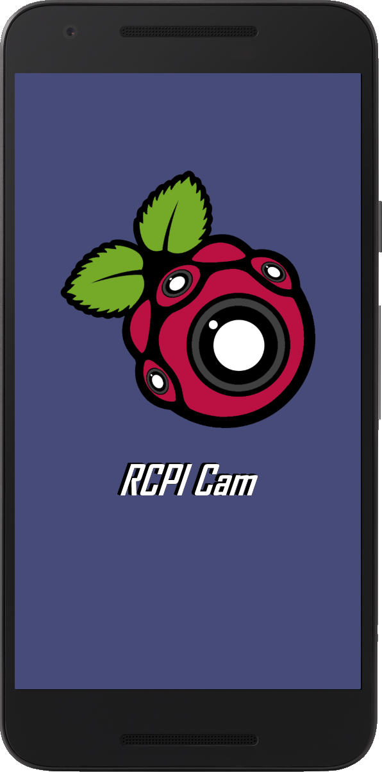

The Android app will start with a Splash Screen which features the logo I designed for my project, the name of the project and a Space Blue background. It is an alteration of the Raspberry Pi logo which has minor outline modifications and Grey camera additions. I decided to stick with the unique Leaf Green and Raspberry Red colours of the RPI logo as it’s a defining feature. I used the RPI logo as the RPI is going to be fulfilling the hardware aspect of my project. The cameras within the logo represent the entire utility of the hardware and software.

I finally decided upon the name of the project being RCPI Cam or RCPIC for short. This is a combination of RC meaning ‘Remote Controlled’, PI standing for RPI and Cam for ‘Camera’. The shortened version of the name has ‘PIC’ in it which is a nice hidden addition in itself. The font used is the main font which will be used for most text within the application.

#### RPI Connect Screen

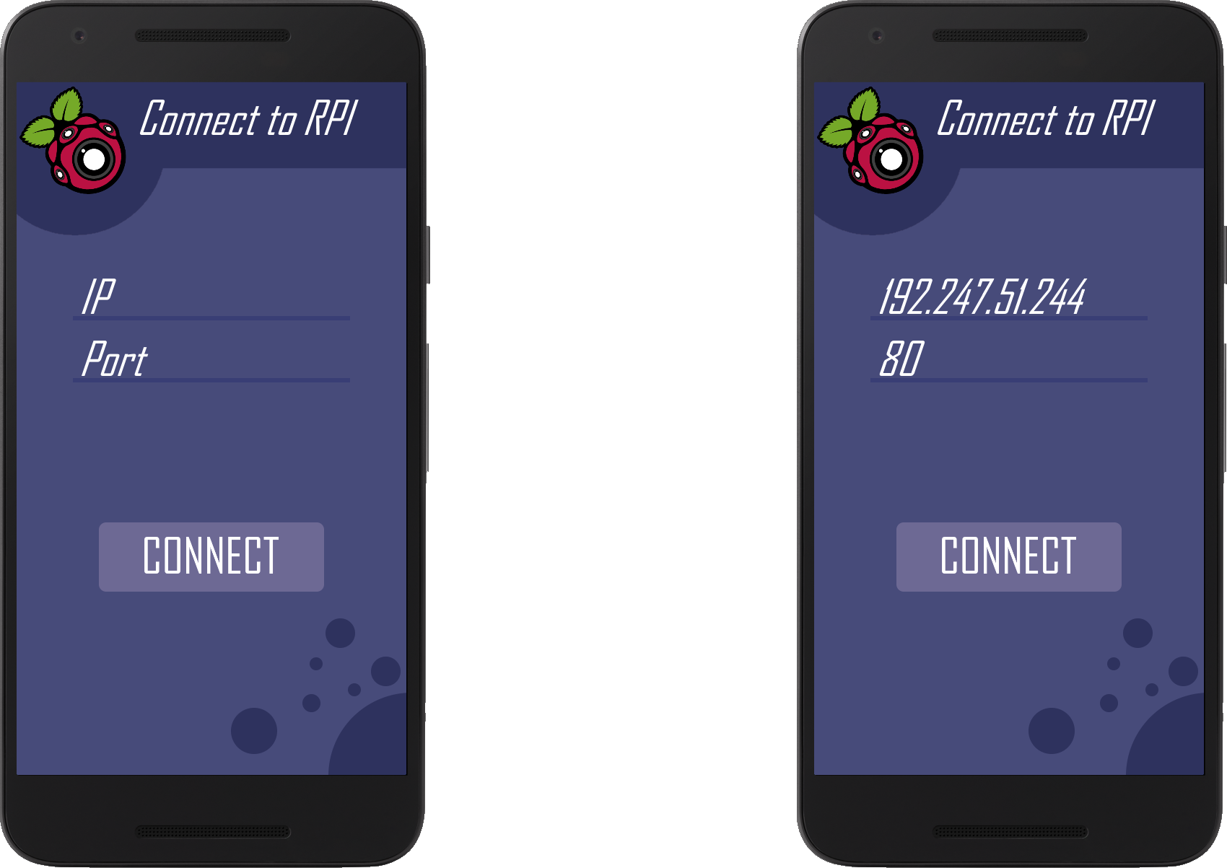

After the Splash Screen, the user will be presented with the RPI Connect’ screen. This will be where the user can hopefully connect to the RPI. From my analysis section, I determined that there are multiple ways to perform video streaming. This means that this GUI mockup could be redundant based on whether or not I actually require the IP and Port for the RPI.

Nevertheless, if I do require both of those - which I most likely will - the user will be able to input the values into both of the text fields. The words ‘IP’ and ‘Port’ will disappear when the user starts typing in that text field and will reappear if said text field becomes empty. This is a modern approach to text fields and fits the minimalistic design I am aiming for.

When the user has inputted both values, they will press the Slate Blue ‘Connect’ button. If I have time to add in smaller details, I will make the background of the button change to a darker colour such as Space Blue in order to indicate to the user that they pressed it. The White font colour will also change as it would look odd if only the background changed.

I would give the user the option of a horizontal view for this screen, however, there are a few points that led me to deciding against it. For one, the keyboard would get in the way for the majority of the screen - this would be an annoyance. Secondly, it would be impractical for a simple screen like this and lastly it means I have to go through more effort in order to implement such a small feature for a screen the user won’t be on for long. If I had more resources for this project, I would completely remake the GUI for a horizontal layout.

The overall design is using the same colour palette with a Space Blue background, Midnight Blue for the top portion and the circles at the bottom, Navy for the text field underline and Slate Blue for the connect button. The font will be the same Main font with a size of 32 for all of the text and the same White colour. The RCPIC logo is also featured in the top left to give a bit of vibrancy to the entire screen.

Once the Splash Screen has served its purpose, I intend on having a fade animation into the RPI Connect screen. However, whether this will be in the project is dependent on time as it’s merely for form, not function which is important for a prototype.

#### Main GUI Screen

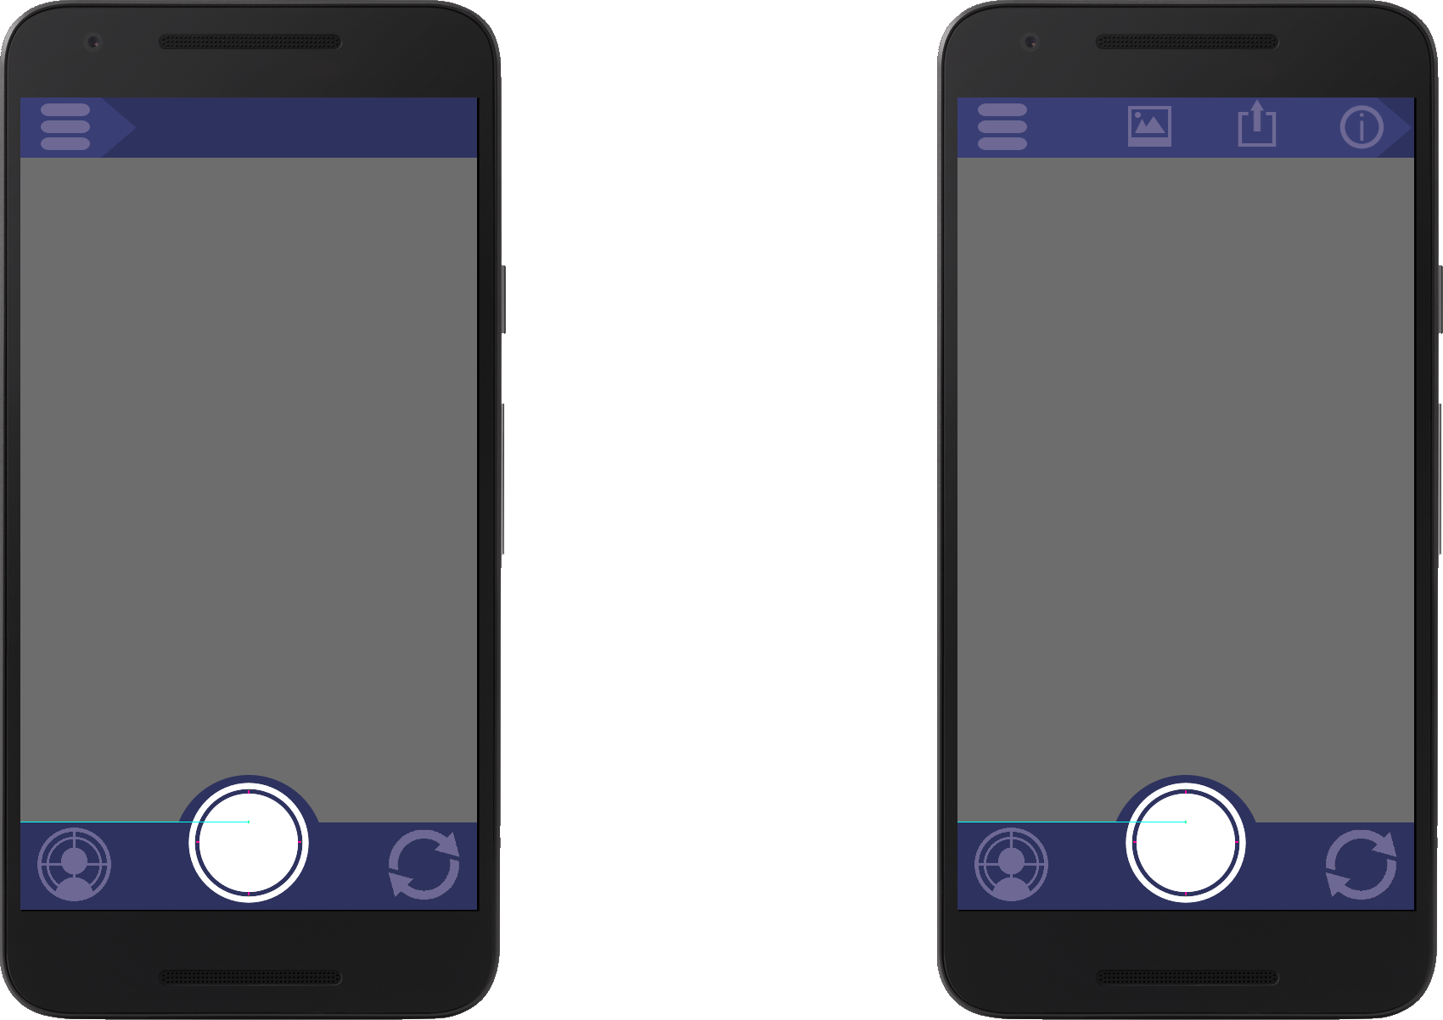

When the user has connected to the RPI, they will be presented with the ‘Main GUI’ screen. This is where the user will be interacting with the RPI and will be spending most of their time. From here you can perform the following functions: take a photo, rotate the camera axis, lock on to a person's face, access the about page, share the last photo taken and open the photo gallery. The greyed out section of the screen is where the video stream from the RPI will be.

The submenu button’s purpose is to reduce screen clutter for when the user doesn’t want to access the features which aren’t as commonly used. An animation for the submenu is intended where the Navy colour moves across to the right and reveals the icons. There will also be a menu for when the user clicks on the ‘Rotate Axis’ button. This will allow the user to modify the pan/tilt values and then send them to the RPI.

Landscape mode may be desirable for this screen for some users. This would be a medium priority feature and I would have to re-arrange the current button layout to have the shutter button, face tracking button and rotate axis button on the right side with the submenu at the top. Despite this being seemingly simple, it is a small quality of life feature which takes up unnecessary time. Due to this, I won’t be including it within the end product potentially along with the submenu animations I discussed in the previous paragraph.

Like previous screens, I used the same colour palette. However, Space Blue wasn’t present in this. I decided on using Midnight Blue for the main colour with Navy at the top for the submenu and Slate Blue for the icon colours. The shutter button is the only icon which uses White. This is to make the button stand out more in comparison to the others as it will be used more frequently.

#### Stakeholder Feedback

I consulted with my Photography stakeholders in order to gather their thoughts on my designs and improve upon them. I held a meeting with Mr. Martin to discuss his views on the 4 GUI concepts and he brought about one main point. He thought that some users may get confused with the current icon for the Rotate Axis Button. He mistakenly admitted to thinking that the button was meant to represent flipping the camera between forward and backwards - like most phones have. He provided a potential solution to this in the form of a camera icon with 4 cardinal arrows extruding from it. I made a mockup of his description which he stated looked a lot better.

### Test Plan - White Box

|  |  |  |
| --- | --- | --- |
| **Test Scenario ID** | **Test Scenario Description** | **Test Type** |
| 1.1.1 | Check IP and Port validation branches | Branch Coverage |
| 1.1.2 | When interacting with the web server, it should ignore invalid requests where possible and respond to valid requests | Functionality Testing |
| 1.1.3 | Check the styling and positioning of an element in the Splash GUI to see if it matches correctly with the coded style | UI Testing |
| 1.1.4 | Check the styling and positioning of an element in the Connect GUI to see if it matches correctly with the coded style | UI Testing |
| 1.1.5 | Check the styling and positioning of an element in the Main GUI to see if it matches correctly with the coded style | UI Testing |

|  |  |  |  |  |  |  |
| --- | --- | --- | --- | --- | --- | --- |
| **Test Case ID** | **Test Scenario ID** | **Test Case Description** | **Test Data** | **Expected Result** | **Actual Result** | **Pass/Fail** |
| 1 | 1.1.1 | Valid IP and valid Port | ip = 191.152.2.90  port = 5000 | invalidData = false |  |  |
| 2 | 1.1.1 | Invalid IP and valid Port | ip = 100.5.300.52  port = 5000 | invalidData = true |  |  |
| 3 | 1.1.1 | Valid IP and invalid Port | ip = 191.152.2.90  port = 80000 | invalidData = true |  |  |
| 4 | 1.1.1 | Invalid IP and invalid Port | ip = 100.5.300.52  port = 80000 | invalidData = true |  |  |
| 5 | 1.1.1 | Absent IP and valid Port | ip = **No data**  port = 5000 | invalidData = true |  |  |
| 6 | 1.1.1 | Valid IP and absent Port | ip = 191.152.2.90  port = **No data** | invalidData = true |  |  |
| 7 | 1.1.1 | Invalid alphabetical IP and valid Port | ip = hello  port = 5000 | invalidData = true |  |  |
| 8 | 1.1.1 | Valid IP and invalid alphabetical Port | ip = 191.152.2.90  port = test | invalidData = true |  |  |
| 9 | 1.1.1 | Boundary IP and valid Port | ip = 255.255.255.255  port = 5000 | invalidData = false |  |  |
| 10 | 1.1.1 | Valid IP and boundary Port | ip = 191.152.2.90  port = 65535 | invalidData = false |  |  |
| 11 | 1.1.2 | Home page | URL = <ip>:<port> | Blank page frontend |  |  |
| 12 | 1.1.2 | Home page with unknown args | URL = <ip>:<port>?test=hello | Blank page frontend, server ignores args |  |  |
| 13 | 1.1.2 | Video page | URL = <ip>:<port>/video | Live video feed frontend |  |  |
| 14 | 1.1.2 | Video page with unknown args | URL = <ip>:<port>/video?lang=py3 | Live video feed frontend, server ignores unknown args |  |  |
| 15 | 1.1.2 | Unknown page | URL = <ip>:<port>/thispagedoesntexist | Error 404 |  |  |
| 16 | 1.1.2 | Unknown page with unknown args | URL = <ip>:<port>/thispagedoesntexist?leave=true | Error 404, server ignores args |  |  |
| 17 | 1.1.3 | RCPI Cam Logo |  | Above RCPI Cam Text, centered |  |  |
| 18 | 1.1.3 | RCPI Cam Text |  | Under RCPI cam logo, centered, white text colour, bold, main font |  |  |
| 19 | 1.1.3 | Background |  | Space blue background colour |  |  |
| 20 | 1.1.4 | Connect to RPI Label |  | Label to the right of RCPI cam logo, white text colour, italic, main font, 32 font size |  |  |
| 21 | 1.1.4 | IP Textfield |  | Under top bar, centered, white text colour, italic, main font, 32 font size, navy textfield underline |  |  |
| 22 | 1.1.4 | Port Textfield |  | Under IP textfield, centered, white text colour, italic, main font, 32 font size, navy textfield underline |  |  |
| 23 | 1.1.4 | Connect Button |  | Under textfields, centered, white text colour, main font, 32 font size, slate blue button colour, rounded edges |  |  |
| 24 | 1.1.4 | Background |  | Space blue background colour, midnight blue circles and top portion |  |  |
| 25 | 1.1.5 | Shutter button |  | White, centered bottom, larger icon size |  |  |
| 26 | 1.1.5 | Rotation button |  | Slate blue, bottom right, consistent icon size |  |  |
| 27 | 1.1.5 | Face detection button |  | Slate blue, bottom left, consistent icon size |  |  |
| 28 | 1.1.5 | Sub menu button |  | Slate blue, top left corner, consistent icon size |  |  |
| 29 | 1.1.5 | Sub menu buttons |  | Slate blue, top left list, consistent icon size |  |  |
| 30 | 1.1.5 | Background |  | Midnight blue colour, slate blue for top submenu section, rounded edge around shutter button |  |  |

### Post Development Test Plan - Black Box

|  |  |  |
| --- | --- | --- |
| **Test Scenario ID** | **Test Scenario Description** | **Test Steps** |
| 1.2.1 | Check IP and Port textfield functionality with a range of combinations of data. | 1. Navigate to Connect GUI  2. Input ip value into IP textfield  3. Input port value into Port textfield  4. Press Connect button |
| 1.2.2 | Check whether a button shows an animation for when it is pressed. | 1. Navigate to button location  2. Press the button  3. Observe the button |
| 1.2.3 | Check whether the live video feed is displaying properly | 1. Navigate to live video feed  2. Observe the video feed |

|  |  |  |  |  |  |  |
| --- | --- | --- | --- | --- | --- | --- |
| **Test Case ID** | **Test Scenario ID** | **Test Case Description** | **Test Data** | **Expected Result** | **Actual Result** | **Pass/Fail** |
| 1 | 1.2.1 | Valid IP and valid Port | ip = 191.152.2.90  port = 5000 | App navigates to webview and loads that IP and Port |  |  |
| 2 | 1.2.1 | Invalid IP and valid Port | ip = 100.5.300.52  port = 5000 | User is notified of invalid IP value |  |  |
| 3 | 1.2.1 | Valid IP and invalid Port | ip = 191.152.2.90  port = 80000 | User is notified of invalid Port value |  |  |
| 4 | 1.2.1 | Invalid IP and invalid Port | ip = 100.5.300.52  port = 80000 | User is notified of invalid IP value and invalid Port value |  |  |
| 5 | 1.2.1 | Absent IP and valid Port | ip = **No data**  port = 5000 | User is notified of missing IP value |  |  |
| 6 | 1.2.1 | Valid IP and absent Port | ip = 191.152.2.90  port = **No data** | User is notified of missing Port value |  |  |
| 7 | 1.2.1 | Invalid alphabetical IP and valid Port | ip = hello  port = 5000 | None of the characters in the IP textfield should be shown when inputted |  |  |
| 8 | 1.2.1 | Valid IP and invalid alphabetical Port | ip = 191.152.2.90  port = test | None of the characters in the Port textfield should be shown when inputted |  |  |
| 9 | 1.2.1 | Boundary IP and valid Port | ip = 255.255.255.255  port = 5000 | App navigates to webview and loads that IP and Port |  |  |
| 10 | 1.2.1 | Valid IP and boundary Port | ip = 191.152.2.90  port = 65535 | App navigates to webview and loads that IP and Port |  |  |
| 11 | 1.2.2 | Connect button |  | Colour change animation on the button plays |  |  |
| 12 | 1.2.2 | Shutter button |  | Colour change animation on the button plays |  |  |
| 13 | 1.2.2 | Rotation button |  | Colour change animation on the button plays |  |  |
| 14 | 1.2.2 | Face Detection  button |  | Colour change animation on the button plays animation on the button plays |  |  |
| 15 | 1.2.3 | Video Resolution |  | The video feed should cover the majority of the screen |  |  |
| 16 | 1.2.3 | Video Frame Rate |  | The video feed should play at a consistent frame rate - 30fps. |  |  |

## Module 2 - Camera Rotation

### Justification

This module contains the logic for rotating the camera mount which, in turn, rotates the camera. This includes both the manual mount rotation and the automatic rotation performed by facial recognition. This module may take longer than Module 1 to complete due to the logic behind facial recognition.

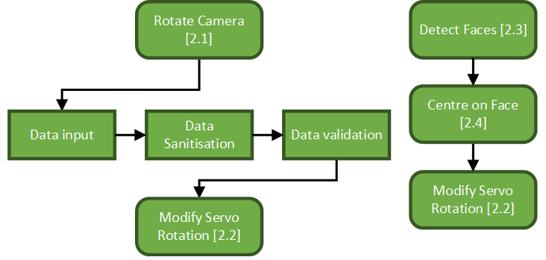

### Flowcharts

#### Rotation GUI

The ‘Rotation GUI’ is one of the more complicated ones due to the nature of it’s design. The idea is that the user inputs two values for pan/tilt and then presses confirm to send the request. However, there are some smaller quality of life additions such as buttons to increment and decrement those input values and a cancel button to close the GUI. On top of this, I also included sections for error logging incases of any issues that may arise and validation for when the user presses the confirm button that will notify the user if there are any issues.

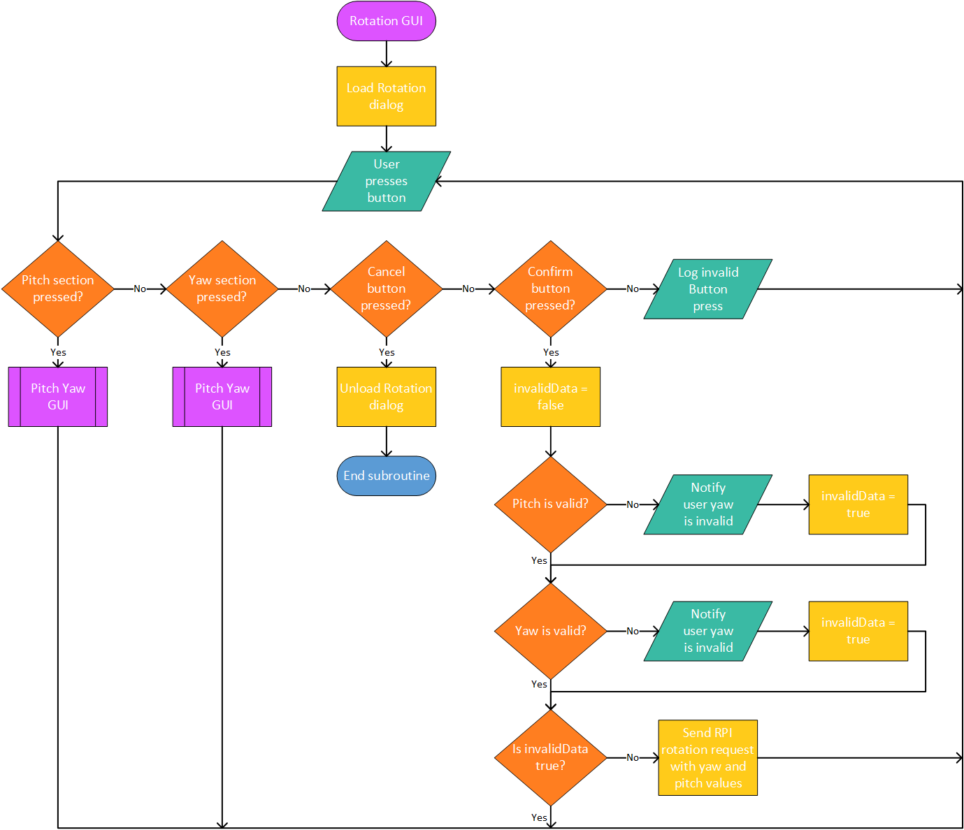

#### Pitch Yaw GUI

This originally wasn’t an intended flowchart but arose when I began redesigning the ‘Rotation GUI’ flowchart. I wanted to add incrementation and decrementation buttons as a quality of life feature since having to type on mobile isn’t the most intuitive way of choosing values. Considering the pitch and yaw sections are extremely similar in design and function, I decided to create a singular flowchart that accommodates both of them instead of two nearly identical flowcharts. The only difference between the flowcharts would be inputting for pitch or yaw and incrementing or decrementing the text field value. As with most of my flowcharts, I included error checking and logging for any issues I could see arising.

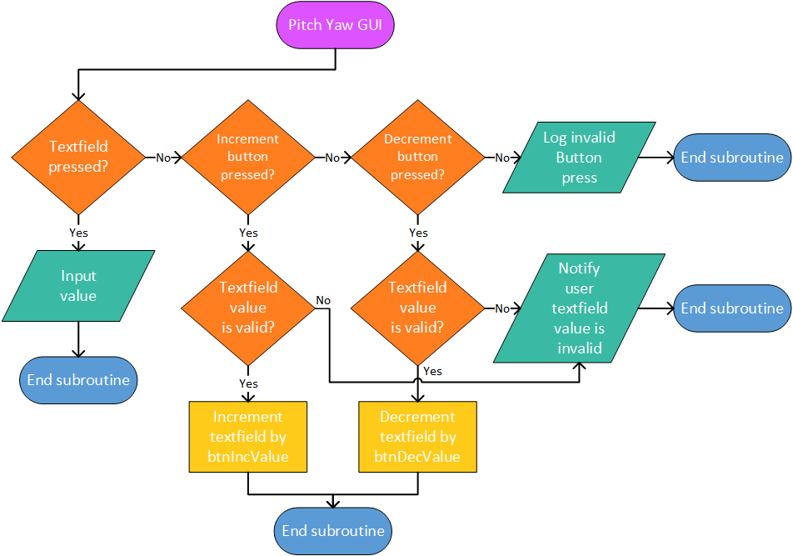

#### Face Detect Algorithm

The flowchart for facial recognition is relatively watered-down - especially for the locating faces aspect. This is since there are multiple algorithms for facial recognition and that as of currently I don’t know which would be best for performance on the RPI. Its hardware isn’t high-end so performance is vital. Additionally, the system may have issues if I only made the algorithm centre on a single face. If for example, you had a group photo it would centre on the first face detected. So, I decided that it should calculate a coordinate in the average position of the centre of the faces detected.

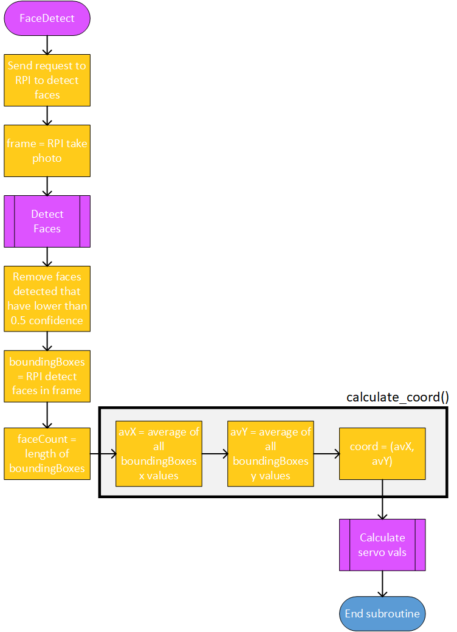

### Pseudocode

#### Rotation GUI

I ended up integrating the <Pitch Yaw GUI> into the Rotation GUI as a subroutine.

|  |
| --- |
| CLASS RotationGUI INHERITS Dialog  ATTRIBUTES  pitch <Integer>  yaw <Integer>  url <String>  btnIncValue <Integer>  btnDecValue <Integer>    SUBROUTINE on_create  Load Rotation dialog  WHILE DO  IF user presses button THEN  IF button is PitchSection THEN  PitchYaw(PitchSection)  ELSE IF button is YawSection THEN  PitchYaw(YawSection)  ELSE IF button is Confirm THEN  set_positive_button()  ELSE IF button is Cancel THEN  set_negative_button()  ELSE THEN  LOG "Invalid Button Press"  ENDIF  ENDIF  ENDWHILE  ENDSUBROUTINE    SUBROUTINE set_positive_button  invalidData = False  IF pitch is invalid THEN  OUTPUT "Pitch is invalid"  invalidData = False  ENDIF    IF yaw is invalid THEN  OUTPUT "Yaw is invalid"  invalidData = False  ENDIF    IF invalidData is True THEN  Send RPI rotation request with pitch and yaw  ENDIF  ENDSUBROUTINE    SUBROUTINE set_negative_button  Unload Rotation dialog  ENDSUBROUTINE    SUBROUTINE IncrementTextfield(Textfield, Value)  Increment Textfield by Value  ENDSUBROUTINE    SUBROUTINE PitchYaw(Section)  IF Textfield pressed THEN  INPUT value    // Incrementation  ELSE IF Increment button pressed THEN  IF Textfield value is valid THEN  IncrementTextfield(SectionTexfield, btnIncValue)  ELSE THEN  OUTPUT "Textfield value is invalid"  ENDIF    // Decrementation  ELSE IF Decrement button pressed THEN  IF Textfield value is valid THEN  IncrementTextfield(SectionTexfield, btnDecValue)  ELSE THEN  OUTPUT "Textfield value is invalid"  ENDIF  ENDIF  ENDSUBROUTINE    ENDCLASS |

#### Face Detect Algorithm

|  |
| --- |
| SUBROUTINE FaceDetect  frame = capture_image()    // Get list of faces  boundingBoxes = detect_faces(frame)  FOR face IN boundingBoxes DO  IF face.confidence is less than 50% THEN  Delete face from boundingBoxes list  ENDIF  NEXT face    // Calculate average co-ords  faceCount = LENGTH(boundingBoxes)  avX = AVERAGE(boundingBoxes.x])  avY = AVERAGE(boundingBoxes.y])  coord = (avX, avY)    // Calculate servo vals and rotate servo  calculate_servo_vals(coord)    ENDSUBROUTINE |

### Variable Table

|  |  |  |  |  |  |
| --- | --- | --- | --- | --- | --- |
| **Class** | **Variable** | **Data Type** | **Constant** | **Validation** | **Justification** |
| RotationButton | icon | Image | True | None | This will hold the image used as an icon for the button. |
| RotationDialog | url | String | True | None | The url entered during the Connect GUI - this will be used to send a request to the RPI to rotate the camera. No validation is needed for this. |
| yaw | Real | False | Must be between the numerical limits of the servo rotation and must be a real | This needs to be a number and the byte data type is the most suitable due to having 8 bits and being the smallest sized. Validation needs to be done to ensure the input doesn’t fall outside of the limits otherwise it could cause damage to the servos. |
| pitch | Real | False | Must be between the numerical limits of the servo rotation and must be a real | This needs to be a number and the byte data type is the most suitable due to having 8 bits and being the smallest sized. Validation needs to be done to ensure the input doesn’t fall outside of the limits otherwise it could cause damage to the servos. |
| invalidData | Boolean | False | Must be True or False. If True then an input is invalid. | After validation checks are done on the pitch or yaw integer, this flag will show whether they were valid inputs or not. |
| btnIncValue | Byte | True | None | This will hold the value that will be added to the textfield for Pitch or Yaw when pressed. |
| btnDecValue | Byte | True | None | This will hold the value that will be deducted from the textfield for Pitch or Yaw when pressed. |
| positiveTitle | String | True | None | This will hold the positive title value of “Continue” |
| negativeTitle | String | True | None | This will hold the negative title value of “Cancel” |
| FaceDectionButton | url | String | True | None | The url entered during the Connect GUI - this will be used to send a request to the RPI to centre the camera on a face. No validation is needed for this. |
| icon | Image | True | None | This will hold the image used as an icon for the button. |
| FaceDetect | frame | List | False | None | This will hold the current image frame that will be processed by the face detection algorithm. |
| faceCount | Integer | False | None | The face count will be an integer representation of the amount of faces detected by the face detection algorithm. |
| confidence | Real | False | None | Confidence is a real value for how confident the face detection algorithm is. |
| attempts | Integer | False | Check if the number of attempts left is 0. | The number of attempts left to find a face. It decreases by 1 for each failed attempt to detect faces. |
| boundingBoxes | List | False | None | A list of all of the bounding box coordinates for each detected face. This will be used in the calculation for finding the coordinate in the average centre of faces. It will be a list since data will be appended into it within a loop. |
| coord | Tuple | True | None | When the co-ord algorithm has calculated where the optimal coordinates for the camera to rotate to is, they’ll be stored in this tuple. |

### Data Structures

|  |  |  |  |
| --- | --- | --- | --- |
| **Variable** | **Data Structure** | **Example** | **Justification** |
| boundingBoxes | List | Bounding box:  [(x1, y1), (x2, y2), (x3, y3), (x4, y4)]  List of 3 bounding boxes:  [  [(1, 2), (4, 2), (1, 5), (4, 5)],  [(2, 3), (8, 3), (2, 4), (8, 4)],  [(5, 5), (7, 5), (5, 7), (7, 7)],  ] | Having a format such as the one specified will allow me to easily calculate the average coordinate location.  I can get the center of all of the bounding boxes by iterating through them and performing a calculation on each. Then I can find the average of the center coordinates. |
| coord | Tuple | Coord:  (x, y)  Example:  (3, 5) | Using this data structure will allow me to easily calculate how much the servos need to rotate from their current position. |
| currentFrame | List | None | The current frame will be in an RGB format as a list - this will be done using the latest version of the Python Imaging Library (PIL). |

### Test Plan - White Box

|  |  |  |
| --- | --- | --- |
| **Test Scenario ID** | **Test Scenario Description** | **Test Type** |
| 2.1.1 | When interacting with the web server, it should ignore invalid requests where possible and respond to valid requests | Functionality Testing |
| 2.1.2 | Check the styling and positioning of an element in the Rotation Dialog GUI to see if it matches correctly with the coded style | UI Testing |
| 2.1.3 | Check how the face detection function interacts with different image formats | Functionality Testing |
| 2.1.4 | Check how accurate the face detection function is for detecting co-ords | Functionality Testing |

|  |  |  |  |  |  |  |
| --- | --- | --- | --- | --- | --- | --- |
| **Test Case ID** | **Test Scenario ID** | **Test Case Description** | **Test Data** | **Expected Result** | **Actual Result** | **Pass/Fail** |
| 1 | 2.1.1 | Servo page | URL = <ip>:<port>/servo | Blank page frontend, server does nothing due to lack of args |  |  |
| 2 | 2.1.1 | Servo page with valid args | URL = <ip>:<port>/servo?pitch=7&yaw=4 | Blank page frontend, server rotates pitch to 7 and yaw to 4 |  |  |
| 3 | 2.1.1 | Servo page with invalid args | URL = <ip>:<port>/servo?pitch=world&yaw=5 | Blank page frontend, server ignores invalid pitch value and rotates yaw to 5 |  |  |
| 4 | 2.1.1 | Servo page with unknown args | URL = <ip>:<port>/servo?foo=bar | Blank page frontend, server ignores unknown args |  |  |
| 5 | 2.1.2 | Increment/ Decrement buttons |  | Matches coded styling, left/right of textfield |  |  |
| 6 | 2.1.2 | Cancel button |  | Matches coded styling, left of confirm button, below textfield |  |  |
| 7 | 2.1.2 | Confirm button |  | Matches coded styling, right of cancel button, below textfield |  |  |
| 8 | 2.1.2 | Textfields |  | Matches coded styling, top |  |  |
| 9 | 2.1.3 | PNG - common lossless image format |  |  |  |  |
| 10 | 2.1.3 | JPG - common lossy image format |  |  |  |  |
| 11 | 2.1.4 | No face | Image with no faces | Returns nothing |  |  |
| 12 | 2.1.4 | Multiple faces | Image with faces in top left, bottom left, bottom right, top right | Returns co-ords for the middle of the image |  |  |
| 13 | 2.1.4 | One face | Image with one face - not in the centre of the screen | Returns co-ords for the middle of the face |  |  |

### Post Development Test Plan - Black Box

|  |  |  |
| --- | --- | --- |
| **Test Scenario ID** | **Test Scenario Description** | **Test Steps** |
| 2.2.1 | Check pitch and yaw textfield functionality with a range of combinations of data. | 1. Navigate to Main GUI  2. Press rotation button  3. Input pitch and yaw values  4. Press confirm button |
| 2.2.2 | Check the functionality of the increment and decrement buttons with a combination of yaw and pitch data. | 1. Navigate to Main GUI  2. Press rotation button  3. Input pitch value  4. Press increment/decrement buttons for pitch textfield the appropriate amount of times |
| 2.2.3 | Check against a range of shots if face detection works as expected. | 1. Navigate to Main GUI  2. Get into the camera's frame the appropriate objects  2. Press the face detection button  3. Wait for the camera to rotate |

|  |  |  |  |  |  |  |
| --- | --- | --- | --- | --- | --- | --- |
| **Test Case ID** | **Test Scenario ID** | **Test Case Description** | **Test Data** | **Expected Result** | **Actual Result** | **Pass/Fail** |
| 1 | 2.2.1 | Valid Pitch and valid Yaw | pitch = 7  yaw = 7 | Dialog closes and the servo rotates appropriately |  |  |
| 2 | 2.2.1 | Invalid Pitch and valid Yaw | pitch = 1000  yaw = 7 | Dialog closes and the servo rotates to maximum pitch and appropriate yaw |  |  |
| 3 | 2.2.1 | Valid Pitch and invalid Yaw | pitch = 7  yaw = 1000 | Dialog closes and the servo rotates to maximum yaw and appropriate pitch |  |  |
| 4 | 2.2.1 | Invalid Pitch and invalid Yaw | pitch = 1000  yaw = 1000 | Dialog closes and the servo rotates to maximum pitch and maximum yaw |  |  |
| 5 | 2.2.1 | Absent Pitch and valid Yaw | pitch = **No data**  yaw = 7 | Dialog closes and the servo rotates to the appropriate yaw |  |  |
| 6 | 2.2.1 | Valid Pitch and absent Yaw | pitch = 7  yaw = **No data** | Dialog closes and the servo rotates to the appropriate pitch |  |  |
| 7 | 2.2.1 | Invalid alphabetical Pitch and valid Yaw | pitch = hello  yaw = 7 | None of the characters in the IP textfield should be shown when inputted, the dialog closes and the servo rotates to the appropriate yaw |  |  |
| 8 | 2.2.1 | Valid Pitch and invalid alphabetical Yaw | pitch = 7  yaw = test | None of the characters in the IP textfield should be shown when inputted, the dialog closes and the servo rotates to the appropriate pitch |  |  |
| 9 | 2.2.1 | Boundary Pitch and valid Yaw | pitch = **Max value**  yaw = 7 | Dialog closes and the servo rotates to maximum pitch and appropriate yaw |  |  |
| 10 | 2.2.1 | Valid Pitch and boundary Yaw | pitch = 7  yaw = **Max value** | Dialog closes and the servo rotates to maximum yaw and appropriate pitch |  |  |
| 11 | 2.2.1 | Boundary Pitch and boundary Yaw | pitch = **Min value**  yaw = **Min value** | Dialog closes and the servo rotates to minimum pitch and minimum yaw |  |  |
| 12 | 2.2.2 | Valid Pitch followed by two increment presses and two decrement presses | pitch = 5  Increment presses: 2  Decrement presses: 2 | The value within the text field should change to 7 and then back to 5. |  |  |
| 13 | 2.2.2 | Maximum boundary Pitch followed by two increment presses and one decrement press | pitch = **Max value**  Increment presses: 2  Decrement presses: 1 | The value within the text field should stay at the maximum value and then go to the maximum value - 1 |  |  |
| 14 | 2.2.2 | Minimum boundary Pitch followed by two decrement presses and one increment press | pitch = **Min value**  Increment presses: 1  Decrement presses: 2 | The value within the text field should stay at the minimum value and then go to the minimum value + 1 |  |  |
| 15 | 2.2.2 | Absent Pitch followed by two increment presses and two decrement press | pitch = **No data**  Increment presses: 2  Decrement presses: 2 | Nothing will happen to the text field when the increment or decrement buttons are pressed |  |  |
| 16 | 2.2.2 | Invalid alphabetical Pitch followed by two increment presses and two decrement press | pitch = hello  Increment presses: 2  Decrement presses: 2 | No characters should appear in the text input resulting in an empty input - should be the same as test case 16 |  |  |
| 17 | 2.2.3 | Close distance face |  | The servo should rotate to the centre of the face |  |  |
| 18 | 2.2.3 | Medium distance face |  | The servo should rotate to the centre of the face |  |  |
| 19 | 2.2.3 | Long distance face |  | The servo should rotate to the centre of the face |  |  |
| 20 | 2.2.3 | No face |  | Nothing should happen |  |  |
| 21 | 2.2.3 | Multiple faces |  | The servo should rotate to the mean of the centre of the faces |  |  |

## Module 3 - Take Photo

### Justification

The ‘Take Photo’ module contains everything to do with taking a photo. From ‘Timed Shots’ to ‘Regular Photos’ - anything which involves the RPI camera taking a photo is included here. This will also contain the logic for the RPI itself taking a photo and sending it to the user.

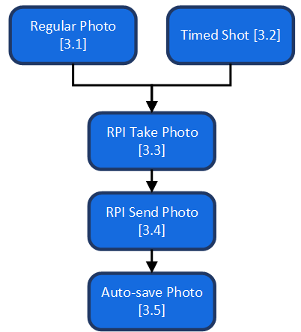

### Flowcharts

#### Take Photo Algorithm

The ‘Take Photo’ subroutine is relatively simplistic despite its complicated look and involves all of the success criteria under module 3. It is just a simple process of asking the RPI to take a picture, the RPI taking the photo, saving it and sending it to the user. Coupled with that is a simple algorithm for determining the file name. The reason the RPI stores the photo is if there is an issue when trying to send the photo to the user. This means they can still access the photo via the RPI desktop environment instead of losing it permanently; this does require the RPI to still receive the request and will only account for issues with sending the photo.

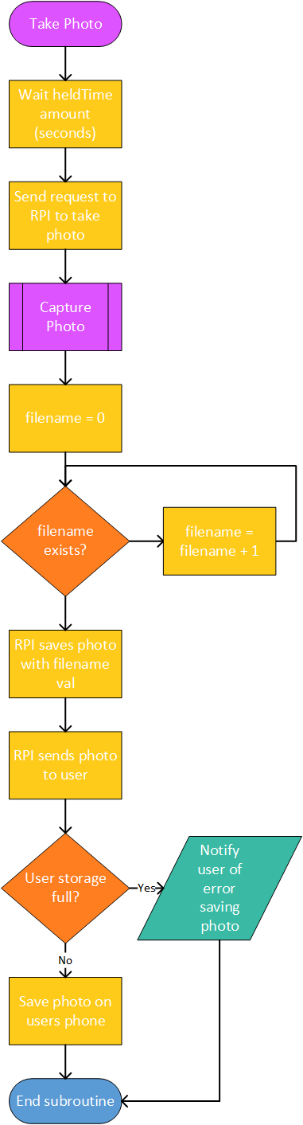

### Pseudocode

#### Take Photo Algorithm

|  |
| --- |
| SUBROUTINE TakePhoto  Wait heldTime  photo = capture_image()  filename = 0  WHILE filename exists in photo folder DO  filename = filename + 1  ENDWHILE    // Save and send photo  save_photo(photo, filename)  error = send_photo(photo)    ENDSUBROUTINE  // Frontend  When photo is received...  IF storage full THEN  OUTPUT "Storage is full"  ELSE THEN  Save photo  ENDIF |

### Variable Table

|  |  |  |  |  |  |
| --- | --- | --- | --- | --- | --- |
| **Class** | **Variable** | **Data Type** | **Constant** | **Validation** | **Justification** |
| ShutterButton | icon | Image | True | None | This will hold the image used as an icon for the button. |
| heldTime | Real | False | None | A Real value that will be cast to a string value when it is concatenated to the url for a timed shot. |
| url | String | True | None | The url entered during the Connect GUI - this will be used to send a request to the RPI to take a photo. No validation is needed for this. |
| Flask Server | time | Real | True | A type check will be used to determine whether the time arg value can be cast to a Real from a String | This is the time argument on the backend. It will only be set once and will be used to delay the web server before it takes a photo. |
| photo | List | False | None | The photo will be an image and within the backend will be represented as a tuple in the RGB format. |
| filename | String | False | None | This will contain the filename for the photo, it will be used in the backend when sending the photo. |

### Data Structures

|  |  |  |  |
| --- | --- | --- | --- |
| **Variable** | **Data Structure** | **Example** | **Justification** |
| photo | List | None | The current frame will be in an RGB format as a list - this will be done using the latest version of the Python Imaging Library (PIL). |

### Test Plan - White Box

|  |  |  |
| --- | --- | --- |
| **Test Scenario ID** | **Test Scenario Description** | **Test Type** |
| 3.1.1 | Checking file name interaction when saving a photo on both the frontend and backend | Functionality Test |
| 3.1.2 | Checking waiting functionality with a variety of values | Functionality Test |
| 3.1.3 | Checking what happens in the case of full storage | Functionality Test |

|  |  |  |  |  |  |  |
| --- | --- | --- | --- | --- | --- | --- |
| **Test Case ID** | **Test Scenario ID** | **Test Case Description** | **Test Data** | **Expected Result** | **Actual Result** | **Pass/Fail** |
| 1 | 3.1.1 | File name 0 already exists on backend | File (0) | Saves file with name 1 on backend |  |  |
| 2 | 3.1.1 | Multiple file names exist on backend | File (0), File (1), File (3) | Saves file with name 2 on backend |  |  |
| 3 | 3.1.1 | File name 0 already exists on frontend | File (0) | Saves file with name 1 on frontend |  |  |
| 4 | 3.1.1 | Multiple file names exist on frontend | File (0), File (1), File (3) | Saves file with name 2 on frontend |  |  |
| 5 | 3.1.2 | Integer value | time = 5 | 5 seconds waited and then photo taken |  |  |
| 6 | 3.1.2 | Float value | time = 3.2 | 3.2 seconds waited and then photo taken |  |  |
| 7 | 3.1.2 | Negative integer value | time = -7 | No time waited and photo taken |  |  |
| 8 | 3.1.2 | Negative float value | time = -6.4 | No time waited and photo taken |  |  |
| 9 | 3.1.3 | Frontend full storage |  | No photo saved, user notified |  |  |
| 10 | 3.1.3 | Backend full storage |  | No photo saved |  |  |

### Post Development Test Plan - Black Box

|  |  |  |
| --- | --- | --- |
| **Test Scenario ID** | **Test Scenario Description** | **Test Steps** |
| 3.2.1 | Check if the shutter button takes a photo via the RPI and saves it to the users phone. | 1. Navigate to Main GUI  2. Press shutter button the specified amount of times |
| 3.2.2 | Check if timed shots wait the held amount of time before taking a photo. | 1. Navigate to Main GUI  2. Press and hold the shutter button for the specified amount of time |

|  |  |  |  |  |  |  |
| --- | --- | --- | --- | --- | --- | --- |
| **Test Case ID** | **Test Scenario ID** | **Test Case Description** | **Test Data** | **Expected Result** | **Actual Result** | **Pass/Fail** |
| 1 | 3.2.1 | Pressing the shutter button once |  | A photo is downloaded onto the users phone with the filename as “1” |  |  |
| 2 | 3.2.1 | Pressing the shutter button twice |  | Two photos are downloaded onto the users phone. The file names should be “2” and “3” |  |  |
| 3 | 3.2.1 | Taking a photo while the users storage is full |  | No photo should be downloaded onto the users phone |  |  |
| 4 | 3.2.2 | Hold the shutter button for 5 seconds | Time held: 3 seconds | The app waits 5 seconds before a photo is taken |  |  |
| 5 | 3.2.2 | Hold the shutter button for 12 seconds | Time held: 10 seconds | The app waits 12 seconds before a photo is taken |  |  |

## Module 4 - Sub Menu

### Justification

The final module is going to contain logic for the sub-menu. This is going to be a relatively small portion of the overall software on the mobile app which will allow the user to access three different buttons. The first allows the user to share their last taken photo, the second one allows the user to open the photo gallery and the third one allows the user to view the about page which has information relevant to the app.

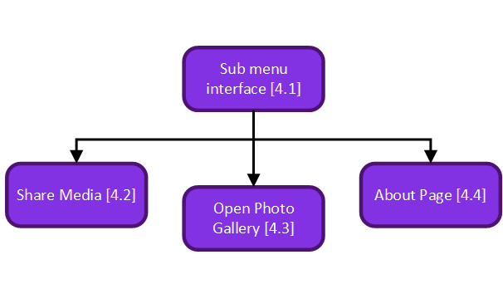

### Flowcharts

#### Share Media Algorithm

For the Share Media algorithm, there is a built-in “Share” GUI you can call and pass the image to which will sort out everything you’d expect for a media share GUI. This means that the only check I’d have to perform would be whether the file path for the photo last taken is still valid.

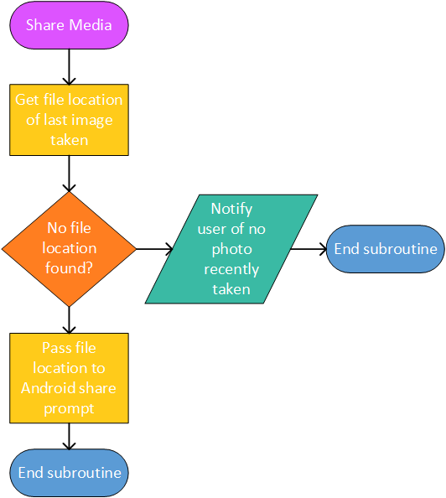

#### About Algorithm

The About algorithm is fairly simplistic as the entire purpose is just to show general information to the user. This includes the apps version, the date of the last time it updated, contact information in case the user wants to contact me for feedback or to report a bug and general information regarding the connection to the RPI. In case of any issues retrieving this information, I will have values set out as defaults which will appear.

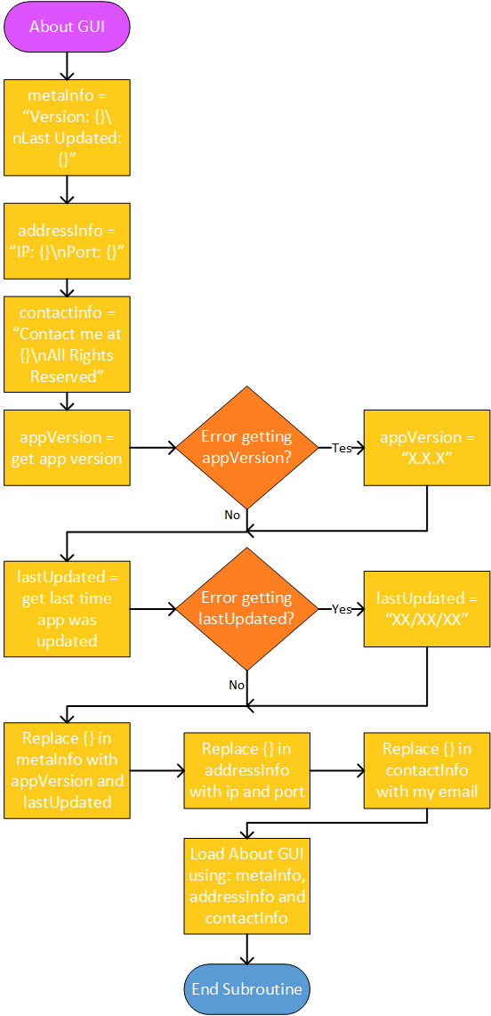

### Pseudocode

#### Share Media Algorithm

|  |
| --- |
| SUBROUTINE ShareMedia  fileLocation = getLastFileLocation()  IF fileLocation is null THEN  OUTPUT "No last image taken"  ELSE THEN  AndroidSharePrompt(fileLocation)  ENDIF  ENDSUBROUTINE |

#### About Algorithm

|  |
| --- |
| SUBROUTINE AboutAlgorithm  metaInfo = "Version: {}\nLast Updated: {}"  addressInfo = "IP: {}\nPort: {}"  contactInfo = "Contact me at {}\nAll Rights Reserved"  appVersion = get_app_version()  IF error getting appVersion THEN  appVersion = "X.X.X"  ENDIF    lastUpdated = get_last_updated()  IF error getting lastUpdated THEN  lastUpdated = "XX/XX/XX"  ENDIF    Replace {} in metaInfo with appVersion and lastUpdated  Replace {} in addressInfo with ip and port  Replace {} in contactInfo with my email    LoadGUI(metaInfo, addressInfo, contactInfo)    ENDSUBROUTINE |

### Variable Table

|  |  |  |  |  |  |
| --- | --- | --- | --- | --- | --- |
| **Class** | **Variable** | **Data Type** | **Constant** | **Validation** | **Justification** |
| SubMenu | isOpen | Boolean | Fase | None |  |
| ShareMediaButton | lastPhoto | String | False | None | The file location of the last photo taken by the app. This will be used with the share media function. |
| About | appVersion | String | True | None | The app version will be set before the app is launched within a file - this variable will pull that value and hold it. It is a string since I will follow the conventional pattern of “<major release>.<minor release>.<patch>” where all elements in the <> are integers. |
| lastUpdated | String | True | None | The last time the app was updated will be a date and therefore has to be a string. |
| ip | String | True | None | This will be the ip entered from the Connect GUI and therefore won’t require validation. |
| port | Integer | True | None | This will be the port entered from the Connect GUI and therefore won’t require validation. |
| email | String | True | None | This will be my email address and won’t be changed during the program at all. |
| metaInfo | String | False | None | This will contain the first section of default text in the About GUI. It will then be concatenated with appVersion and lastUpdated.  It will hold:  “Version: {}\nLast Updated: {}” |
| addressInfo | String | False | None | This will contain the second section of default text in the About GUI. It will then be concatenated with ip and port.  It will hold:  “IP: {}\nPort: {}” |
| contactInfo | String | False | None | This will contain the final section of default text in the About GUI. It will then be concatenated with email.  It will hold:  “Contact me at {}\nAll Rights Reserved” |

### GUI Design

#### About GUI

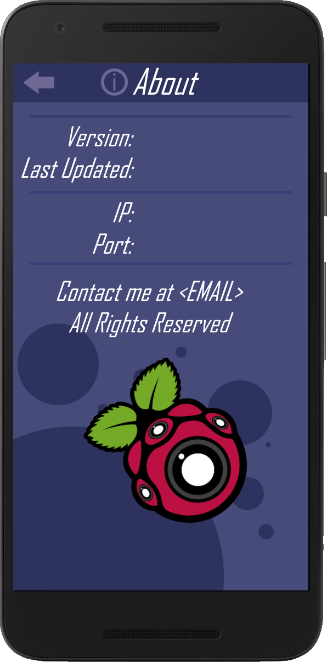

If the user clicks on the About Page button, they will be taken to this page which contains general information. This will include, as shown above, the version of the app, when the app was last updated, the IP and port they used to connect to the RPI and contact information. This has all been excluded in the image above as it is dynamic data. At the top of the screen, there is a back button which will take the user back to the Main GUI screen if they press it. Nothing else on the page is interactable as it is just for information.

Similar to the other GUI concepts, I used a combination of Space Blue for the background, Midnight Blue for the top bar and circles, Navy for the lines between text and White for the text. I also decided to include the RCPIC logo in the about page as it gives the overall design more vibrancy.

### Test Plan - White Box

|  |  |  |
| --- | --- | --- |
| **Test Scenario ID** | **Test Scenario Description** | **Test Type** |
| 4.1.1 | Checking how the about page works with a variety of given values | Branch Coverage |
| 4.1.2 | Checking functionality of share media prompt with different values given | Branch Coverage |
| 4.1.3 | Check the styling and positioning of an element in the About GUI to see if it matches correctly with the coded style | UI Testing |

|  |  |  |  |  |  |  |
| --- | --- | --- | --- | --- | --- | --- |
| **Test Case ID** | **Test Scenario ID** | **Test Case Description** | **Test Data** | **Expected Result** | **Actual Result** | **Pass/Fail** |
| 1 | 4.1.1 | Failed to get appVersion | appVersion not set internally | “X.X.X” is put in after app version |  |  |
| 2 | 4.1.1 | Failed to get lastUpdated | lastUpdated not set internally | “XX/XX/XX” is put in after last updated |  |  |
| 3 | 4.1.1 | appVersion and lastUpdated found | appVersion and lastUpdated set internally | Values for appVersion and lastUpdated appear in respective fields |  |  |
| 4 | 4.1.2 | No photo last taken | photo = null | User is notified that they haven’t taken a photo yet |  |  |
| 5 | 4.1.2 | Photo taken and exists still | photo = file_location | Share media prompt is created for the photo |  |  |
| 6 | 4.1.2 | Photo taken but location to it has changed since | photo = null | User is notified that the file may have been renamed, deleted or moved |  |  |
| 9 | 4.1.3 | Labels |  | Under top bar, between white bars, colon at ⅓ from left side, white text colour, italic, main font, 26 font size |  |  |
| 10 | 4.1.3 | Back button |  | Slate blue colour, top left |  |  |
| 11 | 4.1.3 | Line break |  | Between label sections, navy colour |  |  |
| 12 | 4.1.3 | About icon |  | Slate blue colour, left of about label |  |  |
| 13 | 4.1.3 | RCPI Cam Logo |  | Below contact me label section, centered |  |  |
| 14 | 4.1.3 | Background |  | Space blue colour, midnight blue top bar and circles |  |  |
| 15 | 4.1.3 | About label |  | On top bar, centered, white text colour, italic, main font, 32 font size |  |  |

### Post Development Test Plan - Black Box

|  |  |  |
| --- | --- | --- |
| **Test Scenario ID** | **Test Scenario Description** | **Test Steps** |
| 4.2.1 | Check if the sub menu opening and closing works as expected | 1. Navigate to Main GUI  2. Follow the test case description |
| 4.2.2 | Check whether a button shows an animation for when it is pressed. | 1. Navigate to button location  2. Press the button  3. Observe the button |
| 4.2.3 | Check if each of the sub menu buttons function as intended | 1. Navigate to button location  2. Press the button |
| 4.2.4 | Check if Photo gallery works as intended | 1. Follow test data  2. Press the photo gallery button |

|  |  |  |  |  |  |  |
| --- | --- | --- | --- | --- | --- | --- |
| **Test Case ID** | **Test Scenario ID** | **Test Case Description** | **Test Data** | **Expected Result** | **Actual Result** | **Pass/Fail** |
| 1 | 4.2.1 | Pressing the sub menu button when it’s closed |  | The sub menu opens and displays all the expected buttons |  |  |
| 2 | 4.2.1 | Pressing the sub menu button when it’s open |  | The sub menu closes and hides all the expected buttons |  |  |
| 3 | 4.2.1 | Pressing the original position of the share media button when it’s closed |  | Nothing happens |  |  |
| 4 | 4.2.2 | Sub menu button |  | Colour change animation on the button plays |  |  |
| 5 | 4.2.2 | Share Media button |  | Colour change animation on the button plays |  |  |
| 6 | 4.2.2 | Open photo gallery button |  | Colour change animation on the button plays |  |  |
| 7 | 4.2.2 | About page button |  | Colour change animation on the button plays |  |  |
| 8 | 4.2.3 | Pressing the Share Media button without taking a photo |  | A prompt should be displayed to the user telling them they haven’t taken a photo yet |  |  |
| 9 | 4.2.3 | Pressing the Share Media button after taking a photo | Take photo beforehand | A share media prompt for the most recent photo taken should be displayed |  |  |
| 10 | 4.2.3 | Open photo gallery button |  | This should open the photo gallery app |  |  |
| 11 | 4.2.3 | About page button |  | The app goes to the about page and it displays the relevant information |  |  |
| 12 | 4.2.4 | Photo gallery already open | Open photo gallery. | Photo gallery is opened as if the user switched tabs - if they were originally viewing a photo, it would show that part when apps switch |  |  |
| 13 | 4.2.4 | Photo gallery closed |  | A new photo gallery instance is opened - as if the user went to the home page and clicked the photo gallery icon |  |  |

# Development

## Codeblock Referencing

During the course of this development log, I will be using specific combinations of characters in code blocks to denote certain things. Below is a table listing those symbols and what they represent.

|  |  |  |  |
| --- | --- | --- | --- |
| **Reference Symbol** | **Reference Name** | **Reference Definition** | **Reference Example** |
| ~~ | Code Segment End | Denotes the end of a section of code. This helps me show off multiple code additions within a single code block where the code is in different sections. | I may have added “import random” at the top of the script and “print(’test’)” in the middle of the script. Using ~~ I can put them in the same code block and show that they’re in different positions in the code. |
| ... | Separation | Used to denote a separation between code. Commonly used in replacement of ~~ where the context of the code is hard to understand. | For example, it could be used to hide the code within an if statement if the focus is on an else statements addition. |

## Pre-module Scripting

Before I begin work on the modules, I will be creating and testing small scripts to ensure that certain aspects of my project will work and to gain a larger understanding of how libraries for these modules work. This will be a small section of documentation but will be vital to deciding which libraries I will continue forth with.

### Mono-servo Test Script

The first script I created is a Python script for my Raspberry Pi 3 to ensure that both of the servos for the hardware side function correctly. I attached 3 M/F jumper cables to the end of one of the servo connectors and then plugged the 3 jumper cables into the GPIO header. The jumper cables went into pins: 2 (5VDC power), 6 (Ground) and 7 (GPIO 7). I then loaded up the RPI and found the following script [online](https://tutorials-raspberrypi.com/raspberry-pi-servo-motor-control/) to test the servo. As expected the servo moved so I shut down the RPI, unplugged the connected servo and connected the 2nd servo. I booted up the RPI again, ran the script and that servo moved as well. Both of the servos were fully functioning.

Due to the strange nature of controlling servos in this library, I decided to create a program to test the boundaries of values I could send for the servos rotation. It had a simple input which would set the servos rotation by that value. I modified the script I found online so that I could input values.

|  |
| --- |
| import RPi.GPIO as GPIO  GPIO.setmode(GPIO.BCM)  # GPIO 17 initialisation, 50hz servoPIN = 17 GPIO.setup(servoPIN, GPIO.OUT) servo = GPIO.PWM(servoPIN, 50) servo.start(0)  while True:  val = input(">>> ").replace(" ","").upper()  if val.isdigit(): # Making sure val can be cast to an int  servo.ChangeDutyCycle(int(val)) |

When I did this a warning was outputted to the console regarding the channel already being in use and the servo began flickering. The warning stated that it could be ignored so for now I left it. I discovered that the reason behind the flickering was because the changeDutyCycle function repeatedly sends an electric current to the servo. This causes the servo to constantly try to adjust to the rotation but presumably due to a small issue with the servo or not a consistent pulse, the servo flickers. The reason the script I found didn’t flicker was because the rotation of the servo was changing constantly.

In order to fix this I created a function called change_servo that would change the servos rotation to a value using changeDutyCycle, would wait 0.1 seconds for the servo to move and then would set the pulse to 0 with changeDutyCycle. This would hopefully fix the flickering as there wouldn’t be a continual pulse being sent to the servo. To wait 0.1 seconds I had to import the time module which contains the sleep function. This allows me to suspend the program for a specified amount of time. I ran the script and the servo didn’t flicker when I inputted values.

|  |
| --- |
| import time  ~~  def change_servo(servo, amount): # Changes servo position to 'amount'  servo.ChangeDutyCycle(amount) # Set pulse to amount (rotation)  time.sleep(0.1) # Wait 0.1 seconds for servo to move  servo.ChangeDutyCycle(0) # Stop sending pulse - prevents flickering  ~~  if val.isdigit(): # Making sure val can be cast to an int  change_servo(servo, int(val)) |

### Dual-servo Test Script

In order to make sure that the RPI could handle and control both of the servos, I decided to modify the previous Mono-servo Test Script. I found the very limited [documentation](https://sourceforge.net/p/raspberry-gpio-python/wiki/Home/), if you can even call it that, for the library and navigated to the Examples section. While reading through I found that there was a second mode you could set the GPIO to called GPIO.BOARD. When referencing pins using this mode, they would actually correlate to the pins in the GPIO header reference image I was using. I decided to use this mode to simplify the pins locations. I also found the PWM section which contained the functions I was using.

The documentation didn’t help much so I decided to instead to set up a new pin and create a new instance of it under a different variable name (servo2). I then added in a line of code to change that servo after the first servos rotation had been changed but it didn’t work when I ran the code.

|  |
| --- |
| GPIO.setmode(GPIO.BOARD)  # GPIO pin 11 initialisation, 50hz servoPIN = 11 GPIO.setup(servoPIN, GPIO.OUT) servo1 = GPIO.PWM(servoPIN, 50) servo1.start(0)  # GPIO pin 12 initialisation, 50hz servoPIN = 12 GPIO.setup(servoPIN, GPIO.OUT) servo2 = GPIO.PWM(servoPIN, 50)  servo2.start(0)  ~~  if val.isdigit(): # Making sure val can be cast to an int  change_servo(servo1, int(val))  change_servo(servo1, int(val)) |

I double checked over and found that I had forgotten to pass servo2 into the change_servo function from the copy paste. I fixed this and to my surprise both the servos rotated.

|  |
| --- |
| if val.isdigit(): # Making sure val can be cast to an int  change_servo(servo1, int(val))  change_servo(servo2, int(val)) |

In order to have more functionality, I decided to create a command based system to figure out the bounds of values for the servos. I put a lot of the code within a class called TestApp to have a nicer structure. I initialised this class under a variable called app and ran the code to make sure it worked correctly. There was an error because I had forgotten to change the change_servo calls to app.change_servo. After doing this and running the code it worked as intended.

|  |
| --- |
| class TestApp():  def __init__(self):  GPIO.setmode(GPIO.BOARD)   # GPIO pin 11 initialisation, 50hz  servoPIN = 11  GPIO.setup(servoPIN, GPIO.OUT)  self.yaw = GPIO.PWM(servoPIN, 50)  self.yaw.start(0)   # GPIO pin 12 initialisation, 50hz  servoPIN = 12  GPIO.setup(servoPIN, GPIO.OUT)  self.pitch = GPIO.PWM(servoPIN, 50)   self.pitch.start(0)   def change_servo(self, servo, amount):  servo.ChangeDutyCycle(amount)  time.sleep(0.1)  servo.ChangeDutyCycle(0)   app = TestApp()  ~~  if val.isdigit(): # Making sure val can be cast to an int  app.change_servo(app.pitch, int(val))  app.change_servo(app.yaw, int(val)) |

I then added two if statements to check if the input began with a “p” or a ”y” which I decided on being commands for changing the pitch or the yaw. If one of those triggered they would call the change_servo function for the appropriate servo with the amount. E.g. “p 10” would change the servo called pitch to 10.

|  |
| --- |
| print("Commands\n--------\n"  "p <int> ~ changes the pitch by a specified number\n"  "y <int> ~ changes the yaw by a specified number\n")  while True:  val = input(">>> ").replace(" ","").upper()  if val[0] == "P": # Command for altering pitch  app.change_servo(app.pitch, int(val[1:]))  elif val[0] == "Y": # Command for altering yaw  app.change_servo(app.yaw, int(val[1:])) |

When I ran this code, it worked up until I decided to try a decimal number. The program gave an error because in the change_servo call I was trying to convert a string to an integer and not a float. I changed this to float and the code worked as expected.

|  |
| --- |
| if val[0] == "P": # Command for altering pitch  app.change_servo(app.pitch, float(val[1:])) elif val[0] == "Y": # Command for altering yaw  app.change_servo(app.yaw, float(val[1:])) |

I then decided to address the warning I had been seeing every time I ran the program. After looking at the documentation and reading the warning, I found that I needed to call a function called GPIO.cleanup() after being finished with the program to clean up each pin's channel. I decided to add another command called “close” (alias “c”) so that when I was finished I could call it, the GPIO.cleanup() function would run and I wouldn’t see an error. I also decided to update the print help to include the “close” command.

|  |
| --- |
| print("Commands\n--------\n"  "p <float> ~ changes the pitch by a specified number\n"  "y <float> ~ changes the yaw by a specified number\n"  "close ~ closes the program\n"  "c ~ alias for close\n")  while True:  val = input(">>> ").replace(" ","").upper()  if val == "CLOSE" or val == "C":  GPIO.cleanup()  if val[0] == "P": # Command for altering pitch  app.change_servo(app.pitch, float(val[1:]))  elif val[0] == "Y": # Command for altering yaw  app.change_servo(app.yaw, float(val[1:])) |

After adding this and using the command it worked and I didn’t get an error when I next ran the script. However, I realised that I would need to run this every time I wanted to close the script which was tedious so I decided to add an exception catcher which would do the same thing if an error occurred - such as a keyboard interrupt.

|  |
| --- |
| try:  while True:  val = input(">>> ").replace(" ","").upper()  ~~  except Exception as e:  print(e) finally:  GPIO.cleanup() |

This worked and I was finally free of the warning messages - as long as I remembered to cause an exception to be thrown before I wanted to quit. I then decided to try to find the boundaries for both servos and slowly began a process of elimination for both servos. While I was trying to find one of the boundaries, I accidentally inputted a letter instead of a float. This threw an error when the program tried to cast that to a float so I added a small check using the re module to ensure that the value was a float before casting it. I found a small line of code on [Stack Overflow](https://stackoverflow.com/questions/736043/checking-if-a-string-can-be-converted-to-float-in-python) which accomplished exactly what I was looking for so I decided to use that.

|  |
| --- |
| if val == "CLOSE" or val == "C":  GPIO.cleanup()  if re.match(r"^-?\d+(?:\.\d+)?$", val[1:]) is not None: # Checking if value after command can be a float  if val[0] == "P": # Command for altering pitch  app.change_servo(app.pitch, float(val[1:]))  elif val[0] == "Y": # Command for altering yaw  app.change_servo(app.yaw, float(val[1:])) |

This worked properly and I continued finding the boundaries of both the servos. I found that they were roughly 3<=x<=12.32459 for the pitch servo and 3<=x<=12.33998 for the yaw servo. If a value outside of these boundaries was inputted then the servo would try to move to that rotation but wouldn’t be able to and would make an annoying noise.

Finally, I added in a short “dance” command which moved the servos between their min and max boundary values. This was just so that I could easily visualise their boundaries.

|  |
| --- |
| if val == "DANCE": # Command for testing out the near full rotation options for the mount  while True:  app.change_servo(app.yaw, 12)  app.change_servo(app.pitch, 12)  time.sleep(0.5)  app.change_servo(app.yaw, 3)  app.change_servo(app.pitch, 3)  time.sleep(0.5) |

### Raspbian

After I finished the Dual-servo script, I decided to clean up my RPI a bit. I began by uninstalling Python 2.7 on the RPI as I thought I would never need to use it as Python 3 is vastly superior. I then proceeded to install Python 3.8; the most recent version of Python. Python 3.8, like all Python versions, came with its version of IDLE which I wanted to add to the start menu. When I went to preferences however, the menu editor had vanished. I spent hours trying to found a workaround and then hours trying to reinstall the menu editor. Eventually I gave up and decided to reinstall a new Raspbian image as I was running a fairly old one anyway.

I copied across the Python scripts to my desktop and began installing Raspbian Buster onto the RPI. Everything setup fine and the menu editor was there. I decided to uninstall Python 2.7 and noticed that during the uninstall in the terminal, it uninstalled Alacarte - the name for the menu editor. I fixed the Raspbian Buster image and everything worked fine after that and the issue all along was me uninstalling an outdated Python version.

I then found out about the VNC Server and Viewer application which allows me to control the RPI remotely from my desktop. I wanted this to run on startup and found an [Adafruit article](https://learn.adafruit.com/adafruit-raspberry-pi-lesson-7-remote-control-with-vnc/running-vncserver-at-startup) detailing the commands I would need to run in the terminal in order to get it to work. After doing this I installed the VNC viewer on my desktop and set it up to connect with my RPI. This greatly reduced the amount of ports used on the RPI as it only needed power now.

### Flask Server Test Script

In order for the mobile application to communicate with the RPI, I found that a web server and a webview would be the easiest solution. Flask is a Python library that allows you to easily create web servers and handle incoming requests - it does however suggest that you use a WSGI server for deployment like NGINX or Apache as the built-in server isn’t suitable. After installing Flask through the command line, I located their online documentation and found a small test script.

|  |
| --- |
| from flask import Flask app = Flask(__name__)  @app.route("/") def hello_world():  return "Hello, World!"  app.run() |

Running this test script outputted an IP to the console which, when I went to it on my web browser, displayed the text “Hello, World!”. This confirmed that Flask was working properly on my machine so I decided to read a bit more of the documentation. I found a section called “[Routing](https://flask.palletsprojects.com/en/1.1.x/quickstart/#routing)” which allowed me to get the values of variables from a URL. It also lets you cast those values into a specific data type. I created a route to a new path called “test” and made it get the variable’s value and output it to the webpage.

|  |
| --- |
| @app.route("/test/<string:var>/") def test(var):  print(var)  return "Var: {}".format(var) |

This worked perfectly but it meant that if I wanted multiple variables I would have to follow with more slashes and would have to pass data to the variables before the one I am intending to pass data to. This would be painful so I kept that in mind for later. I wanted to access the website on my phone however, I couldn’t connect. I found that if I wanted to run the web server for any device on my LAN I would need to specify the IP in app.run() as “0.0.0.0”.

|  |
| --- |
| app.run("0.0.0.0") |

This didn’t work when I went to <http://0.0.0.0:5000/> like it stated in the console. After searching Stack Overflow I found an [answer](https://stackoverflow.com/questions/46835568/this-site-can-t-be-reached-flask-python) that basically stated that “0.0.0.0” is referring to my IPv4 address for my desktop. I found this by running ipconfig in the command line and went to that IP instead with the port 5000 and it worked. I could access it from my phone as well.

I then decided to address the multi variable issue I could foresee in the future and found that you could use the requests arg attribute (“requests.arg”) in order to get all the variables from a URL but using a different format within the URL. It used a combination of “?”, variables and “&” within the URL to determine variables. For instance, going to <http://0.0.0.0:5000/var-test?x=1&y=2> would return a dictionary containing “x” and “y” as keys with their appropriate values. This meant I could pass data to the web server a lot easier as I could specify what variables I want to update. I created a short addition to my code as shown below.

|  |
| --- |
| from flask import request  ~~  @app.route("/var-test/") def var-test():  print(request.args)  return request.args |

This worked perfectly so I decided to add a few comments to the code and refactor parts of it to just be easier to understand for when I come back to this script.

|  |
| --- |
| from flask import Flask from flask import request  app = Flask(__name__)  @app.route("/") def landing_page():  return "Go away"  # Terrible way - limited and nasty looking @app.route("/single-var/<string:var>/") def single_var(var):  print(var)  return "Var: {}".format(var)  # Better to work with structurally and functionally @app.route("/multi-var/") def multi_var():  print(request.args)  return request.args  app.run("0.0.0.0") |

### Servo Flask Server Test Script

I wanted to double check that I could control the servos remotely using both the dual-servo test script and the flask server test script. I knew that it should work but just wanted to confirm it and reduce the workload for the modules. I started by copying across the TestApp class from the servo script and pasting it into the flask script. I changed the name of the class to ServoController as it is more appropriate.

|  |
| --- |
| class ServoController():  def __init__(self):  # Code  def change_servo(self, servo, amount, tm=0.1):  # Code |

When I ran the code there was an error as I had forgotten to import the RPi.GPIO. Once I imported the module, I instantiated ServoController under the variable ser_app and changed the name of the Flask instance to web_app.

|  |
| --- |
| web_app = Flask(__name__) ser_app = ServoController() |

I then removed the single_var route and function which was present from the Flask test script as the multi_var route was better at handling multiple requests. Then I added in the code from the servo script for checking which command the user was sending and incorporated it into the multi_var route - including the float check. I had to change the val[0] condition check for the command name to instead see if the command was present in the list of keys from request.args. I made sure to include a print so that I could see via the backend when a request was made. I finally changed the route name to “/servo/” as I felt it was more appropriate than “/multi-var/”.

|  |
| --- |
| @web_app.route("/servo/") def multi_var():  arg_keys = list(request.args.keys())  if "p" in arg_keys and re.match(r'^-?\d+(?:\.\d+)?$', request.args["p"]) is not None:  ser_app.change_servo(float(request.args["p"]))  print("Pitch: {}".format(request.args["p"]))  if "y" in arg_keys and re.match(r'^-?\d+(?:\.\d+)?$', request.args["y"]) is not None:  ser_app.change_servo(float(request.args["y"]))  print("Yaw: {}".format(request.args["y"]))   return "Time to update the servo" |

I ran the code to double check that there weren’t any errors - I’ve been using IDLE up to this point because I didn’t feel like having to set up a project for Pycharm to function properly. When I ran the script, there was an error as I had forgotten to pass the servo value into the change_servo function. I added that in and there were no errors when running the script again.

|  |
| --- |
| ser_app.change_servo(ser_app.pitch, float(request.args["p"]))  ~~  ser_app.change_servo(ser_app.yaw, float(request.args["y"])) |

Using VNC viewer, I then transported the py file over to the RPI. From there I had to figure out what my RPIs IP was and so I started searching online as I have little experience with UNIX based operating systems. I found a list of commands a user posted on [StackOverflow](https://raspberrypi.stackexchange.com/questions/1409/easiest-way-to-show-my-ip-address) and tried both “sudo ip addr show” and “sudo hostname --ip-address”. Neither of these IPs worked when I tried to connect to them via my PC. I guessed that neither of the IPs shown were local and tried the final command "sudo ifconfig -a" which showed a huge list of information. I navigated to “wlan0” and then tried the first IP under “inet”. This worked and I could connect to the Flask server so I navigated to “<ip>/servo”. This also worked so I tried “<ip>/servo?p=5” and nothing happened to the servos. I only had one servo plugged in and figured I was unlucky enough to command the servo that wasn’t plugged in. Instead I went to “<ip>/servo?y=5” and the servo connected worked. I could finally control the servos remotely. I turned off the RPI so that I could plug in the jumper cables of the second servo and rebooted it. I ran the Flask servo script and I could now control both servos with minimal noticeable latency.

After messing around with the servos I realised that the names for the pitch and yaw servo were wrong. Pitch should be controlling yaw and yaw should be controlling pitch. Instead of unplugging the two servos and swapping which jumper cables went where, I decided to just change the pins values in the code.

|  |
| --- |
| # GPIO 12 initialisation, 50hz servoPIN = 12 GPIO.setup(servoPIN, GPIO.OUT) self.yaw = GPIO.PWM(servoPIN, 50) self.yaw.start(0)  # GPIO 11 initialisation, 50hz servoPIN = 11 GPIO.setup(servoPIN, GPIO.OUT) self.pitch = GPIO.PWM(servoPIN, 50)  self.pitch.start(0) |

This worked perfectly and the only slight issue was the GPIO channel already in use warning which I decided to just ignore for this test script. I then realised that I could make a mistake when calling the URL on the mobile app with incorrect capitalisation for the pitch and yaw commands. I quickly added in some small input sanitisation for arg_keys using simple list comprehension - arguably a feature which should be in more programming languages due to its vast versatility.

|  |
| --- |
| arg_keys = [item.lower() for item in list(request.args.keys())] |

I then sent the newly updated code over to the RPI via the VNC viewer.

## Pre-module Setup

Before starting module 1, I will need to set up various workspaces and tools in order for my project to go smoothly. This will be vital to developing an end-product quicker and is worth the time invested into it.

### Git Repository

As stated previously, I will be utilising Git through Gitkraken in order to help aid development. To begin using this, I will need to initialise a Git repository.

I opened up GitKraken - a Git GUI Client - and began by starting to initialise a local repository for the backend. I decided against a private Github repository as there were no benefits to doing this for my coursework. I chose to use a Python .gitignore template and no license as this project isn’t intended to be made publicly available. I also decided to initialise with LFS incase I wanted to utilise image files for aspects of the project later on.

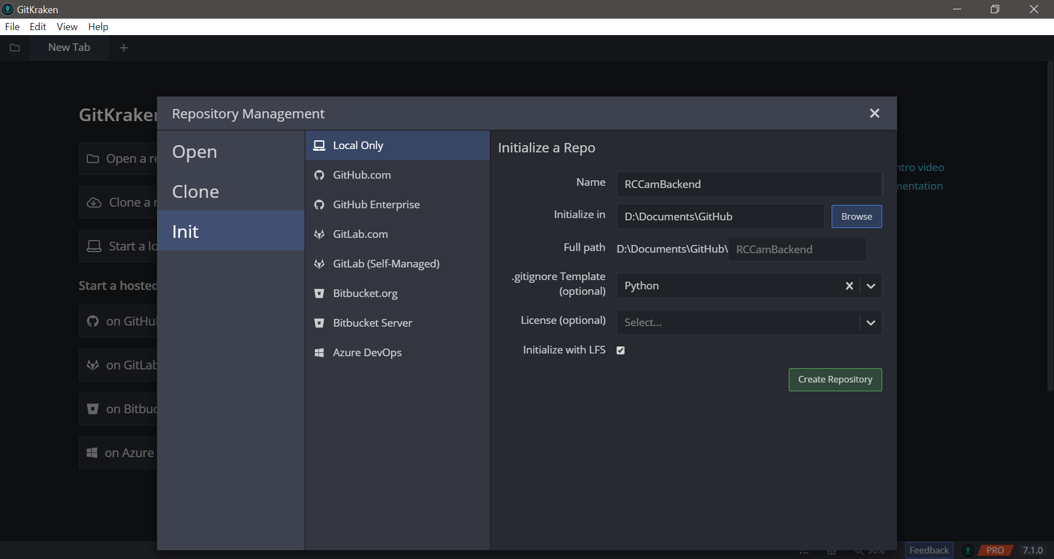

After this, I initialised another repository with an Android gitignore template and no license for the frontend Android software - appropriately named RCCamFrontend. My two repositories were now ready for development.

### Trello

Now I needed somewhere to track development - from progress to what needs to be done. This is where Trello comes in; a board management system. I began by creating a new Trello board under the name RC Camera Project.

Then, I added five lists:

* **Info** ~ for any information about the project
* **Completed** ~ for any cards that have been finished
* **Currently Working On** ~ any cards that are currently in development
* **Backburner** ~ cards that are low priority and have been partially completed
* **Module 1 ~ To Do** ~ module 1 cards that are yet to be completed
* **Module 2 ~ To Do** ~ module 2 cards that are yet to be completed
* **Module 3 ~ To Do** ~ module 3 cards that are yet to be completed
* **Module 4 ~ To Do** ~ module 4 cards that are yet to be completed
* **Archive** ~ any cards that have been discarded

I then deleted all of the default labels and created the following:

* Module 1
* Module 2
* Module 3
* Module 4
* Issue ~ for any cards that relate to issues with the product
* Undecided~ for any cards that haven’t been decided whether they will make it to the final product

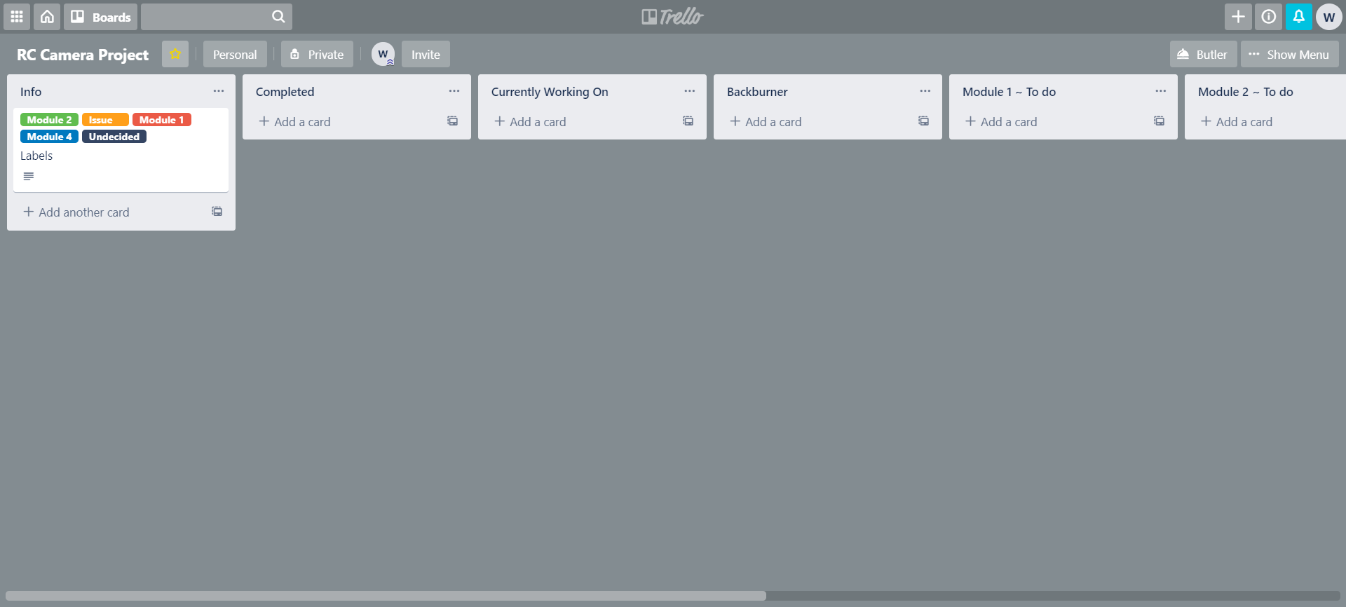

I began to fill out the Trello board with some cards for Module 1 and decided on adding two more labels:

* Hardware ~ for cards related to the RPI hardware
* Extras ~ for cards that can be completed but don't have to be

For each of the cards I made sure there was an in depth description and some included checklists or attachments. I will mainly be creating cards based on the success criteria which was established at the end of the analysis section.

Below is an example of one of the cards:

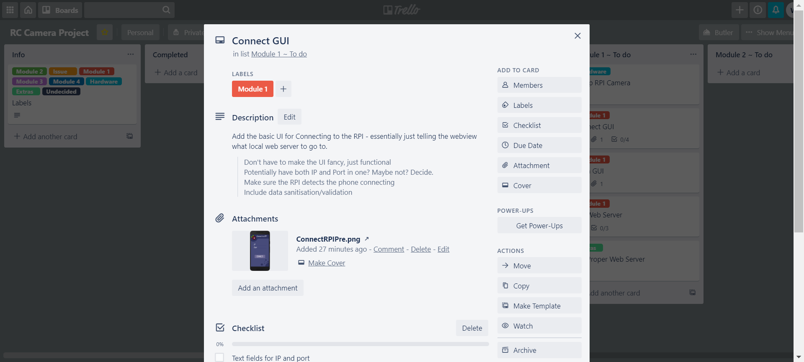

## Module 1 - Main Interface

Module 1 consists mainly of setting up the basis of the RPI web server for remote connections and the majority of the UI for the mobile app. This includes both the initial login screen and the main GUI that the user will be using.



### RPI Camera

I had to develop a web server for the RPI backend that I can then work off of in my mobile app. But, first I needed to set up the RPI camera on my RPI and make sure it is functioning correctly. I started by booting up Pycharm, Gitkraken, the VNC server and opening the Trello board. While waiting for these to open, I realised that I need the RCCamBackend repository to be on Github so that I can easily pull from the repo on my RPI.

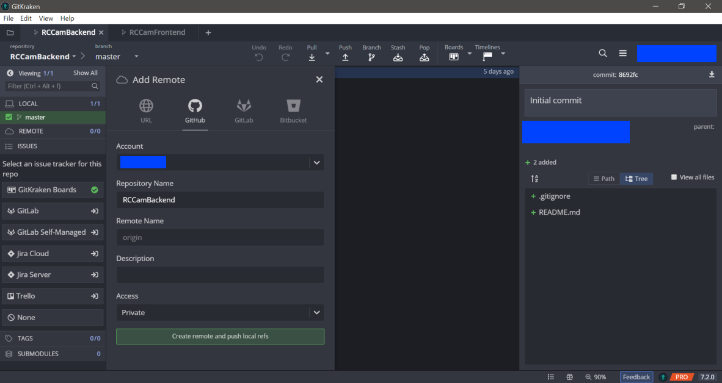

I began by unboxing my RPI Camera Module V2 and then by deconstructing the case the RPI was sitting in. I pulled up on the CSI port and inserted the camera's ribbon cable into it. I then booted up the RPI, enabled the camera and restarted the RPI. I then found a test script online and ran it on the RPI.

|  |
| --- |
| from time import sleep from picamera import PiCamera  camera = PiCamera() camera.resolution = (1024, 768) camera.start_preview()  sleep(2) camera.capture('test_photo.jpg') |

However, when I ran the script, I got an error:

picamera.exc.PiCameraRuntimeError: No data received from sensor. Check all connections, including the SUNNY chip on the camera board

So, I decided to double check the connections. I looked up what the SUNNY chip was and found that it was the connection on the RPI cam board which seemed intact. So I then checked the CSI port and made sure that the connection was correct. The part of that port which slides down wasn’t correctly in place - I had tried before but it felt like it wasn’t meant to be slid in anymore. I pushed down on it and managed to get it further in and then booted up the RPI again.

I then ran the test script again and nothing was outputted to the console. I checked the image on the RPIs desktop and it was a black image - most likely because I had the camera face down on it’s packaging. I ran the script again but held up the camera instead and I got the right photo.

I then decided to see if I could capture at a higher resolution - I vaguely remember seeing that it could capture at 1080p. I modified the code appropriately and ran the script again.

|  |
| --- |
| camera.resolution = (1920, 1080) |

The new image was blurry but that was most likely due to me holding the camera up but was captured at the correct resolution according to the image viewer.

### RPI Git Setup

Now that I had a remote repository for the RCCamBackend, I needed to set up the RPI to be able to interact with this repo. I opened up the RPI terminal and typed out the following command.

|  |
| --- |
| git clone https://github.com/Redacted/RCCamBackend.git |

I then proceeded to sign in to Github and the repository was now cloned to my RPI.

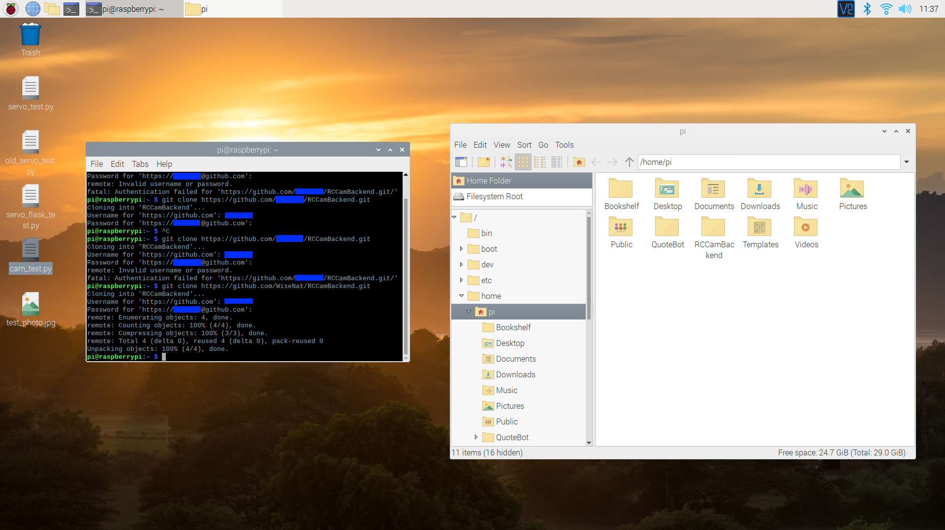

### 1.4 - Live Video Feed

#### RPI Web Server Setup

I began by trying to add to the gitignore to ignore my .idea folder since it would be a waste of storage for the RPI to pull that entire folder - it is a folder for project settings for Pycharm. However, for some reason, my gitignore file was in read only mode. I changed this attribute under file settings and then proceeded to add in Notepad++ the following to the file:

|  |
| --- |
| # My Ignores /.idea |

I committed these changes and pushed them to the remote repo. Now I wouldn’t be bothered with changes to the idea folder whenever those occurred.

Within Pycharm I created a new Python file, main.py, and then added a configuration. I decided to check what version of Python 3 the RPI was running so I used the following command in the terminal.

|  |
| --- |
| python3 --version |

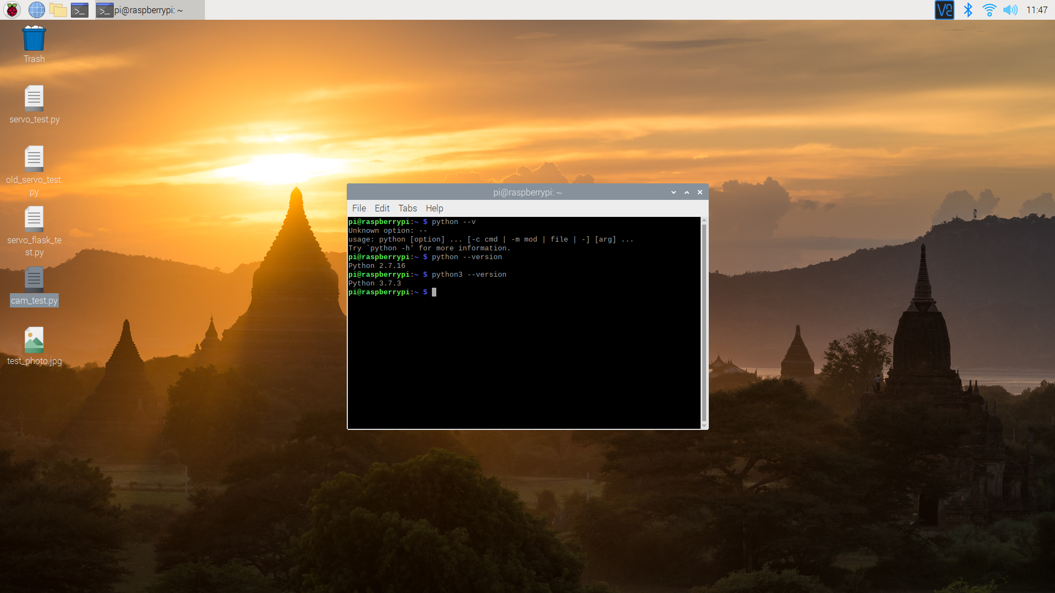

The RPI was running Python 3.7.3. Since there wasn’t anything new in Python 3.8 that I was going to use, I decided to just use Python 3.8 as the interpreter - it would save time as I wouldn’t need to install Python 3.7. I copied across the servo flask server test script from the pre-module scripting into this new file.

Pycharm recommended a bunch of changes to the code that I acted upon, the previous code had been typed up in IDLE which is extremely lightweight.

The first change was removing redundant parentheses from the class declaration.

|  |
| --- |
| class ServoController: |

The second change was suggesting that the change_servo function may be static so I gave it a staticmethod decorator.

|  |
| --- |
| @staticmethod def change_servo(servo, amount, tm=0.1):  servo.ChangeDutyCycle(amount)  time.sleep(tm)  servo.ChangeDutyCycle(0) |

This meant that I could keep the relevant function within the class. Maintainability is key for development. Any programmer can write code that a computer can understand while a decent programmer writes code that humans can understand. It would be strange for this function to sit outside of the class.

I also added in some checks for whether I was running the program on my computer or my RPI - the RPi.GPIO module would only work on an RPI for obvious reasons.

|  |
| --- |
| try:  import RPi.GPIO as GPIO  isRPI = True except ModuleNotFoundError:  print("WARNING: RPI functions won't work on this environment")  isRPI = False  ~~  if isRPI:  ser_app = ServoController() |

I tried connecting to the Flask server with my previous IP I had saved to make sure everything was functioning correctly but it refused connection. I presumed my IP had changed so I checked ipconfig and used the IP displayed there. When I tried using that instead I could connect.

I also decided to rename the multi_var flask function to something more fitting and to add in the crucial Python if name is main code.

|  |
| --- |
| # Better to work with structurally and functionally @web_app.route("/servo/") def modify_servo():  arg_keys = [item.lower() for item in list(request.args.keys())]  ~~  if __name__ == "__main__":  web_app.run("0.0.0.0") |

I was going to create an error 404 page, however, Flask comes with a generic one built in. Since this was only a precaution as the user most likely won’t be visiting the site via a web browser, I will leave it as the generic error 404 page.

#### Live Video Feed

I then decided to add in a live video feed to the website. First I pulled all the changes across to my RPI and found that I had to login to Github again to do this. So, I searched online for a way to not have to input my username and password and ran the following commands

|  |
| --- |
| git config --global user.email "Redacted" git config --global user.name "Redacted" git config --global credential.helper store |

After this, I began work on the live camera feed. I looked up the picamera module documentation and found a [section on a byte stream](https://picamera.readthedocs.io/en/release-1.13/recipes1.html#capturing-to-a-stream). This seemed somewhat useful but from my lacking knowledge of flask, wouldn’t help me pass a continuous stream to a static site. I then found an article on [video streaming in Flask](https://blog.miguelgrinberg.com/post/video-streaming-with-flask) and looked over a section of the code they posted for streaming.

It returned a custom generator with a specific mimetype kwarg. I then checked the picamera documentation and found the capture_continuous method. I tried passing this alone into the Response return but was met with an error when running the script on my RPI. The output arg was missing. I remembered the file stream from earlier and decided to look more into it.

I first tried just passing the capture_continuous method alone.

|  |
| --- |
| try:  import RPi.GPIO as GPIO  from picamera import PiCamera   camera = PiCamera()  camera.start_preview()  isRPI = True except ModuleNotFoundError:  print("WARNING: RPI functions won't work on this environment")  ~~  @web_app.route("/video/") def video_feed():  return Response(camera.capture_continuous(), mimetype='multipart/x-mixed-replace; boundary=frame') |

However, this didn’t work and returned an error. I then tried using a generator and didn’t use yield to see if I could get a bytes stream working first off. I decided to use pillow (PIL fork) to work with the image files since it is useful in these scenarios.

|  |
| --- |
| def gen(cam):  stream = BytesIO()  for image in cam.capture_continuous(stream):  stream.seek(0)  out_image = PIL.Image.open(out_image)  print(out_image)  ~~  return Response(gen(camera), mimetype='multipart/x-mixed-replace; boundary=frame') |

This also returned an error. I modified two argos within the code that were causing issues. I had forgotten to specify the image format and I was passing the wrong variable into the open method.

|  |
| --- |
| for image in cam.capture_continuous(stream, format="jpeg"):  stream.seek(0)  out_image = PIL.Image.open(image)  print(out_image) |

When I tried to connect to the website this time, it wouldn’t load on the client end. So, I checked the server side and it was repeatedly outputting the class information.

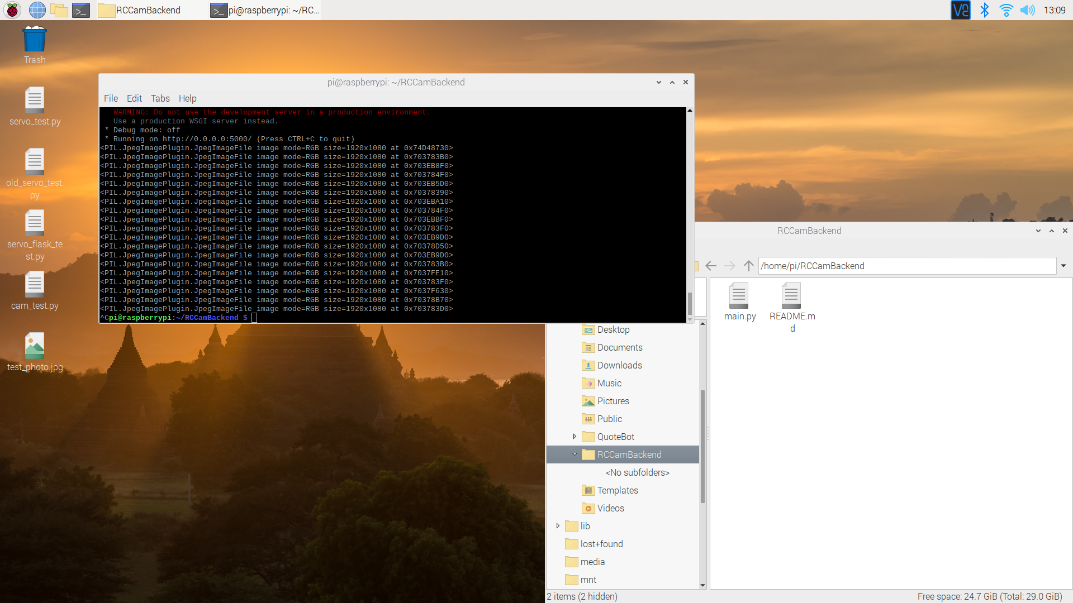

I changed the print function to a yield hoping that it would now work but was met with another error.

AssertionError: applications must write bytes

I remembered that the video streaming code I had seen before didn’t just yield the image alone. It had some metadata with it. So, I modified that section of code to fit my script.

|  |
| --- |
| yield (b"--frame\r\n"  b"Content-Type: image/jpeg\r\n\r\n" + out_image + b"\r\n") |

When running the script I then got another error:

TypeError: can't concat JpegImageFile to bytes

I tried converting out_image directly into a bytearray but that also didn’t work. Searched up the JpegImageFile, a class for PIL, and found that the Image class it inherits from has a tobytes() method.

|  |
| --- |
| yield (b"--frame\r\n"  b"Content-Type: image/jpeg\r\n\r\n" + out_image.tobytes() + b"\r\n") |

This worked, somewhat, because I now could see a black image. I tried moving the camera around and restarting the connection but all I could see was a black screen with a white square outline.



I decided to try and get to the bottom of this issue since I wasn’t getting any errors now so I created a new branch called “testing”. I then changed the entire gen function to just continually open a local jpeg to see if it was an image with PIL.

|  |
| --- |
| def gen(cam):  while True:  out_image = PIL.Image.open("test_photo.jpg")  yield (b"--frame\r\n"  b"Content-Type: image/jpeg\r\n\r\n" + out_image.tobytes() + b"\r\n") |

When I pulled the changes onto my RPI and ran the code, I still had a black screen on the web page. This confirmed that the issue was with how I was passing data to Flask.

I decided to do some searching online to see if anybody else had been having the same issue and then I came across a Github project for Flask video streaming cameras with a [Raspberry Pi Camera class](https://github.com/Mjrovai/Video-Streaming-with-Flask/blob/master/camWebServer/camera_pi.py).

I decided to look into implementing this class into my code as it would make life significantly easier.

I added this class into a separate file called “camera.py” and also took time to move the ServoController class into a “servo.py” file. I then changed how the generator function worked and slightly modified the video_feed function.

|  |
| --- |
| def generator(cam):  while True:  yield (b"--frame\r\n"  b"Content-Type: image/jpeg\r\n\r\n" + cam.get_frame() + b"\r\n")  ~~  @web_app.route("/video/") def video_feed():  return Response(generator(Camera()), mimetype='multipart/x-mixed-replace; boundary=frame') |

When I ran the code I was shown an error for “servo.py” where apparently amount was a duplicated arg. I checked and it was because I changed the name of “tm” when moving it across to “amount” to make more sense but neglected the fact that “amount” also was for the amount you wanted to change the servo by. I changed this back for obvious reasons under the commit name “I’m Stupid”.

When I ran the code again and went onto the website I could finally see a video stream! However, it was extremely slow and was upside down.

I commented out both of the flips in the camera class and modified the camera resolution to a lower resolution - I had changed it to 1080p when adding the class. I also spent time modifying the comments to look nicer and changing some other small things. I won’t show these below however.

|  |
| --- |
| # Pi Camera setup camera.resolution = (320, 240) # camera.hflip = True # camera.vflip = True |

When I ran it again it worked a lot faster although it was still slow. I don’t believe it was an issue with the software but rather the hardware. I was sending these frames using the RPIs built in WiFi card which, from my experience, was decent but can be slow at times. However, it was still decent.

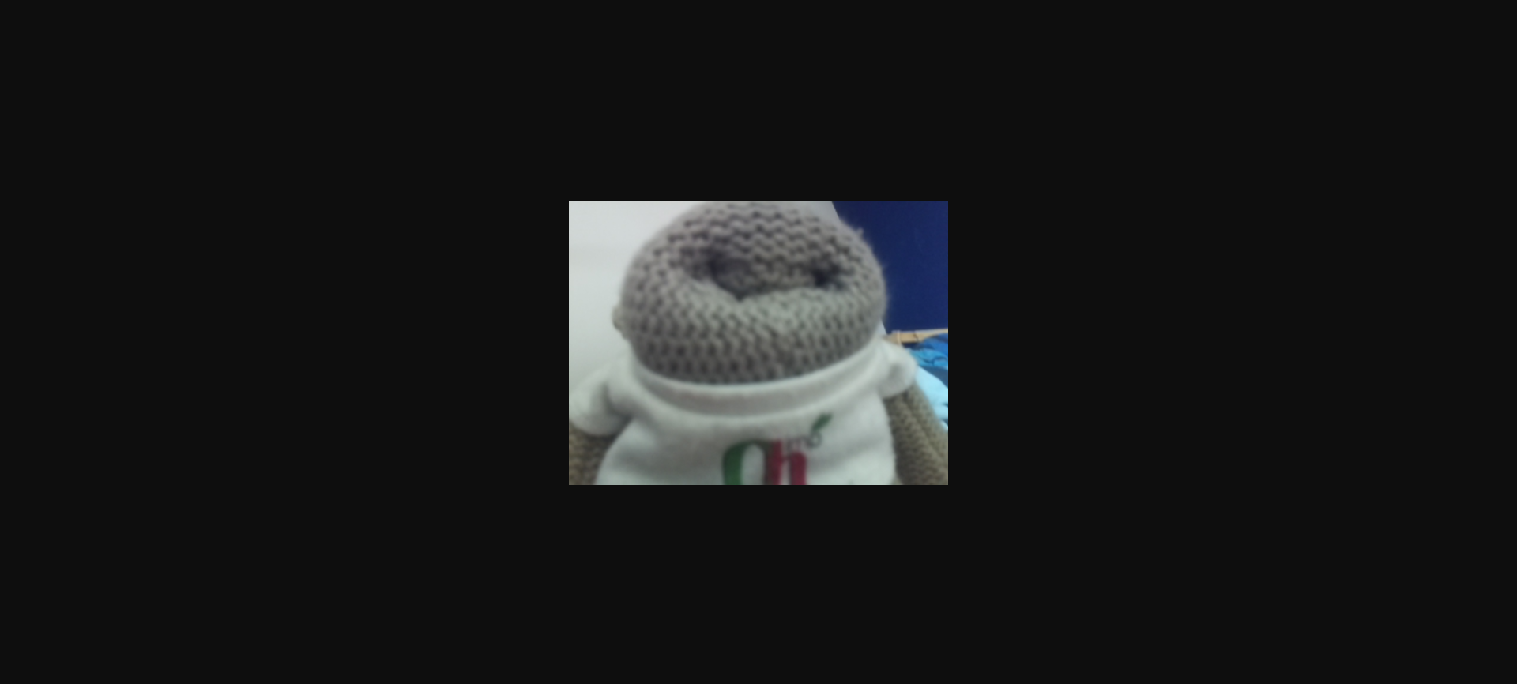

I checked the RPIs task manager to make sure it wasn’t an issue of processing power and as I expected the CPU and memory usage was relatively normal. This verified in my mind it was a connection issue.

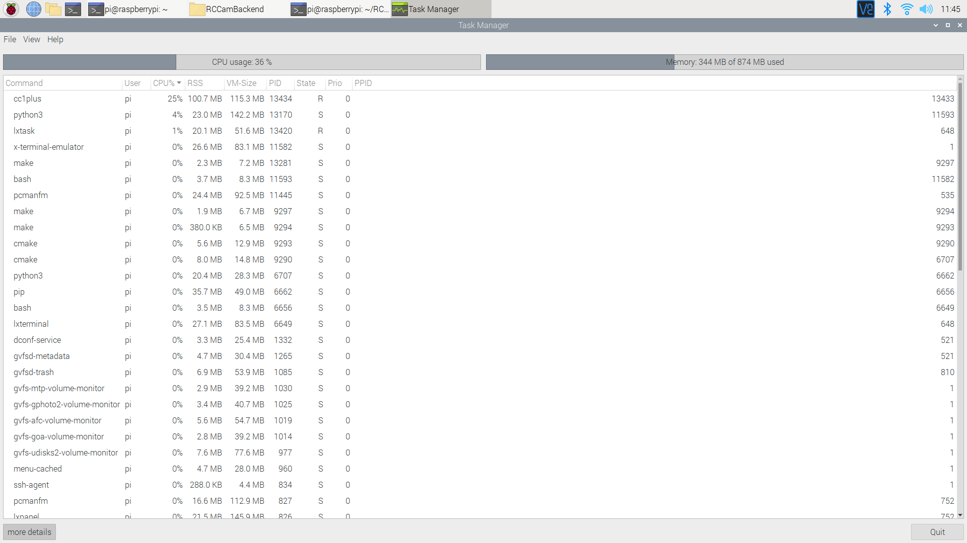

I then realised that if I was going to change the servos I would lose access to the video streaming page. So, instead I changed up the structure of the website to better suit this model.

#### Final touches

I removed all of the current routes and merged them together into a single route. This way the user is presented with the video feed when they go onto the website and can modify the servos on this same route.

|  |
| --- |
| @web_app.route("/") def main_page():  # Servo modification logic  arg_keys = [item.lower() for item in list(request.args.keys())]   if "p" in arg_keys and re.match(r"^-?\d+(?:\.\d+)?$", request.args["p"]) is not None:  ser_app.change_servo(ser_app.pitch, float(request.args["p"]))  print("Pitch: {}".format(request.args["p"]))   if "y" in arg_keys and re.match(r"^-?\d+(?:\.\d+)?$", request.args["y"]) is not None:  ser_app.change_servo(ser_app.yaw, float(request.args["y"]))  print("Yaw: {}".format(request.args["y"]))   # Live video feed  return Response(generator(Camera()), mimetype="multipart/x-mixed-replace; boundary=frame") |

However, in order to modify the servos the webpage would still need to be reloaded which could be a small annoyance. For now, this was better than nothing. At a later point in time I would need to find a way to fullscreen the video feed as well.

### 1.1 - Connect GUI

I had decided after looking into mobile frameworks that it would be a lot easier to instead just develop the app within Android studio. This however does mean that the app will only be for the Android operating system but the other frameworks I looked into were lacking in functionality that was necessary for my project.

#### Setup

I installed Android Studio and set it up to work with Kotlin. I deleted my old Git repository called “RCCamFrontend” and created a project folder in the same location. I set up this project with an empty activity.

Then, within Android Studio, I initialised the repository as a Git repository. Within Gitkraken, I made an initial commit for all the android studio files. I set up a Pixel 3 XL virtual machine and when I went to run it I had an error - Error while waiting for device: Could not start AVD.

After looking up the error, I found that I needed to enable virtualisation within the BIOS. I quickly shut down my PC, went into the BIOS and enabled virtualisation and restarted. Then, when I tried to run the virtual machine the next time it appeared without faults.

#### Initial Design

I then loaded up my mock GUI design for the RPI connection screen and opened activity_main.xml. This file represents how the GUI looks for the user. It is essentially the CSS and HTML of the app for specific screens.

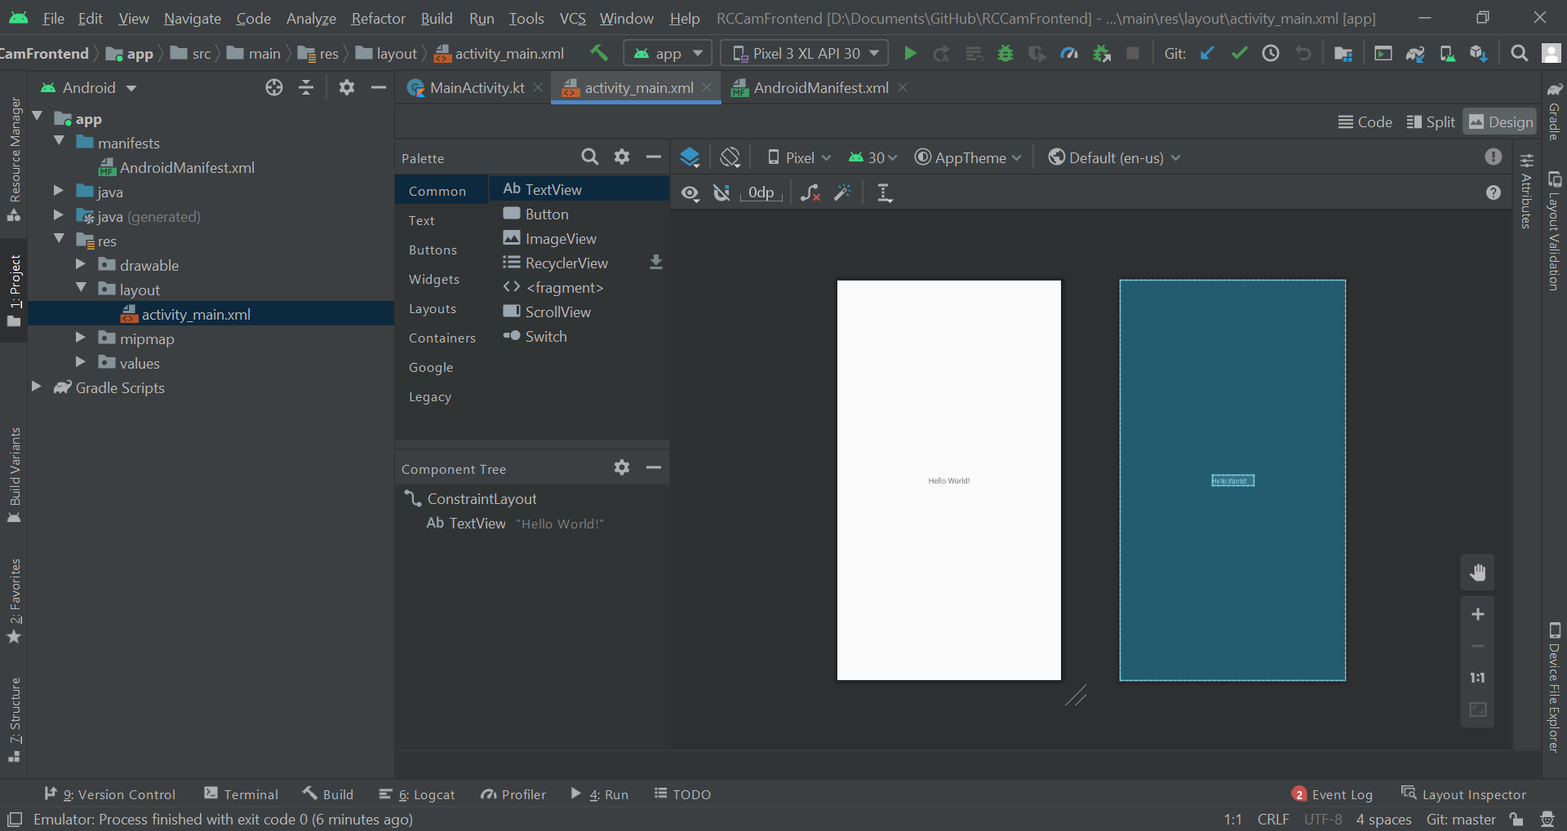

I began by removing the “Hello World” textview and adding in two Text objects. The first, a plaintext variant for the IP input for the user. The second, a number variant for the port input. The reason I chose plaintext for the IP was to account for the periods within the IP address.

I then realised that I could just have the IP input as a number variant with decimalisation. I tried this but unfortunately, it restricts the number of periods you can use. Instead I tried using a phone variant in the off chance that you can use periods with that. Luckily, that’s exactly what the phone variant has. I just needed to apply the appropriate validation. This could always be changed later to a nicer version with periods being added automatically but for now this would do.

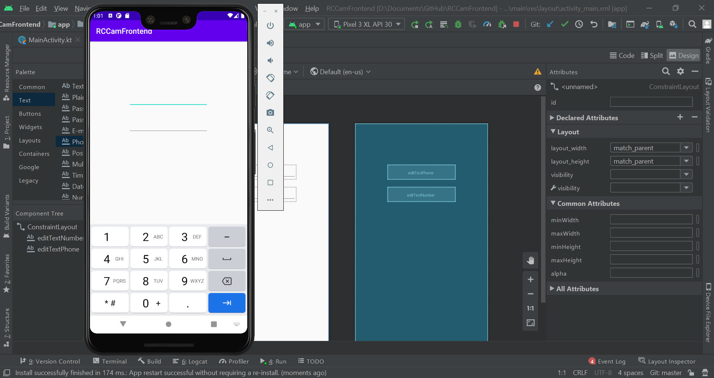

I then added a button with constraints which will be used to confirm the IP and port and attempt to connect to the RPI. I also edited the hints attributes of the text fields to be both “IP Address” and “Port Number” respectively as well as the text attribute of the button to be “Connect”. Then, I updated the id of all 3 elements to be: “textfieldIP”, “textfieldPort” and “btnConnect”.

In order to get the Agency FB font I used in the design, I had to add it’s associated TTF file to app/assets/fonts since it wasn’t available with Google Fonts. I then initialised this font as the typeface variable and set all of the element's typeface attributes to become the new typeface in MainActivity.kt.

|  |
| --- |
| val typeface = Typeface.createFromAsset(assets, "AGENCYR.TTF")  textfieldIP.typeface = typeface textfieldPort.typeface = typeface btnConnect.typeface = typeface |

This however, threw an error so I checked Logcat and found this error Caused by: java.lang.RuntimeException: Font asset not found agencyb.ttf. After prodding around a bit, I realised that the assets folder I had created wasn’t an Android assets folder which may have caused the crashes. I deleted the old assets folder and added a new android assets folder with a font folder and put the fonts within.

After a few more crashes and staring at the screen in confusion, I found that I had been now calling the file by the wrong name and changed this. When I ran it again, the app worked perfectly and the font appeared. I decided however to try the bold variant of the font which looked a lot nicer.

|  |
| --- |
| val typeface = Typeface.createFromAsset(assets, "agencyb.ttf") |

After refactoring the file however, it wouldn’t work. I eventually figured out that in order for the file to be found, the name had to be left as the original for whatever reason. I reverted the filename back and everything was in working order.

|  |
| --- |
| val typeface = Typeface.createFromAsset(assets, "AGENCYR.TTF") |

Then, as a decent practice, I decided to create a new branch titled “dev” which would be used for development and the main branch as a sort of release for new polished features. I then modified a lot of the elements attributes ranging from text size to width in order to get the dimensions closer to my mockup.

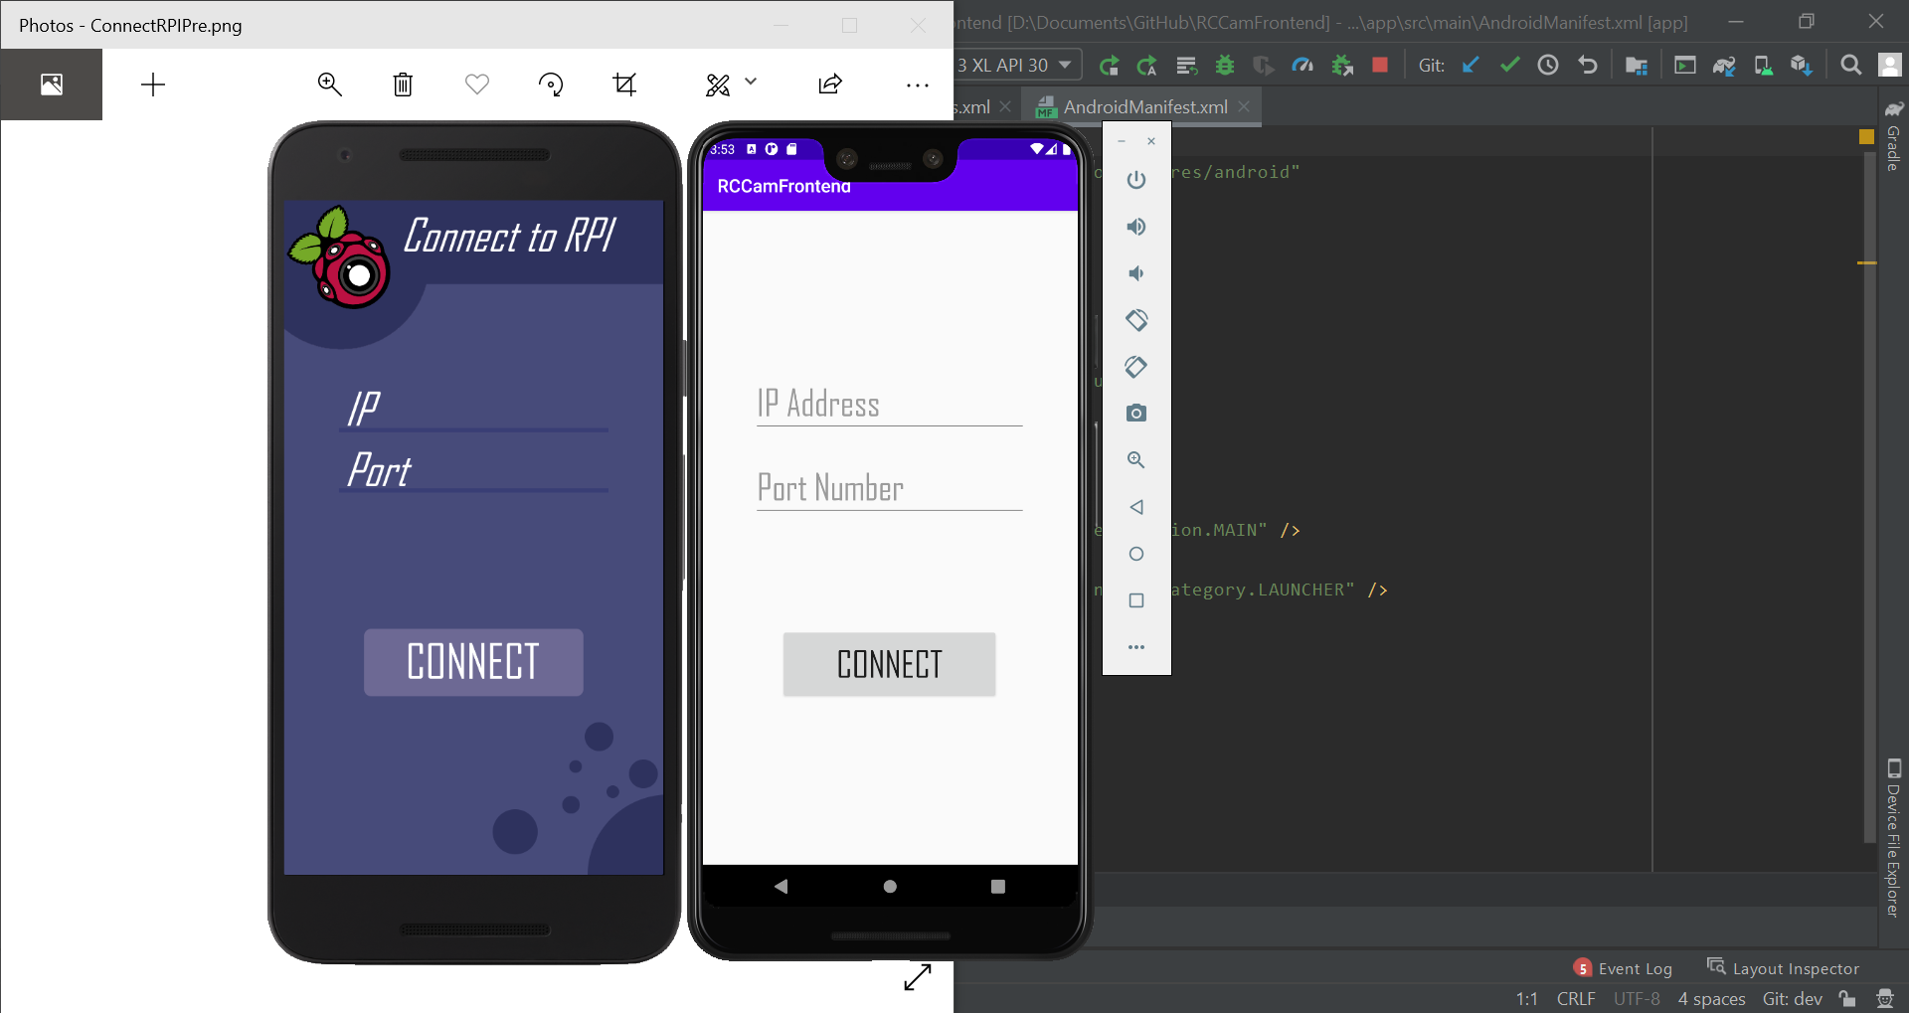

I then noticed some warnings Android Studio was giving me about hard coded string values for hints and text. I fixed this up automatically by letting it move the values into the strings.xml file under values. Android Studio then prompted me to act on autofill content - this is essentially me deciding what I should let a text field be autofilled as. This is useful for passwords, names and credit card information among other things. I decided to just explicitly disable this feature as I deemed it unnecessary. This was simple to do, for each textfield I just had to give it the following attribute.

|  |
| --- |
| android:importantForAutofill="no" |

### 1.2 - Button to next Activity

I then started to work on adding functionality to the Connect button. I started by trying to get an onclick listener working for the button. To test this I added the following code which would show a toast (text popup) if the button was clicked. If something was wrong with the code then the button wouldn’t show.

|  |
| --- |
| btnConnect.setOnClickListener{  Toast.makeText(this, "Testing", Toast.LENGTH_SHORT).show() } |

Luckily, when I clicked the button, the toast appeared below. Now I had to just make another activity with a webview and from there try and figure out a way to connect to the server using the input fields with some input sanitisation and validation.

Then, to check I was getting the correct values from both text fields, I changed the text shown in the toasts to the data from the fields.

|  |
| --- |
| btnConnect.setOnClickListener{  Toast.makeText(this, textfieldPort.text, Toast.LENGTH_SHORT).show()  Toast.makeText(this, textfieldIP.text, Toast.LENGTH_SHORT).show()  } |

From there, I created a new activity for the main GUI.

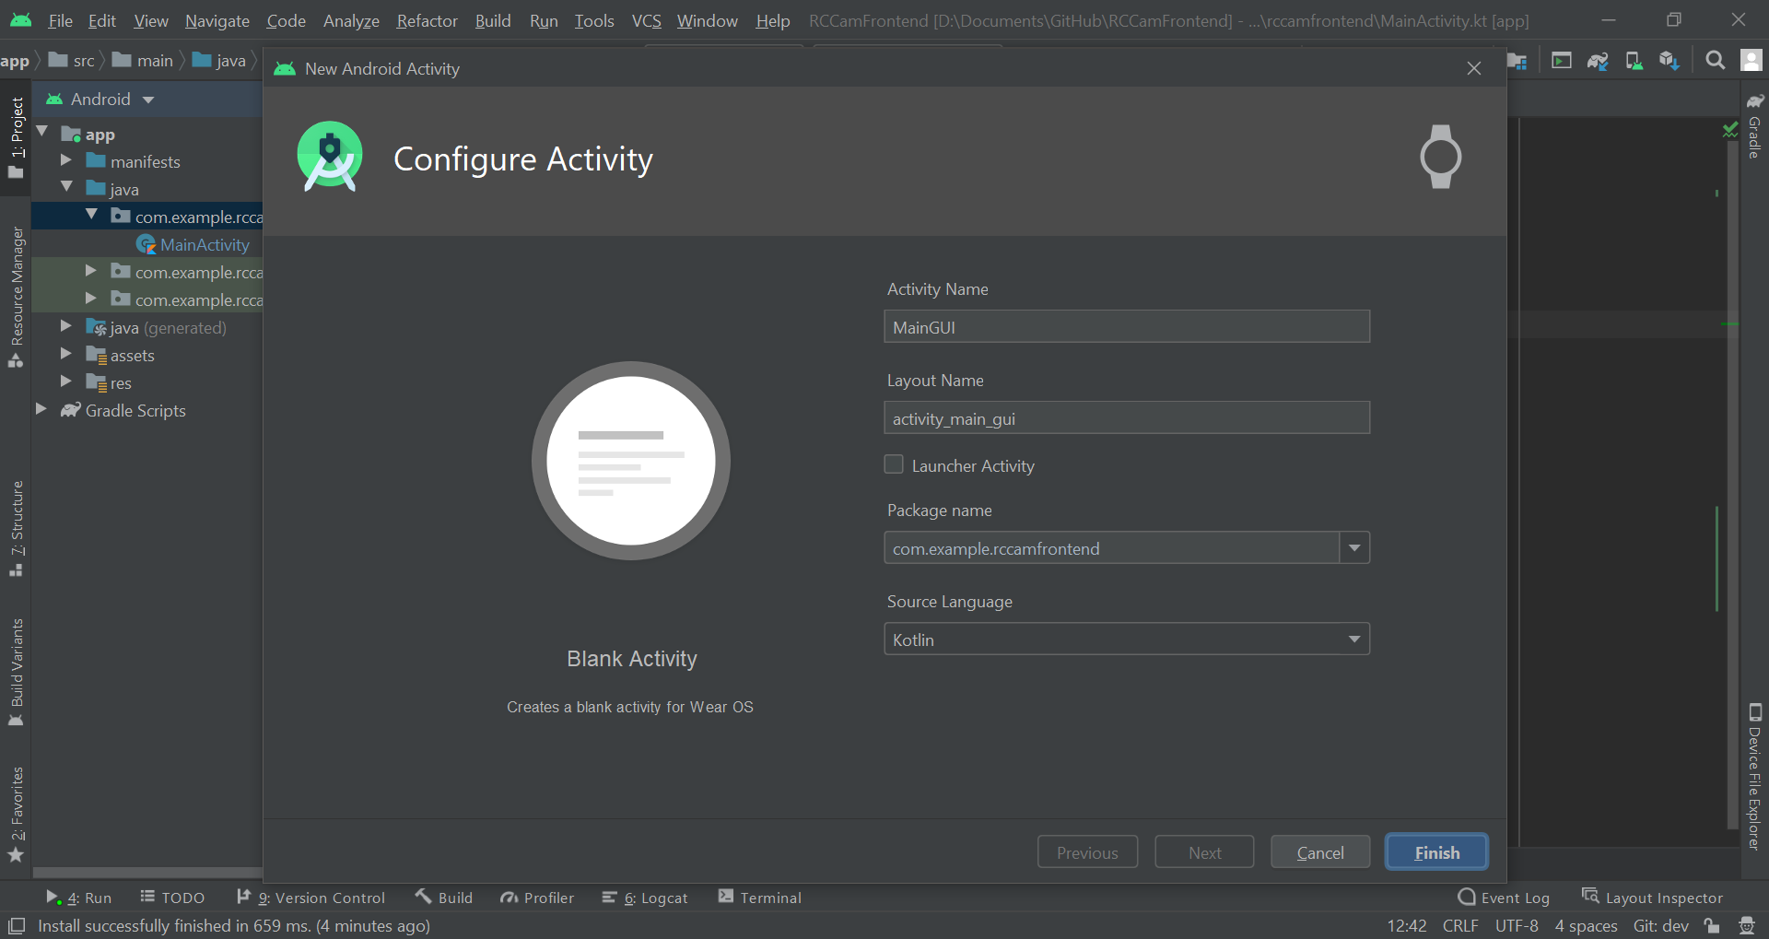

I then decided to refactor both of the activities to be both “ConnectActivity” for the connect screen and “Main Activity” for the main portion of the GUI. This caused some issues so I reverted back to my previous commit and redid everything up to the point of adding a new activity. I also decided to refactor the layout xml file for the connect activity for consistency. I presume the issue caused by adding a new activity was because when adding the file I created a new activity from the menu instead of the gallery so the next time I used the gallery.

For some reason, when adding this new activity, it wouldn’t let me name the layout xml file “activity_main.xml” since the name had to be unique. Confused, I hit Ctrl+Shift+F to search the entire project for any occurrences of “activity_main” and none came up. So, I chose to call the layout file “activity_main_.xml” and then would refactor it after. When I went to refactor it gave me a conflict in “activity_connect.xml” but there was nothing there when I checked. So I refactored ignoring this.

Temporarily, I decided to make the button just visit the Main GUI activity, so I added a new intent and then would use that to view the next activity via the startActivity function.

I then cobbled together a quick GUI for the activity with just a webview and a temporary button. I made sure that the button used the same Agency FB font as the rest of the software. However, when I booted it up and clicked “Connect” to go to the Main GUI activity, I was presented with a blank screen.

I presumed that the reason it wasn’t working was because of something to do with the webview and because I hadn’t actually given it a website to go to. So, I deleted the webview. Then, when I launched the application I could see the button. I added back in the webview but this time I didn’t constrain the button to the webview and it worked as intended.

#### Revised Font System

I then found out that I could reference a font within XML instead of applying it programmatically by moving the font directory to the res dir and from there accessing it via “@font/<fontname>”. I followed the [guide](https://developer.android.com/guide/topics/ui/look-and-feel/fonts-in-xml) in the documentation on doing this. First, I created a new Android resource directory for the fonts and I moved the existing font files into there. I then deleted the old font directory and had to leave the assets folder.

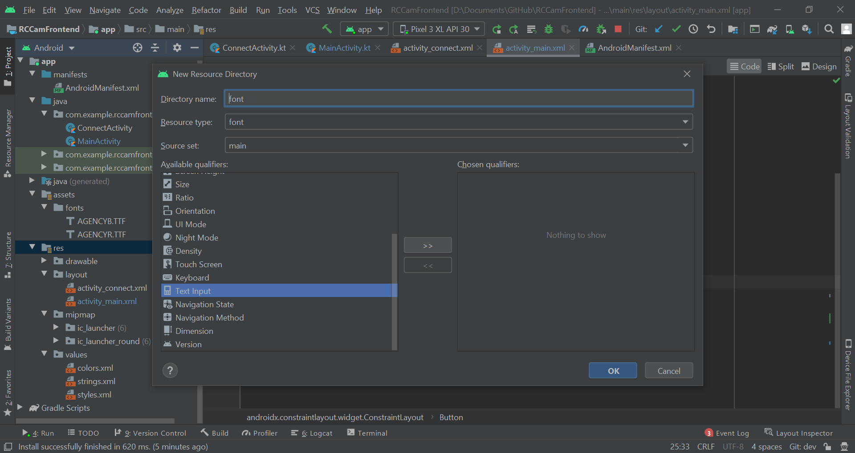

I then went and removed any existing kotlin code for setting the font for each element and instead added the following XML to one of those elements:

|  |
| --- |
| android:fontFamily="@font/AGENCYR.TTF" |

However, this didn’t work and I got an error saying that the file couldn’t have any capitalization within the name. So, I modified the name of the TTF files to be all lowercase - even the extension - and the XML.

|  |
| --- |
| android:fontFamily="@font/agencyr" |

Now my code functioned correctly so I added the above XML to all of the previous elements. This would make it a lot easier to apply the font instead of having to initialise the font and apply it within the Kotlin script. Everything worked when I ran it without any errors and I could see the font applied within the design editor as well. Before I had to predict the outcome of the text size and box boundaries but now I could actually see the font which would make it a lot easier in the future.

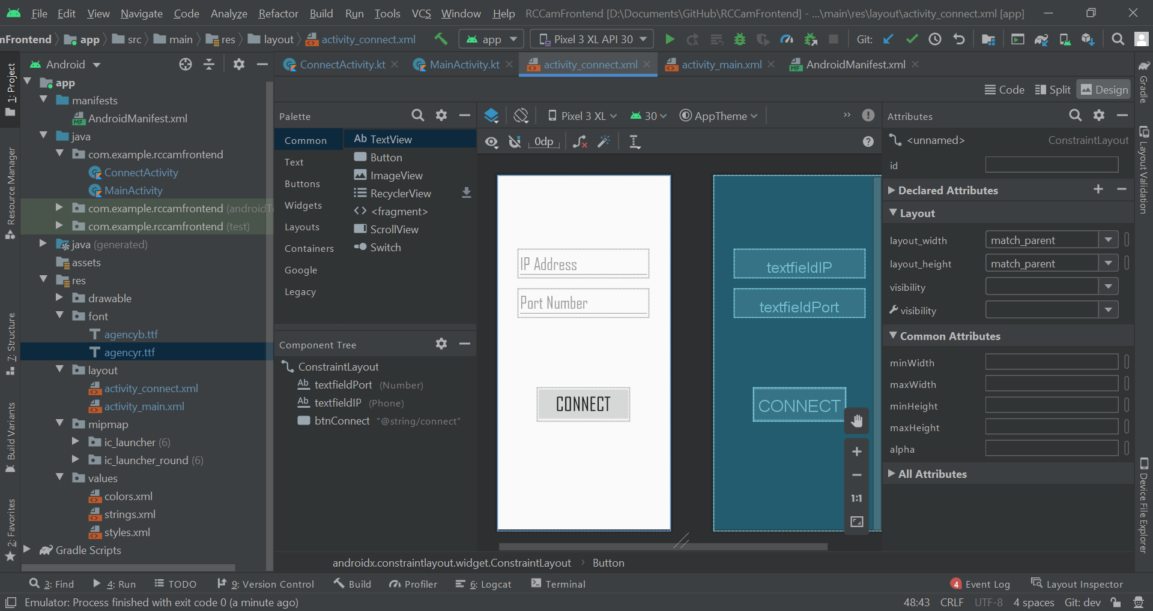

### 1.3 - Main GUI

#### Webview Functionality Programming

I then tried to set the webviews URL from the Connect activity - another class. I added the following lines of code to the button click listener:

|  |
| --- |
| val webview = findViewById<WebView>(R.id.webView) webview.loadUrl("https://google.com/") |

When I ran this, the app crashed and in logcat it stated I was referring to a null object. When putting this code inside of the Main activity, it worked as expected and loaded up Google. I had to find a way to access the webview in the connect class somehow. I then tried to instantiate the Main activity class and then to use the findViewById method on that. This didn’t work.

|  |
| --- |
| val x = MainActivity() val webview = x.findViewById<WebView>(R.id.webView) |

I then realised I can just load the Main activity and load the URL there. If that fails then return to the previous activity. So, I added the load url code back into the main activity and added in some code to get the values from the IP textfield and the Port textfield. A lot of iterations were built with a lot of mistakes that I forgot to note down. I eventually reached the code below which still didn’t work.

|  |
| --- |
| btnConnect.setOnClickListener{  val intent = Intent(this, MainActivity::class.java)  intent.putExtra("ip", textfieldIP.text)  intent.putExtra("port", textfieldPort.text)  startActivity(intent) }  ~~  if (intent != null) {  val webview = findViewById<WebView>(R.id.webView)  webview.loadUrl("http://%s:%s/".format(  intent.getStringExtra("ip"),  intent.getStringExtra("port")))  Toast.makeText(this, "http://%s:%s/".format(  intent.getStringExtra("ip"),  intent.getStringExtra("port")), Toast.LENGTH_SHORT).show() } |

I then tried checking to make sure it wasn’t an issue with the data I was passing. I created the following toast to check and put it within the button listener:

|  |
| --- |
| Toast.makeText(this, textfieldIP.text, Toast.LENGTH_SHORT).show() |

This worked to my surprise so I decided to check elsewhere. I spent an hour or so trying to figure out the issue and eventually went to the debugger. I found that for some reason the following lines were returning null values.

|  |
| --- |
| intent.getStringExtra("ip") intent.getStringExtra("port") |

I then checked the debugger with multiple lines of code checking the variables and then decided to check the rest of the code. I decided to try to add a toString method to the data I was passing to the main activity since I was running out of ideas. This worked..

|  |
| --- |
| intent.putExtra("ip", textfieldIP.text.toString()) intent.putExtra("port", textfieldPort.text.toString()) |

Why did I have to convert the text attribute which should have been a string but wasn’t to a string? I have no idea. After checking the documentation, apparently the value is a “CharSequence” instead of just a string. They are basically the same data type. This is why Python is a better programming language.

When I tried connecting to my RPI I found that the webview was showing an error - ERR_CLEARTEXT_NOT_PERMITTED. After searching the docs I found something about cleartext traffic. I presume this was because my RPI web server was using HTTP instead of HTTPS. I stated that I could set parameters for networking within an xml file. I created a new directory inside of res called XML and generated this file within it. I then inserted the following XML into it:

|  |
| --- |
| <?xml version="1.0" encoding="utf-8"?> <network-security-config>  <domain-config cleartextTrafficPermitted="true">  <domain includeSubdomains="true">RPI IP</domain>  </domain-config> </network-security-config> |

This didn’t work and then I found that I can set a value in the manifest file.

|  |
| --- |
| android:usesCleartextTraffic="true" |

Now when I ran the program, I got the error ERR_CACHE_MISS. I tried searching the docs and then Stack Overflow. I found this [post](https://stackoverflow.com/questions/30637654/android-webview-gives-neterr-cache-miss-message) that stated I needed to add the correct permissions to the manifest file. I decided instead to read up again on the [webview guide](https://developer.android.com/guide/webapps/webview).

I added the following XML to the manifest file and then ran the program again.

|  |
| --- |
| <uses-permission android:name="android.permission.INTERNET" /> |

This worked but I could see a few issues with the webview size as you can see below in the whitespace.

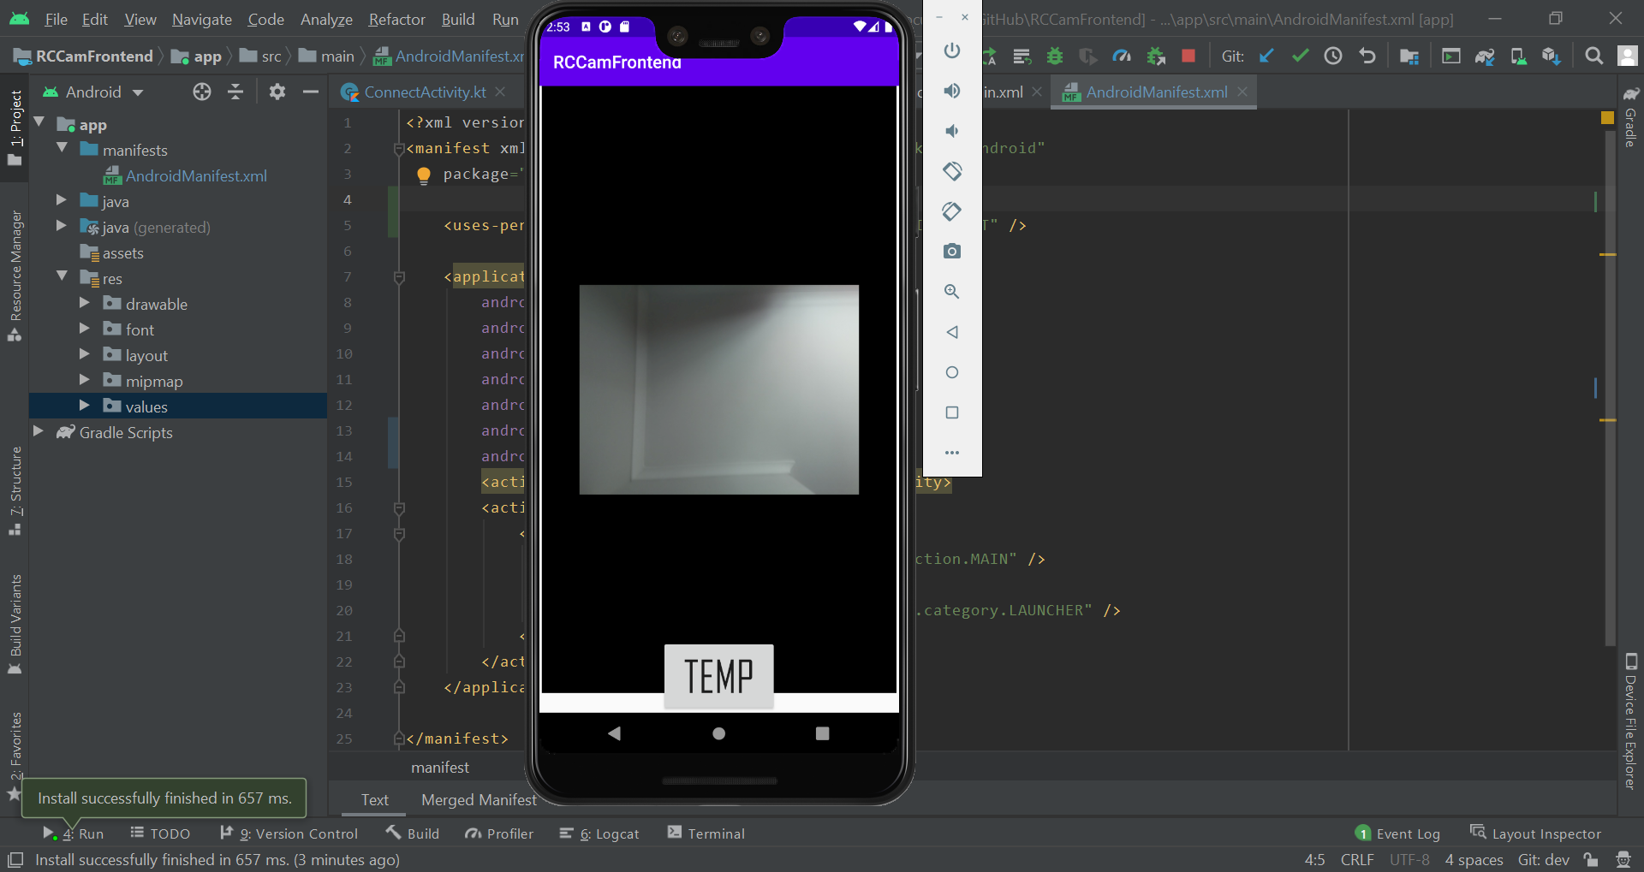

In order to fix this, I made the layout_width and layout_height both 0dp and added a new constraint to the bottom of the webview. This made it fill the entire screen. I also slightly modified the positioning and constraints of the TEMP button. I then fixed up the main activity code to remove any lines of code used for testing.

|  |
| --- |
| if (intent != null) {  val webview = findViewById<WebView>(R.id.webView)  webview.loadUrl("http://%s:%s/".format(  intent.getStringExtra("ip"),  intent.getStringExtra("port"))) } |

I decided to now work on input sanitisation, validation and error messages. I started with trying to find a way to either replace characters or restrict the keyboard to stop the user sending certain characters. I found both the replace method for strings and the [setFilter](https://developer.android.com/reference/android/widget/TextView#setFilters(android.text.InputFilter%5B%5D)) method for textviews. I tried implementing the setFilter method using this [Stackoverflow question](https://stackoverflow.com/questions/21828323/how-can-restrict-my-edittext-input-to-some-special-character-like-backslash-t) for reference. According to the Stackoverflow question, you can achieve the same within the XML - I’m slowly starting to realise that you can do most simple tasks within the XML. That’s what it seems like anyway.

I found this in the [documentation](https://developer.android.com/reference/android/widget/TextView#attr_android:digits) and it seemed to fit exactly what I needed. So for the textviews I added the following XML:

|  |
| --- |
| <!-- Port Textfield --> android:digits="1234567890" ~~  <!-- IP Textfield --> android:digits="1234567890." |

This made it so that the characters I tried to input that weren’t in the set didn’t work. I tried to see if I could circumvent this by copying and pasting characters outside of the data set into the textview but this didn’t work either. This builtin feature is well designed and I love it. However, users could still enter invalid IP addresses. I looked into the [wikipedia article for IPv4 addresses](https://en.wikipedia.org/wiki/IPv4) to figure out what constraints and patterns there were. The values for each section seem to range between 0 and 255. And are in this pattern:

integer.integer.integer.integer with each integer being between 0 and 255.

I’ve previously used a module in Python called Regex which after searching online also exists in Kotlin. I found that it exists in a lot of languages and decided to read up a bit more on the syntax on [Wikipedia](https://en.wikipedia.org/wiki/Regular_expression) since it had been a while since I had last used it.

I then started to try and construct a regex expression using a [regex testing website](https://www.regextester.com/) to help test the expression. I first developed this following expression which accepted 4 numbers separated by periods with a maximum number of digits as 3 for each.

|  |
| --- |
| ^[0-9]{1,3}.[0-9]{1,3}.[0-9]{1,3}.[0-9]{1,3}$ |

I then simplified it down to be a lot shorter and changed the “." to mean a literal period instead of any character.

|  |
| --- |
| ^\d{1,3}(\.\d{1,3}){3}$ |

I then needed a way of checking whether the number was in range. I then tried to create a separate regex expression which would determine whether a string was between 0 and 255.

This would have to be split up into 0-199 and 200-255 due to how regex works. I made the following regex expression for the first range.

|  |
| --- |
| ^[01]?\d\d?$ |

I tried creating a single 200-255 but struggled so I broke it down into 200-249 and 250-255. These are both below.

|  |
| --- |
| ^2[0-4]\d$ # 200-249 ^25[0-5]$ # 250-255 |

Combining all of these gave me the following expression:

|  |
| --- |
| ^([01]?\d\d?|2[0-4]\d|25[0-5])$ |

Now I had to implement this into the original regex format checker. Doing so got me this extremely long but functional IPv4 regex expression:

|  |
| --- |
| ^([01]?\d\d?|2[0-4]\d|25[0-5])(\.([01]?\d\d?|2[0-4]\d|25[0-5])){3}$ |

I didn’t feel it necessary for including a regex expression for a port number since the maximum is just a 16-bit integer and it would be easier to check that another way. To check if the ip regex expression was working correctly, I added the following code to the button listener.

|  |
| --- |
| val ipPat = Regex("^([01]?\\d\\d?|2[0-4]\\d|25[0-5])(\\.([01]?\\d\\d?|2[0-4]\\d|25[0-5])){3}\$") val result = ipPat.matches(textfieldIP.text.toString()) Toast.makeText(this, result, Toast.LENGTH_SHORT).show() |

When I ran it I got an error and I knew exactly what the issue was so I changed the line of code to the following where I just converted the result value to a string.

|  |
| --- |
| Toast.makeText(this, result.toString(), Toast.LENGTH_SHORT).show() |

I tested a bit and it all seemed to be functioning correctly. I also noticed that the return button wasn’t working - it had automatically made me select the next widget which was rather useful. I’ll come back to this after since I believe I know what’s causing it. I changed the button onclick listener to prevent the user continuing to the next activity if the ip address was invalid.

|  |
| --- |
| btnConnect.setOnClickListener{  val ipPat = Regex("^([01]?\\d\\d?|2[0-4]\\d|25[0-5])(\\.([01]?\\d\\d?|2[0-4]\\d|25[0-5])){3}\$")  val ipResult = ipPat.matches(textfieldIP.text.toString())   if (!ipResult){ // Checking if IP address is valid  Toast.makeText(this, "Invalid IP Address", Toast.LENGTH_SHORT).show()   } else { // Start Main activity  val intent = Intent(this, MainActivity::class.java)   intent.putExtra("ip", textfieldIP.text.toString())  intent.putExtra("port", textfieldPort.text.toString())   startActivity(intent)  } |

I then decided to add a check for the port number to see if it was in a valid range. This was fairly simple since the maximum was just the largest possible 16 bit integer. I decided to limit the number of characters for the port to 5 to prevent any exceptions when casting this value to an integer (could run into issues if they input a number larger than 32 bits). I added this XML for both of the text fields.

|  |
| --- |
| android:maxLength="10" |

I then added a simple check to see if the integer was less than the largest possible port. Before doing this I made sure to check the [documentation](https://developer.android.com/reference/android/widget/TextView) for any XML that would limit the integer input value but couldn’t find any.

|  |
| --- |
| val ipPat = Regex("^([01]?\\d\\d?|2[0-4]\\d|25[0-5])(\\.([01]?\\d\\d?|2[0-4]\\d|25[0-5])){3}\$")  btnConnect.setOnClickListener{  val ipInput = textfieldIP.text.toString()  val portInput = textfieldPort.text.toString()  val ipResult = ipPat.matches(ipInput)  var nextActivity = true   if (!ipResult) { // Checking if IP address is valid  Toast.makeText(this, "Invalid IP Address", Toast.LENGTH_SHORT).show()  nextActivity = false  }   if(portInput.toInt() > 65536){  Toast.makeText(this, "Invalid Port", Toast.LENGTH_SHORT).show()  nextActivity = false  }   if (nextActivity){  // Start Main activity  val intent = Intent(this, MainActivity::class.java)   intent.putExtra("ip", textfieldIP.text.toString())  intent.putExtra("port", textfieldPort.text.toString())   startActivity(intent)  } |

When I ran the script and inputted a random IP address, the program crashed. I checked the error log and the issue was when the program was trying to convert the null Port value to an integer. I fixed this by adding the toDoubleOrNull method to the portInput and changing the if statement.

|  |
| --- |
| val portInput = textfieldPort.text.toString().toDoubleOrNull()  ~~  if(portInput == null || portInput > 65536){ |

While testing this I found an issue with the max length of my IP textfield. I meant to have a different value for each of the max lengths. I changed the XML for both of the text fields to the following:

|  |
| --- |
| <!-- Port Textfield --> android:maxLength="5"  <!-- IP Textfield --> android:maxLength="15" |

When I next tested this, I inputted a few invalid values which all prompted the toasts to show and the activity to not continue. I also tried inputting “255.255.255.255” and “65535” which were the largest valid values I could. These worked but I got a net::ERR_ADDRESS_UNREACHABLE which was expected. I’ll probably have a custom error appear for that and will send the user back to the connection screen; I added a Trello card for this so I wouldn’t forget.

I then decided to add some toasts to tell the user to input values for the IP address and port if they didn’t.

|  |
| --- |
| if(ipInput == ""){  Toast.makeText(this, "Enter an IP Address", Toast.LENGTH_SHORT).show()  nextActivity = false }else if (!ipResult) { // Checking if IP address is valid  Toast.makeText(this, "Invalid IP Address", Toast.LENGTH_SHORT).show()  nextActivity = false }  if(portInput == null){  Toast.makeText(this, "Enter a Port number", Toast.LENGTH_SHORT).show()  nextActivity = false } else if(portInput > 65536){  Toast.makeText(this, "Invalid Port", Toast.LENGTH_SHORT).show()  nextActivity = false } |

I then changed how toasts were initialised and shown by instead setting a variable for the text to be displayed called toastText. I did this for every check where there was an issue. It made the code a lot nicer to read.

|  |
| --- |
| var toastText = "You shouldn't see this.."  ~~  toastText = "Enter an IP Address"  ~~  toastText = "Invalid IP Address"  ~~  toastText = "Enter a Port number"  ~~  toastText = "Invalid Port"  if (nextActivity){  ... } else{  val toast = Toast.makeText(this, toastText, Toast.LENGTH_SHORT)  toast.setGravity(Gravity.TOP)  toast.show() } |

When I ran this I had an error for the setGravity line. I had forgotten to pass args for the x and y offset. I added these in and ran the program again.

|  |
| --- |
| toast.setGravity(Gravity.TOP, 0, 0) |

However, when I ran this I realised that the whole point of initialising multiple toasts was to show multiple toasts. I reverted the code back to how it was beforehand and set gravity to each. Instead I created a toast generating function. This would make it easier to generate toasts. I added default arguments for the gravity positioning so that if I could change them using this function if I wanted to but it meant that by default they would be in a more favourable position than the bottom where the keyboard is.

|  |
| --- |
| if(ipInput == ""){ // Checking if a value was entered for the IP  generateToast("Enter an IP Address")  nextActivity = false  }else if (!ipResult) { // Checking if IP address is valid  generateToast("Invalid IP Address")  nextActivity = false }  if(portInput == null){ // Checking if a value was entered for the port  generateToast("Enter a Port number")  nextActivity = false  } else if(portInput > 65536){ // Checking if port number is valid  generateToast("Invalid Port")  nextActivity = false  }  ~~  private fun generateToast(text: String, position: Int = Gravity.TOP,  offsetX: Int = 0, offsetY: Int = 0){   val toast = Toast.makeText(this,text, Toast.LENGTH_SHORT)  toast.setGravity(position, offsetX, offsetY)  toast.show() } |

However, the gravity wasn’t working so I checked the documentation and noticed it stating that the method is a no-op. I presumed this meant that it wasn’t operational anymore and saw in the console the following message E/Toast: setGravity() shouldn't be called on text toasts, the values won't be used. For now I will still use toasts but may change to a different system later on.

I removed the setGravity method and the default arguments. The generateToast function for now is just a shorthand way of initialising and showing a toast. I added a duration default argument in case I wanted to change that for some toasts.

|  |
| --- |
| private fun generateToast(text: String, duration: Int = Toast.LENGTH_SHORT){  Toast.makeText(this, text, duration).show() } |

I spent a while searching through the docs to try to find a way to enable the return button that beforehand acted like a tab button. So, after searching for a while I found android:imeOptions. The table suggested it was what I was looking for so I added the following XML to the port textview.

|  |
| --- |
| android:imeOptions="actionDone|actionGo|actionNext" |

These were some of the keywords I thought could be associated with the button although I wasn’t even sure it was for the keyboard. When I ran the code and went onto the port textview, the button worked but went to the previous IP textview. I used trial and error to try to find the right one. I started with -

|  |
| --- |
| <!-- Port Textfield --> android:imeOptions="actionGo" <!-- IP Textfield --> android:imeOptions="actionNext" |

Luckily, this worked exactly as I needed it to. I now decided to fix up the webview for when it received the error net::ERR_ADDRESS_UNREACHABLE. I found in the [documentation under WebViewClient](https://developer.android.com/reference/android/webkit/WebViewClient#onReceivedError(android.webkit.WebView,%20android.webkit.WebResourceRequest,%20android.webkit.WebResourceError)), you could create a function under the name onReceivedError that would handle errors. I first decided to move the generateToast function to a new file called “PublicFunctions” and slightly modified it for the context arg.

|  |
| --- |
| fun generateToast(context: Activity, text: String, duration: Int = Toast.LENGTH_SHORT){  Toast.makeText(context, text, duration).show() } |

In order to test it was working correctly, I added the following line of code to the main activities onCreate function.

|  |
| --- |
| generateToast(this, "test") |

When I ran the code and inputted two valid values for the IP and port, I saw the test toast appear. I removed the function completely from the connection GUI since it was working correctly in the other file. Then, within the error handler function, I added some code to see what data I was working with.

|  |
| --- |
| fun onReceivedError (view: WebView, request: WebResourceRequest, error: WebResourceError) {  println(error.description)  println(error.errorCode)  generateToast(this, error.description.toString())  generateToast(this, error.errorCode.toString()) } |

While testing, I found another network error - unsafe port. I also found that my onReceivedError function isn't being called when the network error occurred. I realised it was because I wasn’t overriding any actual function related to the webview and was just creating a function with the same name. I modified my code to hopefully fix this issue.

|  |
| --- |
| if (intent != null) {  val webview = findViewById<WebView>(R.id.webView)  webView.webViewClient = object : WebViewClient() {  override fun onReceivedError (view: WebView, request: WebResourceRequest, error: WebResourceError) {  println(error.description)  println(error.errorCode)  }  }    webview.loadUrl("http://%s:%s/".format(  intent.getStringExtra("ip"),  intent.getStringExtra("port"))) } |

When I entered an invalid IP and port, I saw the following output in console: I/System.out: net::ERR_UNSAFE_PORT. I couldn’t tell whether this was from the description attribute or the errorCode attribute so I loaded up the debugger and did the same process again. I found that that string was from the description attribute. I added some code so that if an error occurs, a toast is made and the user goes back to the connect activity.

|  |
| --- |
| override fun onReceivedError (view: WebView, request: WebResourceRequest, error: WebResourceError) {  generateToast(this@MainActivity, error.description.toString(), dur=Toast.LENGTH_LONG)   val intent = Intent(this@MainActivity, ConnectActivity::class.java)  startActivity(intent) } |

When there is an error however, you see an annoying flickering where you go from one activity to another and then back. To fix this, I decided to use a cheap tactic. I created an invisible webview on the connect activity and if that had an error then the app wouldn’t go to the main activity.

|  |
| --- |
| if (nextActivity){ // Process for Main activity  val webview = findViewById<WebView>(R.id.hiddenWebview)  var webViewError = false   webView.webViewClient = object : WebViewClient() {  override fun onReceivedError (view: WebView, request: WebResourceRequest, error: WebResourceError) {  generateToast(this@ConnectActivity, error.description.toString(), dur=Toast.LENGTH_LONG)  webViewError = true  }  }   println(webViewError)  if (!webViewError) {  // Go to next activity  val intent = Intent(this, MainActivity::class.java)  intent.putExtra("ip", textfieldIP.text.toString())  intent.putExtra("port", textfieldPort.text.toString())   startActivity(intent)  } |

When I tried this however, my program crashed after I hit connect. I attached the debugger and began to go through line by line. I looked through again and realised I had called the variable “webview” while referring to it later as “webView”. I fixed this and it worked the same as before - which is what I intended. I then made the hidden webview try to load the URL so that if there was an issue it wouldn’t go to the main activity.

|  |
| --- |
| hiddenWebview.loadUrl("http://%s:%s/".format(ipInput, portInput))  if (!webViewError) {  ... } |

However, when I tried to cause an error - nothing happened. I loaded up the debugger to see what was going wrong. I realised that for some reason the webview error handler wasn’t firing. I changed the if statement to see if I wasn’t giving the webview enough time to react but nothing happened. I then changed the webview to be visible to see if that was the issue but still nothing happened. The webview didn’t even change. I then decided to generate a toast to see if I was loading the URL properly.

|  |
| --- |
| hiddenWebview.loadUrl("http://%s:%s/".format(ipInput, portInput)) generateToast(this, "http://%s:%s/".format(ipInput, portInput)) |

This looked fine but when I changed the string format to hiddenWebview.url.toString(), I got a null value instead. For whatever reason, the webview wasn’t loading the URL. I spent a while trying to figure it out through the debugger, commenting out code or other means but nothing was working. Until I added the following line of code which worked:

|  |
| --- |
| hiddenWebview.loadUrl("https://www.google.com/") |

This meant that there was an issue with loading the URL I was sending even though no error was being shown. I tried to change the loadUrl arg to the following.

|  |
| --- |
| hiddenWebview.loadUrl("http://%s:%s/".format(  textfieldIP.text.toString(),  textfieldPort.text.toString())) |

Surprisingly, this worked and I could see the webview load the URL. It must have been an issue with the portInput. That’s the only reason I could understand it not working. I removed the return I had added to the webview error condition so that if everything worked correctly it could go to the next activity. For some reason, even though there was an error, the program continued to the next activity. This was because onReceivedError was an asynchronous function. To fix this, I had to find an event function similar to onReceivedError but for when a webpage successfully loads. The Android API has an event function for this called onPageFinished. I included that and made it go to the next activity if the page can be successfully loaded.

|  |
| --- |
| override fun onReceivedError (view: WebView, request: WebResourceRequest, error: WebResourceError) {  generateToast(this@ConnectActivity, error.description.toString(), dur=Toast.LENGTH_LONG) }  override fun onPageFinished(view: WebView?, url: String?) { // Go to next activity  super.onPageFinished(view, url)   val intent = Intent(this@ConnectActivity, MainActivity::class.java)  intent.putExtra("ip", textfieldIP.text.toString())  intent.putExtra("port", textfieldPort.text.toString())   startActivity(intent) } |

When I ran this I got an error when building - this was because at some point during coding the above I managed to get an extra ending brace in the program. I removed one and the program ran correctly. However, the program went to the next activity even though there was an error. I decided to try to reintroduce the error flag to see if that would fix my problem since it was now all contained within the WebViewClient class.

|  |
| --- |
| var webviewError = false val hiddenWebview = findViewById<WebView>(R.id.hiddenWebview) hiddenWebview.webViewClient = object : WebViewClient() { // Webpage failed to load  override fun onReceivedError (view: WebView, request: WebResourceRequest, error: WebResourceError) {  generateToast(this@ConnectActivity, error.description.toString(), dur=Toast.LENGTH_LONG)  webviewError = true  }   override fun onPageFinished(view: WebView?, url: String?) { // Go to next activity  super.onPageFinished(view, url)   if (!webviewError){  val intent = Intent(this@ConnectActivity, MainActivity::class.java)  intent.putExtra("ip", textfieldIP.text.toString())  intent.putExtra("port", textfieldPort.text.toString())   startActivity(intent)  }  } } |

Surprisingly, this worked exactly as intended. All I had to do now was hide the Webview from the Connect UI.

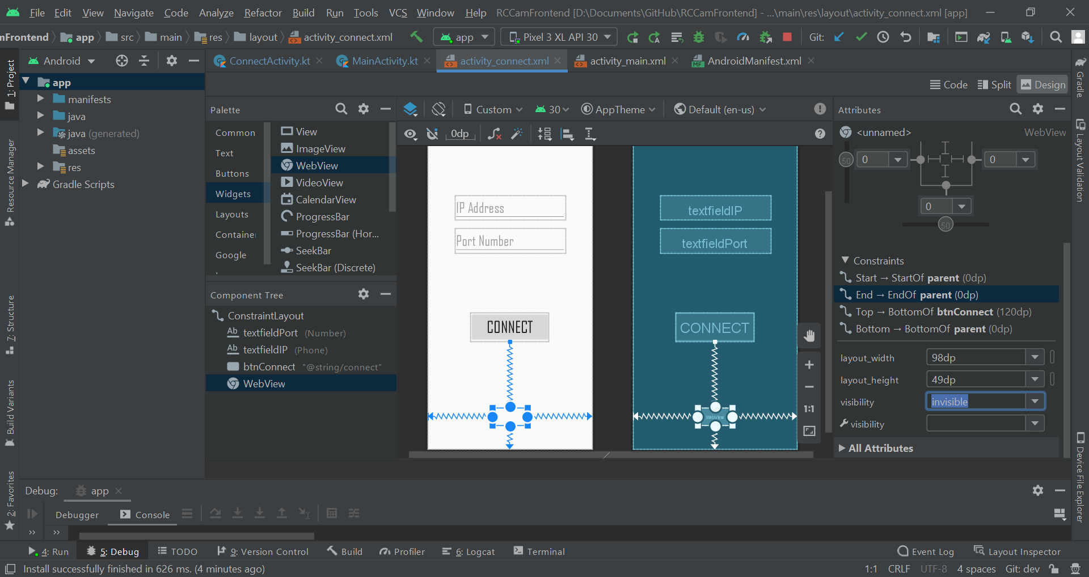

I set the webview to invisible and rebooted the app.

#### GUI

Everything worked as intended so I decided to now add the rest of the base for the main GUI. This meant adding the following buttons - shutter, rotation and face detection. I used an “ImageButton” component for all three of these and removed the temporary button. I had to add the mockup button designs from a while back to the res/drawable dir in order to use them for the button images. These were hopefully only temporary because they didn’t look that great but functionality comes first.

I then realised that for whatever reason I had only saved a higher resolution version of the face detection button. So, I quickly grabbed up the mock up buttons for the other two from the GUI PNG. I also made sure to initialise LFS in the Git repo otherwise I would be increasing the amount of storage used by a decent amount everytime I changed one of those PNGs. Now, this GUI isn’t the nicest thing I’ve ever made - far from it actually. But functionality over form is currently top priority. I also had to refactor the names of all of the images I was using since they had uppercase characters. Somehow doing this completely broke the images so I added them back with the correct names.

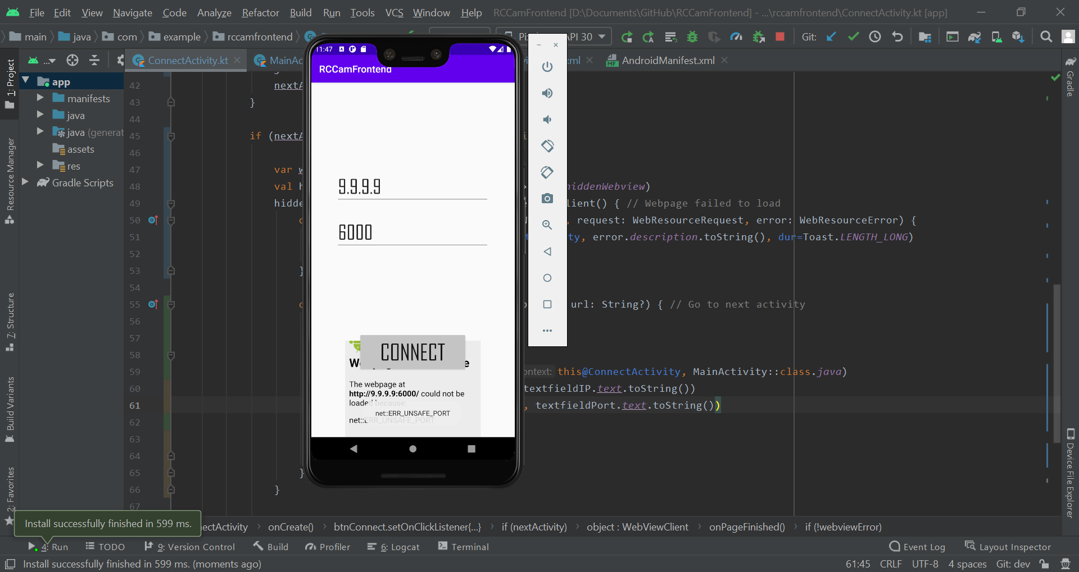

I then decided to fix up the bottom navigation bar using the [documentation](https://developer.android.com/reference/com/google/android/material/bottomnavigation/BottomNavigationView). I first removed the existing images and created vector images for all of the buttons.

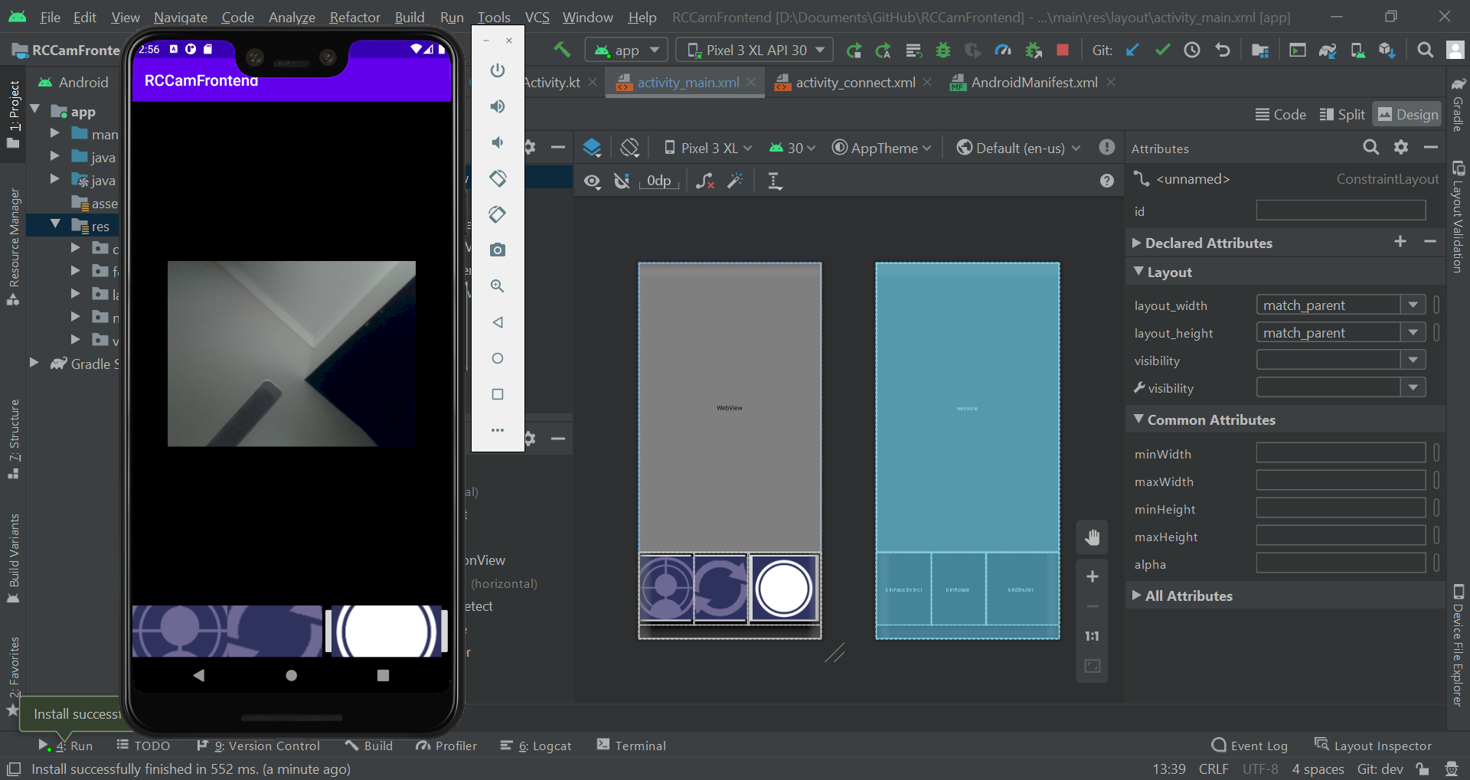

I then spent a long time trying to get it functional while looking somewhat decent and completely forgot to write stuff down about it here. I did take an image with the default colours however and remember creating a navigation XML file in res/menu

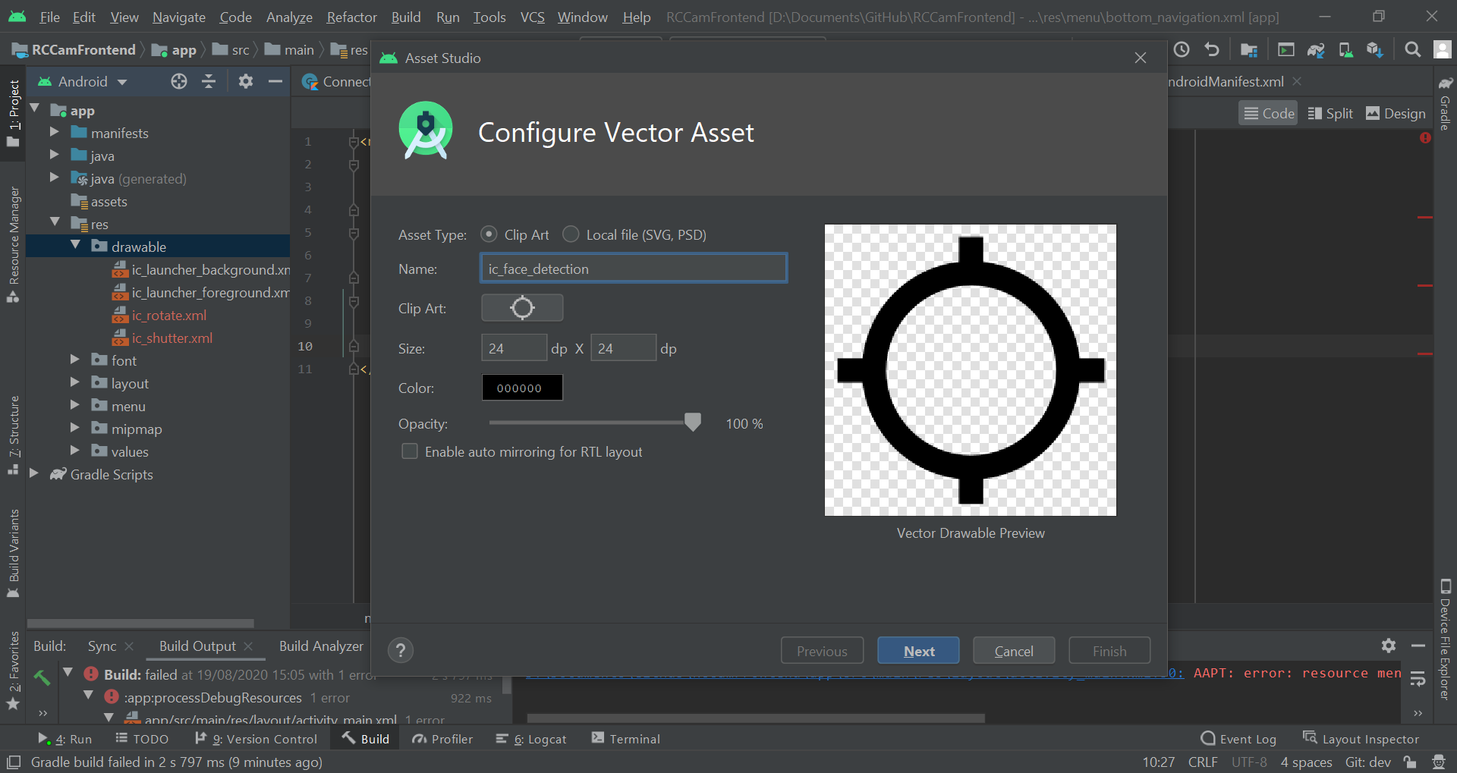

I then added all of the custom colours to the incorrectly spelt “colors” XML files for all of the colours I will be using which were mentioned in the design GUI phase. I then modified all of the current used colours to make the app a lot more bearable to look at.

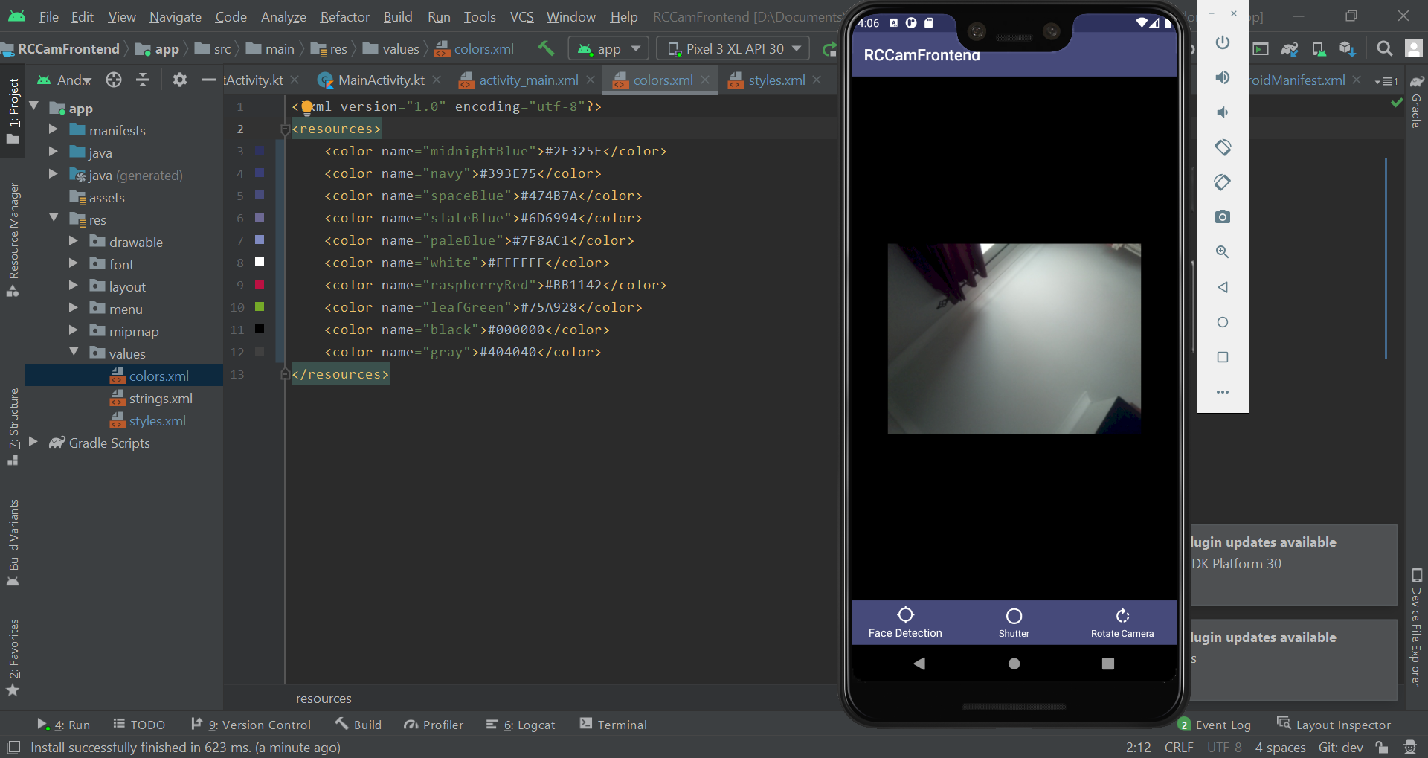

#### Connect Bug

I had for some time been realising that the connect button wasn’t working properly and you needed to click it multiple times for it to work - such a fun bug. I decided to try and give it a go to fix it and first set the invisible connect GUI webview to be visible. I tried connecting to my website and saw the website load straight away. I added a toast to the “onPageFinished” event to see if it was firing properly.

|  |
| --- |
| override fun onPageFinished(view: WebView?, url: String?) { // Go to next activity  super.onPageFinished(view, url)  generateToast(this@ConnectActivity, webviewError.toString()) |

For whatever reason, the event wasn’t firing every time I clicked connect. I checked the code and realised that the cause could be the flask server itself. The server isn’t coded with threading in mind so when the program enters the live video feed it stays in the loop and therefore the website shows it hasn’t finished loading. So, I booted up Pycharm to begin working on a fix for that. I have two options - asyncio and the generic threading lib. Asyncio is more powerful but I’ve never had to use it outside of creating aysnc functions and awaiting specific lines of code.

I first found that there is prebuilt threading for Flask which can be enabled with a simple flag

|  |
| --- |
| web_app.run("0.0.0.0", threaded=True) |

This however didn’t fix the issue. I tried some other things but realised that this isn’t top priority and that I can come back to it later.

### Splash Screen

I decided to now work on a Splash screen and found a useful [tutorial](https://abhiandroid.com/programming/splashscreen) as well as this [section](https://developer.android.com/topic/performance/vitals/launch-time#themed) in the documentation. I started by creating a new activity called “SplashScreen” and then configuring the manifest to run that activity on startup. I then added in a bit of code to wait a few seconds and then swap to the connect activity.

|  |
| --- |
| class SplashScreen : AppCompatActivity() {  override fun onCreate(savedInstanceState: Bundle?) {  super.onCreate(savedInstanceState)  setContentView(R.layout.activity_splash_screen)   supportActionBar?.hide()   Handler(Looper.getMainLooper()).postDelayed({  val intent = Intent(this, ConnectActivity::class.java)  startActivity(intent)  }, 3000)  } } |

I then created a new SVG and ported across my mockup Splash screen from the design phase. I then tried importing this into the res/drawables directory in the project. However, for some reason it wasn’t recognised as a proper SVG - I blame the SVG paint.net plugin I was using. Apparently, Inkscape supports SVG files primarily so I decided to download that software and create the Splash Screen there. However, I realised that it would be a lot easier if I just set a background colour and put the splash screen elements on top.

I first changed the background colour to space blue.

|  |
| --- |
| android:background="@color/spaceBlue" |

I then used Inkscape to convert my existing logo into the SVG format and tried adding it to res/drawables. However, the image was apparently “incomplete”. I decided to just spend some time completely recreating the logo. I realised I didn’t have anywhere near the amount of knowledge or skill for SVG art so I decided to just use the PNG logo instead. I imported this PNG as well as the Gill Sans MT font.

After doing a lot of touch ups I found that the RCPI Cam text was cut off for smaller screens. I added 10sp horizontal padding to fix this. I also added a duplicate black text behind to get the desired effect for the font. However, when I ran the program, my logo was blurry despite it now being blurry in the editor.

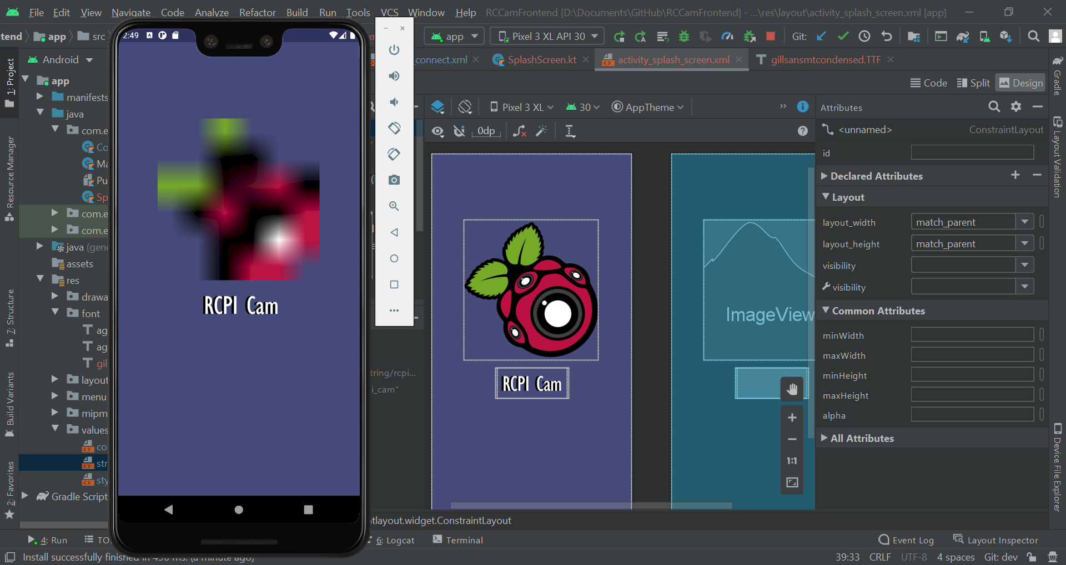

I then decided to re-add the image to the folder and choose “Medium density” instead of “Any Density”. This somehow fixed the image and it wasn’t blurry anymore.

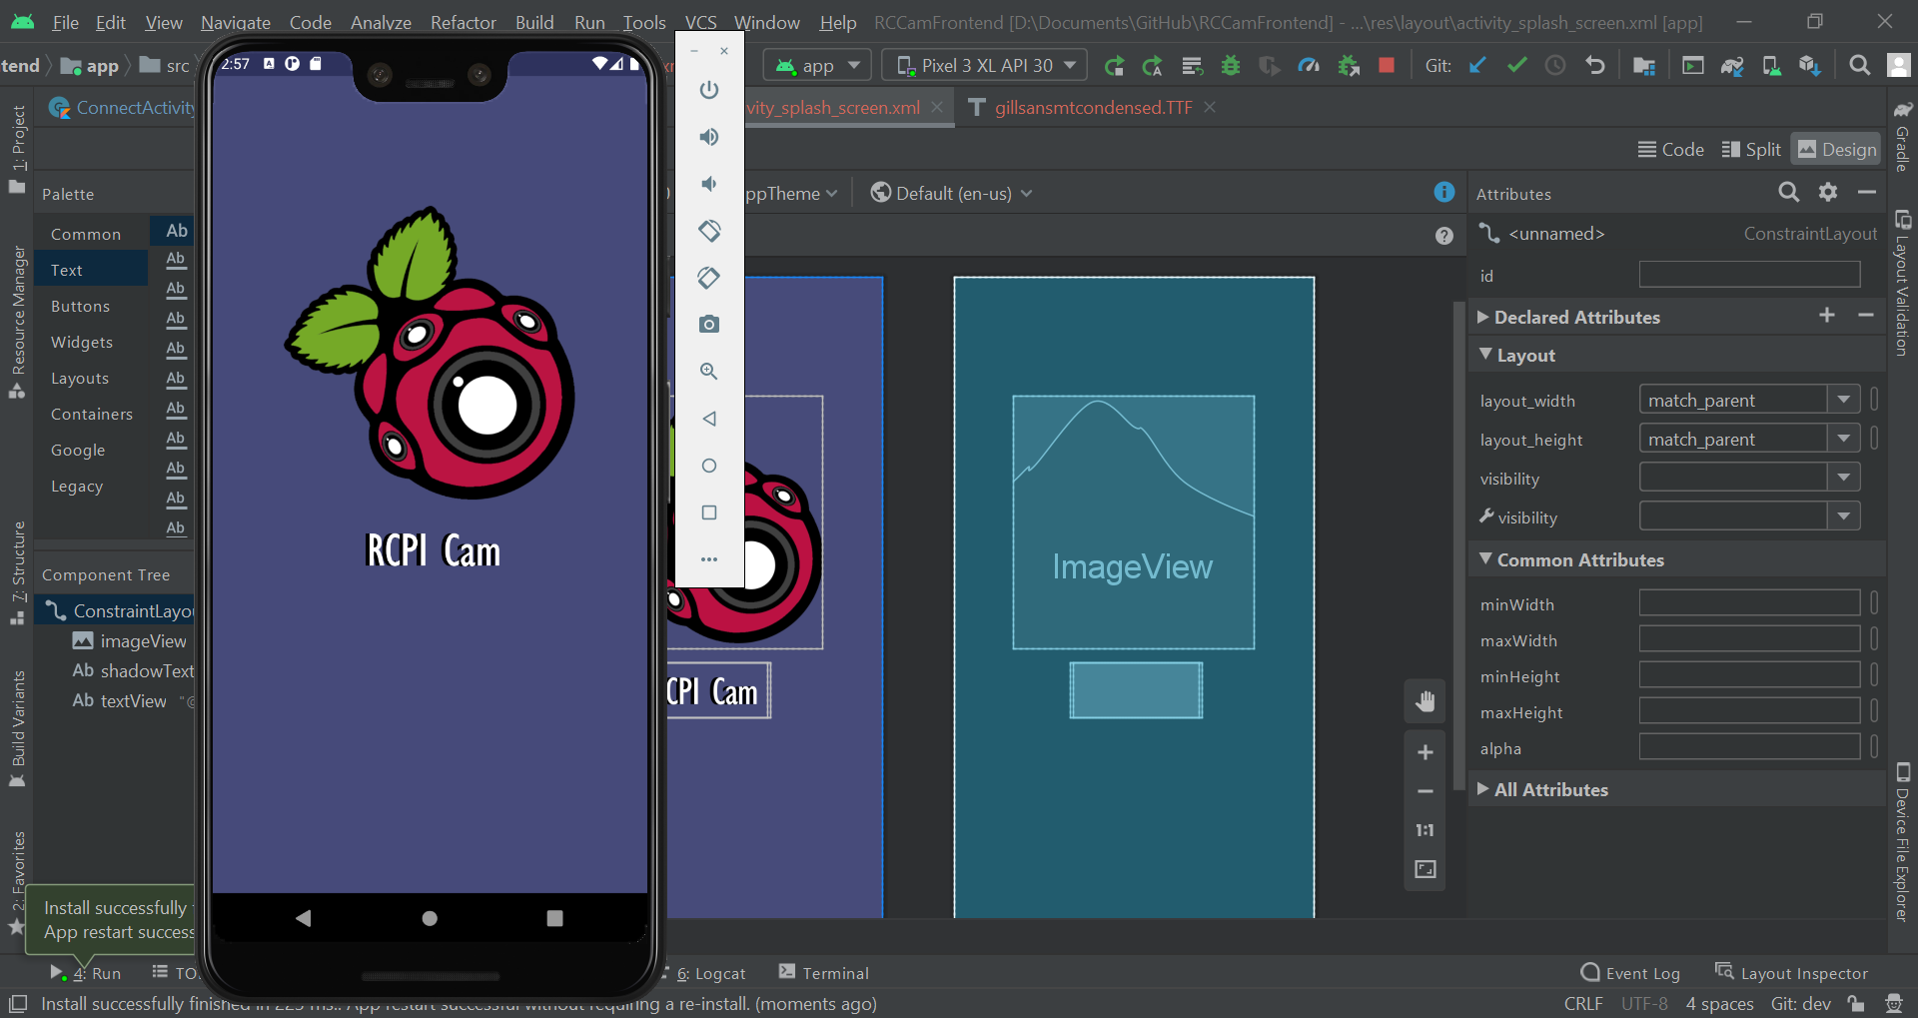

There were two issues. For one, you could press the back button to view the splash screen after it finished. The other issue was the transition - it was nasty. I found that there’s an XML attribute called noHistory that should hopefully fix the first issue. I added this to the manifest file under the splash screen activity. This fixed that issue entirely.

|  |
| --- |
| android:noHistory="true" |

Now, to handle the animation issue. It turns out that there’s a [Transition manager](https://developer.android.com/training/transitions/start-activity) built in to Android. I read through it which took a while (like most of this coursework) and settled on the following code.

|  |
| --- |
| Handler(Looper.getMainLooper()).postDelayed({  val intent = Intent(this, ConnectActivity::class.java)   window.exitTransition = Fade()  startActivity(intent, ActivityOptions.makeSceneTransitionAnimation(this).toBundle())  }, 3000) |

I then realised that I had done most of module 1 - asides from a few small issues that aren’t top priority right now. So, I decided I would move on to module 2 and come back to clean things up later.

### Module Evaluation

|  |  |  |  |
| --- | --- | --- | --- |
| **Module** | **Criteria** | **Justification** | **Priority** |
| **Main Interface** | 1.1 - Connect GUI | The interface provides an easy way for the user to connect to the RPI without having to set up the software to only be able to connect to a single RPI. | **High** |
| 1.2 - Connect to RPI | Allows the user to connect to the RPI so that the app can send requests and receive data such as the live video feed and images. | **High** |
| 1.3 - Main GUI | This interface appears after the Connect GUI screen and will allow the user to interact with the camera. It will have buttons for taking photos, rotating the camera, centring the camera on a face and accessing the submenu. | **High** |
| 1.4 - Live Camera Feed | The main portion of the screen will display a live camera feed from the RPIs camera. | **High** |

Module 1 has been completed with all of the success criteria features implemented successfully. Using the Android app, you can now connect to the RPI web server and be able to see a live video feed from the camera connected to the RPI. The Connect GUI also informs you of any invalid inputs such as absent data or erroneous data; 266.30.100 as the IP input for example would show a message to the user to inform them that it’s incorrect.

Despite meeting the success criteria, there are still some issues with the module as it stands. There exists a bug with the Connect GUI whereby pressing “Connect” with valid IP and Port won’t always take you to the next screen - most likely due to how the live video feed is returned to the user resulting in a state of always loading. This means that the event that is triggered when the web page is finished loading doesn’t get triggered most of the time when accessing the site which results in the app not going to the next screen. Repeatedly pressing the “Connect” button will eventually allow the user to continue to the next screen however.

The current state of the GUI also doesn’t reflect how it was originally designed - only partial colour elements and the locations of the interactable components are present.

These issues, while important, won’t be fixed now. They aren’t a necessity and can be worked on at a later point in time.

#### Issues

* Connect button doesn’t always take you to the next screen

## Module 2 - Camera Rotation

Module 2 is entirely focussed around the idea of rotating the camera through the modification of the rotation of the servos. This includes both rotating the camera mount manually or through detecting faces and using that to change the servos. I created all the necessary cards on the Trello for this module and then got to work.



### 2.1 - Rotate Camera

#### Snackbar Implementation

The first thing I decided to work on was 2.1, the manual camera rotation. The first thing I had to do was make the rotate button show a menu. I found in the documentation something called a context menu, however, I wasn’t sure whether I could add text inputs to it. I then found in the documentation something called a Snackbar which seemed like an overall better version of a Toast. So, I decided to create a function to easily generate and show them. It didn’t take long since it used similar syntax to Toasts except it took a view instead of context.

|  |
| --- |
| fun generateSnack(view: View, text: String, dur: Int = Snackbar.LENGTH_SHORT){  Snackbar.make(view, text, dur).show() } |

I then spent a while trying to figure out how to get the view class to pass to the function. I eventually stumbled across this [documentation](https://material.io/develop/android/components/snackbars) and then created the following code.

|  |
| --- |
| generateSnack(findViewById<View>(R.id.mainConstraint), "Loaded URL") |

It worked perfectly. I decided to swap out my generateToast calls for snackbars instead since it visually looks so much better.

|  |
| --- |
| val view = findViewById<View>(R.id.connectConstraint) generateSnack(view, "Enter an IP Address") // I did this for the other errors |

When I ran the code, I had an error. However, this was because I had left an empty call for generateSnack for some reason. I removed that line and then ran the program again. However, now only one error message was being displayed due to the nature of the snackbar. I decided to double check the documentation for anything builtin that could fix this. I couldn’t find anything so for a simple fix - since I was taking so long on this - I decided to just leave it as is.

#### Bottom Navbar Click Listener

After some more searching, I came across something called “[Action Dialogs](https://developer.android.com/guide/topics/ui/dialogs)” where a small menu would be brought up that I could easily customise the content of in XML. It supported buttons, sliders and edittext which was perfect. I then decided to quickly fix up the MainActivity onCreate method and move unnecessary code outside of the if statement.

|  |
| --- |
| val webview = findViewById<WebView>(R.id.webview) webview.webViewClient = object : WebViewClient() {  override fun onReceivedError (view: WebView, request: WebResourceRequest, error: WebResourceError) {  generateToast(this@MainActivity, error.description.toString(), dur=Toast.LENGTH_LONG)  } }  if (intent != null) {  webview.loadUrl("http://%s:%s/".format(  intent.getStringExtra("ip"),  intent.getStringExtra("port")))    generateSnack(findViewById<View>(R.id.mainConstraint), "Loaded URL") } |

I started by creating an XML layout file for the dialog and modifying their [example code](https://developer.android.com/guide/topics/ui/dialogs).

|  |
| --- |
| <?xml version="1.0" encoding="utf-8"?> <LinearLayout xmlns:android="http://schemas.android.com/apk/res/android"  android:orientation="vertical"  android:layout_width="wrap_content"  android:layout_height="wrap_content">  <EditText  android:layout_width="match_parent"  android:layout_height="wrap_content"  android:fontFamily="@font/gillsansmtcondensed"  android:hint="yaw" />  <EditText  android:layout_width="match_parent"  android:layout_height="wrap_content"  android:fontFamily="@font/gillsansmtcondensed"  android:hint="pitch"/> </LinearLayout> |

I then added a click listener for my bottom navigation and generated unique Snackbars for each to test if I had programmed it correctly.

|  |
| --- |
| val view = findViewById<View>(R.id.mainConstraint)  ~~  bottomNavigationBar.setOnClickListener{item ->  when(item.id) {  R.id.action_face_detection -> {  generateSnack(view, "Face Detection")  }  R.id.action_shutter -> {  generateSnack(view, "Shutter")  }  R.id.action_rotation -> {  generateSnack(view, "Rotation")  }  } } |

However, nothing happened when I pressed the buttons. So, I added an else in the when statement to see if it was an issue with the IDs.

|  |
| --- |
| else -> {  generateSnack(view, "TEST") } |

I then remembered that I had seen two listener methods and decided to check the documentation for the difference between them both. I couldn’t find anything specific for that in the documentation but there were other similar methods where a value has to be specified to work as a listener. After reading a bit more on it I found that there was a method called OnNavigationItemSelectedListener. I also realised that you could specify private values outside of the onCreate method which heavily reduced clutter inside of that method.

|  |
| --- |
| class MainActivity : AppCompatActivity() {  private val webview = findViewById<WebView>(R.id.webview)  private val view = findViewById<View>(R.id.mainConstraint)   override fun onCreate(savedInstanceState: Bundle?) {  super.onCreate(savedInstanceState)  setContentView(R.layout.activity_main)   webview.webViewClient = object : WebViewClient() {  override fun onReceivedError (view: WebView, request: WebResourceRequest, error: WebResourceError) {  generateToast(this@MainActivity, error.description.toString(), dur=Toast.LENGTH_LONG)  }  }   bottomNavigationBar.setOnNavigationItemReselectedListener{ item ->  when(item.itemId) {  R.id.action_face_detection -> {  generateSnack(view, "Face Detection")  }  R.id.action_shutter -> {  generateSnack(view, "Shutter")  }  R.id.action_rotation -> {  generateSnack(view, "Rotation")  }  else -> {  generateSnack(view, "TEST")  }  }  }   if (intent != null) {  webview.loadUrl("http://%s:%s/".format(  intent.getStringExtra("ip"),  intent.getStringExtra("port")))   generateSnack(view, "Loaded URL")  }  }  } |

When I ran my app again it crashed and didn’t output any errors - there may have been some in logcat but it was outputting a lot of irrelevant data. I temporarily removed the listener to see if that was the issue and restarted the app. It wasn’t. I then removed the private webview value since I realised it was redundant and moved the private view value into the onCreate method. This worked so it seemed as if I had done something wrong in creating a private value inside that area. I decided to just move on.

When I ran the program again it didn’t crash and when I double clicked one of the nav elements, it prompted the snackbar. However, I didn’t want to have to double press one of those buttons. I double checked my code and found that I was using the setOnNavigationItemReselectedListener instead of setOnNavigationItemSelectedListener. When I fixed this, Android Studio then spewed a lot of errors over my existing generateSnackbar code stating I should be returning a bool value.

I fixed up the code to also return a true bool value if one of the nav elements were pressed and false if otherwise.

|  |
| --- |
| bottomNavigationBar.setOnNavigationItemSelectedListener{ item ->  when(item.itemId) {  R.id.action_face_detection -> {  generateSnack(view, "Face Detection")  return@setOnNavigationItemSelectedListener true  }  R.id.action_shutter -> {  generateSnack(view, "Shutter")  return@setOnNavigationItemSelectedListener true  }  R.id.action_rotation -> {  generateSnack(view, "Rotation")  return@setOnNavigationItemSelectedListener true  } else -> {  return@setOnNavigationItemSelectedListener false  }  } } |

This fixed the issue I was having and now I could work on a menu for the Rotation button.

#### Rotation Menu

I read up on the Dialog docs again since I had just spent a while figuring out how to get a listener for the navbar working. After a while I figured out how to create an Alert with just two buttons.

|  |
| --- |
| val alertBuilder = AlertDialog.Builder(this) alertBuilder.apply{  setPositiveButton("test") {_, _ ->  generateToast(this@MainActivity, "Positive")  }  setNegativeButton("test") {_, _ ->  generateToast(this@MainActivity, "Negative")  } } |

When I ran the code, nothing happened. I checked the docs and found I had forgotten to include a create method to actually show the menu. I fixed up my code to include this.

|  |
| --- |
| val alertBuilder: AlertDialog.Builder = AlertDialog.Builder(this) alertBuilder.apply{  setPositiveButton("pos") {_, _ ->  generateToast(this@MainActivity, "Positive")  }  setNegativeButton("neg") {_, _ ->  generateToast(this@MainActivity, "Negative")  } }  ~~  R.id.action_rotation -> {  generateSnack(view, "Rotation")  alertBuilder.create()  return@setOnNavigationItemSelectedListener true |

However, nothing still happened when I clicked the rotation button and the only error I was getting in console was to do with Chromium exceeding tile memory which wasn’t helpful at all. I checked the documentation again and noticed that they used the setTitle and setMessage methods. I tried adding those to see if that was the reason my action dialog wasn’t showing.

|  |
| --- |
| alertBuilder  .setTitle("TITLE")  .setMessage("MESSAGE")  .apply{  setPositiveButton("pos") {_, _ ->  generateToast(this@MainActivity, "Positive")  }  setNegativeButton("neg") {_, _ ->  generateToast(this@MainActivity, "Negative")  }  } |

But still, nothing. I then searched the documentation to check if there was something wrong with the create method and found [this](https://developer.android.com/reference/android/app/AlertDialog.Builder#show()). A show method. So not only did I have to create a dialog, which I guessed was their way of instantiating it, I had to also tell Android to display it. Just to make sure I wasn’t being completely incorrect, I checked the [“create” method](https://developer.android.com/reference/android/app/AlertDialog.Builder#create()). It stated that I could just use show instead if no additional processing was required. So, I removed the create method and replaced it with show instead.

|  |
| --- |
| alertBuilder.show() |

This actually fixed it. The entire time I was just supposed to use the show method instead. They didn’t even bother to put this in the overview of dialogs. Anyway, the code now prompted it to show.

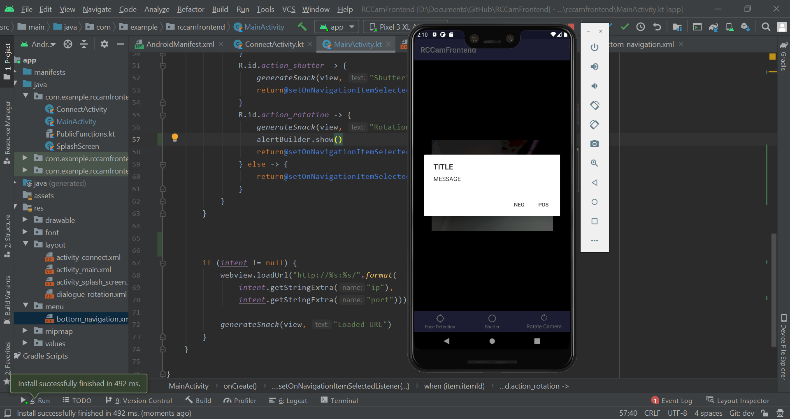

I decided to fix up the action dialog to be more representative of what it’s actually supposed to be. I removed the message, changed the title and the two button names.

|  |
| --- |
| alertBuilder  .setTitle("Set Rotation")  .apply{  setPositiveButton("Confirm") {_, _ ->  generateToast(this@MainActivity, "Positive")  }  setNegativeButton("Cancel") {_, _ ->  generateToast(this@MainActivity, "Negative")  }  } |

This changed the dialog to what you can see below.

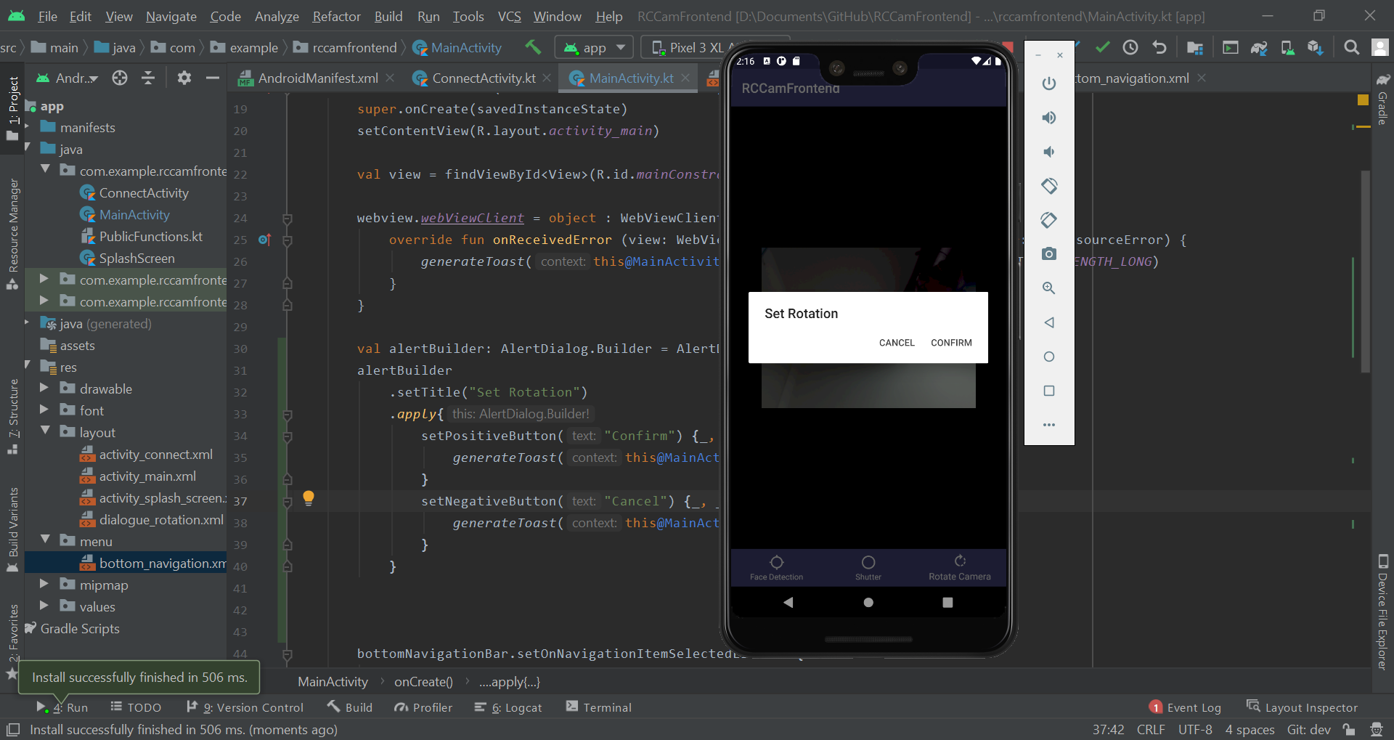

I then wanted to apply the layout I had created a while back so I checked the documentation and added the following code.

|  |
| --- |
| val alertBuilder = AlertDialog.Builder(this) alertBuilder  .setTitle("Set Rotation")  .setView(this.layoutInflater.inflate(R.layout.dialogue_rotation, null))  .apply{  setPositiveButton("Confirm") {_, _ ->  generateToast(this@MainActivity, "Positive")  }  setNegativeButton("Cancel") {_, _ ->  generateToast(this@MainActivity, "Negative")  }  } |

Android Studio was giving me a warning about sending a null value despite the overview stating to do so. I checked Stack overflow and found [this answer](https://stackoverflow.com/questions/24832497/avoid-passing-null-as-the-view-root-need-to-resolve-layout-parameters-on-the-in) which told me to replace the null value with parent and including a false. However, this caused more issues. I looked around some more and just decided to see what would happen if I passed null. It did load properly but when I clicked off it and tried to load it again the app crashed. I commented out the line I had just added to see if that was the reason why and rebooted the app.

There were no issues when I commented out that line. So, it was time to spend a while trying to figure out what to pass through the method. I started by checking the value it was expecting - a ViewGroup. I then checked what that was. I then tried to get the root view and send it using the following code.

|  |
| --- |
| .setView(this.layoutInflater.inflate(R.layout.dialogue_rotation, findViewById(R.id.content), false)) |

This worked without errors but my dialog was still causing crashes the second time I tried to show it. I felt as if it had to do with how Android creates the dialog so I checked on Stack overflow and found [this](https://stackoverflow.com/questions/16307445/why-does-alertdialog-dialog-show-crash-the-second-time-through). Neither of the answers had been upvoted or accepted but I tried to follow the advice of the first answer. Before I did this, I tried removing the apply method to see if that was the reason.

|  |
| --- |
| alertBuilder  .setTitle("Set Rotation")  .setView(this.layoutInflater.inflate(R.layout.dialogue_rotation, findViewById(R.id.content), false))  .setPositiveButton("Confirm") {_, _ ->  generateToast(this@MainActivity, "Positive")  }  .setNegativeButton("Cancel") {_, _ ->  generateToast(this@MainActivity, "Negative")  } |

The app still crashed. I then followed their advice and moved the entirety of the alertBuilder inside of where I was showing it.

|  |
| --- |
| R.id.action_rotation -> {  generateSnack(view, "Rotation")  val alertBuilder = AlertDialog.Builder(this)  alertBuilder  .setTitle("Set Rotation")  .setView(this.layoutInflater.inflate(R.layout.dialogue_rotation, findViewById(R.id.content), false))  .setPositiveButton("Confirm") {_, _ ->  generateToast(this@MainActivity, "Positive")  }  .setNegativeButton("Cancel") {_, _ ->  generateToast(this@MainActivity, "Negative")  }  alertBuilder.show()  return@setOnNavigationItemSelectedListener true |

This fixed it. How do people make Android apps for a living with this many niche issues. I then decided to polish up the layout and address some of the warnings in it. I started by addressing the autofill warning and set it to not use autofill. I then fixed the hardcoded string warning by putting the string inside of the values file. I finally set the input type as a number for both. My idea for simplifying the system was to use the current scale multiplied by 10. So, the largest value would go from 12.9 (if I remember it correctly) to 129.

I also changed the font to the basic one since my custom font didn’t fit and also added some margins to make it look a lot nicer.

|  |
| --- |
| <EditText  android:layout_width="match_parent"  android:layout_height="wrap_content"  android:fontFamily="sans-serif"  android:hint="@string/yaw"  android:importantForAutofill="no"  android:inputType="number"  android:layout_marginTop="30dp"  android:layout_marginBottom="5dp"  android:layout_marginLeft="20dp"  android:layout_marginRight="20dp" />  <EditText  android:layout_width="match_parent"  android:layout_height="wrap_content"  android:fontFamily="sans-serif"  android:hint="@string/pitch"  android:importantForAutofill="no"  android:inputType="number"  android:layout_marginTop="5dp"  android:layout_marginBottom="5dp"  android:layout_marginLeft="20dp"  android:layout_marginRight="20dp" /> |

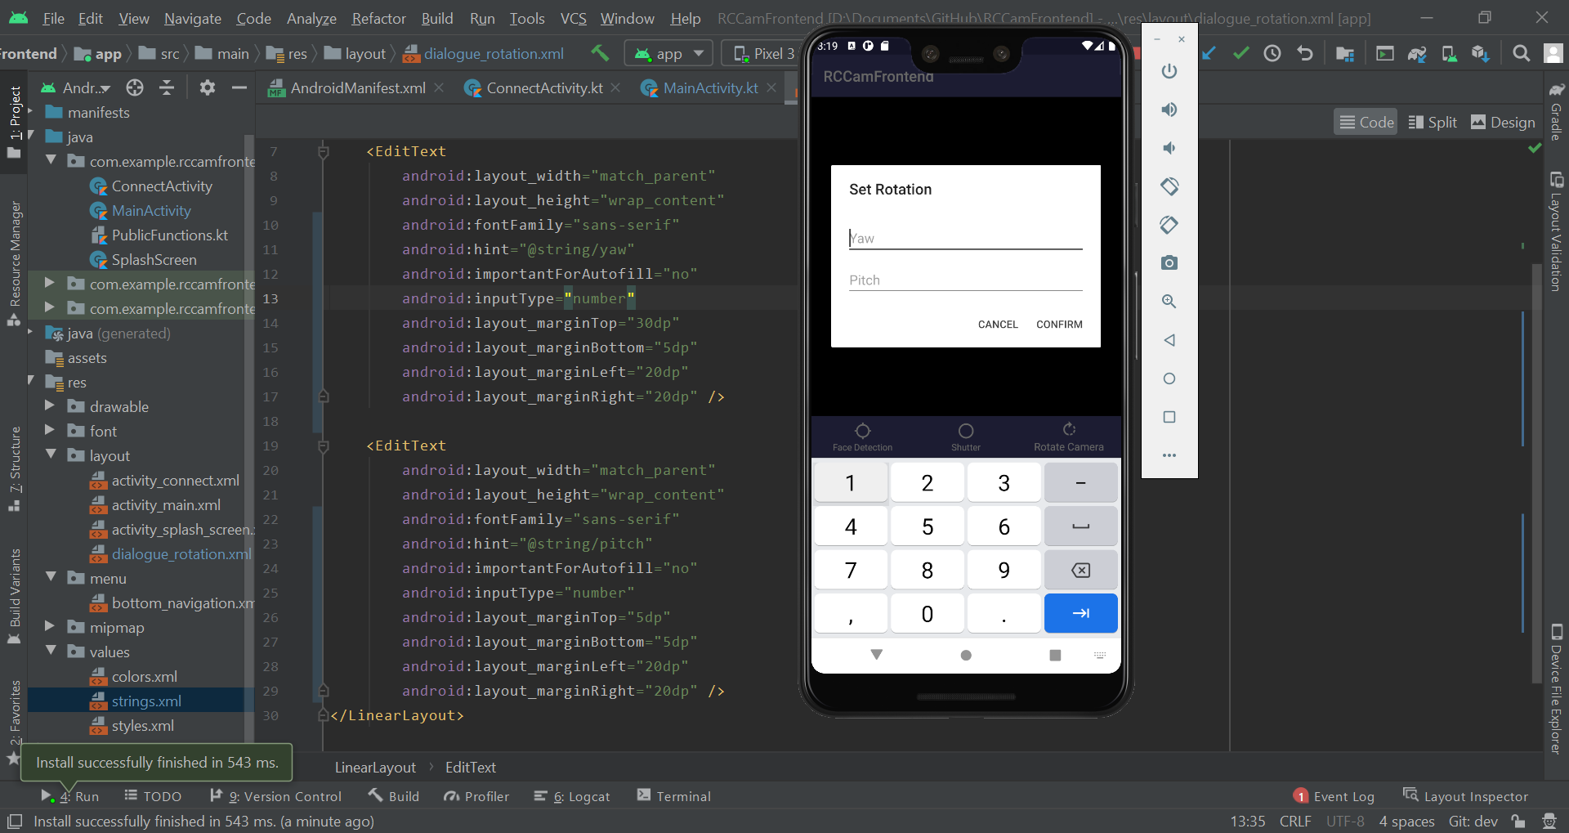

I then changed a bit of the code for the click methods for both the buttons.

|  |
| --- |
| .setPositiveButton("Confirm") {_, _ ->  generateSnack(view, "Confirm code here") } .setNegativeButton("Cancel") {_, _ ->  // Do nothing - Android auto dismisses } |

I then went about trying to design buttons to the left and right of the text fields for incrementation and decrementation. I created 4 new buttons, 2 for each of the text fields. I then added two new horizontal layout managers to contain 2 buttons and a textview each. When I ran the program, I saw that the buttons were way bigger than the textview. I changed a few things such as their layout height and width.

|  |
| --- |
| <?xml version="1.0" encoding="utf-8"?> <LinearLayout xmlns:android="http://schemas.android.com/apk/res/android"  android:orientation="vertical"  android:layout_width="wrap_content"  android:layout_height="wrap_content">   <LinearLayout  android:layout_width="match_parent"  android:layout_height="match_parent"  android:orientation="horizontal"  android:layout_marginLeft="20dp"  android:layout_marginTop="30dp"  android:layout_marginRight="20dp"  android:layout_marginBottom="5dp">   <Button  android:id="@+id/btnYawPlus"  android:layout_width="wrap_content"  android:layout_height="wrap_content"  android:layout_weight="1"  android:text="@string/btnPlus" />   <Button  android:id="@+id/btnYawMinus"  android:layout_width="wrap_content"  android:layout_height="wrap_content"  android:layout_weight="1"  android:text="@string/btnMinus" />   <EditText  android:layout_width="wrap_content"  android:layout_height="wrap_content"  android:layout_weight="2"  android:fontFamily="sans-serif"  android:hint="@string/yaw"  android:importantForAutofill="no"  android:inputType="number" />   </LinearLayout>   <LinearLayout  android:layout_width="match_parent"  android:layout_height="match_parent"  android:orientation="horizontal"  android:layout_marginLeft="20dp"  android:layout_marginTop="5dp"  android:layout_marginRight="20dp"  android:layout_marginBottom="5dp">   <Button  android:id="@+id/btnPitchPlus"  android:layout_width="wrap_content"  android:layout_height="wrap_content"  android:layout_weight="1"  android:text="@string/btnPlus" />   <Button  android:id="@+id/btnPitchMinus"  android:layout_width="wrap_content"  android:layout_height="wrap_content"  android:layout_weight="1"  android:text="@string/btnMinus" />   <EditText  android:layout_width="wrap_content"  android:layout_height="wrap_content"  android:layout_weight="2"  android:fontFamily="sans-serif"  android:hint="@string/pitch"  android:importantForAutofill="no"  android:inputType="number" />   </LinearLayout> </LinearLayout> |

However, the button was still huge despite the wrap content. I then searched and found this stack overflow question for reducing a button's size. One of the answers mentioned a minHeight XML attribute. I added a minWidth to see if this would fix this.

|  |
| --- |
| android:minWidth="0dp" |

Still this didn’t fix it. I then tried reducing the padding on the left and right side of the button - I presumed there was a default value set for this.

|  |
| --- |
| android:paddingStart="0dp" android:paddingEnd="0dp" |

This fixed the issue for one button so I applied the three attributes to all of the buttons. The buttons still seemed a bit too big so I tried increasing the layout_weight for one of the textviews. This fixed the issue I was having so I applied it to the other textview.

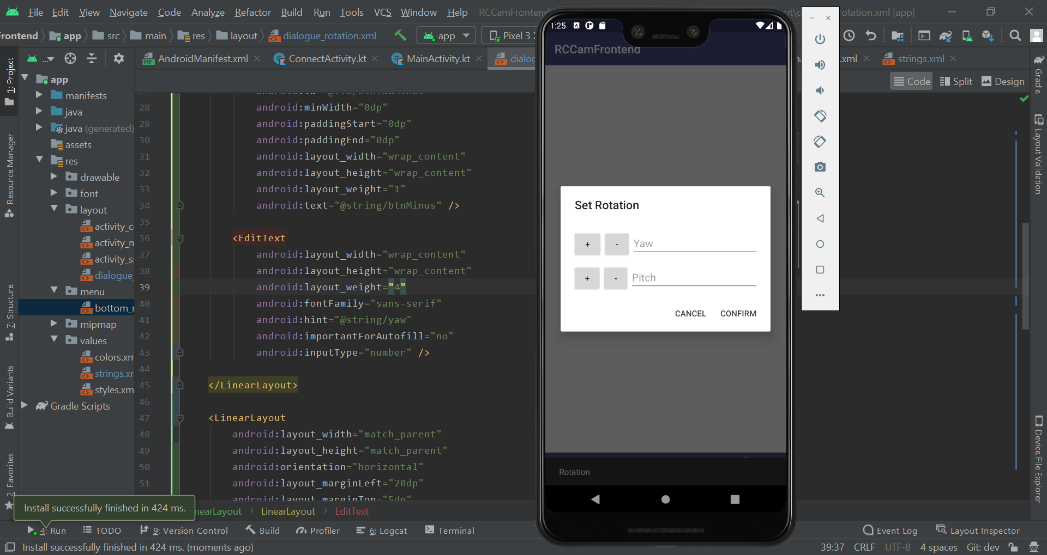

I then got to work adding functionality to the rotation confirmation itself. With the current system of sending data to the RPI, all I had to do was append the rotation values to the end of the current URL. Sounds easy right? Nothing is easy in Android development if you’ve never done it before. I spent a while trying to figure out how to get the text input from the Yaw and Pitch textfields. I started with the following but was getting an error since the text attribute didn’t exist.

|  |
| --- |
| val textfieldPitch = findViewById<View>(R.id.textfieldPitch) val textfieldYaw = findViewById<View>(R.id.textfieldYaw) textfieldPitch.text.toString() |

After a long while I changed the View to TextView and everything worked fine because of course it did. I then changed the values to the following for simplicity.

|  |
| --- |
| val textfieldPitchData = findViewById<TextView>(R.id.textfieldPitch).text.toString() val textfieldYawData = findViewById<TextView>(R.id.textfieldYaw).text.toString() |

I then added the following lines to figure out what data type would be stored if I passed nothing into the text views.

|  |
| --- |
| println(textfieldPitchData) println(textfieldYawData) |

My app instead decided to crash after I clicked confirm. I attached the debugger to figure out what line caused this. It was because the ID I believe was null. To confirm this, I removed the text attribute and the to string method to see if it still crashed. The output showed that both of the attempts to retrieve the textfields returned null. I tried replacing the TextView with View to see if I got a different result. Still, no luck. I found this [Stack Overflow answer](https://stackoverflow.com/questions/13663878/how-to-get-data-from-a-custom-dialog-box) but it didn’t help. I then found this [article](https://www.dev2qa.com/android-custom-layout-alertdialog-example/) which, after inspecting the code, set the view as a value and used that to retrieve the textviews.

|  |
| --- |
| val dialogView = this.layoutInflater.inflate(R.layout.dialogue_rotation, findViewById(R.id.content), false)  ~~  .setView(dialogView) .setPositiveButton("Confirm") {_, _ ->  val textfieldPitchData = dialogView.findViewById<TextView>(R.id.textfieldPitch)  val textfieldYawData = dialogView.findViewById<TextView>(R.id.textfieldYaw)   println(textfieldPitchData)  println(textfieldYawData) |

This time, the output wasn’t null so I tried to grab the text. I also tried to see if doing something else would work so that I wouldn’t have to grab the widgets by their IDs.

|  |
| --- |
| generateToast(this, textfieldPitchData.text.toString()) generateToast(this, textfieldPitch.text.toString()) |

The second line of code caused some issues so I removed it. I then moved the URL into a private variable and created the following code:

|  |
| --- |
| private var url = ""  ~~  // <ip>/?p=int&y=int // URL Arg Logic if (textfieldPitchData != ""){ // Pitch arg supplied  url += "?p=%s"  if (textfieldYawData != ""){ // Both args supplied  url += "&y=%s"  } } else if (textfieldYawData != ""){ // Just yaw arg supplied  url += "?y=%s" }  webview.loadUrl(url)  ~~  if (intent != null) {  url = "http://%s:%s".format(  intent.getStringExtra("ip"),  intent.getStringExtra("port"))  webview.loadUrl(url) |

However, when I ran the code and inputted values, the webpage just reloaded. So, I decided to check the URL I was going to.

|  |
| --- |
| generateToast(this, url) |

The toast that generated showed the following:

“http://(IP REDACTED)?p=%s&y=%s”

I had been forgotten to use the format method to concatenate the strings and was missing a forward slash. This was a simple fix so I fixed up the code and tried again.

|  |
| --- |
| // <ip>/?p=int&y=int // URL Arg Logic if (textfieldPitchData != ""){ // Pitch arg supplied  url += "/?p=%s".format(textfieldPitchData)  if (textfieldYawData != ""){ // Both args supplied  url += "&y=%s".format(textfieldYawData)  } } else if (textfieldYawData != ""){ // Just yaw arg supplied  url += "/?y=%s".format(textfieldYawData) } |

When I inputted values, the servos updated and the video feed flashed as expected - the webpage had to reload after all. After I inputted more values however, there was a noticeable issue. I never reset the URL to the original which could cause a lot of issues for the servo. A simple fix was to just use a different variable for updating the servo.

|  |
| --- |
| // <ip>/?p=int&y=int // URL Arg Logic var servoUrl = url if (textfieldPitchData != ""){ // Pitch arg supplied  servoUrl += "/?p=%s".format(textfieldPitchData)  if (textfieldYawData != ""){ // Both args supplied  servoUrl += "&y=%s".format(textfieldYawData)  } } else if (textfieldYawData != ""){ // Just yaw arg supplied  servoUrl += "/?y=%s".format(textfieldYawData) }  webview.loadUrl(servoUrl) generateToast(this, servoUrl) |

This fixed the issue and now I could rotate the servos from within the app! Only issue was the incrementation and decrementation buttons weren’t functional, there wasn’t input sanitisation, there wasn’t input validation or any limits to the values you could enter. However, I got the base working. I removed the generateToast call and added another method to the dialog. I then added a condition for checking if any data was actually passed.

|  |
| --- |
| // <ip>/?p=int&y=int // URL Arg Logic var servoUrl = url if (textfieldPitchData != "" || textfieldYawData != ""){  if (textfieldPitchData != ""){ // Pitch arg supplied  servoUrl += "/?p=%s".format(textfieldPitchData)  if (textfieldYawData != ""){ // Both args supplied  servoUrl += "&y=%s".format(textfieldYawData)  }  } else if (textfieldYawData != ""){ // Just yaw arg supplied  servoUrl += "/?y=%s".format(textfieldYawData)  }   webview.loadUrl(servoUrl) } |

I then grabbed all of the references to the incrementation and decrementation buttons so I could implement functionality into them.

|  |
| --- |
| // Getting incrementation and decrementation buttons val btnYawPlus = dialogView.findViewById<Button>(R.id.btnYawPlus) val btnYawMinus = dialogView.findViewById<Button>(R.id.btnYawMinus) val btnPitchPlus = dialogView.findViewById<Button>(R.id.btnPitchPlus) val btnPitchMinus = dialogView.findViewById<Button>(R.id.btnPitchMinus) |

I then added on click listeners for every button and modified how I got the text views.

|  |
| --- |
| // Getting text fields val textfieldYaw = dialogView.findViewById<TextView>(R.id.textfieldYaw) val textfieldPitch = dialogView.findViewById<TextView>(R.id.textfieldPitch)  ~~  btnYawPlus.setOnClickListener { // Increment btnYaw   }  btnYawMinus.setOnClickListener { // Decrement btnYaw  }  btnPitchPlus.setOnClickListener { // Increment btnPitch  }   btnPitchMinus.setOnClickListener{ // Decrement btnPitch  }  ~~  .setPositiveButton("Confirm") {_, _ ->  val textfieldPitchData = textfieldPitch.text.toString()  val textfieldYawData = textfieldYaw.text.toString() |

I then started to create a function that would increment a text view by a given integer. This didn’t take long to code because Kotlin is actually brilliant and this was fairly easy to implement into the on click listeners.

|  |
| --- |
| fun incrementTextView(view: TextView, amount: Int){  val intText = Integer.parseInt(view.text.toString())  view.text = (intText + amount).toString() }  ~~  btnYawPlus.setOnClickListener { // Increment btnYaw  incrementTextView(textfieldYaw, 1) }  btnYawMinus.setOnClickListener { // Decrement btnYaw  incrementTextView(textfieldYaw, -1) }  btnPitchPlus.setOnClickListener { // Increment btnPitch  incrementTextView(textfieldPitch, 1) }  btnPitchMinus.setOnClickListener{ // Decrement btnPitch  incrementTextView(textfieldPitch, -1) } |

The code worked and when I put a value in, the code would increment/decrement it dependent on the button I pressed. Unfortunately, I can’t show exactly what that looks like since I’m only using screenshots. One issue I was expecting was when no value was inputted but the user would try to increment/decrement using the buttons. This, expectedly, crashed the program. So, I decided to add a quick check into the function to see if any data was present.

|  |
| --- |
| fun incrementTextView(view: TextView, amount: Int){  if (view.text != ""){  val intText = Integer.parseInt(view.text.toString())  view.text = (intText + amount).toString()  } } |

For some reason the program still crashed. I then immediately realised while typing the previous sentence the reason why - I didn’t convert the char sequence from “view.text” into a string.

|  |
| --- |
| if (view.text.toString() != ""){  ... } |

This fixed the bug and the program didn’t crash if I pressed the increment/decrement button with no value in the text view. I decided to also swap the increment/decrement buttons because it made a lot more sense visually. The next thing I decided to work on was creating a filter to limit the value that could be inputted. I first found the documentation for [input filters](https://developer.android.com/reference/android/text/InputFilter). I then found an [example](https://stackoverflow.com/questions/30259294/how-to-filter-the-input-of-edittext) of how to use Input Filter on Stack Overflow as I couldn’t find one with the Android documentation and constructed my own.

|  |
| --- |
| var rotIntLimit = InputFilter { source, _, _, _, _, _ ->  val input = source.toString().toInt()  if (input > 13){  return@InputFilter "13"  } else if (input < 0){  return@InputFilter "0"  }  return@InputFilter null } |

In order to change an input you simply return what you want that input to be and null if you want to use the inputted text. When I tried to set the filter for a textview, I was getting a syntax error. I was supposed to be passing an array Input filter but was only supplying an Input filter.

|  |
| --- |
| textfieldPitch.filters = rotIntLimit |

The Java code within the Stack overflow example simply set the input filter to an array and my IDE prompted me to do the same.

|  |
| --- |
| // Setting filters for text views textfieldPitch.filters = arrayOf(rotIntLimit) textfieldYaw.filters = arrayOf(rotIntLimit) |

I then realised that my Android webview was extremely slow - I had recently given my RPI ethernet connection so my video stream was a lot smoother. On my web browser it was brilliant but on my Android emulator it was extremely laggy. So, I found a [Stack overflow answer](https://stackoverflow.com/questions/7422427/android-webview-slow) stating to add an attribute to my XML file.

|  |
| --- |
| android:hardwareAccelerated="true" |

I added this to the manifest file and it actually fixed the issue - why this isn’t enabled by default I don’t know. I read the documentation and found that it’s enabled by default if you set a minimum or target SDK version which I haven’t. Anyway, I decided to get back to work on the Input filters and test if they worked properly. It didn’t work - I could input as many values as I wanted but as soon as I tried to remove one, the app would crash. I attached the debugger and found this error message - java.lang.NumberFormatException: For input string: "". It seemed that I had completely misunderstood the arguments and that the source value is the current character inputted. So, in that case it was a backspace which cannot be converted to an integer.

I attached the debugger again and put a breakpoint within the filter to see what the arg values were. I then changed the arg names to something more legible and did the same thing again.

|  |
| --- |
| private val rotIntLimit = InputFilter { source, start, end, dest, dstart, dend ->  ... } |

After reading through the debugger and seeing how input values interact with the args, I decided to try and find an alternative where I can just get and set the text. I found an [event](https://developer.android.com/reference/android/widget/TextView#onTextChanged(java.lang.CharSequence,%20int,%20int,%20int)) which fires when the text within a textview is modified. I decided to remove all the previous code asides from the hardware acceleration and to start working with this event instead. I started by adding the following code but got an error.

|  |
| --- |
| textfieldPitch.doOnTextChanged() |

The error was Cannot inline bytecode built with JVM target 1.8 into bytecode that is being built with JVM target 1.6. Please specify proper '-jvm-target' option. I first updated the Gradle Kotlin version. I then found a [Stack overflow answer](https://stackoverflow.com/questions/48988778/cannot-inline-bytecode-built-with-jvm-target-1-8-into-bytecode-that-is-being-bui) and somehow it worked. I then read up on adding a text changed event and created the following.

|  |
| --- |
| // Setting value limit for text views textfieldPitch.doOnTextChanged { text, start, before, count ->  val textInt = text.toString().toInt()  if (textInt > 13){  textfieldPitch.text = getString(R.string.maxRot)  } else if (textInt < 0){  textfieldPitch.text = "0"  } }  textfieldYaw.doOnTextChanged { text, start, before, count ->  val textInt = text.toString().toInt()  if (textInt > 13){  textfieldYaw.text = getString(R.string.maxRot)  } else if (textInt < 0){  textfieldYaw.text = "0"  } } |

I then tested to see if it worked. When I inputted a value larger than 13 it did change the value to 13 and placed the cursor at the start. However, when I pressed backspace there was an error - I presumed due to converting to an integer. I changed the following code and attached a debugger.

|  |
| --- |
| val textInt = text.toString() print(textInt) |

I then realised when inputting values that the issue was when there was nothing in the textview and it was trying to convert that to an integer. So, I changed the code to be the following and change to an integer or a null value if it failed to cast.

|  |
| --- |
| // Setting value limit for text views textfieldPitch.doOnTextChanged { text, start, before, count ->  val textInt = text.toString().toIntOrNull()  if (textInt != null){  if (textInt > 13){  textfieldPitch.text = getString(R.string.maxRot)  } else if (textInt < 0){  textfieldPitch.text = "0"  }  } } |

I applied this to both of the text views and then tested again. Everything worked properly except the cursor moving which was annoying. I also realised the user couldn’t input a negative number but I decided to keep that code just in case. I also realised I was looking at textview instead of edittext the entire time so I changed to the right part of the documentation. In the documentation, I found setSelection which lets you change the cursor position.

|  |
| --- |
| // Getting textfields val textfieldYaw = dialogView.findViewById<EditText>(R.id.textfieldYaw) val textfieldPitch = dialogView.findViewById<EditText>(R.id.textfieldPitch)  ~~  // Setting value limit for text views textfieldPitch.doOnTextChanged { text, start, before, count ->  val textInt = text.toString().toIntOrNull()  if (textInt != null){  if (textInt > 13){  textfieldPitch.setText(getString(R.string.maxRot))  } else if (textInt < 0){  textfieldPitch.setText("0")  }  }  textfieldPitch.setSelection(textfieldPitch.text.length) }  textfieldYaw.doOnTextChanged { text, start, before, count ->  val textInt = text.toString().toIntOrNull()  if (textInt != null){  if (textInt > 13){  textfieldYaw.setText(getString(R.string.maxRot))  } else if (textInt < 0){  textfieldYaw.setText("0")  }  }  textfieldYaw.setSelection(textfieldYaw.text.length) } |

This worked perfectly. The only issue that I had found was the button size changing with a large value - this could be accomplished by inputting a lot of 0s. To try to fix this, I changed the minimum width to 5dp instead of 0dp.

|  |
| --- |
| android:minWidth="5dp" |

This didn’t fix it so I tried changing the padding values to 5dp as well.

|  |
| --- |
| android:paddingStart="5dp" android:paddingEnd="5dp" |

This also didn’t fix it so I just decided to make it so that if the user inputs text view a length greater than 2 it would remove their most recent value.

|  |
| --- |
| // Setting value limit for text views textfieldPitch.doOnTextChanged { text, start, before, count ->  var textInp = text.toString()  if (textInp.length > 2){  textInp = textInp.substring(0, 2)  textfieldPitch.setText(textInp)  }   val textInt = textInp.toIntOrNull()  if (textInt != null){  if (textInt > 13){  textfieldPitch.setText(getString(R.string.maxRot))  } else if (textInt < 0){  textfieldPitch.setText("0")  }  }  textfieldPitch.setSelection(textfieldPitch.text.length) }  textfieldYaw.doOnTextChanged { text, start, before, count ->  var textInp = text.toString()  if (textInp.length > 2){  textInp = textInp.substring(0, 2)  textfieldYaw.setText(textInp)  }   val textInt = textInp.toIntOrNull()   if (textInt != null){  if (textInt > 13){  textfieldYaw.setText(getString(R.string.maxRot))  } else if (textInt < 0){  textfieldYaw.setText("0")  }  }  textfieldYaw.setSelection(textfieldYaw.text.length) } |

I then realised after coding this that there exists an XML attribute that does the same thing. So, I removed all of the code I just created and added the XML attribute instead. This did the same thing as my code but looked a lot cleaner.

|  |
| --- |
| android:maxLength="2" |

### 2.3 - Detect Faces

#### Setup

I then installed Docker onto my RPI in order to meet the alwaysAI requirements. AlwaysAI is a CLI based library that allows you to run AI models such as facial recognition and object detection. I recently developed a live product for that company and have experience with the library so I will be using it in the coursework for the facial recognition portion.

I started by installing Docker onto my RPI by following the guide alwaysAI has for [manual RPI setup](https://alwaysai.co/docs/reference/raspberry_pi_setup.html). I followed the 3 commands they supplied and pasted them one by one into the terminal and Docker had been successfully installed. I then proceeded to set up my RCCamBackend repo to work with alwaysAI. I typed in “aai app configure” inside of the repository and chose what settings I wanted. However, when it came to SSHing into my RPI, it didn’t work.

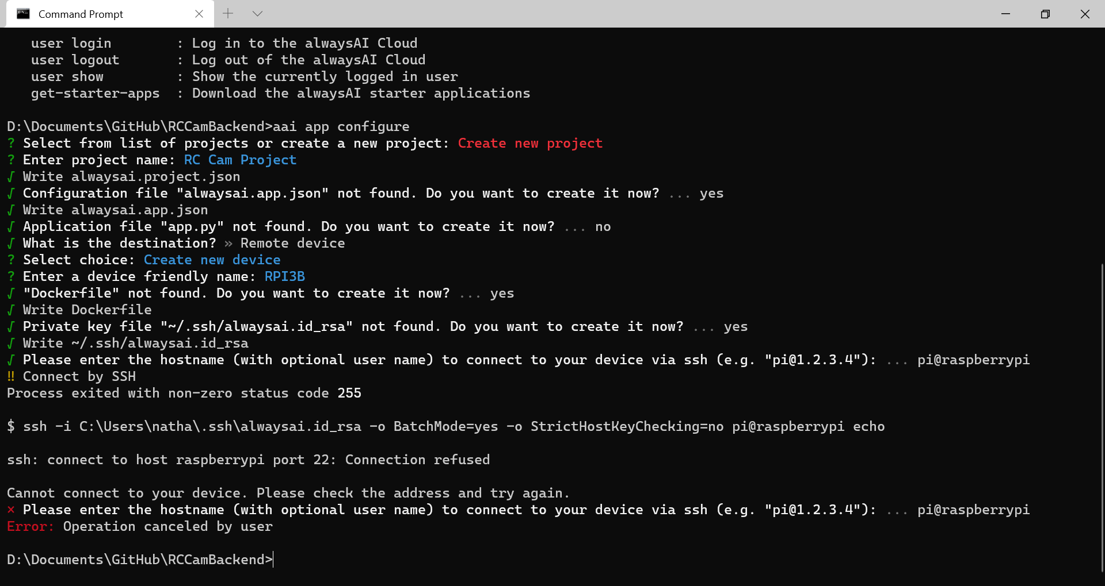

I checked my RPIs config and SSH was disabled so I enabled it and tried to SSH to it from the terminal and it worked. I ran the aai app configure command again. I went through all the settings and the SSH portion worked. I then ran aai app deploy to install the repo with all the necessary AAI files onto my RPI.

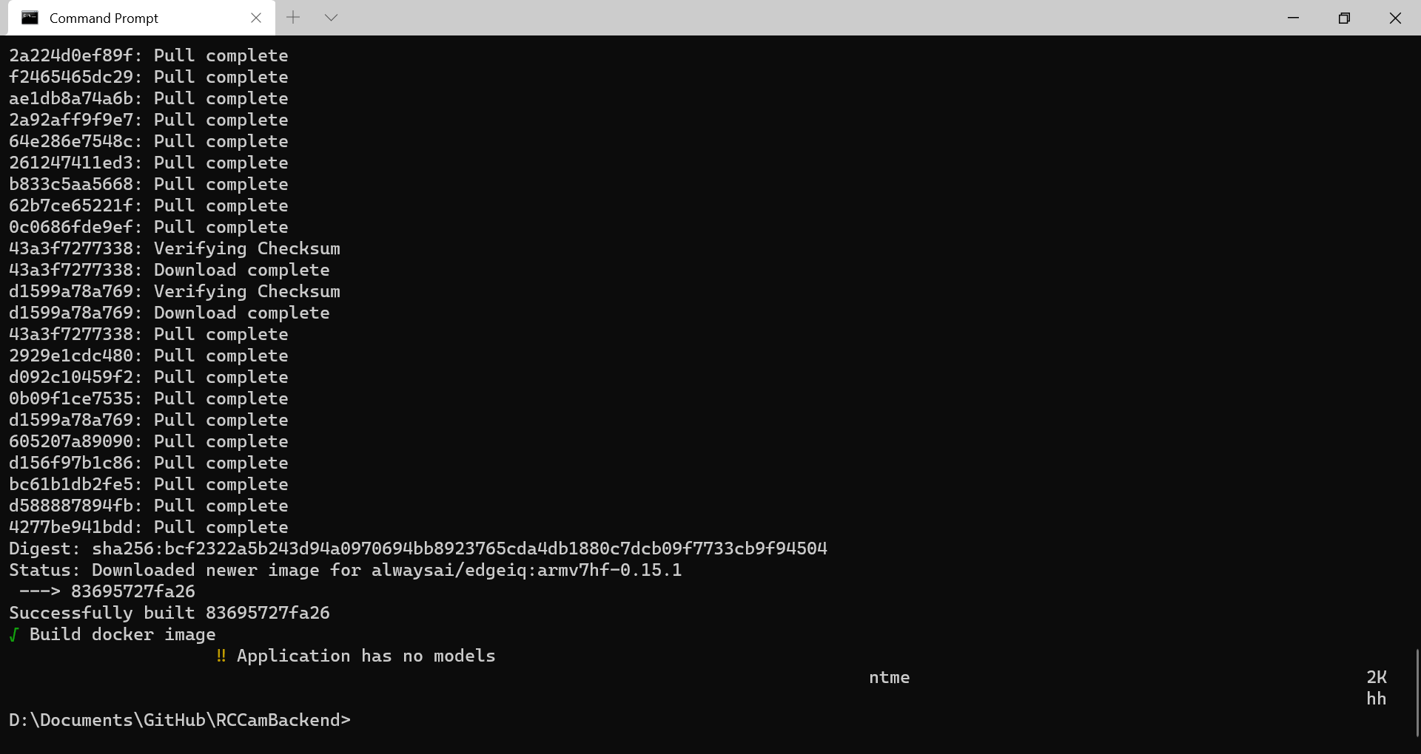

Then, I opened up alwaysai.app.json and changed the start value to python main.py so that when I ran the app using AAI, it would run that file.

|  |
| --- |
| {  "models": {},  "scripts": {  "start": "python main.py"  } } |

When I tried running aai app start, I had an error with picamera not being found. This was because AAI uses a venv and I hadn’t installed the right modules onto that venv since it was brand new. On my RPI, I opened a terminal at venv/bin and ran the activate file. However, when I tried to pip install picamera, the module was apparently already installed. I then double checked supported devices and as it turns out my RPI 3B isn’t supported, the RPI 3B+ and above is which is unfortunate.

In the meantime while I decide what to do, I’m going to work on the start of the facial recognition feature. I started by working on the web server to allow it to handle the request. This didn’t take long and soon I had added the following code with some updated comments for the servo handling.

|  |
| --- |
| # Servo pitch modification logic ~ <ip:port>?p=int  ~  # Servo yaw modification logic ~ <ip:port>?y=int  ~  # Other requests ~ <ip:port>?o=str if "o" in arg_keys:  # Face Detection Rotation ~ <ip:port>?o=f  if request.args["o"] == "f":  print("FACE DETECT") |

I removed the AAI files from the repo, created a dev branch (I didn’t have one until now on the backend and was developing on the master branch) and pushed the changes. On the RPI, I removed the AAI repo and pulled the changes across. I then went onto [http://<ip>:5000/?o=f](http://192.168.1.212:5000/?o=f) and “FACE DETECT” was outputted to the console. This meant that I could start developing the face detection feature from there when I had a solution to the AAI problem. I then went on to open up Android Studio to set up the frontend which should be really quick.

I navigated to the face detection click event under navigation and added the following code.

|  |
| --- |
| R.id.action_face_detection -> {  generateSnack(view, "Face Detection")  val faceURL = "$url?o=f"  webview.loadUrl(faceURL)  return@setOnNavigationItemSelectedListener true } |

I booted up the Android Emulator and went to test the button. When I clicked the button the snackbar came up confirming I pressed the button and the RPI terminal outputted “FACE DETECT”.

I then went to try to get alwaysAI working again with the repository and an edge device (the edge device referring to my RPI). I contacted the alwaysAI team and asked for some support explaining the situation and, after 2 days of trying commands and such that they guided me with, I eventually got it working. The only issue was that in order to run the backend (which shouldn’t happen often) I just needed to do the following commands within my desktop terminal.

|  |
| --- |
| >>> aai app shell --no-container >>> docker run --network=host --privileged -v /opt/vc:/opt/vc --env LD_LIBRARY_PATH=/opt/vc/lib alwaysai-rccam-image |

I finally had alwaysAI working so now I could work on the face detection feature.

Then I checked to see if the RPI Cam could run smoothly at 1080p instead of the terrible resolution it was currently using: (320, 240).

|  |
| --- |
| camera.resolution = (1920, 1080) |

However, this unfortunately came with the downside of a slower frame rate and a more zoomed in view so I reverted back to 320 by 240 and decided to just upscale the video feed on the web server at a later date.

In order to start working on this feature, I needed to have a case for the RPI Camera so that it can be attached to the camera mount safely since the silicon boards backing has soldering and taping that to the mount would be a terrible idea. After 3D printing a lot of failed designs such as the one below:

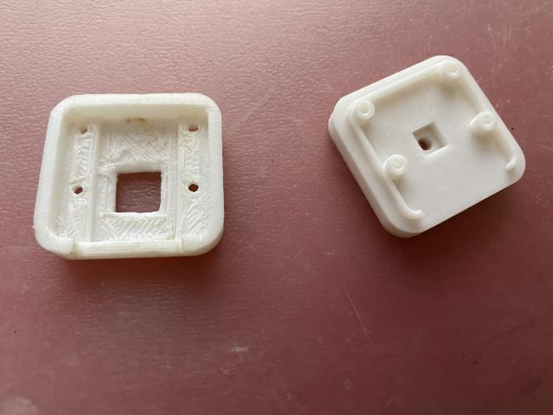

I eventually found a [backplate that fit the RPI Camera V2](https://www.thingiverse.com/thing:2307685), I’m presuming a lot of the other designs failed because their title of “V2” was referring to a remake of their previous design for the old RPI Camera. The backplate also had [3 Remixes on Thingiverse](https://www.thingiverse.com/thing:2307685/remixes) which meant that these design’s front plate most likely worked for the RPI Camera I had.

Below you can see the backing with the RPI Camera and a much longer ribbon cable I had ordered and added to remove any issues with the short length of the previous when rotating the camera mount. It is still an absolute mess right now and yes the sticky covering for the camera is still on just to protect it.

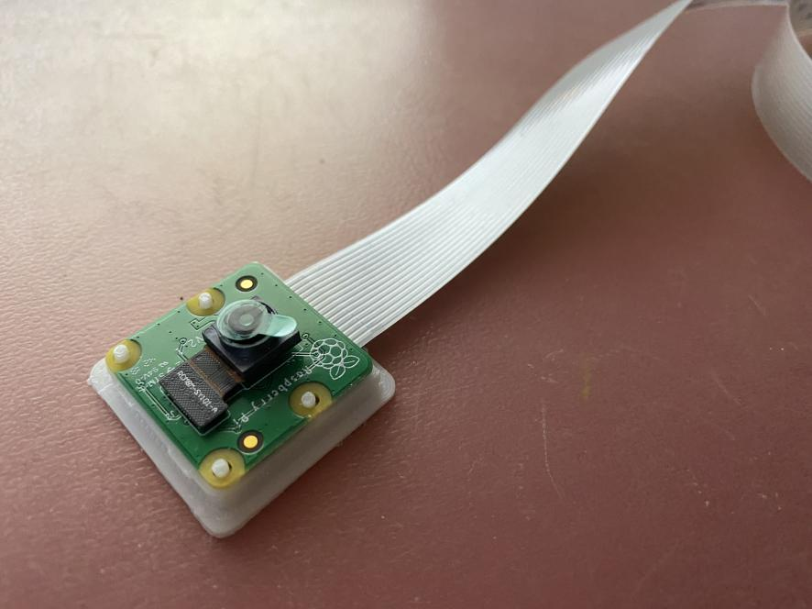

I then eventually found a [STL file for a front plate](https://www.thingiverse.com/thing:92208) by going through remixes and similar products. I printed it off and to my surprise it fit. Due to the low amount of plastic used, the result was very thin which meant that I could easily take the case apart when fit together. Also to my surprise, after putting the camera within, I could wedge it between the two “prongs” on the camera mount. This meant that my overall result was a very robust design where the camera sat firmly in place. I experimented with the camera rotation now that the camera was actually in and it was perfect - I might add a video at a later date.

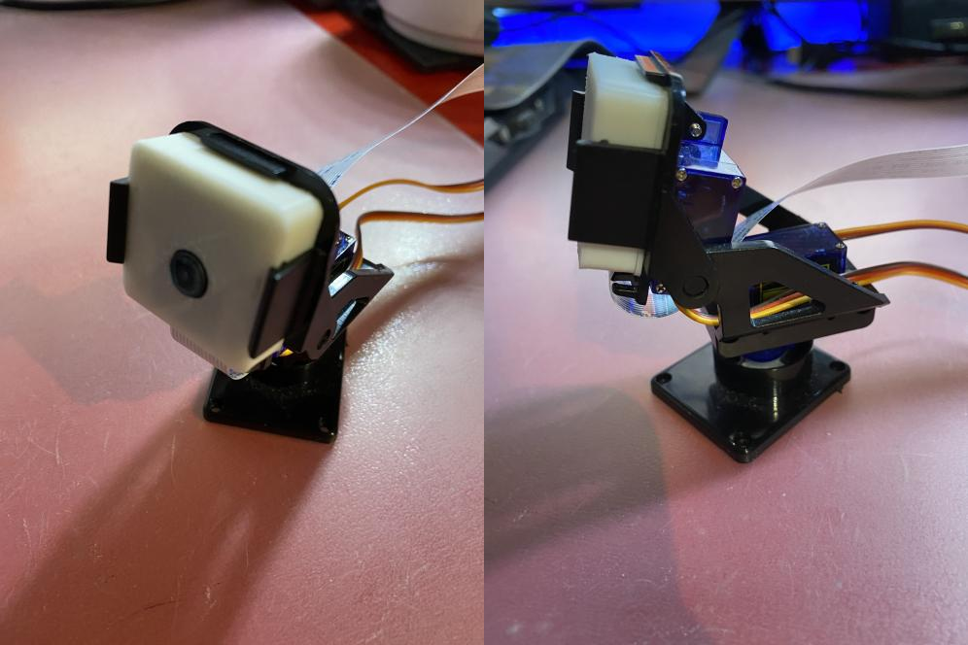

The ribbon cable managed to just slide between the two servos and at the worst case there was a very small amount of friction between the cable and the two servos.

I then went through testing some face detection models using the alwaysAI bot I programmed and settled on alwaysai/res10_300x300_ssd_iter_140000. There was a variation that detected at a longer range but I decided to choose res10 since it was around twice as fast and detected the same amount of faces.

In terminal - I had now installed Windows Terminal which is a lot better than cmd - I ran the following commands:

|  |
| --- |
| >>> aai app models add alwaysai/res10_300x300_ssd_iter_140000 >>> aai app install |

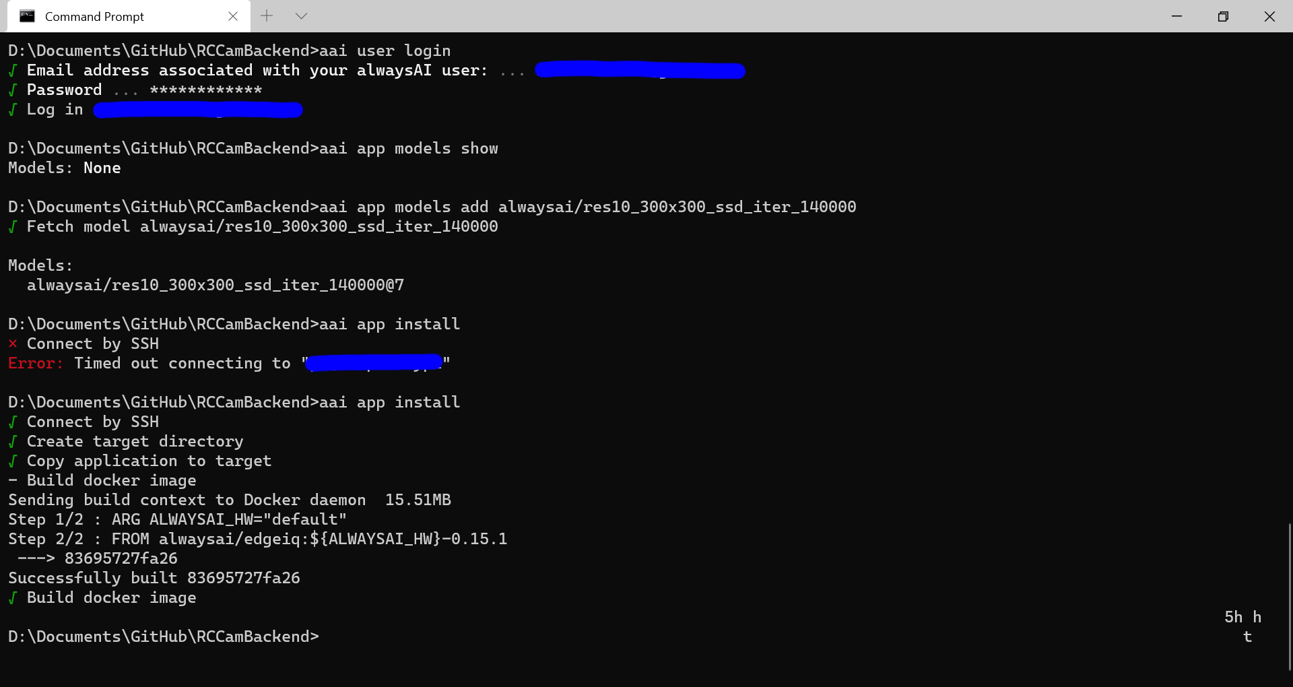

Then, I went into main.py on the backend repository and started by cleaning up the code a bit. I started by adding a function called is_float to reduce some redundancy within the program.

|  |
| --- |
| def is_float(val):  return re.match(r"^-?\d+(?:\.\d+)?$", val)  ~~  if "p" in arg_keys and is_float(request.args["p"]) is not None:  ~~  if "y" in arg_keys and is_float(request.args["y"]) is not None: |

I then went and tried to see if I could fix the loading bug with the web server. I tried by creating a separate thread and returning it.

|  |
| --- |
| video_feed = threading.Thread(target=Response, args=(generator(Camera())),  kwargs={"mimetype": "multipart/x-mixed-replace; boundary=frame"},  daemon=True) return video_feed.start() |

Despite adding this and the code working, for some reason the website was still shown to be loading. I reverted the commit and went on to try to code face detection. I first went ahead and confirmed that the model type was Object Detection. Then, I went and grabbed the code from my alwaysAI bot that worked as a foundation for that category.

|  |
| --- |
| def detection_base(model, confidence, image_array):  detector = edgeiq.ObjectDetection(model) # model example: "alwaysai/res10_300x300_ssd_iter_140000"  detector.load(engine=edgeiq.Engine.DNN)   centroid_tracker = edgeiq.CentroidTracker(deregister_frames=100, max_distance=50)  results = detector.detect_objects(image_array, confidence_level=confidence)  objects = centroid_tracker.update(results.predictions)   predictions = []  for (object_id, prediction) in objects.items():  prediction.label = "{}: {}".format(prediction.label, object_id)  predictions.append(prediction)   image = edgeiq.markup_image(image_array, predictions)   return image, results, None |

I removed the model arg as well as the labels since the only thing that would be detected would be a face. I simplified a lot more of it down to the following:

|  |
| --- |
| def detection_base(confidence, image_array):  # Model to be used  detector = edgeiq.ObjectDetection("alwaysai/res10_300x300_ssd_iter_140000")  detector.load(engine=edgeiq.Engine.DNN)   # Fancy face detection  results = detector.detect_objects(image_array, confidence_level=confidence)  image = edgeiq.markup_image(image_array, results.predictions)   return image |

I needed to pass the correct class to the function so I needed to figure out what class I was getting when getting the frame for the camera. I set up a print in the following small code to try to figure it out.

|  |
| --- |
| # Other requests ~ <ip:port>?o=str  if "o" in arg_keys:  # Face Detection Rotation ~ <ip:port>?o=f  if request.args["o"] == "f":  print(type(Camera().get_frame())) |

I then realised that for some reason, my prints weren’t outputting. So, after trying to get that working, I decided to just see what would happen if I sent in the image to the function. I then found out that Pycharm can state the data type of a variable. This showed me that I was sending in a bytestring which I conveniently also had with the alwaysAI Bot. I took the conversion code from there and plugged it into my web server.

|  |
| --- |
| if "o" in arg_keys:  # Face Detection Rotation ~ <ip:port>?o=f  if request.args["o"] == "f":  np_arr = np.fromstring(Camera().get_frame(), np.uint8)  img_np = cv2.imdecode(np_arr, 1)  image = detection_base(0.5, img_np) |

No errors appeared so it seemed to be working - I did a final test by saving the result image to my RPI (I had a feeling there might have been an error but it could be suppressed just like the print stdouts). I added the following code to see if anything would be saved:

|  |
| --- |
| result = Image.fromarray(image) result.save("result.png") |

This didn’t do anything when I ran the code so I tried adding a return to intercept the live video stream. This would confirm whether it was an issue with the code within the condition or the condition itself.

|  |
| --- |
| return "why" |

This didn’t stop the video stream and left either one of two reasons.

1. The RPI wasn’t pulling the changes when I’m running “aai app deploy”, despite the RPI showing the changes when I check it
2. The condition is wrong and isn’t firing

I started with the 2nd issue. I began by outputting arg_keys.

|  |
| --- |
| print(arg_keys)  # Other requests ~ <ip:port>?o=str  if "o" in arg_keys: |

This also didn’t output anything to the console. I was stumped. I then realised that for whatever reason, after hitting Ctrl+C to end the program, it was outputting FACE DETECT which was nowhere to be found in my new code.

|  |
| --- |
| print(arg_keys)  # Other requests ~ <ip:port>?o=str  if "o" in arg_keys:  # Face Detection Rotation ~ <ip:port>?o=f  if request.args["o"] == "f":  np_arr = np.fromstring(Camera().get_frame(), np.uint8)  img_np = cv2.imdecode(np_arr, 1)  image = detection_base(0.5, img_np)   result = Image.fromarray(image)  result.save("result.png")   return "why" |

For whatever reason it seemed to be running the old repository instead of the new one - potentially relating to the docker image I had to build to get AAI working. I ran through all the previous commands to set up the repository and ran the command to start it. Somehow, I got an error about PIL not being able to be imported - which made a lot of sense. I added it to “requirements.txt” and ran the command to run it again.

#### 2.3 Evaluation

For some reason, AAI wasn’t co-operating well. I asked their team about why it wasn’t working since I had tried to run all the commands again but couldn’t get the venv to be rebuilt. I also found there was an issue with their CLI where it wasn’t outputting progress after building a Docker image.

I realised that in order for me to finish my project within a reasonable amount of time, I would need to drop using AlwaysAI. I had asked their team about the issues I was having with their CLI but they wouldn’t be able to resolve them within a timeframe I could work with. I looked into other alternatives such as Google’s Vision API but I couldn’t find a simple way to get the bounding boxes of any detected faces which was vital for the rotation calculation.

### Module Evaluation

|  |  |  |  |
| --- | --- | --- | --- |
| **Module** | **Criteria** | **Justification** | **Priority** |
| **Camera Rotation** | 2.1 - Rotate Camera | This brings up a menu which allows the user to input values which will increment or decrement the rotation of the camera mount by sending a request to the RPI. The menu will be accessed via a button to the right of the ‘Take Photo’ button. | **High** |
| 2.2 - Modify Servo Rotation | For the camera device to be rotated from a distance, the RPI needs to be able to change the rotation of the servos. In turn, this will change the rotation the camera is facing as the servos control the camera mount. | **High** |
| 2.3 - Detect Faces | Facial recognition will be a minor feature on the app. The RPI will detect faces and then modify the servo rotation to centre the camera on any detected faces. | **Medium** |
| 2.4 - Centre on Face | The button sends a request to the RPI to centre the camera on a face or the average position using the location of multiple faces. | **Medium** |

Module 2 unfortunately hasn’t been as successful as Module 1. I only managed to complete the high priority features because AlwaysAI (the face detection CLI based library I was intending on using) had some issues with the CLI and didn’t work. If I had more time to develop this, I would look into alternatives for the face detection but as it currently stands the feature won’t make it in.

The rest of the module was very successful. I managed to create an intuitive menu for rotating the camera with buttons to increment and decrement values in the text fields and it worked without issues.

I left the button in for the face detection so that I could implement face detection at a later point in time if I so chose to.

#### Issues

* GUI menu theming
* No face detection feature

## Module 3 - Take Photo

The purpose of this module is to focus on the photo-taking aspect of my coursework. The highest priority is to get the regular photo-taking completed as the timed shot is more of a minor feature.



### 3.1 - Regular Photo

As this is a higher priority over timed shots, I will most likely be doing timed shots last. This part of the success criteria is just for getting the frontend Android app to send a request to the RPI. I started by reverting all of the branches on my RCCamBackend repository so that all of the work that had been done to get alwaysAI working was removed.

#### Sending the Request

I then pulled the changes across to my RPI and booted up the web server. I started by modifying the bottom navigation code under the MainActivity class.

|  |
| --- |
| bottomNavigationBar.setOnNavigationItemSelectedListener{ item ->  when(item.itemId) {  R.id.action_face_detection -> {  generateSnack(view, "Face Detection")  val faceURL = "$url?o=f"  webview.loadUrl(faceURL)  }  R.id.action_shutter -> {  generateSnack(view, "Shutter")  val shutterURL = "$url?o=s"  webview.loadUrl(shutterURL)  }  R.id.action_rotation -> {  ...  }  }  return@setOnNavigationItemSelectedListener true  } |

I removed all of the returns for each individual element in the bottom navigation bar and added a terminating return at the end of the listener. This made it look an awful lot nicer. I also added in a loading mechanism for sending a request via the loadUrl function - I realised recently that I can use HTTP requests instead of relying on loading another URL which will be a lot cleaner. I might implement this later on.

I was getting an error on my RPI which was to be expected since the user was trying to send data that the RPI wasn’t ready to handle yet.

#### Snackbar Anchor

I wasn’t finished with this success criteria yet since the snackbar wasn’t positioned correctly when generated; it obscured the bottom navigation bar.

To fix this, I first searched the documentation and found a method called setAnchorView - using Kotlin you’d use the direct property access instead. This lets you tie your snackbar to a widget which means it will show above said widget. I modified my generateSnackbar function to allow for this functionality.

|  |
| --- |
| fun generateSnack(view: View, text: String, dur: Int = Snackbar.LENGTH_SHORT, anch: View? = null){  val snack = Snackbar.make(view, text, dur)  if (anch != null){  snack.anchorView = anch  }  snack.show() } |

Then, to test this new functionality, I changed the call in the shutter listener event to the following:

|  |
| --- |
| R.id.action_shutter -> {  generateSnack(view, "Shutter", anch=bottomNavigationBar)  ...  } |

When I ran the code and pressed the shutter button, this did work. The snackbar originated from the bottom of the screen and moved to above the bottom navigation bar. However, this looked odd and still temporarily obscured the bar. Since the functionality worked as intended, I decided to leave the function as is and just modify the call to the following.

|  |
| --- |
| generateSnack(bottomNavigationBar, "Shutter") |

This unfortunately didn’t work. I couldn’t find a fix so I reverted back to the call with the bottom navigation bar as the anchor.

I also noticed that certain screen widths would cause a black portion to show on the bottom navigation bar. I checked the attributes and found a background attribute. When I changed this it modified that black portion's colour. I set this to space blue - the same as the items background.

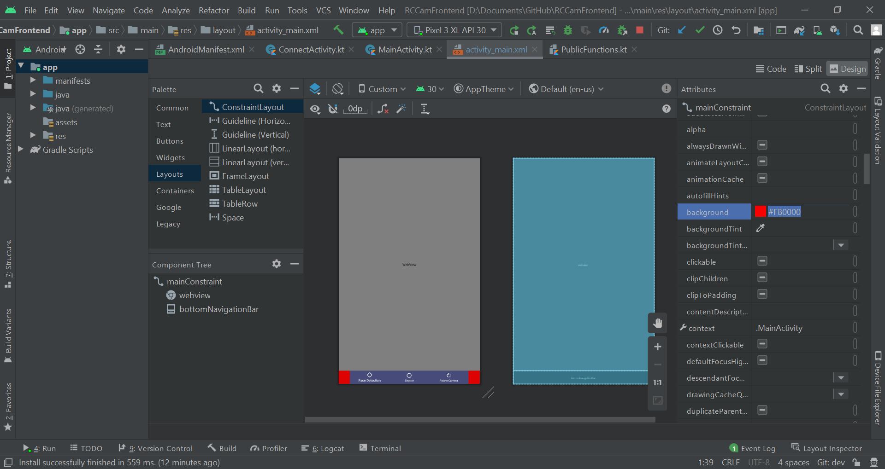

I changed the text for the shutter snackbar and also modified the snackbar call for the face detection button as well for consistency.

|  |
| --- |
| R.id.action_face_detection -> {  generateSnack(view, "Face Detection", anch=bottomNavigationBar)  val faceURL = "$url?o=f"  webview.loadUrl(faceURL) } R.id.action_shutter -> {  val shutterURL = "$url?o=s"  webview.loadUrl(shutterURL)  generateSnack(view, "Taken photo", anch=bottomNavigationBar) } |

### 3.3 - RPI Take Photo, 3.4 - RPI Send Photo, 3.5 - Autosave Image

The aim for this portion of the success criteria is to get the RPI to take a photo upon a request and then to save that photo onto the SD card.

#### HTTP Requests

I initially tried overhauling the entirety of how the camera currently works but had major issues with it. Instead, I decided to fix up how the web server currently handles requests. Right now it can only receive data from loading the URL. This is easy to set up; however, this means that whenever I need to send data, I have to reload the webpage.

Instead, I should be utilising HTTP requests which won’t force me to reload the webpage. It technically uses a GET HTTP request already when loading the web page.

I found [this article](https://pythonbasics.org/flask-http-methods/) on HTTP requests with Flask and will be using it to change the web server.

Most of my code seemed correct, it was just a matter of altering the structure to better suit how I would send and handle the HTTP requests. I didn’t need to implement any new HTTP methods since the interactions would be sending and receiving data.

My current backend code became the following:

|  |
| --- |
| web_app = Flask(__name__) ser_app = ServoController()  camera = Camera()   def generator(cam):  while True:  yield b"--frame\r\nContent-Type: image/jpeg\r\n\r\n" + cam.get_frame() + b"\r\n"   # GET message is send, and the server returns data # POST ~ Used to send HTML form data to the server. The data received by the POST method is not cached by the server. @web_app.route("/servo") def servo():  arg_keys = [item.lower() for item in list(request.args.keys())]   # Servo pitch modification logic  if "p" in arg_keys and re.match(r"^-?\d+(?:\.\d+)?$", request.args["p"]) is not None:  ser_app.change_servo(ser_app.pitch, float(request.args["p"]))  print("Pitch: {}".format(request.args["p"]))   # Servo yaw modification logic  if "y" in arg_keys and re.match(r"^-?\d+(?:\.\d+)?$", request.args["y"]) is not None:  ser_app.change_servo(ser_app.yaw, float(request.args["y"]))  print("Yaw: {}".format(request.args["y"]))   @web_app.route("/photo") def photo():  return camera.frame   @web_app.route("/") def main_page():  return Response(generator(camera), mimetype="multipart/x-mixed-replace; boundary=frame")   if __name__ == "__main__":  web_app.run("0.0.0.0", threaded=True) |

#### Take Photo

The return I put under the photo route was temporary and just to see if it was that easy to implement. As expected, when running the application and going to that route, I was greeted with a huge amount of unicode characters rather than an image. I then changed the code to the following:

|  |
| --- |
| @web_app.route("/photo") def photo():  return Response(camera.frame, mimetype="multipart/x-mixed-replace; boundary=frame") |

When I ran this and went to the same URL, I was greeted with a small black square like I had seen a while back. I checked the documentation to see how I previously solved this problem and I realised that it must be to do with either the mimetype or the first argument. The first argument was changed originally to a binary string so I did the same with this code.

|  |
| --- |
| test = b"--frame\r\nContent-Type: image/jpeg\r\n\r\n" + camera.frame() + b"\r\n" return Response(test, mimetype="multipart/x-mixed-replace; boundary=frame") |

However, I got the response that a Nonetype object was not callable. I accidentally had brackets leftover that were now present in camera.frame(). I removed these and ran the script again. I then got another error stating that I couldn’t concatenate NoneType objects and strings.

I realised that this was most likely due to that attribute being set as “None” before the camera live streams. I booted up the main page for the website and then went back and refreshed the photo website url. To my surprise, it loaded an image of when I pressed F5.

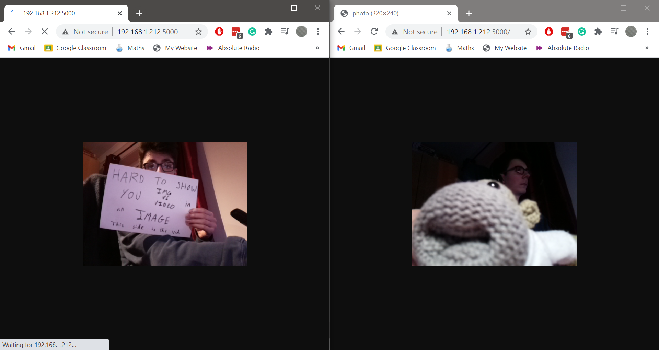

On the image above, the video is the Chrome tab on the left while the photo taken was on the right tab. Yes, I put the light on so that I could write that out on a sheet of paper. No, it didn’t magically become daytime.

Now that I knew I had access to the image, all I had to do was save said image to the RPI. However, I disliked the fact that the current Camera class uses JPEG instead of PNG. This means that while the MJPEG stream will be a lot quicker, the photos taken will look worse than they could. To remedy this, I will be modifying the camera class.

I began by moving the camera to a class field.

|  |
| --- |
| class Camera:  thread = None # Background thread that reads frames from camera  frame = None # Current frame is stored here by background thread  last_access = 0 # Time of last client access to the camera   camera = picamera.PiCamera()  # camera.hflip = True  # camera.vflip = True |

Finally, I made a function called get_current_frame and made it change the resolution to 1080p, take a photo and then change it back. I also made the _thread function stop previewing the camera after the thread ends.

|  |
| --- |
| def get_current_frame(self):  self.camera.resolution = (1920, 1080)  self.camera.capture("test.png")  self.camera.resolution = (320, 240)  @classmethod def _thread(cls):  # Giving time for the camera to warm up  cls.camera.resolution = (320, 240)  cls.camera.start_preview()  time.sleep(2)   ...    if time.time() - cls.last_access > 10:  cls.camera.stop_preview()  break |

I expected the webpage to not load when I tried to connect to the main page but it loaded the video stream. When I went to the photo route it showed the exact same as before the camera rewrite which I thought was odd. I then realised that I hadn’t implemented a call for the new get_current_frame.

Temporarily I modified the function to return a filename and changed the function’s name. I also added a proper call under the photo route.

|  |
| --- |
| def capture_image(self):  self.camera.resolution = (1920, 1080)  self.camera.capture("test.png")  self.camera.resolution = (320, 240)  return "test.png"  ~~  @web_app.route("/photo") def photo():  return send_from_directory("", camera.capture_image(), as_attachment=True) |

It worked and didn’t even stop the stream after routing to it. It actually returned me to the stream and just tried to download the image onto my desktop (where I am currently testing the web server). When I tried to download the image on my IOS phone and on the Android emulator, both froze the video feed on my computer (expected) and took a while to download. Due to this, I decided to change the file type to JPEG instead to reduce the file size from ~2-3MB.

|  |
| --- |
| def capture_image(self):  self.camera.resolution = (1920, 1080)  self.camera.capture("test.jpeg")  self.camera.resolution = (320, 240)  return "test.jpeg" |

When I went to the photo route on my desktop it downloaded the image as a PNG. However, when I downloaded it on the Android emulator it downloaded as a JPEG. Flask must have an algorithm that determines what file type to download as based on the device.

#### Multiple Photos

After this, I realised that my previous method of generating unique file names made it hard to distinguish images from a user perspective. So, I decided to instead use the date and time as the file name. However, this means that there could be conflicting file names for photos that are taken on the same day and time. To remedy the issue, I could add an incremental number to the end for files with the same date and time. This would also help the user identify a photo they might be after on the RPI without having to check the metadata of images.

I created a small script on the RPI to test if the OS module functioned as intended on Raspbian.

|  |
| --- |
| import os  def save_file(filename):  if not os.path.exists("photos"):  os.mkdir("photos")   f = open(f"photos/{filename}.txt", "w+")  f.write("I'm just testing aight")  f.close()   save_file(input("Filename >>> ")) |

When I ran this and inputted testing, it created a photos directory on my desktop and created the file within it. The file created wasn’t an image file however I already knew that functioned correctly; this code was for testing the OS module mainly.

I modified the capture_image function to now handle alternate paths and image extensions. These kwargs have the default values of “” (current directory) and “jpeg” (file extension) but can be changed. This allows me to not only store the images within a photos directory but also store two of the same image - one as a PNG and one as a JPEG. The JPEG version will be sent to the user’s mobile since it is quicker to access however a PNG version will be accessible on the RPI itself.

|  |
| --- |
| def capture_image(self, path="", ext="jpeg"):  # Appending a / to the end of path if it is missing  if path != "" and path[-1] != "/":  path += "/"   filename = f"{path}test.{ext}"   # Changing to higher resolution to capture image  self.camera.resolution = (3200, 2400)  self.camera.capture(filename)   # Reverting to live stream resolution  self.camera.resolution = (320, 240)   return filename |

To reflect these changes, I modified where the function is called. The code now checks whether two paths exist - compressed_photos and photos. Compressed photos will store the JPEGs (photos sent to the phone) while photos will store the PNG versions. My only concern currently is that the images won’t be of the same point in time due to the capture function running twice. I will have to check whether that is an issue and potentially find a solution which hopefully involves a new function or running capture once.

|  |
| --- |
| @web_app.route("/photo") def photo():  image_paths = ["compressed_photos", "photos"]   for path in image_paths:  if not os.path.exists(path):  os.mkdir(path)   jpeg_image = camera.capture_image(path=image_paths[0]) # JPEG  camera.capture_image(path=image_paths[1], ext="png") # PNG   return send_from_directory("", jpeg_image, as_attachment=True) |

In order to make sure the code ran appropriately, I pushed the changes onto the repo and pulled them across to the RPI to run. When I tried running the code an error occurred to do with the f strings - a Python 3.6 feature. I realised that I’d been running the code on Python 2.7 the entire time (this is unfortunately a dependency on Raspbian for certain applications). When I tried running python3 main.py, the console didn’t output anything and the web server didn’t boot up.

I was able to take a photo however. I checked the JPEG photo and it came out as expected. When I checked the PNG photo however there was apparently no data. I believed that it might be to do with trying to capture another photo in such a short time frame.

I found within the [picamera documentation](https://picamera.readthedocs.io/en/release-1.13/recipes1.html#capturing-to-a-stream) mention of capturing to a stream and then saving the image from that stream using PIL. However, this requires an extension mentioned.

I realised that instead of relying on the picamera module, I could just take a high quality PNG photo and then convert that to a JPEG using PIL. I found this [code on Stack overflow](https://stackoverflow.com/questions/43258461/convert-png-to-jpeg-using-pillow) which accomplishes exactly what I was after.

I took the time to slightly modify the capture_image function and to change the call to it.

|  |
| --- |
| def capture_image(self, path="", ext="jpeg"):  ...   filename = f"{path}test"   # Changing to higher resolution to capture image  self.camera.resolution = (3200, 2400)  self.camera.capture(f"{filename}.{ext}")   ...  ~~  @web_app.route("/photo") def photo():  image_paths = ["compressed_photos", "photos"]   for path in image_paths:  if not os.path.exists(path):  os.mkdir(path)   image_name, image_ext = camera.capture_image(path=image_paths[1]) # PNG  im = Image.open(f"{image_name}.{image_ext}").convert("RGB")   jpeg_path = f"{image_name}.jpeg"  im.save(jpeg_path) # JPEG   return send_from_directory("", jpeg_path, as_attachment=True) |

I rebooted the RPI, pulled the changes and ran the program again. When I navigated to the photos route, it attempted to download the photo as per usual however I noticed a black streak across the middle of the photo. I tried again and got the same result. I made sure to check on the RPI to see if the images saved there also had the same issue. Strangely, under the compressed photos directory the image was normal. However, under the photos directory the image had the black streak and was saved as a JPEG instead of a PNG. It seemed as though I had a logic error in my code.

I made a few adjustments to the route such as changing the kwarg call for the capture_image method and the logic for the image paths.

|  |
| --- |
| image_path, image_ext = camera.capture_image(path=image_paths[1], ext="PNG") # PNG im = Image.open(f"{image_path}.{image_ext}").convert("RGB")  jpeg_path = f"{image_paths[0]}{image_path}.jpeg" im.save(jpeg_path) # JPEG |

I moved my light to see a noticeable difference but when I went to the route the photos hadn’t been replaced. I deleted them and tried to go to the route again. I tried modifying the code again. I changed the capture_image ext kwarg default value to png to make the call a lot nicer and modified the paths a lot - including how capture_image returns data.

|  |
| --- |
| def capture_image(self, path="", ext="png"):  # Appending a / to the end of path if it is missing  if path != "" and path[-1] != "/":  path += "/"   filename = "test"   # Changing to higher resolution to capture image  self.camera.resolution = (3200, 2400)  self.camera.capture(f"{path}{filename}.{ext}")   # Reverting to live stream resolution  self.camera.resolution = (320, 240)   return filename, ext  ~~  @web_app.route("/photo") def photo():  image_paths = ["photos/", "compressed_photos/"]   for path in image_paths:  if not os.path.exists(path):  os.mkdir(path)   image_name, image_ext = camera.capture_image(path=image_paths[0]) # PNG  im = Image.open(f"{image_paths[0]}{image_name}.{image_ext}").convert("RGB")   jpeg_path = f"{image_paths[1]}{image_name}.jpeg"  im.save(jpeg_path) # JPEG   return send_from_directory("", jpeg_path, as_attachment=True) |

Again I had the same result despite the JPEG image seemingly not existing on the RPI. I added a print to see if the issue was with the RPI running the code itself.

|  |
| --- |
| im.save(jpeg_path) # JPEG  print("test") return send_from_directory("", jpeg_path, as_attachment=True) |

Nothing was outputted. I tried adding a print to the start and again nothing was outputted. I then removed the entirety of the function and put in a pass. It still sent the image to be downloaded despite there not being code instructing it to. After shutting down the server I attempted to connect to the photo route and it tried to download my file.

I tried on Edge instead and it tried to download an image. However, my live stream became a singular green barred image. I checked the file directories and no images had been saved there. I had to reboot the RPI for the camera to work again.

When the RPI came online again I tested out the following code to see if it was an issue with my paths.

|  |
| --- |
| image_name, image_ext = camera.capture_image(path=image_paths[0]) # PNG return send_from_directory(image_paths[0], f"{image_name}.{image_ext}", as_attachment=True)  ~~  self.camera.capture(f"photos/test.png") |

This had the same issue as before so I tried changing the route name to test temporarily. I received an error this time which I had noticed once before but ignored - PiCameraMMALError: out of resources. Upon looking this error up. It essentially had little to no info on the actual error other than the fact that I had done something wrong with capture. I believed it to be one of two things:

1. It didn’t like the fact that I used png as an extension
2. It didn’t like the path

I tried the following first:

|  |
| --- |
| self.camera.capture(f"photos/test.jpeg") |

Unfortunately this worked which meant that for some reason capture didn’t want to support PNG captures - potentially due to the large resolution.

I decided to put together a small script to see if I could determine the issue with PNGs and to see if it was to do with the camera resolution.

|  |
| --- |
| from time import sleep from picamera import PiCamera  camera = PiCamera() camera.resolution = (320, 240) camera.start_preview()  # Camera warm-up time sleep(2)  for i in range(1,11):  camera.resolution = (320*i, 240*i)  camera.capture(f"foo{i}.png")  sleep(0.5) |

When observing the script, the images took significantly longer at higher resolutions. After it had finished, I attempted to open foo10.png which used the existing resolution on the Flask server. I couldn’t open this. When trying to open any other foo.png it worked perfectly. It seemed as if I had chosen a resolution too high for the camera despite the specs stating it can handle 3280 by 2464 pixels. I decided instead to lower the resolution down to 1920 by 1440 - 6 times the resolution of the livestream.

When I tried to go to the photo route on Chrome I had the same issue as before where it would download the first ever image from that route. On Edge, it downloaded the correct image without any issues (even as a JPEG). I double checked the RPIs photos and compressed photos directories and found that it had worked perfectly. There was a JPEG in the compressed photos dir and a PNG in the photos dir.

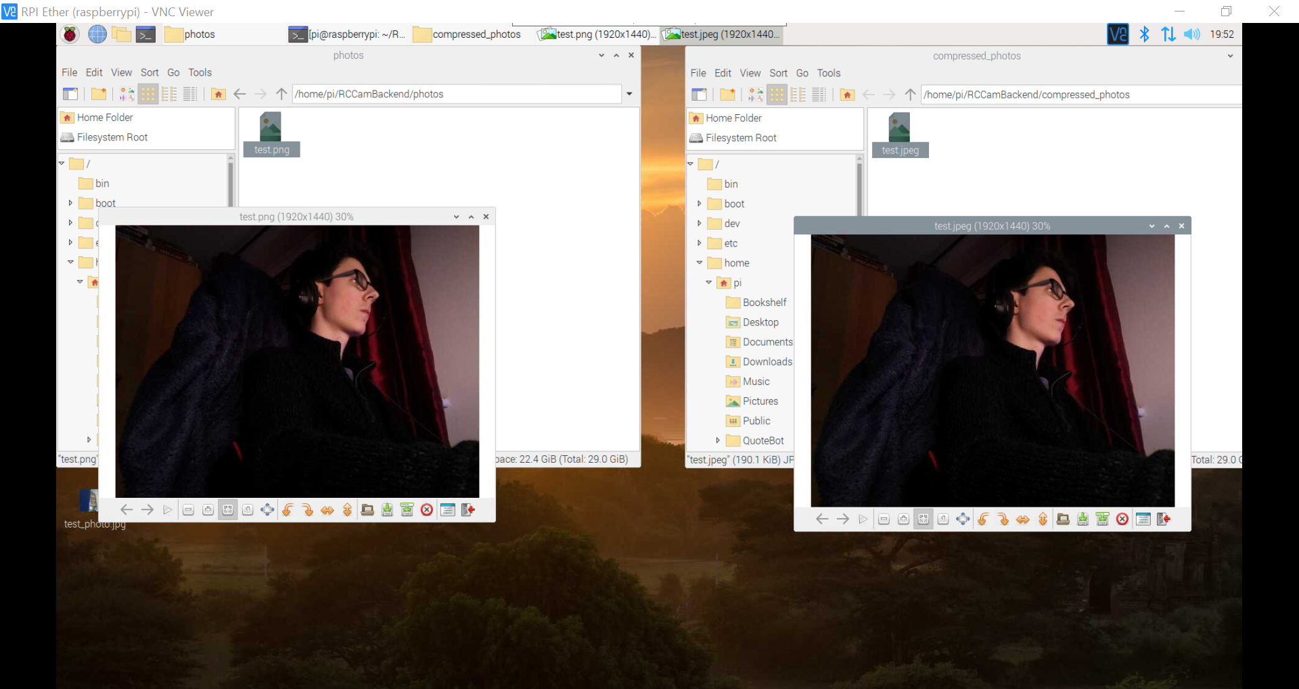

It is hard to see a difference between the photos. This is not only due to their small size in the image but also because of the VNC viewer encoding the stream using JPEG. However, one thing that I can see is that massive difference in file size. The PNG uses ~3mb of storage compared to the ~190kb for the JPEG. This is a considerable difference and is the reason why I am sending the JPEG to the user.

#### Unique File Name

As mentioned before, I will be using a file naming system that uses the time and date. When a file exists that already has that date and an image is being saved, that image will have that time and date + #X+1 where X is the number of existing files before saving.

|  |
| --- |
| counter = 1 date = datetime.today() filename = f"{date.day}/{date.month}/{date.year} #{counter}"  while True:  if os.path.isfile(filename): # Increment counter if filename already exists  counter += 1  filename = f"{date.day}/{date.month}/{date.year} #{counter}"  else: # Filename doesn't already exist, end loop  break |

In order to test this, I made a separate Python file and put the code in as a function. I added a print to the end to output the filename and ran tests by adding files to the directory it was in.

I realised that the file can’t have / characters in the name so I modified the code appropriately.

|  |
| --- |
| filename = f"{date.day}-{date.month}-{date.year} #{counter}" |

When I ran the script, the program didn’t detect the file 11-11-20 #1.txt. I checked the docs and realised that the method checks the extension and doesn’t have a way of ignoring it. To fix this, I added an arg to the function where the extension is passed.

|  |
| --- |
| def filename_gen(ext):  counter = 1  date = datetime.today()  filename = f"{date.day}-{date.month}-{date.year} #{counter}.{ext}"   while True:  if os.path.isfile(filename): # Increment counter if filename already exists  counter += 1  filename = f"{date.day}/{date.month}/{date.year} #{counter}.{ext}"  else: # Filename doesn't already exist, end loop  break   print(filename)  filename_gen("txt") |

When I ran the program again it worked fine. Then I added another file called 11-11-20 #2.txt and it didn’t work. After briefly checking my code, I saw the logic error and fixed it.

|  |
| --- |
| counter += 1 filename = f"{date.day}-{date.month}-{date.year} #{counter}.{ext}" |

I tested with a few more files and no files at all and it seemed to work fine so I implemented it into my main code.

|  |
| --- |
| def gen_filename(ext):  counter = 1  date = datetime.today()  filename = f"{date.day}-{date.month}-{date.year} #{counter}.{ext}"   while True:  if os.path.isfile(filename): # Increment counter if filename already exists  counter += 1  filename = f"{date.day}-{date.month}-{date.year} #{counter}.{ext}"  else: # Filename doesn't already exist, end loop  break   return filename  ~~  def capture_image(self, path="", ext="png"):   ...    # Generating filename  filename = gen_filename(ext) |

When I ported it over to the RPI, I saw an issue that I had seen before but haven’t paid much attention to. The RPI seems to sometimes have an issue switching the resolution to 1920 by 1440. I couldn’t find much info on it however.

I realised two things after going to the photo route twice:

* The filename for the images were .png.jpeg or .png.png
* The files weren’t getting new filenames

The first fix was easy:

|  |
| --- |
| def gen_filename(ext):    ...   filename = f"{date.day}-{date.month}-{date.year} #{counter}"   while True:  if os.path.isfile(f"{filename}.{ext}"): # Increment counter if filename already exists  counter += 1  filename = f"{date.day}-{date.month}-{date.year} #{counter}" |

Now the program only returned the filename without the extension. The second issue was also fairly easy to fix. I just needed to add a path arg so that it checked the correct location.

|  |
| --- |
| def gen_filename(ext, path=""):  while True:  if os.path.isfile(f"{path}{filename}.{ext}"): # Increment counter if filename already exists  ~~  self.camera.capture(f"{path}{filename}.{ext}") |

I pushed these changes to the RPI and ran the web server again. I got the same exception again when trying to set the resolution despite it working a lot of the time. I presumed it was a conflict between when the camera was trying to send a photo via the live stream and by the photo route so I put in an exception catch.

|  |
| --- |
| while True:  try:  # Changing to higher resolution for capturing image  self.camera.resolution = (1920, 1440)  self.camera.capture(f"{path}{filename}.{ext}")  break  except picamera.exc.PiCameraMMALError:  pass  while True:  try:  # Reverting to live stream resolution  self.camera.resolution = (320, 240)  break  except picamera.exc.PiCameraMMALError:  pass |

Hopefully this should “fix” the issue. Again, I ran the web server. I saw an error for the one try except I forgot to implement but asides from that the program worked fine. It was generating the right filenames and storing images with them in the right places. I added a try except loop to the other resolution setter as well.

|  |
| --- |
| @classmethod def _thread(cls):  # Giving time for the camera to warm up  while True:  try:  cls.camera.resolution = (320, 240)  break  except picamera.exc.PiCameraMMALError:  pass |

#### Android App Compatibility

Due to the Flask servers route overhaul that started on page 143, I will have to modify the Android app to be compatible. This also extends to being able to receive downloads since the Webview won’t handle those automatically.

Before that, I added a return to the servo route since I had forgotten to do that previously.

|  |
| --- |
| @web_app.route("/servo") def servo():    ...   return redirect(url_for("/")) |

This didn’t work however. After reading the [documentation](https://flask.palletsprojects.com/en/1.1.x/quickstart/#url-building) I found how to fix it.

|  |
| --- |
| return redirect(url_for("main_page")) |

I then booted up the Android emulator to see what was now incompatible. As expected, both the shutter button and rotate camera button didn’t do anything. I modified the URLs to remedy this. It included a complete overhaul for the URL logic of the rotate camera button.

|  |
| --- |
| R.id.action_shutter -> {  val shutterURL = "$url/photo"  webview.loadUrl(shutterURL)  generateSnack(view, "Taken photo", anch=bottomNavigationBar) }  ~~  R.id.action_rotation -> {  // <ip>/servo?p=int&y=int  // URL Arg Logic  var servoUrl = ""   if (textfieldPitchData != "") { // Pitch arg supplied  servoUrl += "p=$textfieldPitchData&"  }   if (textfieldYawData != "") { // Yaw arg supplied  servoUrl += "y=$textfieldYawData"  }   if (servoUrl != "") {  webview.loadUrl("$url/servo?$servoUrl")  } } |

I booted up the Android App and tested out the buttons. The rotate servo button worked completely fine. The shutter button also sent the request but, as expected, no image was downloaded. The image was present on the RPI so the request itself definitely worked.

I had previously found something called a Download Listener and decided to read into it. With the help of this [Stack Overflow answer](https://stackoverflow.com/questions/4042762/android-webview-download-listener), I managed to create a hopefully functional basic download listener.

|  |
| --- |
| // Download Listener webview.setDownloadListener(DownloadListener { url, _, _, _, _ ->  val intent = Intent(Intent.ACTION_VIEW)  intent.data = Uri.parse(url)  startActivity(intent) }) |

However, this method opened a Chrome tab and sent the request again which resulted in two photos being taken. Also, the Chrome cache made it so that when I tried again it tried downloading the same photo as before. I checked the documentation again and found something called a [DownloadManager](https://developer.android.com/reference/android/app/DownloadManager). According to the documentation, this would allow me to request to download files within the app itself.

My thought process for using this is:

* Call Download Manager when shutter button is pressed
* Use Download manager to go to the URL requested and download the file

This way seems to have a lot of benefits. Only one photo will be taken, the download will be done within the app and I have complete control over how I want the user to see how the download happens.

I also found [this article](https://www.harpreetstudio.com/2019/12/how-to-create-download-listener-with.html) which I may use at times to help program this.

Before doing this, I first wanted to see if I could fix the seemingly random errors when taking a photo.

#### Photo Taking Error Fix - Backend

While I was eating, I had a thought of how to potentially fix the issue of the random errors. The current system works off the basis of trying to change the resolution and take a photo all while the live stream code is still running. I believe the issue is where the resolution is being altered during a portion of the live stream code running.

So, to fix this - I will instead take the photo within the code of the live stream.

Essentially, I will have a flag attribute in the class which dictates whether a user requested a photo to be taken. When they go to the photo route, this will be toggled to true. In the live stream code there will be an if statement which will check whether the flag is true and if so it will take a photo.

This means that both sections of capturing and live streaming will occur linearly and not in parallel. Hopefully, this will fix these issues.

However, while coding this I realised a major problem - I wouldn’t be able to return a filename and extension from within the thread.

So, instead I decided to use flags to determine whether the live stream or capture process was occurring and hold the code for each within a while loop until the other process had finished. Alternatively, I could use flags and suspend the live stream thread.

I tried to test the pausing thread idea with the following code:

|  |
| --- |
| class Camera:  ...   capture = False # Whether a photo is being taken   def capture_image(self, path="", ext="png"):   Camera.capture = True   def predicate():  print("WAITING FOR PHOTO")  return False if Camera.capture is True else True   Camera.thread.wait_for(predicate)    ...   # Reverting to live stream resolution  self.camera.resolution = (320, 240)   Camera.capture = False   return filename, ext |

However, I got an attribute error (thread object has no wait_for attribute). I checked the modules source code and found that it was under a Conditional class instead of the Thread class. I modified my code to the following to implement this class:

|  |
| --- |
| class Camera:  ...   thread_cond = threading.Condition()   def initialise(self):  if Camera.thread is None:  # Start background frame thread  Camera.thread = threading.Thread(target=self._thread, args=(Camera.thread_cond,))   def capture_image(self, path="", ext="png"):  def predicate():  print("WAITING FOR PHOTO")  return False if Camera.capture is True else True   Camera.thread_cond.wait_for(predicate) |

However, this threw an error TypeError: _thread() takes 1 positional argument but 2 were given. It seems as if this amount of hassle to get threading properly working for something I can simply do with a while loop isn’t worth it. Due to this, I decided to revert back to my previous code while retaining the above changes on a threading branch.

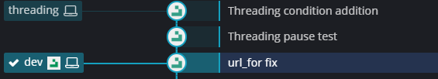

So, my plan for using this second method is the following. I will have two flags which represent whether the capturing process or live stream process is currently running. When the capture flag becomes True, the capture process will wait for the live stream process to finish its current frame iteration and to get stuck in a while loop. Then, the capture process will act out and eventually will finish and change its flag back. Then the live stream will continue. I’ve made a flowchart to try to illustrate this better:

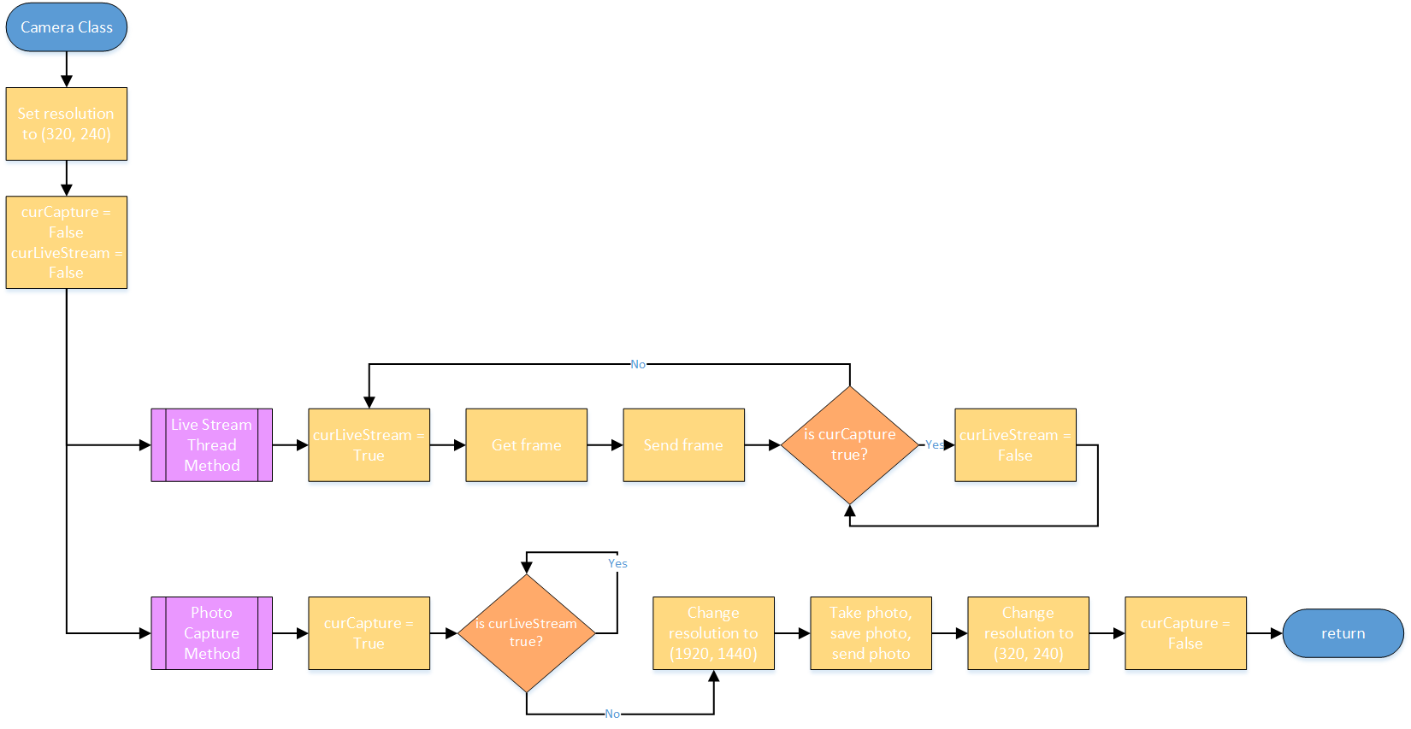

I then went about implementing within my web server’s Camera class.

|  |
| --- |
| class Camera:  curCapture = False  curStream = False  ~~   def capture_image(self, path="", ext="png"):  Camera.curCapture = True   while Camera.curStream is True:  pass   ...   Camera.curCapture = False   return filename, ext  ~~   @classmethod  def _thread(cls):  # Setting currently streaming flag to true  Camera.curStream = True   ...    for foo in cls.camera.capture_continuous(stream, "jpeg", use_video_port=True):   ...   # Wait here for Capture camera process to finish if it requests to be run  if Camera.curCapture is True:  Camera.curStream = False   while Camera.curCapture is True:  pass   Camera.curStream = True   cls.thread = None |

This seemed to work fine but I got an error when I tried to change the resolution. I had removed the try except blocks around the resolution change to see if it would work with the current code but it appeared to not have fixed the issue. I put them back in and hopefully this code should solve any conflicts between the capture and live stream. In the documentation it states that the resolution attribute can’t be changed while the camera is active however it has worked previously.

This seemed to fix the issue.

#### Download Manager

Now I could start working on the download manager so that the photos are saved onto the users’ phone. I began by first adding the write to storage permission to the manifest xml.

|  |
| --- |
| <uses-permission android:name="android.permission.WRITE_EXTERNAL_STORAGE" /> |

I also realised when reading through the [original article](https://www.harpreetstudio.com/2019/12/how-to-create-download-listener-with.html) and this [new article](https://www.mysamplecode.com/2012/09/android-downloadmanager-example.html) that I didn’t need to set a download listener to the webview. Doing that would handle ALL downloads on the webview and I only wanted to handle photo downloads.

While coding the download manager portion, I ran into an issue. In order to set a directory, I had to specify the sub path which had to include the file name. Due to the way my Flask server handled downloads, this wouldn’t work. My current code was as follows for the download manager:

|  |
| --- |
| R.id.action_shutter -> {  // Setting up Download Request Manager  val shutterURL = Uri.parse("$url/photo")  val request = DownloadManager.Request(shutterURL)  request.setDestinationInExternalPublicDir(DIRECTORY_PICTURES, "Need filename...")   // Setting up Main Download Manager  val manager = getSystemService(DOWNLOAD_SERVICE) as DownloadManager   generateSnack(view, "Taken photo", anch = bottomNavigationBar) } |

To fix this I had to change how the Flask server handled downloads. Instead of sending a file to be downloaded to the client, it will instead redirect the user to a URL containing the file. This way I can get the filename from the redirected URL.

I tried making it so that the send_from_directory function doesn’t send an image as an attachment and I modified the passed args to it so that it should work properly.

|  |
| --- |
| @web_app.route("/photo") def photo():   ...    jpeg_name = f"{image_name}.jpeg"  im.save(f"{image_paths[1]}{jpeg_name}") # JPEG   return send_from_directory(image_paths[1], jpeg_name) |

I realised shortly after that you can call a method to get the filename so I modified the call to send it as an attachment again - this required a download listener for the webview however. I decided to run the app and see what would happen with the existing code.

Nothing happened. I forgot to enqueue the download. I added this code and rebooted the program.

|  |
| --- |
| manager.enqueue(request) |

This didn’t do anything. Due to this, I decided to go back to setting a download listener and handling downloads there instead. After trying to figure out how to get the onDownloadStart function working, I asked around and found that for Kotlin Lambdas, you don’t need to override a function if it’s the only function in the class - like for the DownloadListener.

|  |
| --- |
| val view = findViewById<View>(R.id.mainConstraint) webview.setDownloadListener { url, _, contentDisposition, mimeType, _ ->  // Getting filename  val filename = URLUtil.guessFileName(url, contentDisposition, mimeType)   // Setting up Download Request Manager  val request = DownloadManager.Request(Uri.parse(url))  request  .setTitle("Photo")  .setDescription("Taken from RPI")  .setDestinationInExternalPublicDir(DIRECTORY_PICTURES, filename)   // Setting up Main Download Manager  val manager = getSystemService(DOWNLOAD_SERVICE) as DownloadManager  manager.enqueue(request)  } |

When I ran the code nothing seemed to happen. I checked files and there was nothing downloaded. I modified the code a bit to see if it was missing data.

|  |
| --- |
| // Getting filename val filename = URLUtil.guessFileName(url, contentDisposition, mimeType) val cookies = CookieManager.getInstance().getCookie(url)  // Setting up Download Request Manager val request = DownloadManager.Request(Uri.parse(url)) request  .setMimeType(mimeType)  .addRequestHeader("cookie", cookies)  .addRequestHeader("User-Agent", userAgent)  .setTitle(filename)  .setDescription("Taken from RPI")  .setDestinationInExternalPublicDir(DIRECTORY_PICTURES, filename)  // Setting up Main Download Manager val manager = getSystemService(DOWNLOAD_SERVICE) as DownloadManager manager.enqueue(request)  generateSnack(view, "Downloading file") |

Still nothing. I tried changing the directory to the downloads directory to see if that was the issue.

|  |
| --- |
| .setDestinationInExternalPublicDir(DIRECTORY_DOWNLOADS, filename)  ...  generateSnack(view, filename) |

It showed the right filename in the Snackbar when I clicked the shutter button and I could see the image in files now. However, you cannot view the photo in the gallery.

I did some searching and messing around with the Android emulator. I found that when I renamed my downloaded files, it would show them in the gallery under the directory storage/emulated/0/Download/filename. The filename was only the date which was also interesting. To fix this, I changed the naming system on the backend.

I tried adding back in DIRECTORY_PICTURES but that didn’t work. I then spent ages searching online. After literally hours of searching and testing out various bits of code I finally figured out why it wasn’t working.

Google Photos doesn’t like the character #. My file names all followed the format of day-month-year#int which is fine if you want to store the file in the “Files” app. However, the media scanner or Google Photos itself refuses to put your image into the app if it has a # character in the filename. I changed the backend code to change the filename and now the code worked fine. Such an odd bug.

|  |
| --- |
| filename = f"{date.day}-{date.month}-{date.year}-no{counter}"  while True:  if os.path.isfile(f"{path}{filename}.{ext}"): # Increment counter if filename already exists  counter += 1  filename = f"{date.day}-{date.month}-{date.year}-no{counter}" |

#### Double Photo Take Request Bug

Now for some reason, the app was sending two requests to take a photo. I realised that in the Android code, cookies used the URL. This made me think that somehow the cookies method was sending a request to the website in addition to the expected request.

I modified the code to following:

|  |
| --- |
| webview.setDownloadListener { url, _, contentDisposition, mimeType, _ ->  // Getting filename  val filename = URLUtil.guessFileName(url, contentDisposition, mimeType)   // Setting up Download Request Manager  val request = DownloadManager.Request(Uri.parse(url))  request  .setTitle(filename)  .setDescription("Taken from RPI")  .setDestinationInExternalPublicDir(DIRECTORY_DOWNLOADS, filename)   // Setting up Main Download Manager  val manager = getSystemService(DOWNLOAD_SERVICE) as DownloadManager  manager.enqueue(request)   generateSnack(view, filename)  } |

I tried again but still it sent two requests and I also noticed that it had the wrong filename. I came to the conclusion that the following line was most likely sending a request to the server which resulted in it taking a photo.

|  |
| --- |
| val filename = URLUtil.guessFileName(url, contentDisposition, mimeType) |

However, upon running the debugger, I found that the initial webview loading caused the first capture and manager.enqueue(request) caused the second. In order to fix this, I would need to have a system on the backend that would allow you to access images. Then the place where the second capture would happen would instead use the image access route to get the image instead of triggering another capture.

I started by modifying the existing photo route to make more sense name wise. I then created a new path and made it output the path I would input so I could understand what I was working with. Flask recommended using an escape function from markupsafe in it’s documentation so I tried to see how that would affect the path.

|  |
| --- |
| @web_app.route("/get_photo/<path:path>") def get_photo(path):  print(path)  print(escape(path)) |

When I tried to load this route I got an error - I had forgotten to add a return. I modified the code and ran it again.

|  |
| --- |
| @web_app.route("/get_photo/<path:path>") def get_photo(path):  return f"{path}\n{escape(path)}" |

When I went to the route using the URL http://ip:route/get_photo/compressed_photos/14-11-2020-no16.jpeg I saw compressed_photos/14-11-2020-no16.jpeg displayed twice - it seemed like escape in this instance didn’t do much. I then modified the code so that it would send a file from the compressed_photos directory.

|  |
| --- |
| @web_app.route("/get_photo/<path:filename>") def get_photo(filename):  return send_from_directory("compressed_photos/", filename, as_attachment=True) |

When I used this route I could access any file on the RPI within that directory that I requested. When I used an invalid file name it didn’t throw an error on the backend console - it just sent an error 404 on the client end. Now I just had to change the frontend to work with this change.

All I modified was the Download Listener scoped url to thisUrl so that I could access the class scoped url that contains the IP and Port used to connect. I then changed the URL that is loaded to $url/take_photo to comply with the new routing. The download manager request instance now also parses the newUrl instead of the old one.

|  |
| --- |
| webview.setDownloadListener { thisUrl, _, contentDisposition, mimeType, _ ->  // Getting filename and new URL  val filename = URLUtil.guessFileName(thisUrl, contentDisposition, mimeType)  val newUrl = "$url/get_photo/$filename"   // Setting up Download Request Manager  val request = DownloadManager.Request(Uri.parse(newUrl))  ~~  R.id.action_shutter -> {  // Setting up Download Request Manager  val shutterURL = "$url/take_photo" |

This surprisingly worked on the first try and the double request bug had been fixed.

### 3.2 - Timed Shot

#### Backend

Now I had to code the backend for timed shot support. I had previously tried adding in a time.sleep into the take_photo route and surprisingly it worked without interrupting the video stream.

I started with the following code, expecting default kwargs for routes to work as they would in regular Python.

|  |
| --- |
| @web_app.route("/take_photo/<int:dur>") def take_photo(dur=0):  image_paths = ["photos/", "compressed_photos/"]   time.sleep(dur) |

When I tried going to this route however it didn’t work. I checked the [Flask documentation](https://flask.palletsprojects.com/en/1.1.x/api/#url-route-registrations) and it turns out that you’re supposed to use the route decorator with specific syntax for default values. Using this, I modified the code.

|  |
| --- |
| @web_app.route("/take_photo/", defaults={"dur": 0}) @web_app.route("/take_photo/<int:dur>") def take_photo(dur):  image_paths = ["photos/", "compressed_photos/"]   time.sleep(dur) |

This worked perfectly until I tried a float value which obviously didn’t work as expected because it was casting the value to an integer. I quickly fixed this and it worked fine.

|  |
| --- |
| @web_app.route("/take_photo/<float:dur>") |

#### Frontend

Now I had to create a way for this to be activated in the Android app. I had been thinking about my original implementation idea for this where depending on how long you held the shutter button it would wait that long before capturing. So, you would hold the button down for 10 seconds and after that the RPI would wait 10 seconds. The issue with this approach is that it becomes tedious when trying to take a photo.

Instead, a better idea would be to hold the button for a few seconds and it would bring up a menu where you would input in seconds how long you would want to wait.

When I was searching for a way to implement this I found [this article](https://developer.android.com/guide/topics/ui/ui-events.html) on the Documentation. This contained the onLongClick method. This is called when a user presses and holds a button which was perfect for my concept. I checked the BottomNavigationView [reference](https://developer.android.com/reference/com/google/android/material/bottomnavigation/BottomNavigationView) and found it to be one of it’s inherited methods. I read the [reference](https://developer.android.com/reference/android/view/View.OnLongClickListener) for the method and started to implement it.

I first tried by adding a long click listener to the button although I had doubts and believed there could be interference between the Navigation Selected listener.

|  |
| --- |
| bottomNavigationBar.setOnLongClickListener { item ->  generateSnack(view, "HOLDING BUTTON")  when(item.id) {  R.id.action_shutter -> {  generateSnack(view, "YOU HELD THE BUTTON")  }  }  return@setOnLongClickListener true } |

However, nothing happened when I held any of the icons other than it showing their names - built in functionality I presumed. I then tried adding the setOnLongClickListener to one of the items but it appeared as if it wasn’t supported for items - only for views.

I then found a similar question to my current situation on Stack Overflow and found a [response](https://stackoverflow.com/a/59047799/11125378) which isn’t very detailed but provides a potential solution to applying the method to items. I removed the previous code and added this one in instead.

|  |
| --- |
| bottomNavigationBar.findViewById<View>(R.id.action_shutter).setOnLongClickListener{ _ ->  generateSnack(view, "HOLDING BUTTON")  return@setOnLongClickListener true } |

Surprisingly, this worked. It generated the Snackbar when I held the button and didn’t trigger the NavigationItemSelectedListener. When I pressed the button normally the NavigationItemSelectedListener triggered and the onLongClickListener didn’t.

I then copied across the majority of the code and XML for my rotation button action dialogue and repurposed it for this.

|  |
| --- |
| <?xml version="1.0" encoding="utf-8"?> <LinearLayout xmlns:android="http://schemas.android.com/apk/res/android"  android:layout_width="wrap_content"  android:layout_height="wrap_content"  android:orientation="horizontal"  android:layout_marginLeft="20dp"  android:layout_marginTop="30dp"  android:layout_marginRight="20dp"  android:layout_marginBottom="5dp">   <Button  android:id="@+id/btnTimeMinus"  android:layout_width="wrap_content"  android:layout_height="wrap_content"  android:layout_weight="1"  android:minWidth="0dp"  android:paddingStart="0dp"  android:paddingEnd="0dp"  android:text="@string/btnMinus" />   <Button  android:id="@+id/btnTimePlus"  android:minWidth="0dp"  android:paddingStart="0dp"  android:paddingEnd="0dp"  android:layout_width="wrap_content"  android:layout_height="wrap_content"  android:layout_weight="1"  android:text="@string/btnPlus" />   <EditText  android:id="@+id/textfieldTime"  android:layout_width="wrap_content"  android:layout_height="wrap_content"  android:layout_weight="4"  android:fontFamily="sans-serif"  android:hint="@string/seconds"  android:importantForAutofill="no"  android:inputType="number"  android:maxLength="2" />  </LinearLayout> |

|  |
| --- |
| bottomNavigationBar.findViewById<View>(R.id.action_shutter).setOnLongClickListener{ _ ->  val dialog = AlertDialog.Builder(this)  val dialogView = this.layoutInflater.inflate(  R.layout.dialogue_timed,  findViewById(R.id.content),  false  )   // Getting textfield and buttons  val textfieldTime = dialogView.findViewById<EditText>(R.id.textfieldTime)  val btnTimePlus = dialogView.findViewById<Button>(R.id.btnTimePlus)  val btnTimeMinus = dialogView.findViewById<Button>(R.id.btnTimeMinus)    // Setting value limit for text views  textfieldTime.doOnTextChanged { text, _, _, _ ->  val textInt = text.toString().toIntOrNull()  if (textInt != null && textInt < 0) {  textfieldTime.setText("0")  }  textfieldTime.setSelection(textfieldTime.text.length)  }   // Setting onClick actions for inc/dec buttons  btnTimePlus.setOnClickListener { // Increment btnYaw  incrementTextView(textfieldTime, 1)  }   btnTimeMinus.setOnClickListener { // Decrement btnYaw  incrementTextView(textfieldTime, -1)  }   dialog  .setTitle("Choose Time to Wait")  .setView(dialogView)  .setPositiveButton("Confirm") { _, _ ->  val textfieldTimeData = textfieldTime.text.toString()   // <ip>/take_photo/int  webview.loadUrl("$url/take_photo/$textfieldTimeData")   }  .setNegativeButton("Cancel") { _, _ ->  // Do nothing - Android auto dismisses  }  .show() |

When I ran the code I noticed a few issues. The padding on the dialog wasn’t correct and when I tried to confirm a 6 second wait I got a requested URL wasn’t found. When I tried to connect to ip:port/take_photo/1 it didn’t work. I then tried doing the same but with 1.0 as the value instead since I changed the integer to a float and it worked fine. Due to this oddity, I decided to change the backend so that I would convert the value from a string to a float myself.

|  |
| --- |
| @web_app.route("/take_photo/", defaults={"dur": "0"}) @web_app.route("/take_photo/<string:dur>") def take_photo(dur):  dur = float(dur) |

This fixed the issue on my web browser so I tried on the app again. On the app I inputted 5 and it worked perfectly fine. Now all I had to do was clean up the UI on the dialog and I was done.

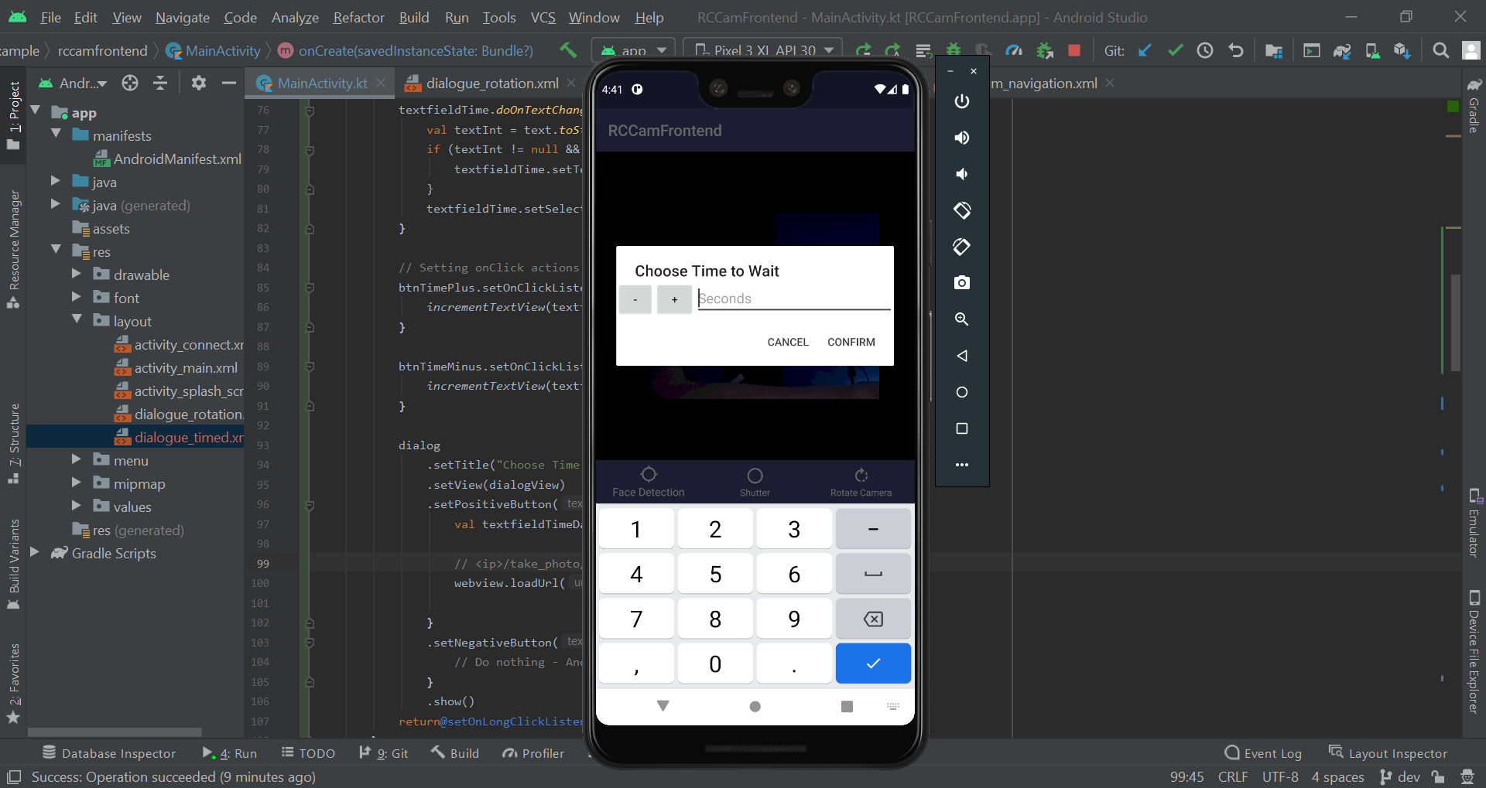

I tried to first move where the margin elements were between elements but that proved to be painful for the top and bottom ones. Instead I reintroduced the LinearLayout parent and suppressed warnings about it being useless - it was far from useless.

|  |
| --- |
| <?xml version="1.0" encoding="utf-8"?> <LinearLayout xmlns:android="http://schemas.android.com/apk/res/android"  xmlns:tools="http://schemas.android.com/tools"  android:layout_width="wrap_content"  android:layout_height="wrap_content"  android:orientation="horizontal">   <LinearLayout  android:layout_width="match_parent"  android:layout_height="match_parent"  android:layout_marginLeft="20dp"  android:layout_marginTop="30dp"  android:layout_marginRight="20dp"  android:layout_marginBottom="5dp"  tools:ignore="UselessParent"> |

This fixed the issue entirely as you can see below.

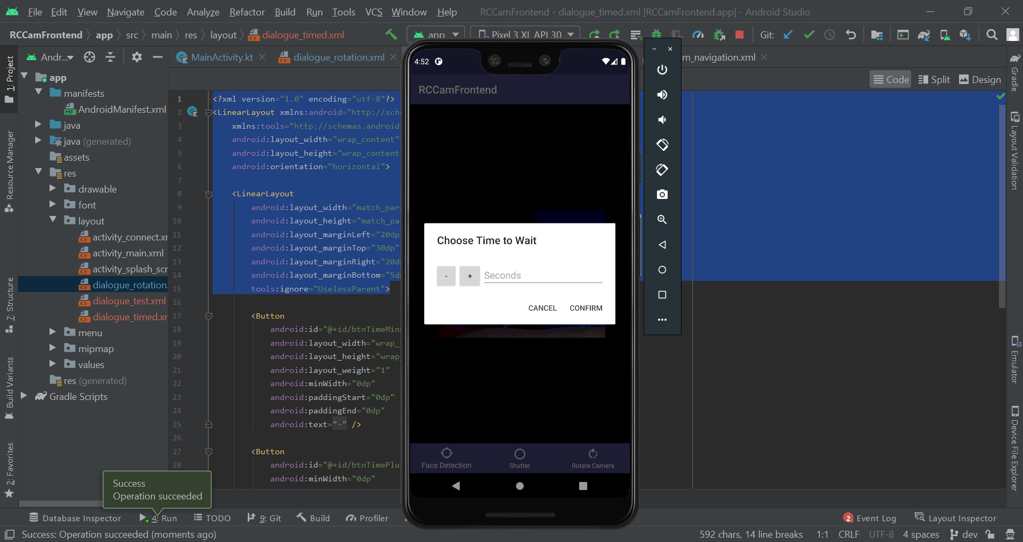

### Module Evaluation

|  |  |  |  |
| --- | --- | --- | --- |
| **Module** | **Criteria** | **Justification** | **Priority** |
| **Take Photo** | 3.1 - Regular Photo | When the user presses the take photo button, it will request for the RPI to take a photo. | **High** |
| 3.2 - Timed Shot | By pressing and holding the take photo button, you can take a timed shot. The number of seconds you hold the button down for will be counted after releasing and then a photo will be taken. | **Low** |
| 3.3 - RPI Take Photo | The user needs to be able to request for the RPI to take a photo. This is vital as the majority of the project relies on this feature to function. | **High** |
| 3.4 - RPI Send Photo | Once the RPI has taken the photo, it will be sent to the user’s phone. This will be a high priority as is vital to the project. | **High** |
| 3.5 - Autosave Image | If the RPI fails to send the user the photo through either connection means, full storage or another factor - the image should still be persistent somewhere. The RPI will save the images taken to local storage. This way the user can access any and all images taken from the RPI. | **Medium** |

Module 3 was completed successfully with all of the success criteria features implemented. It went well and when creating features 3.4 and 3.5, I made it so that the photo taken was in two different quality formats with the worse quality one being sent to the users phone while the RPI kept both in persistent storage.

Similar to Module 1 and 2 however, there are some issues with consistent design. The menu for taking timed shots looks similar to the rotation menu and they both are not consistent with the original planned colour palette.

Despite this, I consider Module 2 as a success. I was able to code every feature within the success criteria and was able to improve upon some of those features.

#### Issues

* GUI menu theming

## Module 4 - Sub Menu



### 4.1 - Sub menu interface

#### Navigation Drawer

Originally, I planned on having a custom animation which displays icons for each of the available options. However, due to Android design philosophy and my lack of knowledge surrounding it, I will be instead using a navigation drawer.

While checking the documentation I found the following [guide](https://developer.android.com/guide/navigation/navigation-ui#add_a_navigation_drawer) and [reference](https://developer.android.com/reference/com/google/android/material/navigation/NavigationView) for the navigation drawer. I will be using these to aid in development.

I started by adding the navigation view to my main activities XML. According to the guide, the root view needed to be a DrawerLayout and the main content and navigation could be separated. Using the guide, I modified my XML to be the following:

|  |
| --- |
| <?xml version="1.0" encoding="utf-8"?> <!-- Use DrawerLayout as root container for activity --> <androidx.drawerlayout.widget.DrawerLayout  xmlns:android="http://schemas.android.com/apk/res/android"  xmlns:app="http://schemas.android.com/apk/res-auto"  android:id="@+id/drawerLayout"  android:layout_width="match_parent"  android:layout_height="match_parent"  android:fitsSystemWindows="true">   <!-- Drawer content -->  <com.google.android.material.navigation.NavigationView  android:id="@+id/navView"  android:layout_width="wrap_content"  android:layout_height="match_parent"  android:layout_gravity="end"  android:fitsSystemWindows="true" />   <!-- Activity Content -->  <androidx.constraintlayout.widget.ConstraintLayout  xmlns:tools="http://schemas.android.com/tools"  android:id="@+id/constraintLayout"  android:layout_width="match_parent"  android:layout_height="match_parent"  tools:context=".MainActivity">   <WebView  android:id="@+id/webview"  android:layout_width="0dp"  android:layout_height="0dp"  android:background="@color/spaceBlue"  app:layout_constraintBottom_toTopOf="@+id/bottomNavigationBar"  app:layout_constraintEnd_toEndOf="parent"  app:layout_constraintStart_toStartOf="parent"  app:layout_constraintTop_toTopOf="parent">   </WebView>   <com.google.android.material.bottomnavigation.BottomNavigationView  android:id="@+id/bottomNavigationBar"  android:layout_width="0dp"  android:layout_height="wrap_content"  android:layout_gravity="start"  android:background="@color/spaceBlue"  app:itemBackground="@color/spaceBlue"  app:itemIconTint="@color/white"  app:itemTextColor="@color/white"  app:layout_constraintBottom_toBottomOf="parent"  app:layout_constraintEnd_toEndOf="parent"  app:layout_constraintStart_toStartOf="parent"  app:menu="@menu/bottom_navigation" />   </androidx.constraintlayout.widget.ConstraintLayout>  </androidx.drawerlayout.widget.DrawerLayout> |

In this, I made sure to set the layout_gravity of the navigation view to end so that it would appear from the right side of the screen.

When trying to find how to implement the navigation drawer, I found that I had been handling navigation in an outdated fashion. Despite this, I found a [detailed video](https://www.youtube.com/watch?v=T9S9rhFOxao&ab_channel=JohanJurrius) on how to implement a custom action bar. I could add a navigation drawer to the custom action bar but I could also add icons to it which I previously thought wasn’t possible. Due to this, I reverted the changes made previously and began working on an action bar.

#### Action Bar

To implement an action bar, I started by overriding the onCreateOptionsMenu function so that I could inflate the existing options menu - a part of the action bar for icons.

|  |
| --- |
| override fun onCreateOptionsMenu(menu: Menu?): Boolean {  menuInflater.inflate(R.menu.INSERT_FILENAME_HERE, menu) // Add menu filename  return super.onCreateOptionsMenu(menu) } |

In order for this to work, I needed to create a menu XML file. I created one under the menu resource directory and coded the following XML:

|  |
| --- |
| <?xml version="1.0" encoding="utf-8"?> <menu xmlns:android="http://schemas.android.com/apk/res/android">  <item android:title="@string/share_latest_photo"  android:id="@+id/share"  android:icon="" />   <item android:title="Open Photo Gallery"  android:id="@+id/open_photo_gallery"  android:icon="" />   <item android:title="About"  android:id="@+id/about"  android:icon="" />  </menu> |

These items currently didn’t have an icon so I added 3 new vector assets to my drawables and then modified the XML to reference these. I also made sure to extract the string resources for the open photo gallery button and the about button. Then, I included a few more tags from the [menu reference](https://developer.android.com/guide/topics/resources/menu-resource).

|  |
| --- |
| <?xml version="1.0" encoding="utf-8"?> <menu xmlns:app="http://schemas.android.com/apk/res-auto"  xmlns:android="http://schemas.android.com/apk/res/android">  <item android:title="@string/open_photo_gallery"  android:titleCondensed="Photo Gallery"  android:id="@+id/open_photo_gallery"  android:icon="@drawable/ic_round_photo_library_24"  app:showAsAction="ifRoom" />   <item android:title="@string/share_latest_photo"  android:id="@+id/share"  android:icon="@drawable/ic_baseline_share_24"  app:showAsAction="ifRoom" />   <item android:title="@string/about"  android:id="@+id/about"  android:icon="@drawable/ic_baseline_info_24"  app:showAsAction="ifRoom" />  </menu> |

When I booted up the app, nothing was different on the connect screen. However, when I went to the main GUI I could see my three icons. Pressing and holding on them also showed their titles. They had no functionality since I hadn’t programmed them to yet but they were showing as expected.

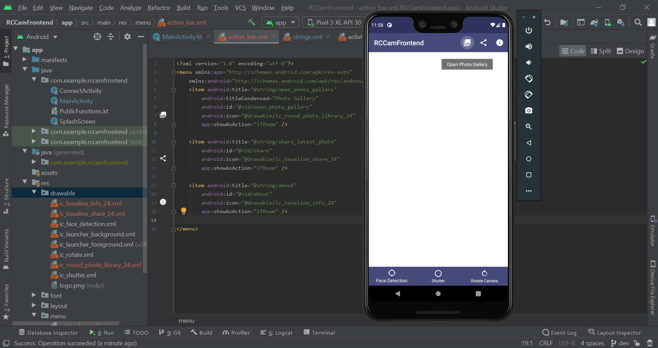

I then tried to change the title - currently RCCamFrontend. That way I can be more specific about the screen they are on. I started by trying the following line of code under the onCreate method.

|  |
| --- |
| actionBar?.title = "TEST" |

However, this seemingly didn’t affect anything. I then tried the following line of code which was more inline with the proposed function in the documentation that returns a reference for the action bar.

|  |
| --- |
| supportActionBar?.title = "TEST" |

This worked so I added the following lines of code for both the connect and the main GUI.

|  |
| --- |
| // Connect UI supportActionBar?.title = "Connect to RPI"  ~~  // Main UI supportActionBar?.title = "" |

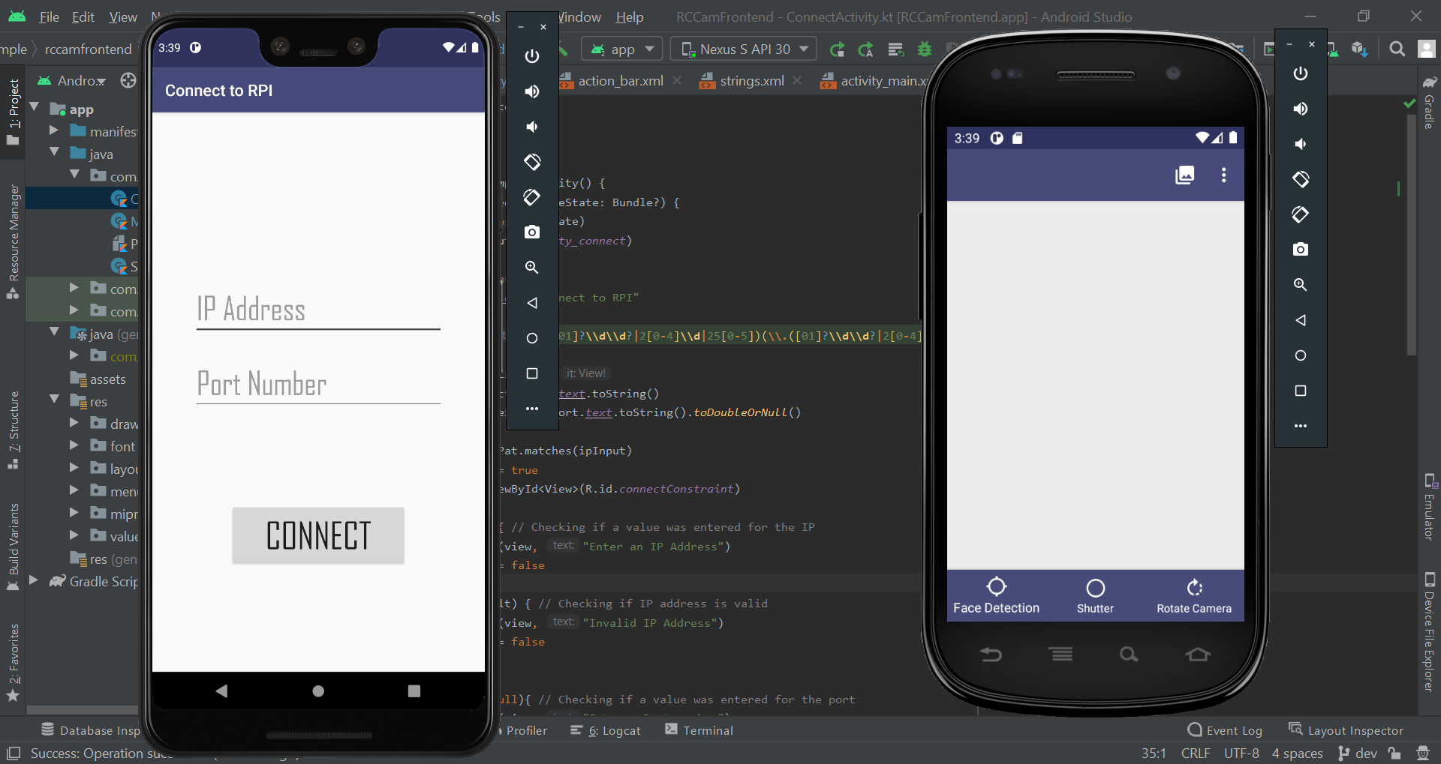

#### Item Functionality

I decided it would be best to set up the basic functionality so that it would be easier to implement proper functionality for later.

I started by reading the [documentation](https://developer.android.com/training/appbar/actions#handle-actions) and found the onOptionsItemSelected function to override.

|  |
| --- |
| override fun onOptionsItemSelected(item: MenuItem): Boolean {  return super.onOptionsItemSelected(item) } |

I then added a when statement for all of the IDs in the action bar so that I could easily write code for these later.

|  |
| --- |
| override fun onOptionsItemSelected(item: MenuItem): Boolean {  when(item.itemId){  R.id.open_photo_gallery -> {  // Open Photo Gallery Clicked  }  R.id.share -> {  // Share Media Clicked  }  R.id.about -> {  // About clicked  }  }  return super.onOptionsItemSelected(item) } |

### 4.2 - Share Media

For sharing media, I would need to have the ability to share the most recent image taken. An easy solution would be to store the URI of an image after it has been taken in a variable and use that with the sharing intent. However, this won’t work in the case of the user initially booting up the app or the app is closed and is reopened. So, I will instead use persistent storage and will update the value for the URI when a new photo is downloaded.

#### Persistent Storage for Image URIs

In order to set this up for when I download the photos, I needed to modify the download manager. I instantiated a broadcast manager and registered it to respond to the download manager completing a download. I then created toasts to test to see if it was functioning properly.

|  |
| --- |
| // Setting up Main Download Manager val manager = getSystemService(DOWNLOAD_SERVICE) as DownloadManager manager.enqueue(request)  val onDownloadComplete = object : BroadcastReceiver() {  override fun onReceive(context: Context?, intent: Intent?) {  val id = intent!!.getLongExtra(DownloadManager.EXTRA_DOWNLOAD_ID, -1)  if (id != -1L) {  // File received  val uri = manager.getUriForDownloadedFile(id)  generateToast(this@MainActivity, id.toString())   // TODO: save URI to shared preference  } else {  generateToast(this@MainActivity, "Failed to get ID, $id")  }  } }  registerReceiver(  onDownloadComplete,  IntentFilter(DownloadManager.ACTION_DOWNLOAD_COMPLETE) )  generateSnack(view, filename) |

When I pressed the shutter button, a toast appeared displaying the number “49”. I then modified the code to show a toast for the URI to see if it was managing to get that.

|  |
| --- |
| generateToast(this@MainActivity, uri.toString()) |

When I pressed the shutter button again, it displayed a URI terminating with “50” which I presumed was the ID. Now I could use something called a Shared Reference to store the URI as a key value pair. This would allow me to have access to this data even when the program is closed.

|  |
| --- |
| // File received val uri = manager.getUriForDownloadedFile(id) with(getPreferences(Context.MODE_PRIVATE).edit()){  putString("URI", uri.toString())  apply() } |

When I ran the app and pressed the shutter button there wasn’t an error outputted to the console so I presumed everything was working as expected.

#### Share Media Intent

Using this article, I tried calling the share media intent and passing the image URI that I retrieved from shared preferences. If there wasn’t an existing URI stored, then “” would be passed by default. If that is returned then a snackbar is shown to the user.

|  |
| --- |
| R.id.share -> {  // Share Media Clicked   with(Intent(Intent.ACTION_SEND)){  val sharedPref = getPreferences(Context.MODE_PRIVATE)  val imagePath = sharedPref.getString("URI", "")   if (imagePath == ""){  generateSnack(findViewById(R.id.mainConstraint), "You haven't got a recent photo to share yet")  } else {  type = "image/*"  putExtra(Intent.EXTRA_STREAM, Uri.parse(imagePath))  startActivity(Intent.createChooser(this, "Share Image Using"))  }  } } |

When I ran the program and clicked the share media button the android share prompt appeared. I went through the available programs to see if it was displaying the image and eventually found print to show it. To make sure it was using the most recent image I took another and pressed share media again.

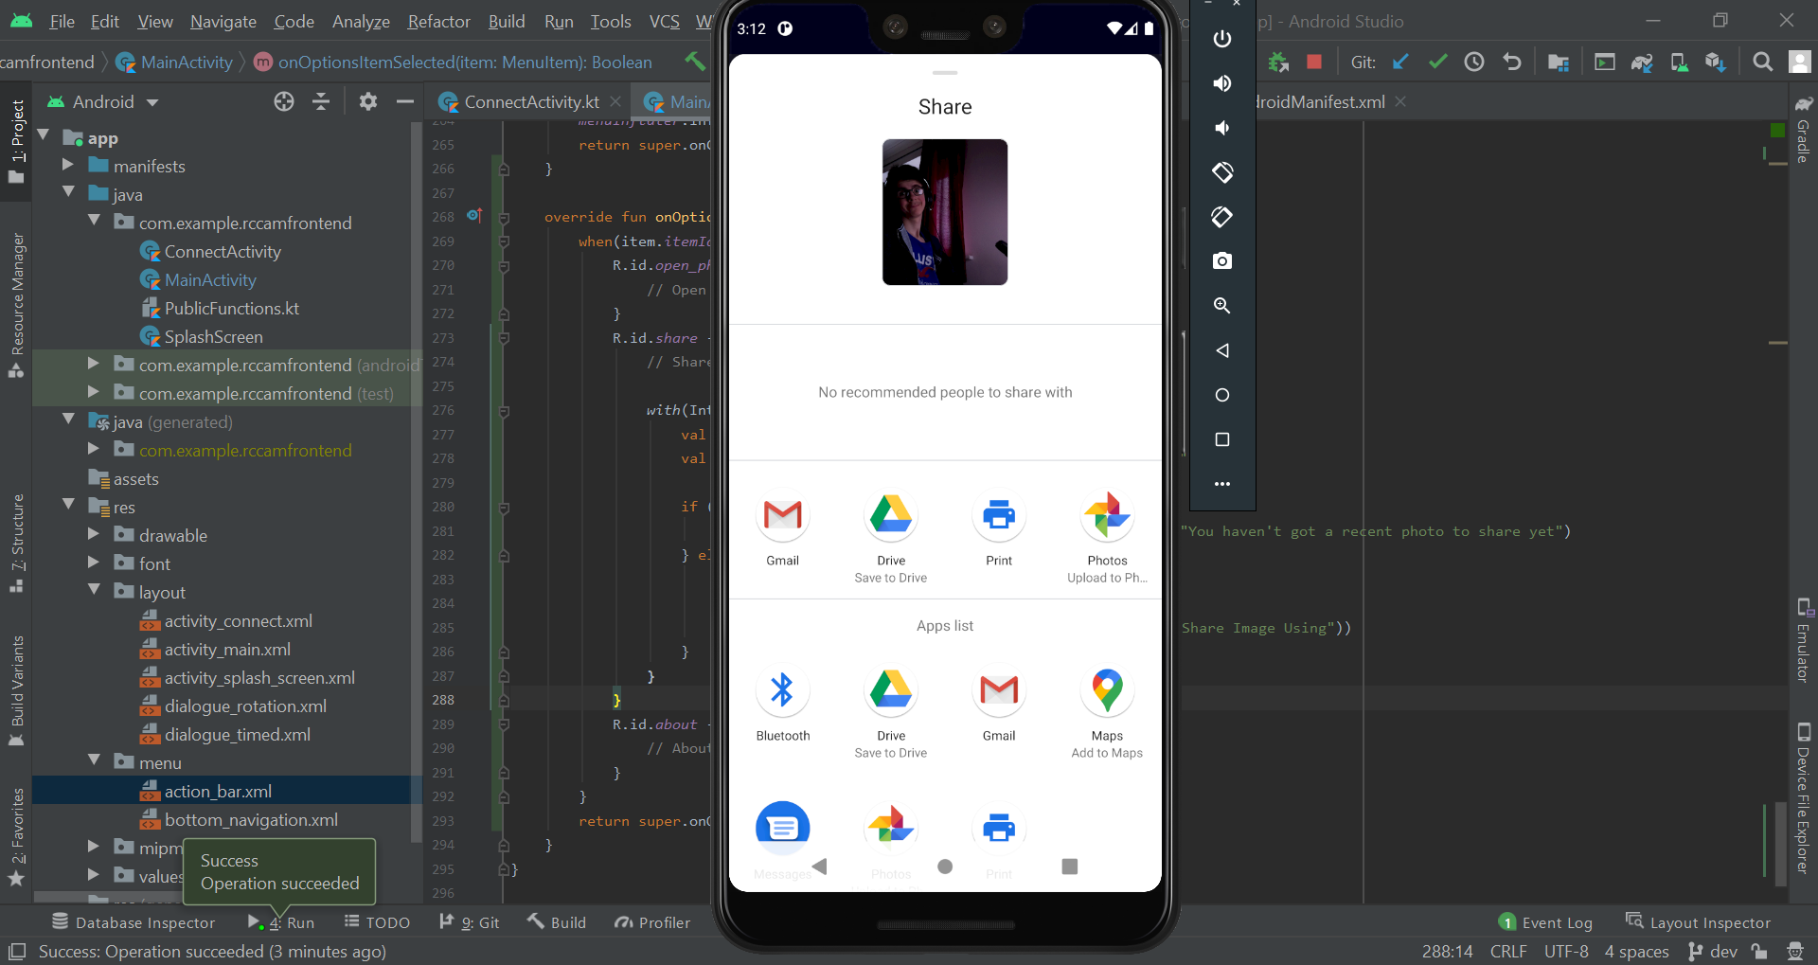

This time it showed the image in the share media prompt. I restarted the app and pressed it again. It still showed the image in the share media which was good. It was seemingly working. I hadn’t yet seen what would happen if a URI wasn’t stored in preferences.

To test this I went to the emulators settings and deleted the existing storage used by the app - this would hopefully remove the shared preference. I then booted up the app again and pressed share media. It showed the snackbar but wasn’t anchored properly.

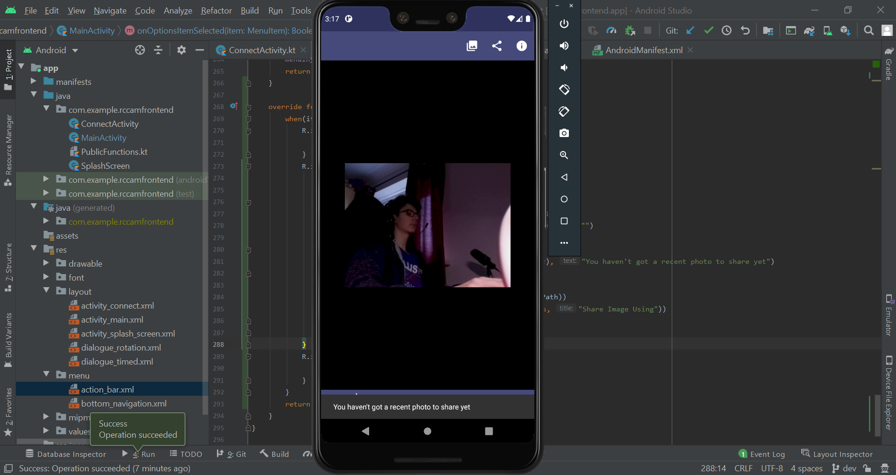

I modified the code and it was anchored to the bottom nav bar as intended.

|  |
| --- |
| if (imagePath == ""){  generateSnack(  findViewById(R.id.mainConstraint),  "You haven't got a recent photo to share yet",  anch = bottomNavigationBar  ) } else {  ... } |

After reading the documentation to add in any code to make it better I added the following as recommended:

|  |
| --- |
| flags = Intent.FLAG_GRANT_READ_URI_PERMISSION |

### 4.3 - Open Photo Gallery

#### Intents

Opening the photo gallery should be a fairly simple task using intents. All the app needs to do is just open the photo gallery when the button is pressed.

I searched for example code in the documentation and couldn’t find anything - intents are fairly difficult for me to understand properly. I checked Stack Overflow and found this [question](https://stackoverflow.com/questions/18416122/open-gallery-app-in-android) with code in the answers. I tried implementing that code into my own.

|  |
| --- |
| R.id.open_photo_gallery -> {  // Open Photo Gallery Clicked   val intent = Intent(  Intent.ACTION_VIEW,  Uri.parse("content://media/internal/images/media")  )  startActivity(intent) } |

This opened the photo gallery when I pressed the button. However, it was opened within my app instead of separately. I searched the documentation and found FLAG_ACTIVITY_NEW_TASK. I tried adding this to my code to see if it would open it outside of my app.

|  |
| --- |
| intent.addFlags(Intent.FLAG_ACTIVITY_NEW_TASK) |

This worked and the app opened outside of my own.

### 4.4 - About Page

#### Activity Initialisation

I started by first generating a new activity called AboutActivity which will host the about page. I then added the following code to my MainActivity.

|  |
| --- |
| R.id.about -> {  // About clicked   val intent = Intent(this, AboutActivity::class.java)  startActivity(intent) } |

I then modified the layout of the activity to the basic following to see if it was all working as intended.

|  |
| --- |
| <?xml version="1.0" encoding="utf-8"?> <androidx.constraintlayout.widget.ConstraintLayout xmlns:android="http://schemas.android.com/apk/res/android"  xmlns:app="http://schemas.android.com/apk/res-auto"  xmlns:tools="http://schemas.android.com/tools"  android:layout_width="match_parent"  android:layout_height="match_parent"  tools:context=".AboutActivity">   <TextView  android:id="@+id/textView2"  android:layout_width="match_parent"  android:layout_height="wrap_content"  android:text="TEST"  app:layout_constraintTop_toTopOf="parent"  tools:layout_editor_absoluteX="0dp" />   <TextView  android:id="@+id/textView3"  android:layout_width="match_parent"  android:layout_height="wrap_content"  android:text="@string/contact"  app:layout_constraintTop_toBottomOf="@+id/textView2"  tools:layout_editor_absoluteX="0dp" /> </androidx.constraintlayout.widget.ConstraintLayout> |

I booted up the app and went to the about page - it didn’t look aesthetically pleasing currently but functionality wise it was working fine. The live stream also didn’t end after waiting 10 seconds on the about page and navigating back. I presumed this meant that webviews from previous activities remained loaded.

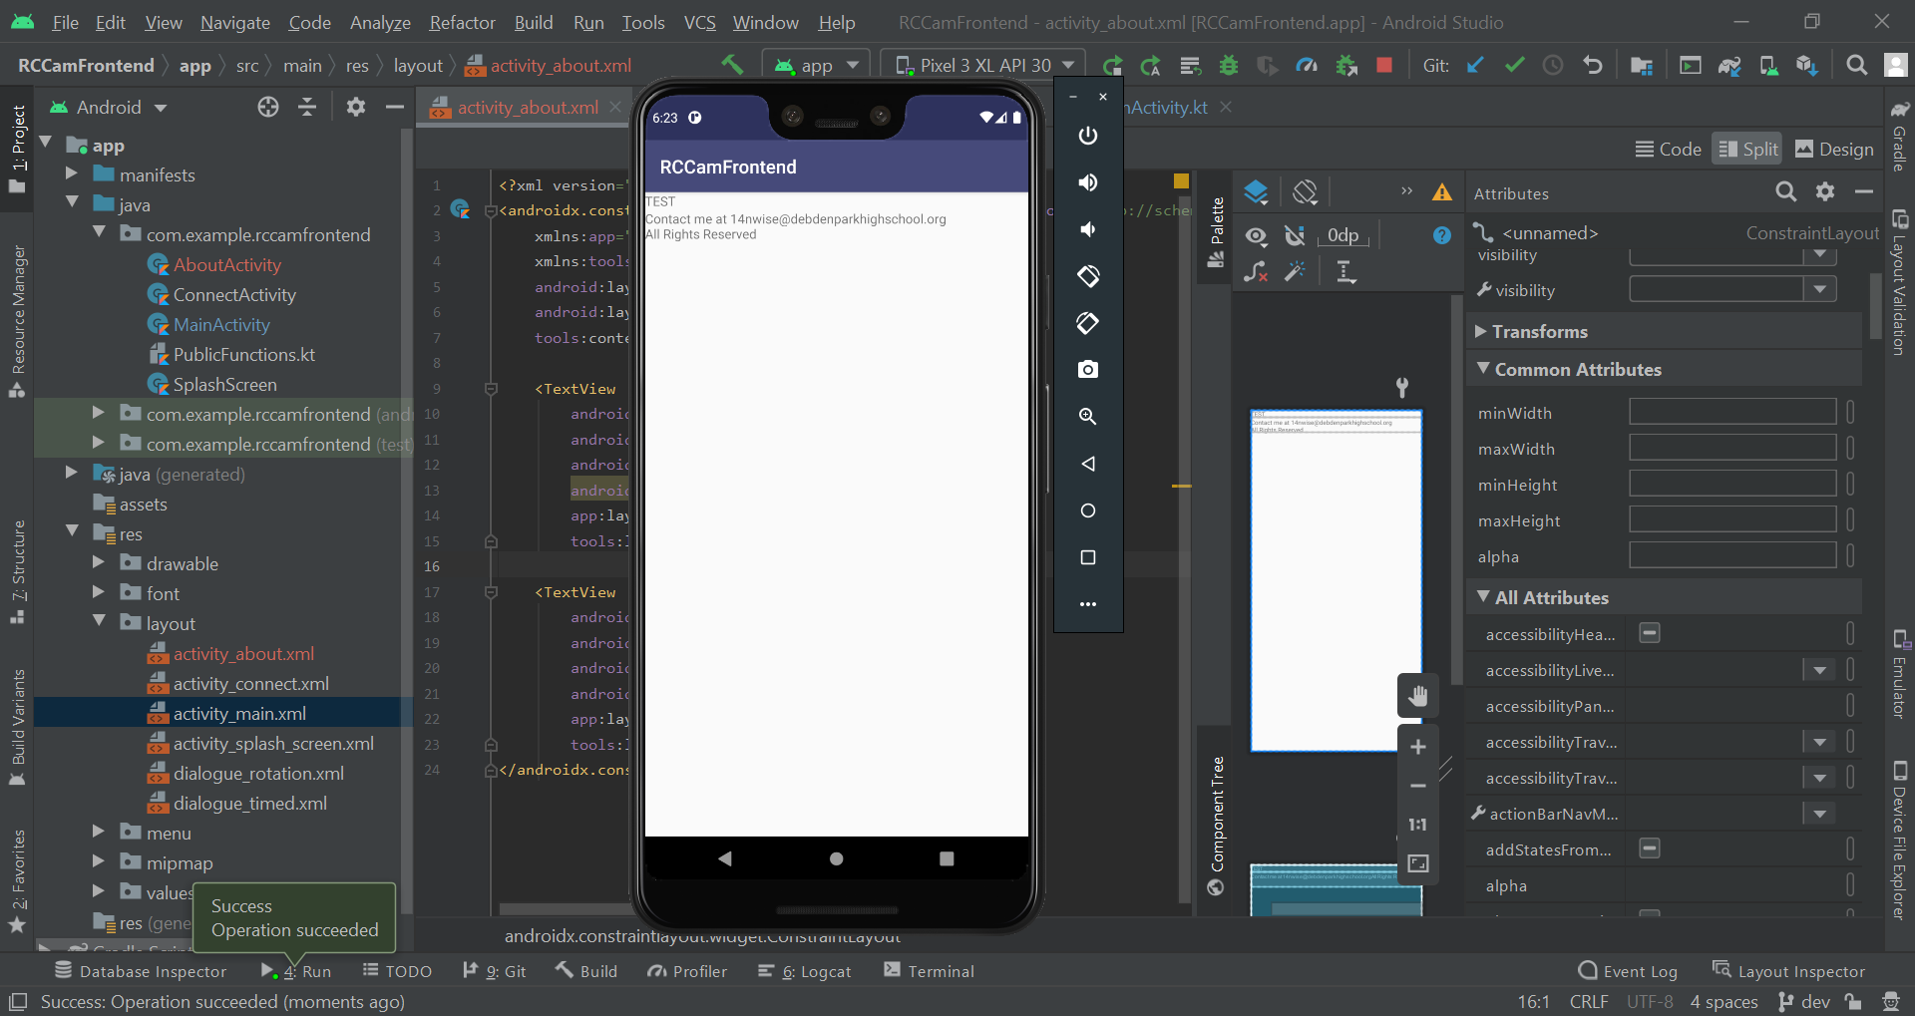

#### Dynamic Information

I am aiming to make the about screen similar to the GUI design which you can see below.



In order to get the action bar to look similar to the one above, I started by first modifying the title of it.

|  |
| --- |
| override fun onCreate(savedInstanceState: Bundle?) {  super.onCreate(savedInstanceState)  setContentView(R.layout.activity_about)   // Modifying Action Bar  supportActionBar?.title = "About" } |

I then added support for showing the IP and Port entered to connect to the RPI. I modified the XML for the about page to be the following.

|  |
| --- |
| <?xml version="1.0" encoding="utf-8"?> <androidx.constraintlayout.widget.ConstraintLayout xmlns:android="http://schemas.android.com/apk/res/android"  xmlns:app="http://schemas.android.com/apk/res-auto"  xmlns:tools="http://schemas.android.com/tools"  android:layout_width="match_parent"  android:layout_height="match_parent"  tools:context=".AboutActivity">   <TextView  android:id="@+id/textViewNet"  android:layout_width="match_parent"  android:layout_height="wrap_content"  android:text="@string/ip_nport"  app:layout_constraintTop_toTopOf="parent"  tools:layout_editor_absoluteX="0dp" />   <TextView  android:id="@+id/textViewVer"  android:layout_width="match_parent"  android:layout_height="wrap_content"  android:text="@string/version"  app:layout_constraintTop_toBottomOf="@+id/textViewNet"  tools:layout_editor_absoluteX="0dp" />   <TextView  android:id="@+id/textViewContact"  android:layout_width="match_parent"  android:layout_height="wrap_content"  android:text="@string/contact"  app:layout_constraintTop_toBottomOf="@+id/textViewVer"  tools:layout_editor_absoluteX="-16dp" /> </androidx.constraintlayout.widget.ConstraintLayout> |

This involved adding a new text view, modifying the text view IDs and other attributes. I then began working on modifying the text views to have their data change when the user views them. This way I can show the current version number and the port and IP address they entered earlier.

I started by modifying the string values to be able to be formatted:

|  |
| --- |
| <string name="ip_port">IP: %1$s\nPort: %2$s</string> <string name="version">Version: %1$s</string> |

I then added the following code to modify the values - the “1” for version is a temporary value.

|  |
| --- |
| override fun onCreate(savedInstanceState: Bundle?) {  ...   // Modifying Text views  val textViewNet = findViewById<View>(R.id.textViewNet) as TextView  val textViewVer = findViewById<View>(R.id.textViewVer) as TextView   val ip = intent.getStringExtra("ip")  val port = intent.getStringExtra("port")  textViewNet.text = getString(R.string.ip_port, ip, port)   textViewVer.text = getString(R.string.version, "1") } |

When I ran the application, the IP and Port strings were showing “null” and the version was showing 1. I checked the code for when the about button was pressed and realised that the code for getting the strings to be put used a reserved variable name. I changed this and ran the program again.

|  |
| --- |
| R.id.about -> {  // About clicked   val aboutIntent = Intent(this, AboutActivity::class.java)  aboutIntent.putExtra("ip", intent.getStringExtra("ip"))  aboutIntent.putExtra("port", intent.getStringExtra("port"))  startActivity(aboutIntent) } |

This time it worked fine - although it still didn’t look like a nice UI. I still needed to add proper functionality to my version portion of the about page. So, I added a versionName attribute to my manifest. Version name is the value that the user will see while version number is an internal integer value used when publishing to help the play store identify between versions. I found this out within the [documentation](https://developer.android.com/studio/publish/versioning.html) and added to my manifest using it.

|  |
| --- |
| <manifest xmlns:android="http://schemas.android.com/apk/res/android"  package="com.example.rccamfrontend"  android:versionName="1.0.0"> |

I then found a [Stack Overflow answer](https://stackoverflow.com/a/3637686/11125378) for a simple way to get the version name within my code using the Gradle build. I implemented this into my code and ran it.

|  |
| --- |
| textViewVer.text = getString(R.string.version, BuildConfig.VERSION_NAME) |

This only showed “1.0” as my version however. I modified the value in the manifest to “2.0.1” and ran the app again. This however didn’t change anything and the “1.0” still showed. I then changed the code to the alternate answer and converted it to Kotlin.

|  |
| --- |
| val versionName = packageManager.getPackageInfo(packageName, 0).versionName textViewVer.text = getString(R.string.version, versionName) |

This also didn’t work. I tried adding a version code to see if it required one for the version name to function.

|  |
| --- |
| android:versionCode="1" |

Unfortunately, this didn’t work either. I read over the version guide and found that I was supposed to be modifying the gradle file - not the manifest. I found a very specific note in the guide as well: “If your app defines the app version directly in the manifest element, the version values in the Gradle build file will override the settings in the manifest”. I found the following part in the Gradle which explained a lot:

|  |
| --- |
| defaultConfig {  applicationId "com.example.rccamfrontend"  minSdkVersion 28  targetSdkVersion 30  versionCode 1  versionName "1.0"   testInstrumentationRunner "androidx.test.runner.AndroidJUnitRunner" } |

I tried modifying the versionName to “1.0.0” and ran the program. This worked. I then changed my code back to the previous version where just BuildConfig.VERSION_NAME is used to get the version name.

#### Theming

Now I wanted to prioritise making the UI look decent - similar to the GUI design I had created previously. This involved creating a new colour for the action bar called deepBlue (#1D2147) in the colours XML file.

|  |
| --- |
| <color name="deepBlue">#1D2147</color> |

After modifying the theme a lot I eventually ended up removing the deep blue. This led to a lot of the rest of the application becoming vastly different due to the theme being heavily modified. A lot of the app now more closely resembles the initial designs.

|  |
| --- |
| <resources>  <!-- Base application theme. -->  <style name="AppTheme" parent="Theme.AppCompat.Light.DarkActionBar">  <!-- App Body Colours -->  <item name="colorPrimary">@color/midnightBlue</item>  <item name="colorPrimaryDark">@color/midnightBlue</item>  <item name="colorAccent">@color/white</item>  <item name="android:windowBackground">@color/spaceBlue</item>   <!-- Default Control Colours -->  <item name="colorControlNormal">@color/navy</item>  <item name="colorControlActivated">@color/white</item>   <!-- Text Related -->  <item name="android:textColor">@color/white</item>  <item name="android:textColorPrimary">@color/white</item>  <item name="android:textColorHint">@color/lightGray</item>   <!-- Button Related -->  <item name="android:colorButtonNormal">@color/slateBlue</item>  </style>   <style name="TextAppearance.AppCompat.Widget.ActionBar.Title" parent="@android:style/TextAppearance">  <item name="android:fontFamily">@font/agencyr</item>  <item name="android:textSize">35sp</item>  </style>  </resources> |

I then added the following view to create a line break between the text views and added padding so that the components didn’t take up the full screen.

|  |
| --- |
| <androidx.constraintlayout.widget.ConstraintLayout xmlns:android="http://schemas.android.com/apk/res/android"  xmlns:app="http://schemas.android.com/apk/res-auto"  xmlns:tools="http://schemas.android.com/tools"  android:layout_width="match_parent"  android:layout_height="match_parent"  android:paddingHorizontal="15dp"  tools:context=".AboutActivity">  ~~  <View  android:id="@+id/line"  android:layout_width="match_parent"  android:layout_height="2dp"  android:background="@color/navy"  app:layout_constraintTop_toBottomOf="@+id/textViewNet" /> |

I then proceeded to edit a lot of the UI. In order for there to be consistency within the margin space between components I had to create a dimens.xml file to store the dp value. This way I could modify a single value and the margins for all components would change.

|  |
| --- |
| <?xml version="1.0" encoding="utf-8"?> <resources>  <dimen name="about_margin">20dp</dimen> </resources> |

My final result for the about page was fairly similar to the GUI design - outside of the italic font, the circles in the background and the alignment for the text fields.

|  |
| --- |
| <?xml version="1.0" encoding="utf-8"?> <androidx.constraintlayout.widget.ConstraintLayout xmlns:android="http://schemas.android.com/apk/res/android"  xmlns:app="http://schemas.android.com/apk/res-auto"  xmlns:tools="http://schemas.android.com/tools"  android:layout_width="match_parent"  android:layout_height="match_parent"  android:paddingHorizontal="15dp"  tools:context=".AboutActivity">   <View  android:id="@+id/about_line1"  android:layout_width="match_parent"  android:layout_height="5dp"  android:layout_marginTop="@dimen/about_margin"  android:background="@color/navy"  app:layout_constraintTop_toTopOf="parent" />   <TextView  android:id="@+id/textViewNet"  android:layout_width="match_parent"  android:layout_height="wrap_content"  android:layout_marginTop="@dimen/about_margin"  android:fontFamily="@font/agencyr"  android:text="@string/ip_port"  android:textSize="30sp"  app:layout_constraintTop_toBottomOf="@+id/about_line1" />    <View  android:id="@+id/about_line2"  android:layout_width="match_parent"  android:layout_height="5dp"  android:layout_marginTop="@dimen/about_margin"  android:background="@color/navy"  app:layout_constraintTop_toBottomOf="@+id/textViewNet" />   <TextView  android:id="@+id/textViewVer"  android:layout_width="match_parent"  android:layout_height="wrap_content"  android:layout_marginTop="@dimen/about_margin"  android:text="@string/version"  android:fontFamily="@font/agencyr"  android:textSize="30sp"  app:layout_constraintTop_toBottomOf="@+id/about_line2" />   <View  android:id="@+id/about_line3"  android:layout_width="match_parent"  android:layout_height="5dp"  android:layout_marginTop="@dimen/about_margin"  android:background="@color/navy"  app:layout_constraintTop_toBottomOf="@+id/textViewVer" />   <TextView  android:id="@+id/textViewContact"  android:layout_width="match_parent"  android:layout_height="wrap_content"  android:layout_marginTop="@dimen/about_margin"  android:text="@string/contact"  android:fontFamily="@font/agencyr"  android:textSize="30sp"  android:textAlignment="center"  app:layout_constraintTop_toBottomOf="@+id/about_line3" />   <ImageView  android:id="@+id/image"  android:layout_width="200dp"  android:layout_height="200dp"  android:layout_marginTop="50dp"  android:src="@drawable/logo"  app:layout_constraintEnd_toEndOf="parent"  app:layout_constraintStart_toStartOf="parent"  app:layout_constraintTop_toBottomOf="@+id/textViewContact" />  </androidx.constraintlayout.widget.ConstraintLayout> |

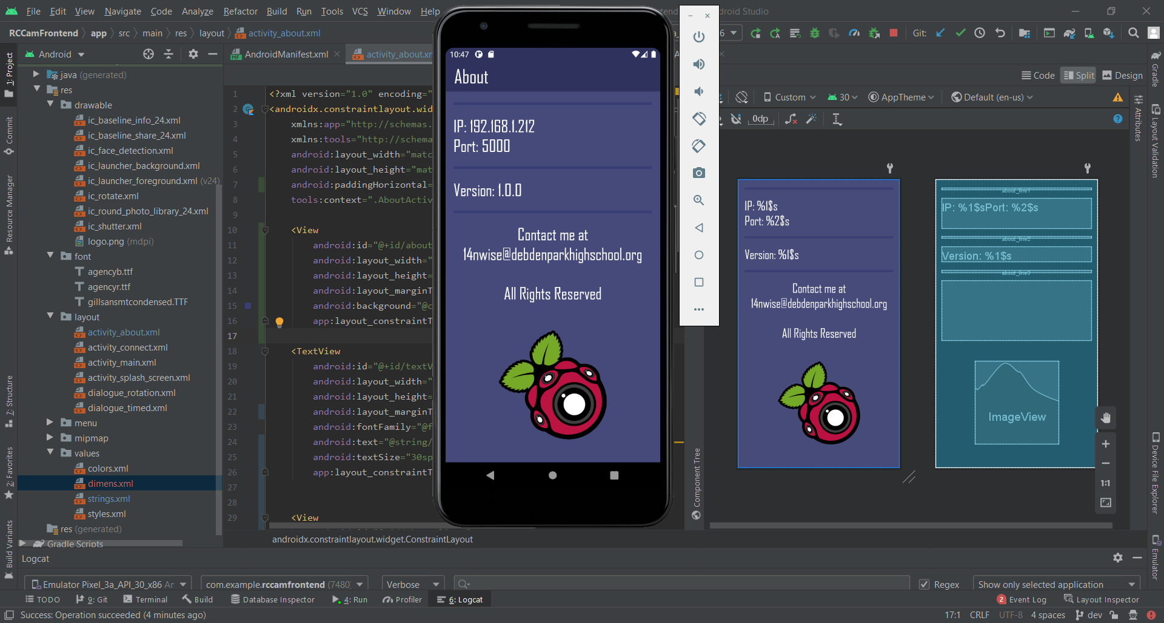

### Module Evaluation

|  |  |  |  |
| --- | --- | --- | --- |
| **Module** | **Criteria** | **Justification** | **Priority** |
| **Submenu** | 4.1 - Sub menu interface | The button to access the submenu will be located in the top left. This will avoid interference with the main interface that will be used more often | **Medium** |
| 4.2 - Share Media | This brings up the generic share menu built into a lot of android apps. Using this will share the most recent photo taken. | **Low** |
| 4.3 - Open Photo Gallery | Opens the Android photo gallery on the user’s phone; means that I don’t have to implement a custom-built photo gallery into the app. | **Medium** |
| 4.4 - About page | Brings up a page which shows information ranging from the connection information to the RPI to my contact details for feedback. | **Low** |

Module 4 was a success; all of the success criteria features have been implemented and I don’t know of any bugs - although I haven’t fully tested it or any other module yet.

The only potential issue which is up for debate is the lack of an animation as originally planned for the sub menu and the positioning of it. However, when I read the Material design guide built by Android, it seems as if the approach I have undertaken was better and more consistent with Android theming.

Another issue I noticed is that by changing the theme of the app for the about screen to look better is that a few parts of the app have changed for the worse. For example, the rotation menu and timed shot menu have white text on a white background which makes it illegible when trying to see what the buttons do or what data you inputted.

However, since the theming issue for other GUI components isn’t a part of this module, it hasn’t been fixed here and will be addressed in development after this module.

Also, sometimes the share prompt will show the photo you are going to be sharing and sometimes it doesn’t. This is most likely the result of the emulator still saving the image so I don’t believe I can fix this.

Asides from the addressed issues, the rest of the module went well.

#### Issues

* Share menu sometimes doesn’t preview the image you’re going to share

# Testing

## Overall Evaluation

All in all, the modules went relatively well. There are some issues still present in the app however which should all be resolved if possible before I move on to properly testing each module. I compiled these into the table below.

|  |  |  |  |  |
| --- | --- | --- | --- | --- |
| **Module** | **Issue** | **Description** | **Potential Solution** | **Priority** |
| **Main Interface** | Connect Button Bug | When pressing the connect button after entering valid data into the IP and Port fields, the app might not move on to the Main GUI screen. | Changing how the Flask server returns the live video feed so that the page isn’t constantly loading - look into templates and how to properly set up a Flask server. | **High** |
| **Camera Rotation** | Menu GUI theme | The menu GUI is unreadable and doesn't fit the colour palette chosen in the design phase. | Design a new menu design that fits the colour palette and implement it. | **Medium** |
| Face Detection | Face detection - one of the more complicated features - hasn’t been implemented despite it being in the success criteria. | Look into an alternative library that can easily be applied and utilised. | **Low** |
| **Take Photo** | Menu GUI theme | The menu GUI is unreadable and doesn't fit the colour palette chosen in the design phase. | Design a new menu design that fits the colour palette and implement it. | **Medium** |
| **Submenu** | Share Menu image Preview | The most recent photo doesn’t always show up in the share menu preview. | Force the image to be displayed or determine whether it’s due to the image still being saved to the clients device. | **Low** |
| **None** | Structure | The current way the project is structured in terms of code and file layout is poor for maintenance. | Code under setting listeners among other things should be put into classes or functions. | **High** |

These issues can be simplified into the following issues that I need to work on:

|  |  |  |  |
| --- | --- | --- | --- |
| **Issue ID** | **Issue Name** | **Description** | **Priority** |
| **1** | **Code Structure** | Completely overhauling the code structure of the project. This mainly includes moving certain parts of code into separate functions and classes. It also includes adding smaller features like comments where deemed necessary. | **High** |
| **2** | **Connect GUI Bug** | Fixing the bug with the “Connect” button not always taking the user to the next screen when a valid IP and Port have been entered for a live RPI web server. | **High** |
| **3** | **Menu GUI Styling** | Improving all of the menu GUIs that exist in the app so that they are fully readable and suit the app better. | **Medium** |
| **4** | **Share Menu Image Preview** | Trying to get the Share Menu to consistently show an image preview when activated. | **Low** |

I ordered the criteria above by priority and by the order in which I will attempt to tackle them. There is no guarantee that I will be successful in development when attempting to solve these problems but I will still try nonetheless. I decided against working on face detection as I felt it was a minor feature and would potentially take too long.

## Remedial Action

### Code Structure

The first thing I decided to do was inspecting the code and fixing any issues that the IDE could find. A lot of changes occurred to do with XML attributes, the drawables folder and a bit of Kotlin syntax so I won’t list them here.

I then researched code structures for Android projects and found [this article](https://medium.com/mindorks/ultimate-android-app-project-structure-a-d-s-003-4e8ce8499469) which helped me somewhat in structuring the project. I added in the following packages: activities, listeners and utils. I moved all of my activities to the activities package and refactored the activity word out of them. Under the utils package I moved the public functions file.

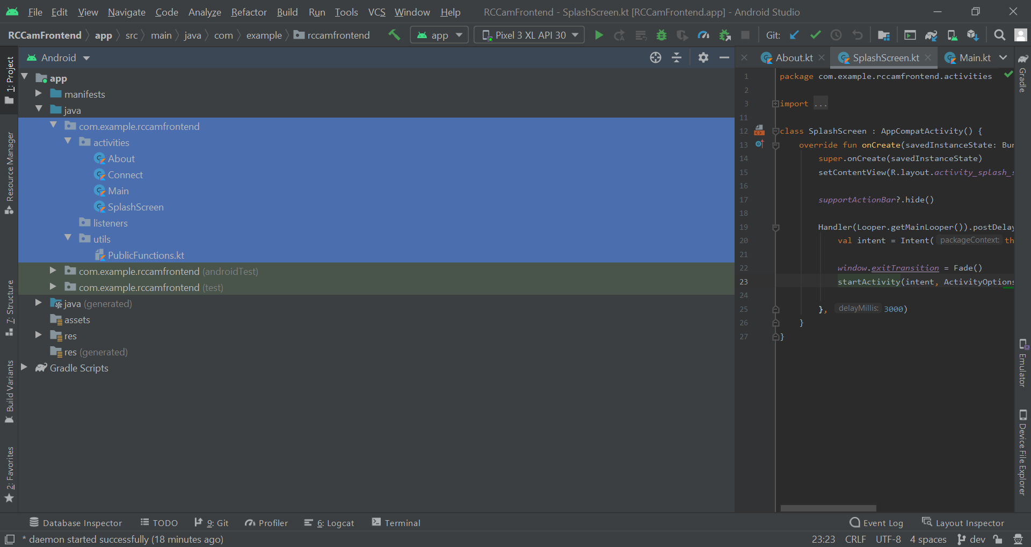

I then went to run the program to see if the refactoring was successful but was met with build errors for the app icon. Apparently, the drawable foreground and background were not found despite the XML linking correctly to them.

I checked through the code inspector again and found that it was prompting to merge the mipmap-anydpi-v26 into mipmap-anydpi. I clicked to do this and nothing happened. I ran the code inspector again and the same prompt appeared. So, I checked through the project structure and found a file called mipmap-anydpi without any extension. I read through the warning in the code inspector and deleted the file. I then created a directory called mipmap-anydpi and clicked the code inspector prompt again.

This time it moved the icons from mipmap-anydpi-v26 into the directory I made and removed the directory they were originally in. I ran the code inspector again and 13 warnings appeared - each for an icon appearing as an XML file and a bitmap.

These warnings were for icons within mipmap-...dpi directories. I tried removing these directories and ran the code inspector again. The only warning appeared was for a missing density folder which for my project was fine to ignore.

When I ran the code again I still got the same build error. I checked the XML and saw errors so I reverted the mipmap changes.

I then went and changed the directory from mipmap-anydpi-v26 to mipmap-anydpi and ran the code inspector. Again, the 13 warnings appeared but I instead just ran the program and it worked. I decided to read a bit into the errors to decide how to address them.

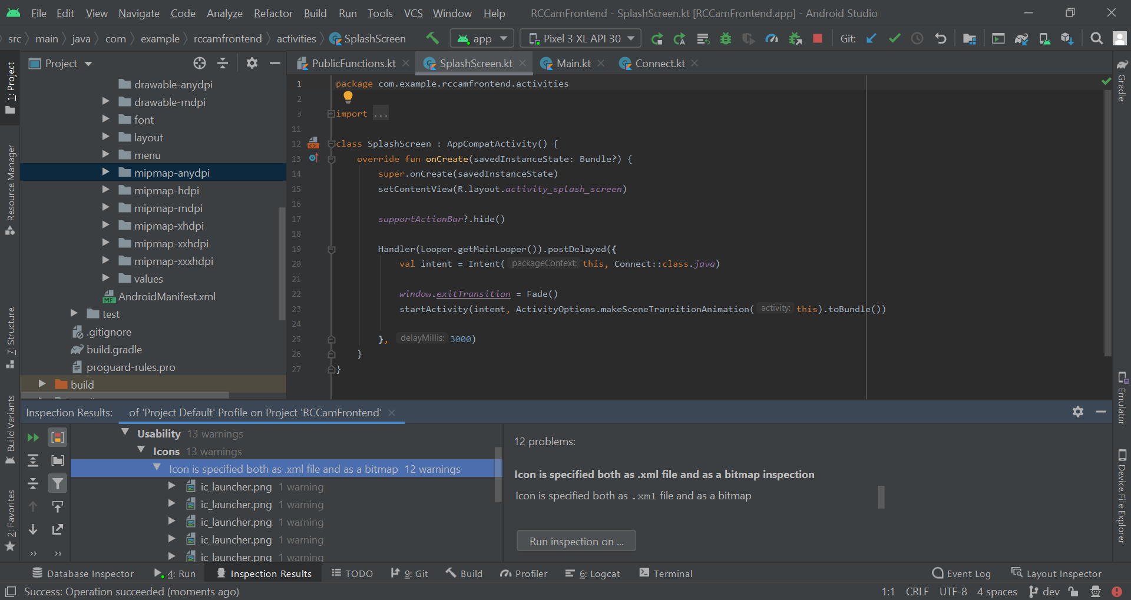

When refactoring the directory - this caused a whole host of problems with Git. So, I instead redid what I did previously by creating a new directory called “mipmap-anydpi” and from there using the code inspector. I still got the warnings when checking the code inspector but it built and ran fine. However, Gitkraken was throwing an error.

Due to this, I instead reverted back to the state of the project before starting to do this criteria. This took a while since Git wasn’t cooperating well so I ended up deleting the project and cloning it back from GitHub. I then ran the code inspector and went through every change but made sure to ignore any relating to icons or drawables. I then went back and added back the packages for the files and refactored them.

I then finally started to work on modifying code. I wanted to address the following and resolve them:

* Setting listeners
* Code that could be in a function or class
* Comments
* General code layout

I began with the smallest class - About. I added some comments, added a newline between getting the intent data and setting the text attribute and simplified the component references.

|  |
| --- |
| class About : AppCompatActivity() {  override fun onCreate(savedInstanceState: Bundle?) {  super.onCreate(savedInstanceState)  setContentView(R.layout.activity_about)   // Modifying Action Bar title  supportActionBar?.title = "About"   // Getting Text view references  val textViewNet = findViewById<TextView>(R.id.textViewNet)  val textViewVer = findViewById<TextView>(R.id.textViewVer)   // Getting IP and Port  val ip = intent.getStringExtra("ip")  val port = intent.getStringExtra("port")   // Setting text attribute of text views  textViewNet.text = getString(R.string.ip_port, ip, port)  textViewVer.text = getString(R.string.version, BuildConfig.VERSION_NAME)  } } |

I then moved on to the other small class - SplashScreen. I originally thought that I would just need to add comments to this class. However, I realised that the exitTransition method could be moved outside of the postDelayed runnable and that the runnable could be instantiated outside of post delayed which - although it uses more lines - looks a lot nicer.

|  |
| --- |
| class SplashScreen : AppCompatActivity() {  override fun onCreate(savedInstanceState: Bundle?) {  super.onCreate(savedInstanceState)  setContentView(R.layout.activity_splash_screen)   // Hiding the Action Bar  supportActionBar?.hide()   // Fade when going to the next activity  window.exitTransition = Fade()   // Runnable for "postDelayed"  val r = Runnable {  val intent = Intent(this, Connect::class.java)  startActivity(  intent,  ActivityOptions.makeSceneTransitionAnimation(this).toBundle()  )  }   // Wait 3 seconds and then go to the "Connect" activity  Handler(Looper.getMainLooper()).postDelayed(r, 3000)  } } |

I then moved on to the Connect class. This file had more lines than the two classes above combined and would need more attention put into overhauling it. I decided that, due to the majority of the class being a single listener, that I wouldn’t separate the code within the listener out into a function and would instead reduce the content within the listener using classes and functions.

I identified that the validity logic for the IP and Port text fields was a large portion of the code which could be simplified using a simple class. Using a Scratches file to test the class while I was developing it, I created the following Address class. It required an IP and a Port as args and had two methods which returned whether the IP and Port entered were valid.

|  |
| --- |
| class Address(private var ip: String, private var port: Int?) {  // Attributes  private val ipPat = Regex(  "^([01]?\\d\\d?|2[0-4]\\d|25[0-5])(\\.([01]?\\d\\d?|2[0-4]\\d|25[0-5])){3}\$"  )   fun isValidIP(): Boolean {  return ipPat.matches(ip)  }   fun isValidPort(): Boolean {  if (port?.let { it > 65536 } == false) {  return true  }  return false  } } |

I then realised that this would barely improve the address logic in the listener. This led me to create two more methods for checking whether the Port or IP args supplied were empty or not.

|  |
| --- |
| class Address(private var ip: String, private var port: Int?) {  // Attributes  private val ipPat = Regex(  "^([01]?\\d\\d?|2[0-4]\\d|25[0-5])(\\.([01]?\\d\\d?|2[0-4]\\d|25[0-5])){3}\$"  )   // Returns true if the IP arg supplied was empty, else false  fun hasEmptyIP(): Boolean{  if (ip == ""){  return true  }  return false  }   // Returns true if the Port arg supplied was empty, else false  fun hasEmptyPort(): Boolean{  if (port == null){  return true  }  return false  }   // Returns true if the IP arg supplied was valid, else false  fun hasValidIP(): Boolean {  return ipPat.matches(ip)  }   // Returns true if the Port arg supplied was valid, else false  fun hasValidPort(): Boolean {  if (port?.let { it > 65536 } == false) {  return true  }  return false  } } |

I then went about implementing this class into the Connect activity. Initially when instantiating the Address class, I got a prompt to convert the port argument from Int? to Double?. Also, while implementing the class, I noticed a few instances of unnecessary calls, unnecessary comments, missing comments and portions of code where argument indentation was necessary.

|  |
| --- |
| class Address(private var ip: String, private var port: Double?) {  ~~  class Connect : AppCompatActivity() {  override fun onCreate(savedInstanceState: Bundle?) {  super.onCreate(savedInstanceState)  setContentView(R.layout.activity_connect)   // Modifying Action Bar Title  supportActionBar?.title = "Connect to RPI"   // Getting view  val view = findViewById<View>(R.id.connectConstraint)   btnConnect.setOnClickListener{  val ip = textfieldIP.text.toString()  val port = textfieldPort.text.toString()   // Instantiating User Inputted Address  val address = Address(ip, port.toDoubleOrNull())   var nextActivity = true   // IP Logic  if (address.hasEmptyIP()) {  generateSnack(view, "Enter an IP Address")  nextActivity = false  } else if (!address.hasValidIP()) {  generateSnack(view, "Invalid IP Address")  nextActivity = false  }   // Port Logic  if (address.hasEmptyPort()) {  generateSnack(view, "Enter a Port number")  nextActivity = false  } else if (!address.hasValidPort()) {  generateSnack(view, "Invalid Port")  nextActivity = false  }   // Process for going to Main activity if text view inputs are valid  if (nextActivity){  var webviewError = false   // Webview instantiating and overriding  val hiddenWebview = findViewById<WebView>(R.id.hiddenWebview)   hiddenWebview.webViewClient = object : WebViewClient() {  override fun onReceivedError(  view: WebView,  request: WebResourceRequest,  error: WebResourceError  ) {  generateSnack(  view,  error.description.toString(),  dur = Snackbar.LENGTH_LONG  )  webviewError = true  }   override fun onPageFinished(view: WebView?, url: String?) {  super.onPageFinished(view, url)  if (!webviewError){  val intent = Intent(this@Connect, Main::class.java)  intent.putExtra("ip", textfieldIP.text.toString())  intent.putExtra("port", textfieldPort.text.toString())   startActivity(intent)  }  }  }   hiddenWebview.loadUrl("http://%s:%s/".format(ip, port))  }  }  } } |

I tested a few inputs against it and the code seemed to work the same as before so I continued on to the final activity - Main. I started by modifying the URL setting and changing the view to a private attribute so that the other functions within the class could access it for snack bars.

|  |
| --- |
| class Main : AppCompatActivity() {   private var url = ""  private var ip = intent.getStringExtra("ip")  private var port = intent.getStringExtra("port")   // Getting view  private val view = findViewById<View>(R.id.mainConstraint)   override fun onCreate(savedInstanceState: Bundle?) {  super.onCreate(savedInstanceState)  setContentView(R.layout.activity_main)   // Modifying Action Bar  supportActionBar?.title = ""   // Changing URL  if (intent != null) {  url = "http://%s:%s".format(ip, port)  webview.loadUrl(url)   generateSnack(view, "Loaded URL")  } |

When I ran the code the app crashed. I checked the traceback and went ahead modifying the code. The issue was where it was trying to access the intent and the view outside of the onCreate function. To fix this I did the following.

|  |
| --- |
| class Main : AppCompatActivity() {  // Address Values  private lateinit var url: String  private lateinit var ip: String  private lateinit var port: String   // View  private lateinit var view: View   override fun onCreate(savedInstanceState: Bundle?) {  super.onCreate(savedInstanceState)  setContentView(R.layout.activity_main)   // Modifying Action Bar  supportActionBar?.title = ""   // Getting view  view = findViewById(R.id.mainConstraint)   // Setting Address values and changing URL  if (intent != null) {  ip = intent.getStringExtra("ip").toString()  port = intent.getStringExtra("port").toString()   url = "http://%s:%s".format(ip, port)  webview.loadUrl(url)   generateSnack(view, "Loaded URL: $ip")  } |

When I ran the program it worked this time. To make sure the values were being saved correctly I navigated to the About page and it displayed the correct IP. To double check I went back to the Connect GUI, inputted a different IP and Address and went to the About page again and it showed the correct values.

I then went through and modified sections of code that previously attempted to retrieve the view or address values to now just use those attributes - this saves on calls and makes the code more efficient and easier to read.

I then realised that I could reduce the IP and port logic in the Connect class so I went back to that. This is because, when two snackbars are generated, it only shows the most recently called one. This means that if the IP and Port are empty that the “Enter a Port number” snackbar will be shown since it’ll cover up the IP snackbar. So, I modified the code to become the following.

|  |
| --- |
| var nextActivity = false  // Address logic if (address.hasEmptyIP()) {  generateSnack(view, "Enter an IP Address") } else if (!address.hasValidIP()) {  generateSnack(view, "Invalid IP Address") } else if (address.hasEmptyPort()) {  generateSnack(view, "Enter a Port number") } else if (!address.hasValidPort()) {  generateSnack(view, "Invalid Port") } else {  nextActivity = true } |

I then went back to the Main activity class. I focused on changing the structure of the sub menu code a bit. I made all of the items use a “with statement” for the intents and slightly modified the indentation of portions of code.

|  |
| --- |
| when(item.itemId){  // Open Photo Gallery Clicked  R.id.open_photo_gallery -> {  val mediaUri = Uri.parse("content://media/internal/images/media")  with(Intent(Intent.ACTION_VIEW, mediaUri)){  addFlags(Intent.FLAG_ACTIVITY_NEW_TASK)  startActivity(this)  }  }   // Share Media Clicked  R.id.share -> {  with(Intent(Intent.ACTION_SEND)) {  val sharedPref = getPreferences(Context.MODE_PRIVATE)  val imagePath = sharedPref.getString("URI", "")   if (imagePath == "") {  generateSnack(  view,  "You haven't got a recent photo to share yet",  anch = bottomNavigationBar  )  } else {  type = "image/*"  flags = Intent.FLAG_GRANT_READ_URI_PERMISSION  putExtra(Intent.EXTRA_STREAM, Uri.parse(imagePath))  startActivity(Intent.createChooser(this, "Share Image Using"))  }  }  }   // About clicked  R.id.about -> {  with(Intent(this, About::class.java)) {  putExtra("ip", ip)  putExtra("port", port)  startActivity(this)  }  } } |

I then removed an unnecessary variable from the Download Manager.

|  |
| --- |
| // Getting filename val filename = URLUtil.guessFileName(thisUrl, contentDisposition, mimeType)  // Setting up Download Request Manager val request = DownloadManager.Request(Uri.parse("$url/get_photo/$filename")) |

I then started looking into ways to reduce my code for a textview with two buttons and found something called a custom view where you can make your own view consisting of other views. This would allow me to make a view for two buttons and a text view and reduce my code a fair bit.

I started by creating a layout file for the custom view which I’ll now call my incrementable text view.

|  |
| --- |
| <?xml version="1.0" encoding="utf-8"?> <merge xmlns:android="http://schemas.android.com/apk/res/android"  android:layout_width="match_parent"  android:layout_height="match_parent"  android:layout_marginLeft="20dp"  android:layout_marginTop="30dp"  android:layout_marginRight="20dp"  android:layout_marginBottom="5dp"  android:orientation="horizontal">   <Button  android:id="@+id/button_minus"  android:layout_width="wrap_content"  android:layout_height="wrap_content"  android:layout_weight="1"  android:minWidth="0dp"  android:paddingStart="0dp"  android:paddingEnd="0dp"  android:text="@string/button_minus" />   <Button  android:id="@+id/button_plus"  android:layout_width="wrap_content"  android:layout_height="wrap_content"  android:layout_weight="1"  android:minWidth="0dp"  android:paddingStart="0dp"  android:paddingEnd="0dp"  android:text="@string/button_plus" />   <EditText  android:id="@+id/textfield"  android:layout_width="wrap_content"  android:layout_height="wrap_content"  android:layout_weight="4"  android:fontFamily="sans-serif"  android:hint="@string/add_text_attribute"  android:importantForAutofill="no"  android:inputType="number"  android:maxLength="2" />  </merge> |

I then found a useful [guide](https://stacktips.com/tutorials/android/creating-custom-views-in-android-tutorial) for setting up other parts of the custom view. I created the following Class for my custom view and added in some temporary listeners for my buttons.

|  |
| --- |
| class IncrementableTextView(ctx: Context, attr: AttributeSet) : ConstraintLayout(ctx, attr) {   init {  inflate(context, R.layout.textview_incrementable, this)   val minusButton = findViewById<Button>(R.id.button_minus)  minusButton.setOnClickListener { Toast.makeText(context, "MINUS", Toast.LENGTH_SHORT).show() }   val plusButton = findViewById<Button>(R.id.button_plus)  plusButton.setOnClickListener { Toast.makeText(context, "PLUS", Toast.LENGTH_SHORT).show() }  } } |

When I added my custom view to the dialogue rotation, it didn’t have the correct margins or button sizes.

|  |
| --- |
| <com.example.rccamfrontend.views.IncrementableTextView  android:layout_width="match_parent"  android:layout_height="match_parent" /> |

After changing the XMl a bit, I finally settled on something that worked.

|  |
| --- |
| <?xml version="1.0" encoding="utf-8"?> <merge xmlns:android="http://schemas.android.com/apk/res/android"  xmlns:tools="http://schemas.android.com/tools"  android:layout_width="match_parent"  android:layout_height="wrap_content"  android:orientation="horizontal"  tools:layout_height="match_parent"  tools:layout_width="match_parent"  tools:parentTag="android.widget.LinearLayout">   <Button  android:id="@+id/button_minus"  android:layout_width="wrap_content"  android:layout_height="wrap_content"  android:layout_weight="2"  android:minWidth="0dp"  android:paddingStart="0dp"  android:paddingEnd="0dp"  android:text="@string/button_minus" />   <Button  android:id="@+id/button_plus"  android:layout_width="wrap_content"  android:layout_height="wrap_content"  android:layout_weight="2"  android:minWidth="0dp"  android:paddingStart="0dp"  android:paddingEnd="0dp"  android:text="@string/button_plus" />   <EditText  android:id="@+id/textfield"  android:layout_width="wrap_content"  android:layout_height="wrap_content"  android:layout_weight="4"  android:fontFamily="sans-serif"  android:hint="@string/add_text_attribute"  android:importantForAutofill="no"  android:inputType="number"  android:maxLength="2" />  </merge> |

I then created an attr.xml file to store my custom views attributes that I wanted to be able to be passed. These included an attribute to change the text hint, values for maximum and minimum number inputs, an increment value, a decrement value and a max number unit value.

|  |
| --- |
| <?xml version="1.0" encoding="utf-8"?> <resources>  <declare-styleable name="IncrementableTextView">  <attr name="maxVal" format="integer" />  <attr name="minVal" format="integer" />  <attr name="incVal" format="integer" />  <attr name="decVal" format="integer" />  <attr name="text" format="string" />  <attr name="maxLength" format="integer" />  </declare-styleable> </resources> |

I then modified my class so that the text view would have it’s text hint and max text length modified by the XML attributes - just as a test.

|  |
| --- |
| class IncrementableTextView(ctx: Context, attrs: AttributeSet) : LinearLayout(ctx, attrs) {   init {  inflate(context, R.layout.textview_incrementable, this)  val attrGetter = context.theme.obtainStyledAttributes(  attrs,  R.styleable.IncrementableTextView,  0,  0  )   // Modifying Text View  val textView = findViewById<TextView>(R.id.textfield)  textView.hint = attrGetter.getString(R.styleable.IncrementableTextView_text)   val maxLength = attrGetter.getInt(R.styleable.IncrementableTextView_maxLength, 2)  textView.filters = arrayOf(InputFilter.LengthFilter(maxLength))   // Modifying Minus Button  val minusButton = findViewById<Button>(R.id.button_minus)  minusButton.setOnClickListener { Toast.makeText(context, "MINUS", Toast.LENGTH_SHORT).show() }   // Modifying Plus Button  val plusButton = findViewById<Button>(R.id.button_plus)  plusButton.setOnClickListener { Toast.makeText(context, "PLUS", Toast.LENGTH_SHORT).show() }  } } |

In order to test this, I added the following XML temporarily to my rotation dialogue.

|  |
| --- |
| <com.example.rccamfrontend.views.IncrementableTextView  android:layout_width="match_parent"  android:layout_height="wrap_content"  android:layout_marginLeft="20dp"  android:layout_marginTop="30dp"  android:layout_marginRight="20dp"  android:layout_marginBottom="5dp"  custom:text="TEST"  custom:maxLength="5" /> |

This changed the size of the buttons and text view still despite having the layout_weight set inside of my custom view. I searched online and found this [Stack Overflow question](https://stackoverflow.com/questions/3995825/what-does-androidlayout-weight-mean) where an answer detailed how you must have “0px” (0dp in my case) specified for the width or height of your components that will have layout_width. So, I modified the layout_width to “0dp” for my two buttons and text view within my custom view and added another to the rotation dialogue with much longer text.

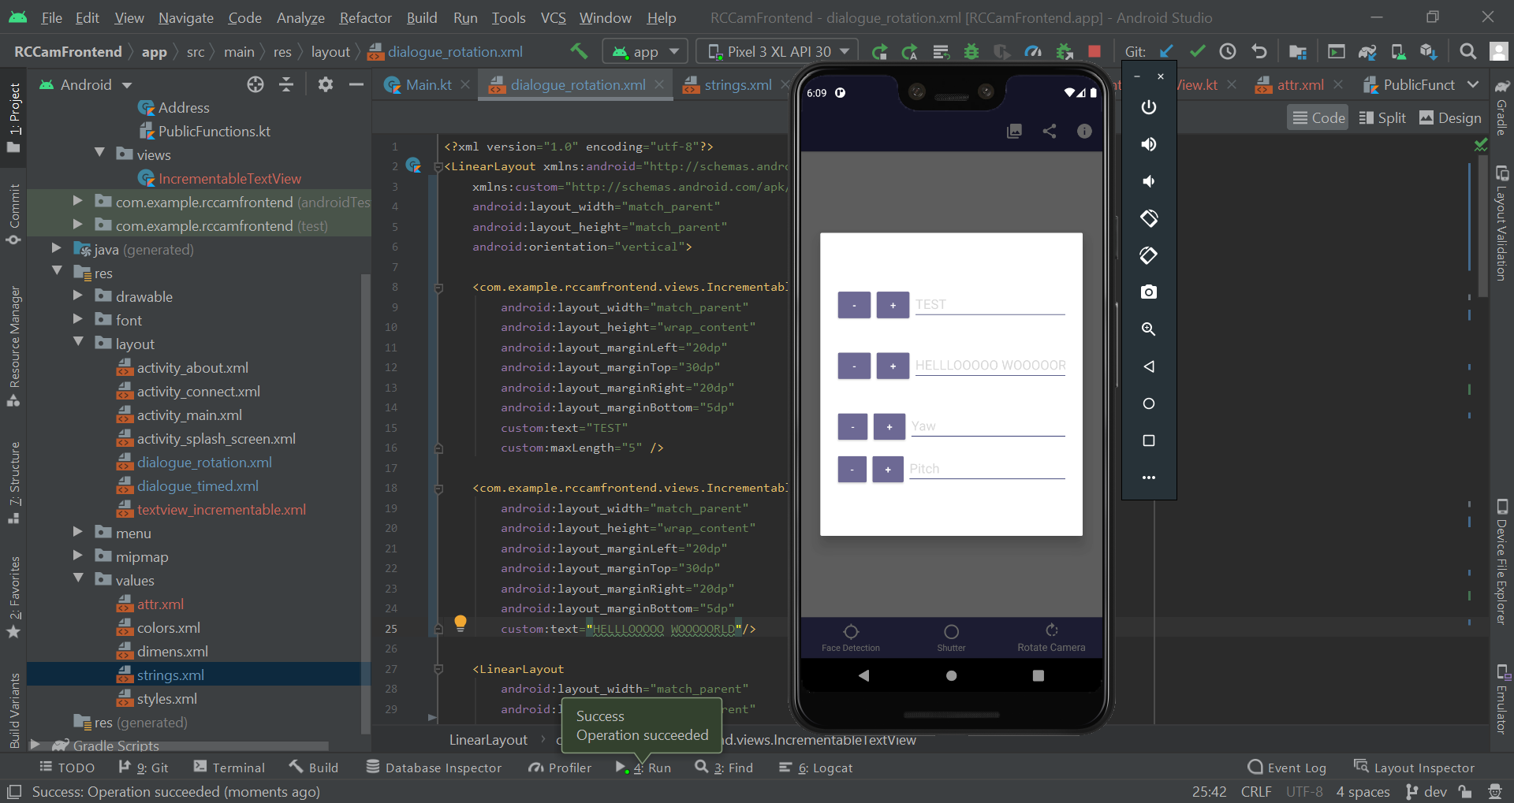

This fixed the issue entirely and I could now continue to focus on functionality. The max length also worked for this - I had to use the highlight tool to see the text since the theming is still wrong. I then worked on implementing some of the basics into the custom view class.

This included:

* Functional min and max values for the text field
* Implementation of increment and decrement button with attribute addition

|  |
| --- |
| class IncrementableTextView(ctx: Context, attrs: AttributeSet) : LinearLayout(ctx, attrs) {   var textView: EditText  var minusButton: Button  var plusButton: Button   init {  inflate(context, R.layout.textview_incrementable, this)  val attrGetter = context.theme.obtainStyledAttributes(  attrs,  R.styleable.IncrementableTextView,  0,  0  )   // Modifying Text View  textView = findViewById(R.id.textfield)  textView.hint = attrGetter.getString(R.styleable.IncrementableTextView_text)   val maxLength = attrGetter.getInt(R.styleable.IncrementableTextView_maxLength, 2)  textView.filters = arrayOf(InputFilter.LengthFilter(maxLength))   // Setting value limit for Text View  val max = attrGetter.getInt(R.styleable.IncrementableTextView_maxVal, 10)  val min = attrGetter.getInt(R.styleable.IncrementableTextView_minVal, 0)   textView.doOnTextChanged { text, _, _, _ ->  val textInt = text.toString().toIntOrNull()  if (textInt != null) {  if (textInt > max) {  textView.setText(max.toString())  } else if (textInt < min) {  textView.setText(min.toString())  }  }  textView.setSelection(textView.text.length)  }    // Modifying Minus Button  minusButton = findViewById(R.id.button_minus)   val dec = attrGetter.getInt(R.styleable.IncrementableTextView_decVal, -1)  minusButton.setOnClickListener { // Decrement btnYaw  incrementTextView(textView, dec)  }    // Modifying Plus Button  plusButton = findViewById(R.id.button_plus)   val inc = attrGetter.getInt(R.styleable.IncrementableTextView_incVal, 1)  plusButton.setOnClickListener { // Decrement btnYaw  incrementTextView(textView, inc)  }  } } |

I then temporarily set the text colour of the text view within the custom view to black and added some of the custom attributes to my rotation dialogue call to see if they worked properly.

|  |
| --- |
| <com.example.rccamfrontend.views.IncrementableTextView  android:id="@+id/customTextView"  android:layout_width="match_parent"  android:layout_height="wrap_content"  android:layout_marginLeft="20dp"  android:layout_marginTop="30dp"  android:layout_marginRight="20dp"  android:layout_marginBottom="5dp"  custom:text="TEST"  custom:maxLength="5"  custom:decVal="-2"  custom:incVal="3"  custom:maxVal="50"  custom:minVal="-10"/> |

After testing different inputs - I found that the custom view was fully functioning! I could now implement it into my layouts and code and this would massively reduce the amount of lines and make the project a lot more maintainable. I removed the XML of the rotation menu and changed it to the following.

|  |
| --- |
| <?xml version="1.0" encoding="utf-8"?> <LinearLayout xmlns:android="http://schemas.android.com/apk/res/android"  xmlns:custom="http://schemas.android.com/apk/res-auto"  android:layout_width="match_parent"  android:layout_height="match_parent"  android:orientation="vertical">   <com.example.rccamfrontend.views.IncrementableTextView  android:id="@+id/yawIncTextView"  android:layout_width="match_parent"  android:layout_height="wrap_content"  android:layout_marginLeft="20dp"  android:layout_marginTop="30dp"  android:layout_marginRight="20dp"  android:layout_marginBottom="5dp"  custom:maxVal="13"  custom:minVal="0"  custom:text="Yaw" />   <com.example.rccamfrontend.views.IncrementableTextView  android:id="@+id/pitchIncTextView"  android:layout_width="match_parent"  android:layout_height="wrap_content"  android:layout_marginLeft="20dp"  android:layout_marginTop="30dp"  android:layout_marginRight="20dp"  android:layout_marginBottom="5dp"  custom:maxVal="13"  custom:minVal="0"  custom:text="Pitch" />  </LinearLayout> |

I then removed the majority of the code behind the original rotation menu dialogue inside of the main activity class and ended up converting it to the following, much smaller, code.

|  |
| --- |
| R.id.action_rotation -> {  val dialog = AlertDialog.Builder(this)  val dialogView = this.layoutInflater.inflate(  R.layout.dialogue_rotation,  findViewById(R.id.content),  false  )   dialog  .setTitle("Set Rotation")  .setView(dialogView)  .setPositiveButton("Confirm") { _, _ ->  val textfieldYaw = findViewById<IncrementableTextView>(R.id.yawIncTextView)  val textfieldPitch = findViewById<IncrementableTextView>(R.id.pitchIncTextView)  val textfieldPitchData = textfieldPitch.textView.text.toString()  val textfieldYawData = textfieldYaw.textView.text.toString()   // URL Arg Logic <ip>/servo?p=int&y=int  var servoUrl = ""   // Pitch arg supplied  if (textfieldPitchData != "") {  servoUrl += "p=$textfieldPitchData&"  }   // Yaw arg supplied  if (textfieldYawData != "") {  servoUrl += "y=$textfieldYawData"  }   // Yaw and/or Pitch args supplied  if (servoUrl != "") {  webview.loadUrl("$url/servo?$servoUrl")  }   }  .setNegativeButton("Cancel") { _, _ ->  // Do nothing - Android auto dismisses  }  .show() } |

When I ran the program and tried to input a value for the yaw and hit confirm, the app crashed and I saw an error message stating that I was referencing a null value on the line:

|  |
| --- |
| val textfieldPitchData = textfieldPitch.textView.text.toString() |

So, I tried adding a getter to the custom view class and tried accessing the value via that instead

|  |
| --- |
| fun getTextVal(): String{  return textView.text.toString()  }  ~~  val textfieldYaw = findViewById<IncrementableTextView>(R.id.yawIncTextView) val textfieldPitch = findViewById<IncrementableTextView>(R.id.pitchIncTextView)  val textfieldPitchData = textfieldPitch.getTextVal() val textfieldYawData = textfieldYaw.getTextVal() |

I got the same error this time - this must mean that getting the view is returning a null value. I spent a long time trying different methods to figure out why it wasn’t working correctly. I then eventually found that I could access the view if it wasn’t in a dialog and looked further into how to properly access views within a dialog and found that I was supposed to use the val returned by the inflater.

In short, all I was missing was dialogView before the findViewById methods.

|  |
| --- |
| .setPositiveButton("Confirm") { _, _ ->  val textfieldYaw = dialogView.findViewById<IncrementableTextView>(R.id.yawIncTextView)  val textfieldPitch = dialogView.findViewById<IncrementableTextView>(R.id.pitchIncTextView) |

While trying to fix this bug, I also found that you don’t need to call findViewById in Kotlin and can instead directly reference the Id of views within the code. At compiler level, the code is the same but from a maintainability perspective, it is a lot better.

I modified my dialog to fit this first.

|  |
| --- |
| .setPositiveButton("Confirm") { _, _ ->  val pitchVal = dialogView.yawIncTextView.textView.text.toString()  val yawVal = dialogView.pitchIncTextView.textView.text.toString()   // URL Arg Logic <ip>/servo?p=int&y=int  var servoUrl = ""   // Pitch arg supplied  if (pitchVal != "") {  servoUrl += "p=$pitchVal&"  }   // Yaw arg supplied  if (yawVal != "") {  servoUrl += "y=$yawVal"  }   // Yaw and/or Pitch args supplied  if (servoUrl != "") {  webview.loadUrl("$url/servo?$servoUrl")  }  } |

In instances where I could, I shortened my code by removing the findViewById methods. I then went about implementing my custom view into the timed shot now that I had gotten the rotation dialog functional. When adding the custom view, I realised that the class for it doesn’t take into consideration where you don’t want a max length or no min/max value. So, I modified it to account for that.

|  |
| --- |
| val maxLength = attrGetter.getString(R.styleable.IncrementableTextView_maxLength)?.toIntOrNull() if (maxLength != null){ textView.filters = arrayOf(InputFilter.LengthFilter(maxLength)) }  // Setting value limit for Text View val max = attrGetter.getString(R.styleable.IncrementableTextView_maxVal)?.toIntOrNull() val min = attrGetter.getString(R.styleable.IncrementableTextView_minVal)?.toIntOrNull()  textView.doOnTextChanged { text, _, _, _ ->  val textInt = text.toString().toIntOrNull()  if (textInt != null) {  if (max != null && textInt > max) {  textView.setText(max.toString())  } else if (min != null && textInt < min) {  textView.setText(min.toString())  }  }  textView.setSelection(textView.text.length) } |

I then removed the Kotlin code for what used to handle the timed shots and added in my custom view.

|  |
| --- |
| <?xml version="1.0" encoding="utf-8"?> <LinearLayout xmlns:android="http://schemas.android.com/apk/res/android"  xmlns:custom="http://schemas.android.com/apk/res-auto"  android:layout_width="wrap_content"  android:layout_height="wrap_content"  android:orientation="horizontal">   <com.example.rccamfrontend.views.IncrementableTextView  android:id="@+id/secIncTextView"  android:layout_width="match_parent"  android:layout_height="wrap_content"  android:layout_marginLeft="20dp"  android:layout_marginTop="30dp"  android:layout_marginRight="20dp"  android:layout_marginBottom="5dp"  custom:minVal="0"  custom:maxLength="10"  custom:text="Seconds" />  </LinearLayout> |

I then added in the Kotlin code to now work with the custom view.

|  |
| --- |
| dialog  .setTitle("Choose Time to Wait")  .setView(dialogView)  .setPositiveButton("Confirm") { _, _ ->  val textfieldTimeData = dialogView.secIncTextView.textView.text.toString()   // <ip>/take_photo/float  webview.loadUrl("$url/take_photo/$textfieldTimeData")   }  .setNegativeButton("Cancel") { _, _ ->  // Do nothing - Android auto dismisses  }  .show() |

When I tried large values with this however, the app crashed and I discovered that the max length was allowing values larger than the integer max value so I lowered the max length XML attribute value to 8.

|  |
| --- |
| custom:maxLength="8" |

I also found a few issues with the code for minimum and maximum values where it would compare an integer value with a null so I fixed that too.

|  |
| --- |
| textView.doOnTextChanged { text, _, _, _ ->  val textInt = text.toString().toIntOrNull()  if (textInt != null) {  if (max != null && textInt > max) {  textView.setText(max.toString())  } else if (min != null && textInt < min) {  textView.setText(min.toString())  }  }  textView.setSelection(textView.text.length) } |

I then found that the arg logic could be greatly simplified as URL arguments are very lenient. I meant that instead of having the following code:

|  |
| --- |
| val pitchVal = dialogView.yawIncTextView.textView.text.toString() val yawVal = dialogView.pitchIncTextView.textView.text.toString()  // URL Arg Logic <ip>/servo?p=int&y=int var servoUrl = ""  // Pitch arg supplied if (pitchVal != "") {  servoUrl += "p=$pitchVal&" }  // Yaw arg supplied if (yawVal != "") {  servoUrl += "y=$yawVal" }  // Yaw and/or Pitch args supplied if (servoUrl != "") {  webview.loadUrl("$url/servo?$servoUrl") } |

I could instead just have this:

|  |
| --- |
| val pitchVal = dialogView.yawIncTextView.textView.text.toString() val yawVal = dialogView.pitchIncTextView.textView.text.toString() webview.loadUrl("$url/servo?p=$pitchVal&y=$yawVal") |

### Connect GUI Bug

After finishing refactoring the code structure for the frontend, I decided to start working on fixing the bug with the connect button. For some reason - the Flask server continually had the page loading with the video stream. This may be due to the fact that I set up the Flask server in an unprofessional way whereby I ignored the use of HTML and relied solely on returns in the code.

I decided to redo the Flask server with the intent of working with templates which would hopefully fix this issue. I started by reading through the [template guide](https://flask.palletsprojects.com/en/1.1.x/tutorial/templates/) provided by Flask. I then created a new directory within the repo called templates.

I then created a template called base.html and created the following HTML.

|  |
| --- |
| <!DOCTYPE html> <html lang="en"> <head>  <meta charset="UTF-8">  <title>Video Feed</title>  </head> <body>  <img src="{{ url_for("main_page") }}" alt="Video Stream"> </body> </html> |

I then added the following code to my Flask script to load the HTML.

|  |
| --- |
| @web_app.route("/") def main_page():  return render_template("base.html")   @web_app.route("/video") def video_feed():  return Response(generator(camera), mimetype="multipart/x-mixed-replace; boundary=frame") |

However, when I ran the script, I didn’t see a video feed and instead saw the alt for the image. I refactored the name of the file from main.py to app.py as standard for Flask apps. However, this didn’t fix the issue either. I then realised that the SRC element was now invalid so I changed it to video_feed.

When I restarted the app, it now worked. The website loaded the video feed and there wasn’t the issue of the constant loading. I then tried with the android app to see if the bug was fixed before attempting to make the video feed look nicer.

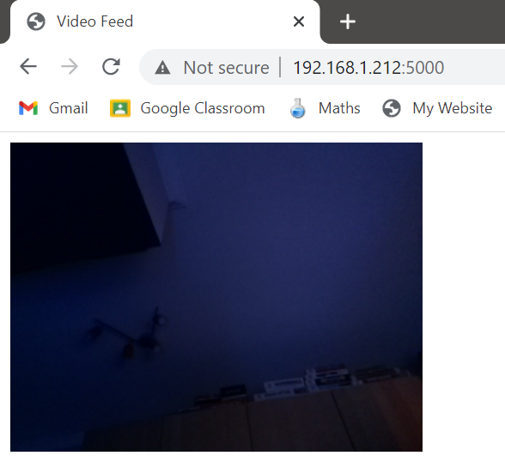

When I used the app, I was getting a few errors - these weren’t present on Chrome in the console. I decided to ignore these and fix up the styling for the web page. I considered adding a CSS stylesheet for the image but instead decided to remove the image element altogether and make the background-image attribute the video stream.

|  |
| --- |
| <!DOCTYPE html> <html lang="en"> <head>  <meta charset="UTF-8">  <title>Video Feed</title>  <style>  body {  background-image: url('{{ url_for("video_feed") }}')  }  </style> </head> <body>  </body> </html> |

However, I was presented with tiling because I forgot to specify to not repeat the image within the background.

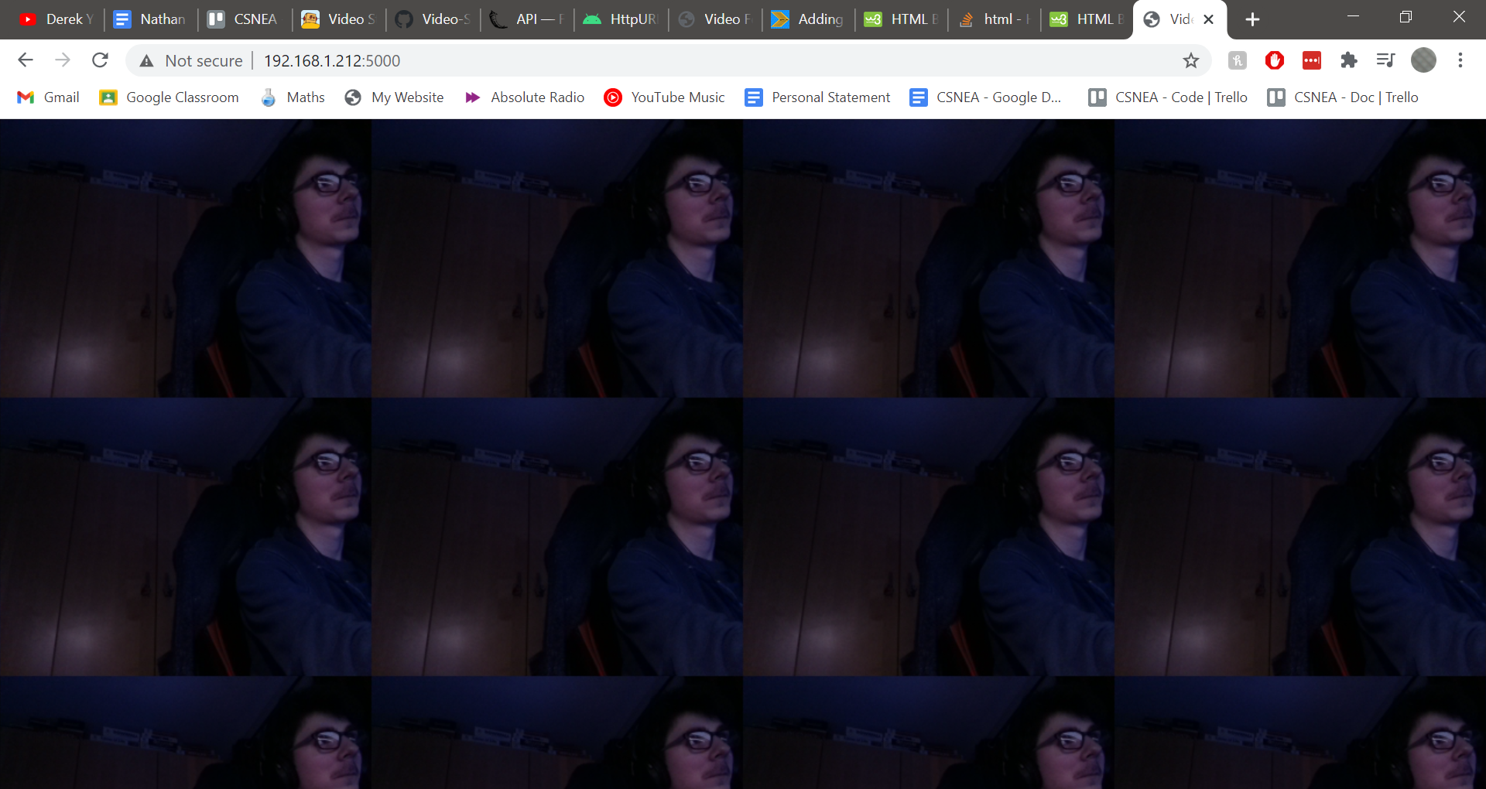

I fixed this and relaunched the web server.

|  |
| --- |
| <!DOCTYPE html> <html lang="en"> <head>  <meta charset="UTF-8">  <title>Video Feed</title>  <style>  body {  background-image: url('{{ url_for("video_feed") }}');  background-repeat: no-repeat;  }  </style> </head> <body>  </body> </html> |

However, this made the background image appear small in the top left of the screen. I added more attributes to try to fix this.

|  |
| --- |
| <style>  body {  background-image: url('{{ url_for("video_feed") }}');  background-repeat: no-repeat;  background-position: center;  background-size: cover;  } </style> |

This also didn’t work. I tried a few more combinations until I settled on these attributes which made the video feed cover the entire screen.

|  |
| --- |
| <style>  body {  background-image: url('{{ url_for("video_feed") }}');  background-repeat: no-repeat;  background-position: center;  background-size: cover;  background-attachment: fixed;  } </style> |

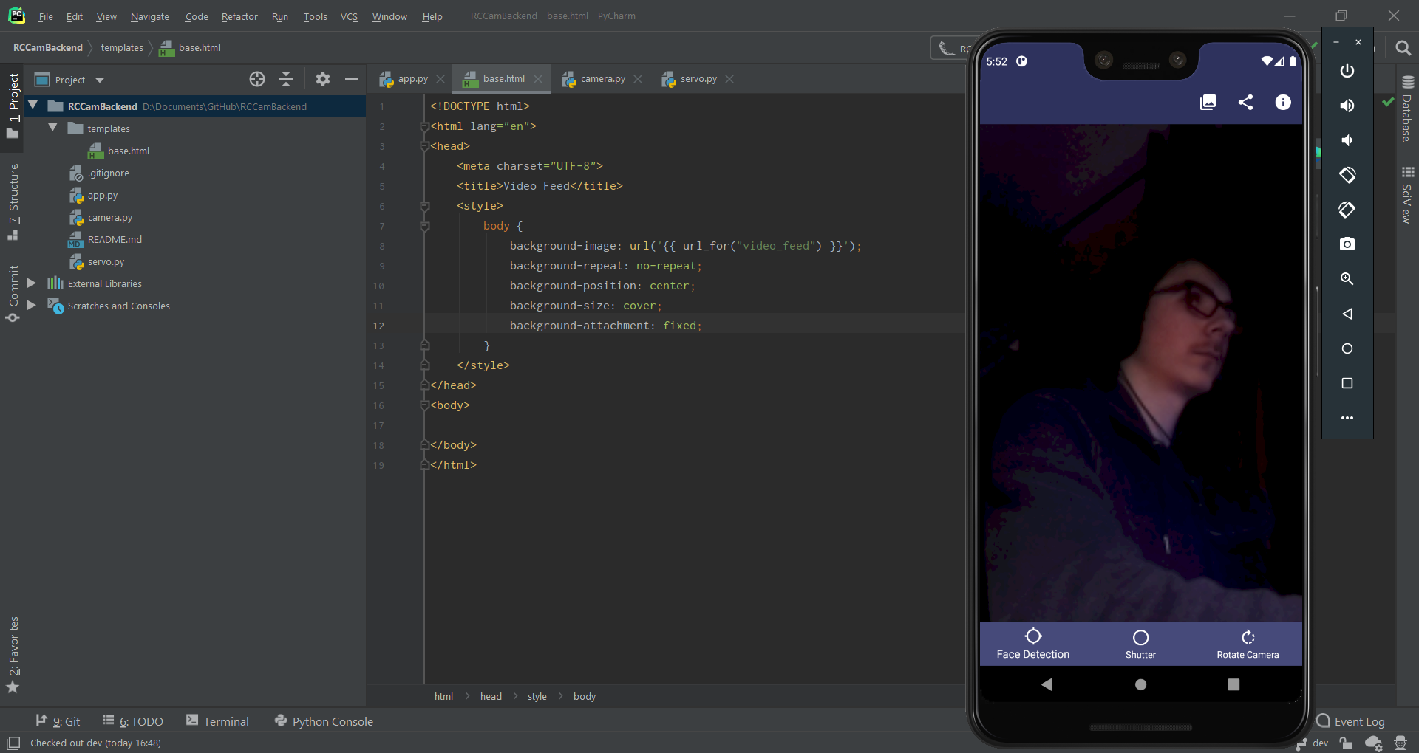

However, this meant that photos now didn’t properly reflect what the user saw. After modifying the attributes and debating whether to add a resolution argument for the Flask server, I eventually decided on having the following attributes and leaving the background black where there was no image.

This way the video feed maintained the same aspect ratio without the cropping of the image and had a black background where the background was visible.

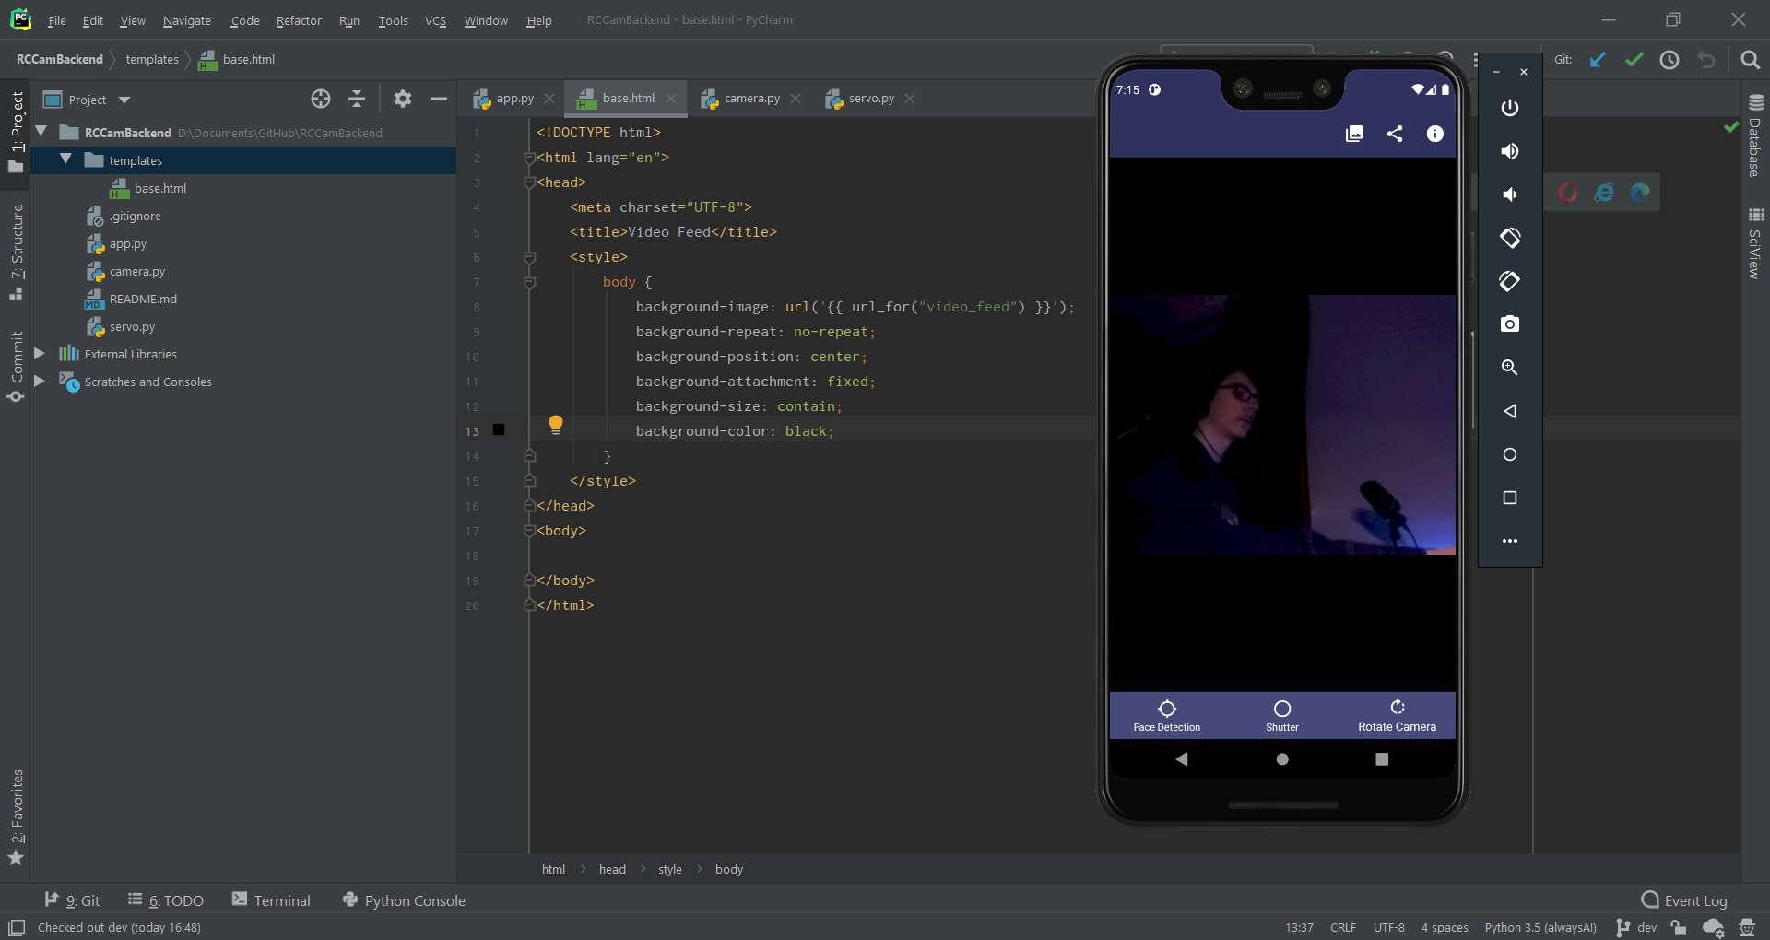

I then realised that when I pressed the connect button that it didn’t anchor correctly like I had fixed with other snackbars. I added an anchor argument for the bottom nav bar for the 2 generateSnack calls that were missing them.

### Menu GUI Styling

I then had to fix the aesthetics of the app. I decided to start working on the menu GUIs first since that should be finished fairly quickly. I added the following XML to the styles.xml file to see if it would work correctly.

|  |
| --- |
| <style name="AppTheme" parent="Theme.AppCompat.Light.DarkActionBar">  ...  <item name="android:alertDialogStyle">@style/Dialog</item>  ... </style>  <style name="Dialog">  <item name="background">@color/black</item> </style> |

It modified the dialog menu but had some odd visual issues. I tried multiple attempts to try and solve this and eventually found this Stack Overflow thread. Using some of the answers, I managed to make the following work.

|  |
| --- |
| <style name="AppTheme" parent="Theme.AppCompat.Light.DarkActionBar">  ...  <item name="android:alertDialogTheme">@style/Dialog</item>  ... </style>  <style name="Dialog" parent="Theme.AppCompat.Light.Dialog.Alert">  <item name="android:background">@color/raspberryRed</item> </style> |

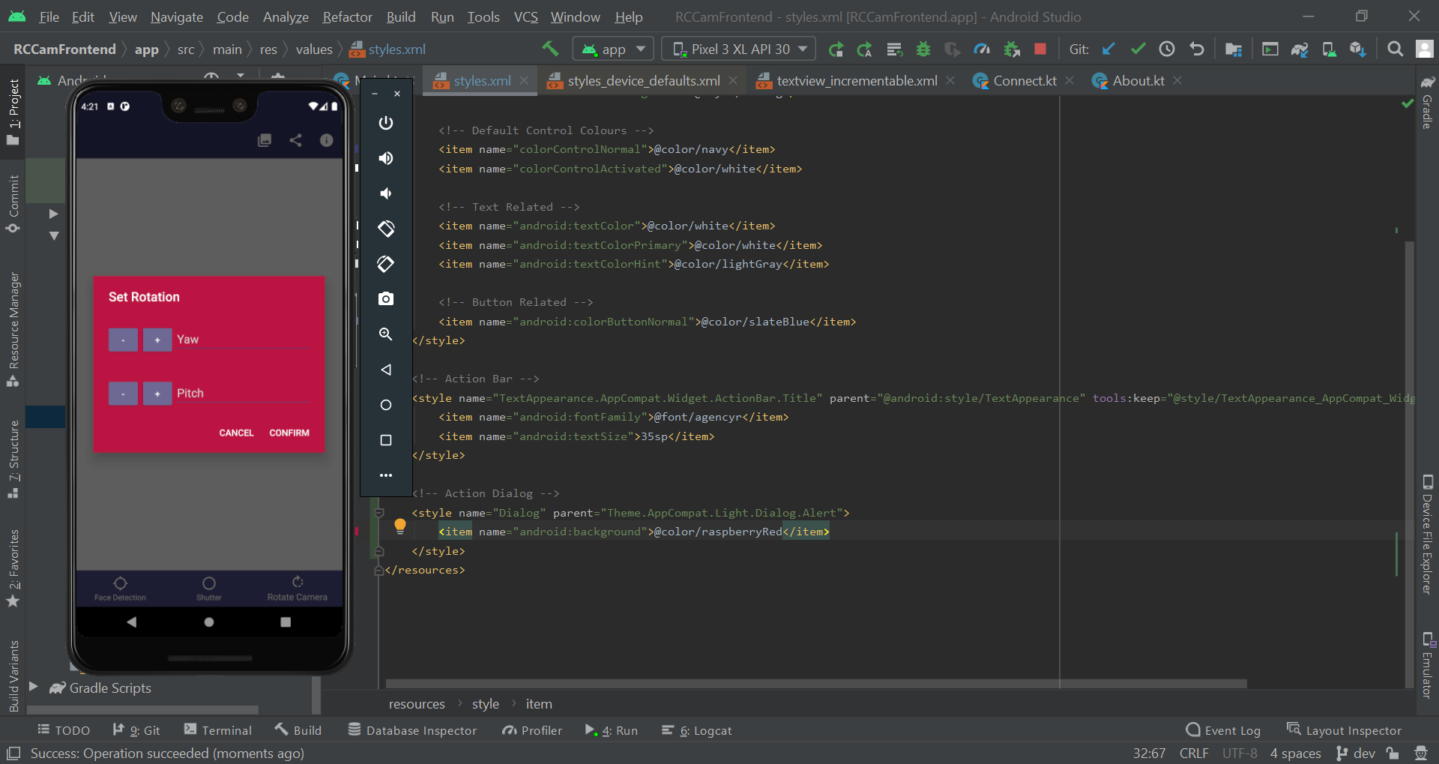

After modifying the attributes, I eventually settled on the following.

|  |
| --- |
| <style name="Dialog" parent="Theme.AppCompat.Light.Dialog.Alert">  <item name="android:background">@color/spaceBlue</item>  <item name="colorAccent">@color/white</item>  <item name="android:textColor">@color/white</item>  <item name="android:editTextColor">@color/lightGray</item> </style> |

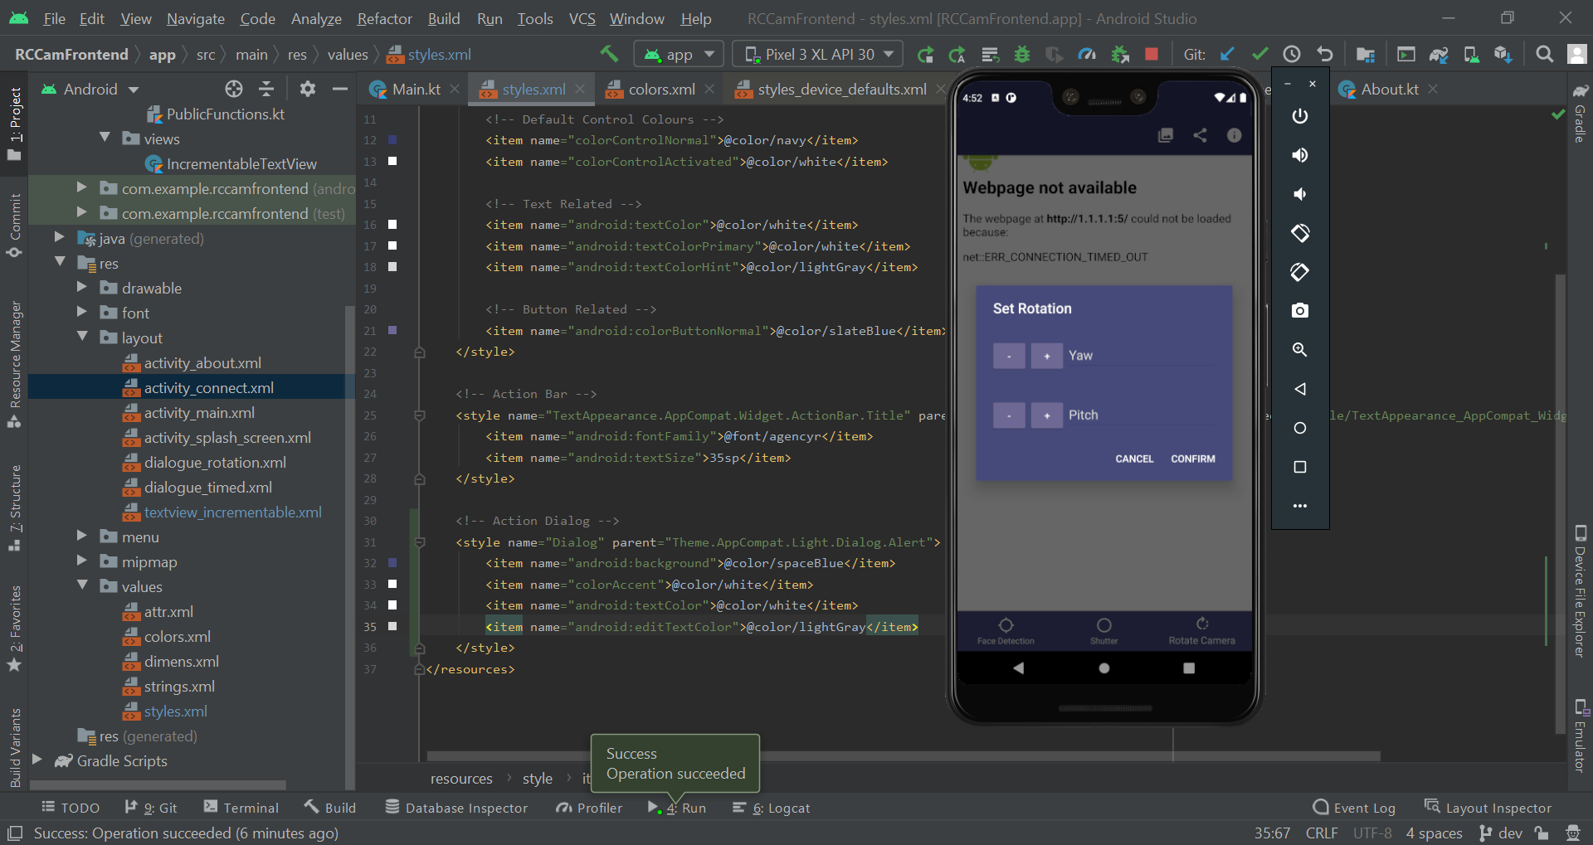

### Share Menu Image Preview

After doing some testing for this bug, I realised that the photo taken just needed a bit of time after being taken before it was able to be shown on the share menu. This was most likely due to the phone downloading and saving the photo.

Due to this, no action was taken.

## White Box Testing

After fixing any outstanding issues found during module development that weren’t resolved during that time, it was time to begin white box testing for each module. For every module, I copied across the test plan from the design phase and updated them where necessary.

### Module 1

#### Test Scenarios and Cases

|  |  |  |
| --- | --- | --- |
| **Test Scenario ID** | **Test Scenario Description** | **Test Type** |
| 1.1.1 | Check IP and Port validation branches | Branch Coverage |
| 1.1.2 | When interacting with the web server, it should ignore invalid requests where possible and respond to valid requests. This will be tested on a web browser instead of the Android app. | Functionality Testing |
| 1.1.3 | Check the styling and positioning of an element in the Splash GUI to see if it matches correctly with the coded style | UI Testing |
| 1.1.4 | Check the styling and positioning of an element in the Connect GUI to see if it matches correctly with the coded style | UI Testing |
| 1.1.5 | Check the styling and positioning of an element in the Main GUI to see if it matches correctly with the coded style | UI Testing |

|  |  |  |  |  |  |  |
| --- | --- | --- | --- | --- | --- | --- |
| **Test Case ID** | **Test Scenario ID** | **Test Case Description** | **Test Data** | **Expected Result** | **Actual Result** | **Pass/Fail** |
| 1 | 1.1.1 | Valid IP and valid Port | ip = 191.152.2.90  port = 5000 | nextActivity = true | nextActivity = true | Pass |
| 2 | 1.1.1 | Invalid IP and valid Port | ip = 100.5.300.52  port = 5000 | nextActivity = false | nextActivity = false | Pass |
| 3 | 1.1.1 | Valid IP and invalid Port | ip = 191.152.2.90  port = 80000 | nextActivity = false | nextActivity = false | Pass |
| 4 | 1.1.1 | Invalid IP and invalid Port | ip = 100.5.300.52  port = 80000 | nextActivity = false | nextActivity = false | Pass |
| 5 | 1.1.1 | Absent IP and valid Port | ip = **No data**  port = 5000 | nextActivity = false | nextActivity = false | Pass |
| 6 | 1.1.1 | Valid IP and absent Port | ip = 191.152.2.90  port = **No data** | nextActivity = false | nextActivity = false | Pass |
| 7 | 1.1.1 | Invalid alphabetical IP and valid Port | ip = hello  port = 5000 | nextActivity = false | nextActivity = false | Pass |
| 8 | 1.1.1 | Valid IP and invalid alphabetical Port | ip = 191.152.2.90  port = test | nextActivity = false | nextActivity = false | Pass |
| 9 | 1.1.1 | Boundary IP and valid Port | ip = 255.255.255.255  port = 5000 | nextActivity = true | nextActivity = true | Pass |
| 10 | 1.1.1 | Boundary IP and valid Port | ip = 255.256.255.255  port = 5000 | nextActivity = false | nextActivity = false | Pass |
| 11 | 1.1.1 | Valid IP and boundary Port | ip = 191.152.2.90  port = 65535 | nextActivity = true | nextActivity = true | Pass |
| 12 | 1.1.1 | Valid IP and boundary Port | ip = 191.152.2.90  port = 65536 | nextActivity = false | nextActivity = true | Fail |
| 13 | 1.1.2 | Home page | URL = <ip>:<port> | Video feed frontend | Video feed frontend | Pass |
| 14 | 1.1.2 | Home page with unknown args | URL = <ip>:<port>?test=hello | Video feed frontend, server ignores unknown args | Video feed frontend, server console recognised unknown arg but nothing happened as a result | Pass |
| 15 | 1.1.2 | Servo page | URL = <ip>:<port>/servo | Servo page frontend | Servo page frontend | Pass |
| 16 | 1.1.2 | Servo page with unknown args | URL = <ip>:<port>/servo?test=hello | Servo page frontend, server ignores unknown args | Servo feed frontend, server console recognised unknown arg but nothing happened as a result | Pass |
| 17 | 1.1.2 | Unknown page | URL = <ip>:<port>/thispagedoesntexist | Error 404 | Web server throws error 404 | Pass |
| 18 | 1.1.2 | Unknown page with unknown args | URL = <ip>:<port>/thispagedoesntexist?leave=true | Error 404, server ignores args | Web server throws error 404, argument had no effect | Pass |
| 19 | 1.1.3 | RCPI Cam Logo |  | Above RCPI Cam Text, centered | As expected | Pass |
| 20 | 1.1.3 | RCPI Cam Text |  | Under RCPI cam logo, centered, white text colour, bold, main font, black shadow | As expected | Pass |
| 21 | 1.1.3 | Background |  | Space blue background colour |  | Pass |
| 22 | 1.1.4 | Connect to RPI Label |  | Label top left, white text colour, main font |  | Pass |
| 23 | 1.1.4 | IP Textfield |  | Under top bar, centered, white text colour, italic, main font, 40 font size, navy textfield underline |  | Pass |
| 24 | 1.1.4 | Port Textfield |  | Under IP textfield, centered, white text colour, italic, main font, 40 font size, navy textfield underline |  | Pass |
| 25 | 1.1.4 | Connect Button |  | Under textfields, centered, white text colour, main font, 45 font size, slate blue button colour, slightly rounded edges |  | Pass |
| 26 | 1.1.4 | Background |  | Space blue background colour |  | Pass |
| 27 | 1.1.5 | Shutter button |  | White, middle bottom, consistent icon size |  | Pass |
| 28 | 1.1.5 | Rotation button |  | White, bottom right, consistent icon size |  | Pass |
| 29 | 1.1.5 | Face detection button |  | White, bottom left, consistent icon size |  | Pass |
| 30 | 1.1.5 | Background |  | Midnight blue colour, space blue for top submenu section |  | Pass |

#### Identified Issues

|  |  |  |
| --- | --- | --- |
| **Issue ID** | **Encompassed Test Cases** | **Issue Description** |
| 1 | 12 | The frontend port validity check function has a logic error which results in an invalid port value being accepted as valid. |

#### Remedial Action

##### Issue 1

A simple fix should resolve issue 1. Port numbers are 16 bit which means that the largest is 65535. Modifying the value in the condition for the function to 65535 instead of 65536 should fix it.

|  |
| --- |
| fun hasValidPort(): Boolean {  if (port?.let { it > 65535 } == false) {  return true  }  return false } |

I then proceeded to run the test case again:

|  |  |  |  |  |  |  |
| --- | --- | --- | --- | --- | --- | --- |
| **Test Case ID** | **Test Scenario ID** | **Test Case Description** | **Test Data** | **Expected Result** | **Actual Result** | **Pass/Fail** |
| 12 | 1.1.1 | Valid IP and boundary Port | ip = 191.152.2.90  port = 65536 | nextActivity = false | nextActivity = false | Pass |

### Module 2

#### Test Scenarios and Cases

|  |  |  |
| --- | --- | --- |
| **Test Scenario ID** | **Test Scenario Description** | **Test Type** |
| 2.1.1 | When interacting with the web server, it should ignore invalid requests where possible and respond to valid requests | Functionality Testing |
| 2.1.2 | Check the styling and positioning of an element in the Rotation Dialog GUI to see if it matches correctly with the coded style | UI Testing |

|  |  |  |  |  |  |  |
| --- | --- | --- | --- | --- | --- | --- |
| **Test Case ID** | **Test Scenario ID** | **Test Case Description** | **Test Data** | **Expected Result** | **Actual Result** | **Pass/Fail** |
| 1 | 2.1.1 | Servo page with no args | URL = <ip>:<port>/servo?p=&y= | Redirects to video feed | Redirects to video feed, server console ignored lack of args | Pass |
| 2 | 2.1.1 | Servo page with unknown args | URL = <ip>:<port>/servo?lang=py3 | Server ignores unknown args, redirects to video feed | Redirects to video feed, server console recognised unknown arg but nothing happened as a result | Pass |
| 3 | 2.1.1 | Servo page with valid Pitch and valid Yaw | URL = <ip>:<port>/servo?p=6.5&y=6.5 | Rotates pitch to 6.5, rotates yaw to 6.5, redirects to video feed | Redirects to video feed, servos both rotated to 6.5 | Pass |
| 4 | 2.1.1 | Servo page with invalid Pitch and valid Yaw | URL = <ip>:<port>/servo?p=50&y=3 | Rotates pitch to max, rotates yaw to 3, redirects to video feed | Redirects to video feed, pitch tried to rotate to 50 and yaw rotated to 3 | Fail |
| 5 | 2.1.1 | Servo page with valid Pitch and invalid Yaw | URL = <ip>:<port>/servo?p=3&y=50 | Rotates pitch to 3, rotates yaw to max, redirects to video feed | Redirects to video feed, yaw tried to rotate to 50 and pitch rotated to 3 | Fail |
| 6 | 2.1.1 | Servo page with invalid Pitch and invalid Yaw | URL = <ip>:<port>/servo?p=50&y=-50 | Rotates pitch to max, rotates yaw to min, redirects to video feed | Web server throws an error due to the negative value; error message claims to only accept values between 0 and 100 | Fail |
| 7 | 2.1.1 | Servo page with absent Pitch and valid Yaw | URL = <ip>:<port>/servo?y=8 | Rotates yaw to 8, redirects to video feed | Redirects to video feed, yaw rotated to 8 | Pass |
| 8 | 2.1.1 | Servo page with valid Pitch and absent Yaw | URL = <ip>:<port>/servo?p=8 | Rotates pitch to 8, redirects to video feed | Redirects to video feed, pitch rotated to 8 | Pass |
| 9 | 2.1.1 | Servo page with invalid alphabetical Pitch and valid Yaw | URL = <ip>:<port>/servo?p=test&y=5 | Rotates yaw to 5, redirects to video feed | Redirects to video feed, yaw rotated to 5, invalid value ignored | Pass |
| 10 | 2.1.1 | Servo page with valid Pitch and invalid alphabetical Yaw | URL = <ip>:<port>/servo?p=5&y=test | Rotates pitch to 5, redirects to video feed | Redirects to video feed, pitch rotated to 5, invalid value ignored | Pass |
| 11 | 2.1.1 | Servo page with boundary Pitch and valid Yaw | URL = <ip>:<port>/servo?p=13&y=3 | Rotates pitch max, rotates yaw to 3, redirects to video feed | Redirects to video feed, pitch rotated to 13, yaw rotated to 3 | Pass |
| 12 | 2.1.1 | Servo page with boundary Pitch and valid Yaw | URL = <ip>:<port>/servo?p=14&y=3 | Rotates pitch to max, rotates yaw to 3, redirects to video feed | Redirects to video feed, pitch tried to rotate to 14 and yaw rotated to 3 | Fail |
| 13 | 2.1.1 | Servo page with valid Pitch and boundary Yaw | URL = <ip>:<port>/servo?p=7&y=2 | Rotates pitch to 7, rotates yaw to min, redirects to video feed | Redirects to video feed, yaw rotated to 2, pitch rotated to 7 | Pass |
| 14 | 2.1.1 | Servo page with valid Pitch and boundary Yaw | URL = <ip>:<port>/servo?p=7&y=1 | Rotates pitch to 7, rotates yaw to min, redirects to video feed | Redirects to video feed, yaw tried to rotate to 1 and pitch rotated to 7 | Fail |
| 15 | 2.1.1 | Servo page with extreme Pitch and valid Yaw | URL = <ip>:<port>/servo?p=5000&y=5 | Rotates pitch to max, rotates yaw to 5, redirects to video feed | Web server throws an error due to the large value; error message claims to only accept values between 0 and 100 | Fail |
| 16 | 2.1.1 | Servo page with valid Pitch and extreme Yaw | URL = <ip>:<port>/servo?p=5&y=50000 | Rotates pitch to 5, rotates yaw to max, redirects to video feed | Web server throws an error due to the large value; error message claims to only accept values between 0 and 100 | Fail |
| 17 | 2.1.2 | Increment/ Decrement buttons |  | Matches coded styling, left of textfield | As expected | Pass |
| 18 | 2.1.2 | Cancel button |  | Matches coded styling, left of confirm button, below textfield | As expected | Pass |
| 19 | 2.1.2 | Confirm button |  | Matches coded styling, right of cancel button, below textfield | As expected | Pass |
| 20 | 2.1.2 | Textfields |  | Matches coded styling, top, pitch above yaw | Everything asides was correct asides from the yaw being above the pitch. The functionality of these text fields also appears to have been swapped; pitch values rotating the yaw servo. | Fail |

#### Identified Issues

|  |  |  |
| --- | --- | --- |
| **Issue ID** | **Encompassed Test Cases** | **Issue Description** |
| 1 | 4, 5, 6, 12, 14, 15, 16 | A lack of a range check on the web server results in potential errors occurring due to a RPI.GPIO function only accepting values between 0.0 and 100.0 |
| 2 | 20 | The pitch and yaw textfields are the wrong way around text hint wise and functionality wise. To fix this, the IDs and text hints may have to be altered. |

#### Remedial Action

##### Issue 1

This issue should also be relatively easy to fix - just adding a range check prior to any calculations are done and terminating the function if there’s an issue should work.

Despite the function allowing between 0 and 100 as acceptable values, the servo only functions roughly between the values of 2-13. Any values higher or lower result in the servo rotating to the max/min and could cause hardware issues with the servo as it attempts to rotate to a value outside of it’s range.

I first tried coding a solution that would just ignore values outside of the range.

|  |
| --- |
| arg_keys = [item.lower() for item in list(request.args.keys())]  # Acceptable value range for servos servo_min = 2 servo_max = 13  # Servo pitch modification logic if "p" in arg_keys and re.match(r"^-?\d+(?:\.\d+)?$", request.args["p"]) is not None:  if not servo_min <= request.args["p"] <= servo_max:  print("Pitch value exceeds range (2 -> 13)")  else:  ser_app.change_servo(ser_app.pitch, float(request.args["p"]))  print("Pitch: {}".format(request.args["p"]))  # Servo yaw modification logic if "y" in arg_keys and re.match(r"^-?\d+(?:\.\d+)?$", request.args["y"]) is not None:  if not servo_min <= request.args["y"] <= servo_max:  print("Yaw value exceeds range (2 -> 13)")  else:  ser_app.change_servo(ser_app.yaw, float(request.args["y"]))  print("Yaw: {}".format(request.args["y"]))  return redirect(url_for("main_page")) |

Then when checking the test cases and description of the issue again I realised that I’d need to create a solution that would rotate the servo to the closer of the two values. I then added functionality to do this.

|  |
| --- |
| # Servo pitch modification logic if "p" in arg_keys and re.match(r"^-?\d+(?:\.\d+)?$", request.args["p"]) is not None:  if request.args["p"] < servo_min:  print("Pitch value exceeded range (2 -> 13)\nPitch value set to 2")  val = servo_min  elif request.args["p"] > servo_max:  print("Pitch value exceeded range (2 -> 13)\nPitch value set to 13")  val = servo_max  else:  val = float(request.args["p"])   ser_app.change_servo(ser_app.pitch, val)  print("Pitch: {}".format(request.args["p"]))  # Servo yaw modification logic if "y" in arg_keys and re.match(r"^-?\d+(?:\.\d+)?$", request.args["y"]) is not None:  if request.args["y"] < servo_min:  print("Yaw value exceeded range (2 -> 13)\nYaw value set to 2")  val = servo_min  elif request.args["y"] > servo_max:  print("Yaw value exceeded range (2 -> 13)\nYaw value set to 13")  val = servo_max  else:  val = float(request.args["y"])   ser_app.change_servo(ser_app.yaw, val)  print("Yaw: {}".format(request.args["y"]))  return redirect(url_for("main_page")) |

When I ran this, there was an error as I tried comparing a string to an integer. I fixed this and slightly modified the rest of the code.

|  |
| --- |
| # Servo pitch modification logic if "p" in arg_keys and re.match(r"^-?\d+(?:\.\d+)?$", request.args["p"]) is not None:  val = float(request.args["p"])  if val < servo_min:  print("Pitch value exceeded range (2 -> 13)\nPitch value set to 2")  val = servo_min  elif val > servo_max:  print("Pitch value exceeded range (2 -> 13)\nPitch value set to 13")  val = servo_max   ser_app.change_servo(ser_app.pitch, val)  print("Pitch: {}".format(val))  # Servo yaw modification logic if "y" in arg_keys and re.match(r"^-?\d+(?:\.\d+)?$", request.args["y"]) is not None:  val = float(request.args["y"])  if val < servo_min:  print("Yaw value exceeded range (2 -> 13)\nYaw value set to 2")  val = servo_min  elif val > servo_max:  print("Yaw value exceeded range (2 -> 13)\nYaw value set to 13")  val = servo_max   ser_app.change_servo(ser_app.yaw, val)  print("Yaw: {}".format(val)) |

After using this for a bit, I realised there were issues with using 2 to 13 as values so I changed it to 2 to 12 instead. This seemed to fix it so I then went and heavily reduced the line count by removing redundancy.

|  |
| --- |
| # Acceptable value range for servos smin = 2.0 smax = 12.0  # Servo pitch modification logic for char, servo_name, ref in (("p", "Pitch", ser_app.pitch), ("y", "Yaw", ser_app.yaw)):  if char in arg_keys and re.match(r"^-?\d+(?:\.\d+)?$", request.args[char]) is not None:  val = float(request.args[char])  if val < smin:  print(f"{servo_name} value '{val}' exceeded range ({smin} -> {smax})\n{servo_name} value set to {smin}")  val = smin  elif val > smax:  print(f"{servo_name} value '{val}' exceeded range ({smin} -> {smax})\n{servo_name} value set to {smax}")  val = smax   ser_app.change_servo(ref, val)  print(f"{servo_name} rotation set to {val}") |

Due to the overhaul of the servo code, I decided that it would be best to run most of the test case for servos, rather than just the ones that failed.

|  |  |  |  |  |  |  |
| --- | --- | --- | --- | --- | --- | --- |
| **Test Case ID** | **Test Scenario ID** | **Test Case Description** | **Test Data** | **Expected Result** | **Actual Result** | **Pass/Fail** |
| 3 | 2.1.1 | Servo page with valid Pitch and valid Yaw | URL = <ip>:<port>/servo?p=6.5&y=6.5 | Rotates pitch to 6.5, rotates yaw to 6.5, redirects to video feed | Redirects to video feed, servos both rotated to 6.5 | Pass |
| 4 | 2.1.1 | Servo page with invalid Pitch and valid Yaw | URL = <ip>:<port>/servo?p=50&y=3 | Rotates pitch to max, rotates yaw to 3, redirects to video feed | Redirects to video feed, pitch was set to rotate to 12 and yaw rotated to 3 | Pass |
| 5 | 2.1.1 | Servo page with valid Pitch and invalid Yaw | URL = <ip>:<port>/servo?p=3&y=50 | Rotates pitch to 3, rotates yaw to max, redirects to video feed | Redirects to video feed, yaw was set to rotate to 12 and pitch rotated to 3 | Pass |
| 6 | 2.1.1 | Servo page with invalid Pitch and invalid Yaw | URL = <ip>:<port>/servo?p=50&y=-50 | Rotates pitch to max, rotates yaw to min, redirects to video feed | Redirects to video feed, pitch was set to rotate to 12 and yaw was set to rotate to 2 | Pass |
| 7 | 2.1.1 | Servo page with absent Pitch and valid Yaw | URL = <ip>:<port>/servo?y=8 | Rotates yaw to 8, redirects to video feed | Redirects to video feed, yaw rotated to 8 | Pass |
| 8 | 2.1.1 | Servo page with valid Pitch and absent Yaw | URL = <ip>:<port>/servo?p=8 | Rotates pitch to 8, redirects to video feed | Redirects to video feed, pitch rotated to 8 | Pass |
| 9 | 2.1.1 | Servo page with invalid alphabetical Pitch and valid Yaw | URL = <ip>:<port>/servo?p=test&y=8 | Rotates yaw to 5, redirects to video feed | Redirects to video feed, yaw rotated to 5, invalid value ignored | Pass |
| 10 | 2.1.1 | Servo page with valid Pitch and invalid alphabetical Yaw | URL = <ip>:<port>/servo?p=5&y=test | Rotates pitch to 5, redirects to video feed | Redirects to video feed, pitch rotated to 5, invalid value ignored | Pass |
| 11 | 2.1.1 | Servo page with boundary Pitch and valid Yaw | URL = <ip>:<port>/servo?p=12&y=3 | Rotates pitch max, rotates yaw to 3, redirects to video feed | Redirects to video feed, pitch rotated to 12, yaw rotated to 3 | Pass |
| 12 | 2.1.1 | Servo page with boundary Pitch and valid Yaw | URL = <ip>:<port>/servo?p=13&y=3 | Rotates pitch to max, rotates yaw to 3, redirects to video feed | Redirects to video feed, pitch was set to rotate to 12 and yaw rotated to 3. Yaw servo seemed to try to move despite being set to the same value. | Fail |
| 13 | 2.1.1 | Servo page with valid Pitch and boundary Yaw | URL = <ip>:<port>/servo?p=7&y=2 | Rotates pitch to 7, rotates yaw to min, redirects to video feed | Redirects to video feed, yaw rotated to 2, pitch rotated to 7 | Pass |
| 14 | 2.1.1 | Servo page with valid Pitch and boundary Yaw | URL = <ip>:<port>/servo?p=7&y=1 | Rotates pitch to 7, rotates yaw to min, redirects to video feed | Redirects to video feed, yaw set to rotate to 2 and pitch rotated to 7. Pitch servo seemed to try to move despite being set to the same value. | Fail |
| 15 | 2.1.1 | Servo page with extreme Pitch and valid Yaw | URL = <ip>:<port>/servo?p=5000&y=5 | Rotates pitch to max, rotates yaw to 5, redirects to video feed | Redirects to video feed, pitch set to rotate to 12 and yaw rotated to 5 | Pass |
| 16 | 2.1.1 | Servo page with valid Pitch and extreme Yaw | URL = <ip>:<port>/servo?p=5&y=50000 | Rotates pitch to 5, rotates yaw to max, redirects to video feed | Redirects to video feed, yaw set to rotate to 12 and pitch rotated to 5 | Pass |

|  |  |  |
| --- | --- | --- |
| **Issue ID** | **Encompassed Test Cases** | **Issue Description** |
| 1.1 | 12, 14 | Servo making an attempt to rotate to its current position when given the same value twice. This causes a noise and wastes power. |

##### Issue 1.1

I ran into a new issue when performing this test case. It seemed that when a servo was set to change to the same value, it would make a noise despite not actually moving. In order to fix this. I decided to add a variable for the current rotation value.

In order to do this, I could create a class for the servos which would contain the current value and the GPIO.PWM instance along with the other boilerplate code.

I modified the servo class to the following which would hopefully work.

|  |
| --- |
| class Servo(GPIO.PWM):  def __init__(self, pin, hz):  GPIO.setup(pin, GPIO.OUT)  super().__init__(pin, hz)  super().start(0)   self.current = 0   class ServoController:  def __init__(self):  GPIO.setmode(GPIO.BOARD)   # GPIO 12 initialisation, 50hz  self.yaw = Servo(pin=12, hz=50)   # GPIO 11 initialisation, 50hz  self.pitch = Servo(pin=11, hz=50)   @staticmethod  def change_servo(servo, amount, tm=0.1):  if servo.current != amount:  servo.ChangeDutyCycle(amount)  servo.current = amount   time.sleep(tm)  servo.ChangeDutyCycle(0) |

This seemed to work fine so I ran it against the two failed test cases with the preceding test cases for each.

|  |  |  |  |  |  |  |
| --- | --- | --- | --- | --- | --- | --- |
| **Test Case ID** | **Test Scenario ID** | **Test Case Description** | **Test Data** | **Expected Result** | **Actual Result** | **Pass/Fail** |
| 11 | 2.1.1 | Servo page with boundary Pitch and valid Yaw | URL = <ip>:<port>/servo?p=12&y=3 | Rotates pitch max, rotates yaw to 3, redirects to video feed | Redirects to video feed, pitch rotated to 12, yaw rotated to 3 | Pass |
| 12 | 2.1.1 | Servo page with boundary Pitch and valid Yaw | URL = <ip>:<port>/servo?p=13&y=3 | Rotates pitch to max, rotates yaw to 3, redirects to video feed | Redirects to video feed, pitch was set to rotate to 12 | Pass |
| 13 | 2.1.1 | Servo page with valid Pitch and boundary Yaw | URL = <ip>:<port>/servo?p=7&y=2 | Rotates pitch to 7, rotates yaw to min, redirects to video feed | Redirects to video feed, yaw rotated to 2, pitch rotated to 7 | Pass |
| 14 | 2.1.1 | Servo page with valid Pitch and boundary Yaw | URL = <ip>:<port>/servo?p=7&y=1 | Rotates pitch to 7, rotates yaw to min, redirects to video feed | Redirects to video feed, yaw set to rotate to 2 | Pass |

The only issue was that it was printing to the console that it was setting a servo to a value even when it was called twice. However, this wasn’t much of a problem since it was notifying anybody looking at the server that it was receiving the right value; I left the code as it was and moved on to the next issue.

##### Issue 2

This issue should be relatively simple to fix - it seems like a simple mixup of the pitch and yaw textfields. I started by fixing the logic. When I checked, it turned out I had the data stored in the pitchVal and yawVal accidentally swapped. I fixed this and then got on to the next part of the issue.

|  |
| --- |
| dialog  .setPositiveButton("Confirm") { _, _ ->  val pitchVal = dialogView.pitchIncTextView.textView.text.toString()  val yawVal = dialogView.yawIncTextView.textView.text.toString()  webview.loadUrl("$url/servo?p=$pitchVal&y=$yawVal")  } |

I then swapped the order of the views in the layout file so that pitch would appear on top and yaw on the bottom.

|  |
| --- |
| <com.example.rccamfrontend.views.IncrementableTextView  android:id="@+id/pitchIncTextView"  android:layout_width="match_parent"  android:layout_height="wrap_content"  android:layout_marginLeft="20dp"  android:layout_marginTop="30dp"  android:layout_marginRight="20dp"  android:layout_marginBottom="5dp"  custom:maxVal="13"  custom:minVal="0"  custom:text="Pitch" />  <com.example.rccamfrontend.views.IncrementableTextView  android:id="@+id/yawIncTextView"  android:layout_width="match_parent"  android:layout_height="wrap_content"  android:layout_marginLeft="20dp"  android:layout_marginTop="30dp"  android:layout_marginRight="20dp"  android:layout_marginBottom="5dp"  custom:maxVal="13"  custom:minVal="0"  custom:text="Yaw" /> |

I then ran it against the failed test case.

|  |  |  |  |  |  |  |
| --- | --- | --- | --- | --- | --- | --- |
| **Test Case ID** | **Test Scenario ID** | **Test Case Description** | **Test Data** | **Expected Result** | **Actual Result** | **Pass/Fail** |
| 20 | 2.1.2 | Textfields |  | Matches coded styling, top, pitch above yaw | As expected | Pass |

### Module 3

#### Test Scenarios and Cases

|  |  |  |
| --- | --- | --- |
| **Test Scenario ID** | **Test Scenario Description** | **Test Type** |
| 3.1.1 | Checking file name interaction when saving a photo on both the frontend and backend | Functionality Test |
| 3.1.2 | Checking waiting functionality with a variety of values | Functionality Test |

|  |  |  |  |  |  |  |
| --- | --- | --- | --- | --- | --- | --- |
| **Test Case ID** | **Test Scenario ID** | **Test Case Description** | **Test Data** | **Expected Result** | **Actual Result** | **Pass/Fail** |
| 1 | 3.1.1 | File extension on frontend |  | Saves file with JPG extension | Saved file with JPEG extension | Pass |
| 2 | 3.1.1 | File name 0 already exists on backend | File (1) | Saves file with name 2 on backend | Saved file with name <date>-2 | Pass |
| 3 | 3.1.1 | Multiple file names exist on backend | File (1), File (2), File (4) | Saves file with name 3 on backend | Saved file with name <date>-3 | Pass |
| 4 | 3.1.1 | Differing file names exist on backend | Compressed: File(1), File(2)  Uncompressed:  F(1) | Saves file with name 3 on compressed, name 2 on uncompressed | Overwrote Compressed File(2), Uncompressed saved as File(2) | Fail |
| 5 | 3.1.1 | Differing file names exist on backend | Compressed: File(1)  Uncompressed:  F(1), File(2) | Saves file with name 2 on compressed, name 3 on uncompressed | Compressed saved as File(3), Uncompressed saved as File(3) | Fail |
| 6 | 3.1.1 | File name 0 already exists on frontend | File (1) | Saves file with name 2 on frontend | As expected | Pass |
| 7 | 3.1.1 | Multiple file names exist on frontend | File (1), File (2), File (4) | Saves file with name 3 on frontend | As expected | Pass |
| 8 | 3.1.2 | Integer value | time = 5 | 5 seconds waited and then photo taken | As expected | Pass |
| 9 | 3.1.2 | Float value | time = 3.2 | 3.2 seconds waited and then photo taken | As expected | Pass |
| 10 | 3.1.2 | Negative integer value | time = -7 | No time waited and photo taken | Error thrown, only non-negative numbers accepted | Fail |
| 11 | 3.1.2 | Negative float value | time = -6.4 | No time waited and photo taken | Error thrown, only non-negative numbers accepted | Fail |
| 12 | 3.1.2 | Empty value | time = **No data** | No time waited and photo taken | As expected | Pass |
| 13 | 3.1.2 | Alphabetical value | time = test | No time waited and photo taken | Error thrown, tried casting alphabetic string to a float | Fail |

#### Identified Issues

|  |  |  |
| --- | --- | --- |
| **Issue ID** | **Encompassed Test Cases** | **Issue Description** |
| 1 | 4, 5 | On the backend, due to the code only checking if the filename is valid under uncompressed photos, it overwrites existing files if one doesn’t exist in that dir but does under compressed photos. To fix this, the code should create two separate filenames for both directories. |
| 2 | 10, 11, 13 | The lack of a validation for the duration argument causes a lot of issues. There is a need for a range and format check. |

#### Remedial Action

##### Issue 1

In order to fix this issue, I tried the following code which would pass the extension and the compressed file path to the gen_filename function. This way, the filename would be different to the one generated using the uncompressed file path. I also took the time to change image_paths to a tuple rather than a list.

|  |
| --- |
| image_paths = ("photos/", "compressed_photos/")  ~~  image_ext = "jpeg" jpeg_name = f"{gen_filename(image_ext, image_paths[1])}.{image_ext}" im.save(f"{image_paths[1]}{jpeg_name}") # JPEG |

I then ran the test cases again.

|  |  |  |  |  |  |  |
| --- | --- | --- | --- | --- | --- | --- |
| **Test Case ID** | **Test Scenario ID** | **Test Case Description** | **Test Data** | **Expected Result** | **Actual Result** | **Pass/Fail** |
| 4 | 3.1.1 | Differing file names exist on backend | Compressed: File(1), File(2)  Uncompressed:  F(1) | Saves file with name 3 on compressed, name 2 on uncompressed | Compressed saved as File(3), Uncompressed saved as File(2) | Pass |
| 5 | 3.1.1 | Differing file names exist on backend | Compressed: File(1)  Uncompressed:  F(1), File(2) | Saves file with name 2 on compressed, name 3 on uncompressed | Compressed saved as File(2), Uncompressed saved as File(3) | Pass |

##### Issue 2

I started by creating a function which checks if a value is a number or not. I was partially doing this for a section of code already so I decided that a function to reduce redundancy was a good idea.

|  |
| --- |
| def is_number(num):  """  Determines whether a given input is a number or not. Valid for num∈ℚ   :param num: string, int, float  :return: true if the given value is a number, false if not.  """  return True if type(num) in [int, float] or re.match(r"^-?\d+(?:\.\d+)?$", num) is not None else False |

I then wrote up code that would check if the dur arg is a number or not before using it in time.sleep.

|  |
| --- |
| @web_app.route("/take_photo/", defaults={"dur": "0"}) @web_app.route("/take_photo/<string:dur>") def take_photo(dur):  if is_number(dur):  time.sleep(float(dur))   image_paths = ("photos/", "compressed_photos/") |

After this I ran the test cases again.

|  |  |  |  |  |  |  |
| --- | --- | --- | --- | --- | --- | --- |
| **Test Case ID** | **Test Scenario ID** | **Test Case Description** | **Test Data** | **Expected Result** | **Actual Result** | **Pass/Fail** |
| 10 | 3.1.2 | Negative integer value | time = -7 | No time waited and photo taken | Error thrown, only non-negative numbers accepted | Fail |
| 11 | 3.1.2 | Negative float value | time = -6.4 | No time waited and photo taken | Error thrown, only non-negative numbers accepted | Fail |
| 13 | 3.1.2 | Alphabetical value | time = test | No time waited and photo taken | Error thrown, tried casting alphabetic string to a float | Pass |

After running these, I realised I had neglected the fact that negative numbers weren’t valid. I quickly fixed this and ran them again.

|  |
| --- |
| if is_number(dur) and float(dur) > 0:  time.sleep(float(dur)) |

|  |  |  |  |  |  |  |
| --- | --- | --- | --- | --- | --- | --- |
| **Test Case ID** | **Test Scenario ID** | **Test Case Description** | **Test Data** | **Expected Result** | **Actual Result** | **Pass/Fail** |
| 10 | 3.1.2 | Negative integer value | time = -7 | No time waited and photo taken | Error thrown, only non-negative numbers accepted | Pass |
| 11 | 3.1.2 | Negative float value | time = -6.4 | No time waited and photo taken | Error thrown, only non-negative numbers accepted | Pass |
| 13 | 3.1.2 | Alphabetical value | time = test | No time waited and photo taken | Error thrown, tried casting alphabetic string to a float | Pass |

### Module 4

#### Test Scenarios and Cases

|  |  |  |
| --- | --- | --- |
| **Test Scenario ID** | **Test Scenario Description** | **Test Type** |
| 4.1.1 | Checking how the about page works with a variety of given values | Branch Coverage |
| 4.1.2 | Checking functionality of share media prompt with different values given | Branch Coverage |
| 4.1.3 | Check the styling and positioning of an element in the About GUI to see if it matches correctly with the coded style | UI Testing |

|  |  |  |  |  |  |  |
| --- | --- | --- | --- | --- | --- | --- |
| **Test Case ID** | **Test Scenario ID** | **Test Case Description** | **Test Data** | **Expected Result** | **Actual Result** | **Pass/Fail** |
| 1 | 4.1.1 | Got appVersion | appVersion = “1.0.1” | “1.0.1” is put in after app version | Result is “Version: 1.0.1” | Pass |
| 2 | 4.1.1 | Failed to get appVersion | appVersion not set internally | “X.X.X” is put in after app version | Result is “Version: ” | Fail |
| 3 | 4.1.1 | Got ip | ip = 191.50.1.182 | “191.50.1.182” is put in after ip | Result is “IP: 191.50.1.182” | Pass |
| 4 | 4.1.1 | Failed to get ip |  | “Unknown” is put in after ip | Result is “IP: null” | Fail |
| 5 | 4.1.1 | Got port | port = 5000 | “5000” is put in after port | Result is “Port: 5000” | Pass |
| 6 | 4.1.1 | Failed to get port |  | “Unknown” is put in after port | Result is “Port: null” | Fail |
| 7 | 4.1.2 | No photo last taken |  | imagePath = “” |  | Pass |
| 8 | 4.1.2 | Photo taken and exists still |  | imagePath = photo uri string |  | Pass |
| 9 | 4.1.2 | Photo taken but location to it has changed since |  | imagePath = “” | imagePath = photo uri string for photo that doesn’t exist anymore | Fail |
| 10 | 4.1.3 | Labels |  | Under top bar, between bars, white text colour, main font |  | Pass |
| 12 | 4.1.3 | Line break |  | Between label sections, navy colour |  | Pass |
| 14 | 4.1.3 | RCPI Cam Logo |  | Below contact me label section, centered |  | Pass |
| 15 | 4.1.3 | Background |  | Space blue colour |  | Pass |
| 16 | 4.1.3 | About label |  | On top bar, centered, white text colour, main font |  | Pass |

#### Identified Issues

|  |  |  |
| --- | --- | --- |
| **Issue ID** | **Encompassed Test Cases** | **Issue Description** |
| 1 | 2, 4, 6 | The default values for the data in the about page are incorrect. Either they don’t have default values or show null which isn’t good for user interaction. These should be set to their proper default values. |
| 2 | 9 | Android still attempts to share a file that doesn’t exist for it’s original URI. In order to fix this, I will need to write code that checks beforehand whether the file still exists. |

#### Remedial Action

##### Issue 1

I started by working on default values for the ip and port. I had neglected doing this when programming module 4 and Kotlin was simply returning null values and casting those as strings for the text.

|  |
| --- |
| // Getting IP and Port var ip: String? = intent.getStringExtra("ip") var port: String? = intent.getStringExtra("port")  if (ip == null){  ip = "Unknown" }  if (port == null){  port = "Unknown" } |

I then created a build variable to store the build version and to check whether a value existed or not for it. When the value is generated, if no build version is set, the default value is an empty string. This made it really easy to change.

|  |
| --- |
| // Getting Version var build = BuildConfig.VERSION_NAME  if (build == ""){  build = "XX.XX.XX" }  // Setting text attribute of text views textViewNet.text = getString(R.string.ip_port, ip, port) textViewVer.text = getString(R.string.version, build) |

I then ran the test cases again

|  |  |  |  |  |  |  |
| --- | --- | --- | --- | --- | --- | --- |
| **Test Case ID** | **Test Scenario ID** | **Test Case Description** | **Test Data** | **Expected Result** | **Actual Result** | **Pass/Fail** |
| 2 | 4.1.1 | Failed to get appVersion | appVersion not set internally | “X.X.X” is put in after app version | As expected | Pass |
| 4 | 4.1.1 | Failed to get ip |  | “Unknown” is put in after ip | As expected | Pass |
| 6 | 4.1.1 | Failed to get port |  | “Unknown” is put in after port | As expected | Pass |

##### Issue 2

For this issue I started by searching the documentation. I found that the [file class](https://developer.android.com/reference/java/io/File) has an exists method which checks whether the file exists already. This way I can create a file instance using the URI I have access to and check whether it exists.

|  |
| --- |
| R.id.share -> {  with(Intent(Intent.ACTION_SEND)) {  val sharedPref = getPreferences(Context.MODE_PRIVATE)  val imagePath = sharedPref.getString("URI", "").toString()  val file = File(imagePath)    if (imagePath == "") { // No photo taken  generateSnack(  view,  "You haven't got a recent photo to share yet",  anch = bottomNavigationBar  )  } else if (!file.exists()) { // File doesn't exist anymore  generateSnack(  view,  "The last photo taken couldn't be found, it likely doesn't exist anymore.",  anch = bottomNavigationBar  )  }  else { // File found  type = "image/*"  flags = Intent.FLAG_GRANT_READ_URI_PERMISSION  putExtra(Intent.EXTRA_STREAM, Uri.parse(imagePath))  startActivity(Intent.createChooser(this, "Share Image Using"))  }  } } |

This seemingly worked but the message didn’t stay up for long enough to read it so I changed the duration to Snackbar.LENGTH_LONG.

|  |
| --- |
| generateSnack(  view,  "The last photo taken couldn't be found, it likely doesn't exist anymore.",  anch = bottomNavigationBar,  dur = Snackbar.LENGTH_LONG ) |

However, after taking a photo and pressing the share button, the same message appeared. I found this [Stack Overflow thread](https://stackoverflow.com/questions/17442518/how-to-check-whether-a-known-uri-file-exists-in-android-storage) which had an answer stating to remove parts of the URI similar to file://. I ran the debugger and found content:// in front of my saved URI. Knowing this, I modified the code to the following:

|  |
| --- |
| val file = File(URI.create(imagePath).path) |

This also didn’t work. After trying for a while I couldn’t find a solution that worked. Then my app seemed to ignore taking a photo and instead just requested to get an old photo. When I deleted the photos stored on my RPI the app crashed due to a null reference.

I fixed that issue with the following.

|  |
| --- |
| if (uri != null){  with(getPreferences(Context.MODE_PRIVATE).edit()){  putString("URI", uri.toString())  apply()  } } |

I believed that the issue was due to the webview caching - an issue I had encountered on my web browser when trying to take a photo. Adding in this code to my Android app fixed that issue.

|  |
| --- |
| //Webview cache control webview.clearCache(true) webview.settings.cacheMode = WebSettings.LOAD_NO_CACHE |

This didn’t fix the overarching issue however and I couldn’t see a viable solution so I decided to leave this alone. This wasn’t a major issue as it caused no crashes

### White Box Evaluation

|  |  |  |  |  |
| --- | --- | --- | --- | --- |
| **Module** | **Issue No.** | **Issue Summary** | **Fixed?** | **Further Comments** |
| **1** | 1 | Frontend: Port number 65536 shows as valid. | Yes | Fixed boundary validation check for the port. |
| **2** | 1 | Backend: No range check for Servo rotation; could break the servo. | Yes | A range validation check for the servo directory was implemented on the backend. |
| 1.1 | Backend: The servo makes a noise when trying to rotate to its current value. | Yes | An attribute called “current_rotation” was added which stored the servos current rotation. This was then checked against the requested rotation and if equivalent the servo didn’t rotate. |
| 2 | Frontend: Textfield’s hints for rotation are swapped. | Yes | The values pulled from the textfields were swapped alongside the position of the textfields in the XML layout file. |
| **3** | 1 | Backend: File name gen only checks one directory - can cause overwrites when there is a desync between the two. | Yes | File name generation is now independent for both directories. There may be a desync in filenames (taking a photo could yield “<date>-no1.png” and “<date>-no2.jpeg” if the original “<date>-no1.png” is deleted before requesting to take a photo) but photos aren’t overwritten anymore. |
| 2 | Backend: No validation for timed shot duration. | Yes | Range validation check was added for timed shots. |
| **4** | 1 | Frontend: No default values for About page fields. | Yes | Default values were added for IP, port and build. |
| 2 | Frontend: Android share still tries to share deleted files. | No | Nothing broke as a result - would just be better from a user standpoint that it didn’t attempt to share. |

Out of all of these issues I found, I fixed all but one; module 4 issue 2. This is an issue where given a URI for a file that doesn’t exist, the builtin share menu will still attempt to share that file.

This issue didn’t cause massive issues as Android already handled it appropriately. Therefore, despite this one issue not being fixed, I still believe that white box testing was a success.

## Black Box Testing

For the black box testing, I asked some of my stakeholders to perform some test cases and informed them on how to fill in the appropriate tables. For each module, I also conversed with the stakeholder testing it to gain their feedback on anything they believe should be modified; black box testing merged with usability testing.

### Module 1

#### Test Scenarios and Cases

|  |  |  |
| --- | --- | --- |
| **Test Scenario ID** | **Test Scenario Description** | **Test Steps** |
| 1.2.1 | Check IP and Port textfield functionality with a range of combinations of data. | 1. Navigate to Connect GUI  2. Input ip value into IP textfield  3. Input port value into Port textfield  4. Press Connect button |
| 1.2.2 | Check whether a button shows an animation for when it is pressed. | 1. Navigate to button location  2. Press the button  3. Observe the button |
| 1.2.3 | Check whether the live video feed is displaying properly | 1. Navigate to live video feed  2. Observe the video feed |

|  |  |  |  |  |  |  |
| --- | --- | --- | --- | --- | --- | --- |
| **Test Case ID** | **Test Scenario ID** | **Test Case Description** | **Test Data** | **Expected Result** | **Actual Result** | **Pass/Fail** |
| 1 | 1.2.1 | Valid IP and valid Port | ip = 191.152.2.90  port = 5000 | App navigates to webview and loads that IP and Port | “Loaded url: 191.152.2.90” | Pass |
| 2 | 1.2.1 | Invalid IP and valid Port | ip = 100.5.300.52  port = 5000 | User is notified of invalid IP value | “Invalid IP address” | Pass |
| 3 | 1.2.1 | Valid IP and invalid Port | ip = 191.152.2.90  port = 80000 | User is notified of invalid Port value | “Invalid port” | Pass |
| 4 | 1.2.1 | Invalid IP and invalid Port | ip = 100.5.300.52  port = 80000 | User is notified of invalid IP value and invalid Port value | “Invalid IP address” (not notified of invalid port) | Fail |
| 5 | 1.2.1 | Absent IP and valid Port | ip = **No data**  port = 5000 | User is notified of missing IP value | “Enter an IP address” | Pass |
| 6 | 1.2.1 | Valid IP and absent Port | ip = 191.152.2.90  port = **No data** | User is notified of missing Port value | “Enter a Port number” | Pass |
| 7 | 1.2.1 | Invalid alphabetical IP and valid Port | ip = hello  port = 5000 | None of the characters in the IP textfield should be shown when inputted | Cannot enter hello as an IP address through typing or pasting | Pass |
| 8 | 1.2.1 | Valid IP and invalid alphabetical Port | ip = 191.152.2.90  port = test | None of the characters in the Port textfield should be shown when inputted | Cannot type test as a port number through typing or pasting | Pass |
| 9 | 1.2.1 | Boundary IP and valid Port | ip = 255.255.255.255  port = 5000 | App navigates to webview and loads that IP and Port | “net::ERR_ADDRESS_UNREACHABLE” | Fail |
| 10 | 1.2.1 | Boundary IP and valid Port | ip = 255.256.255.255  port = 5000 | User is notified of invalid IP value | “Invalid IP address” | Pass |
| 11 | 1.2.1 | Valid IP and boundary Port | ip = 191.152.2.90  port = 65535 | App navigates to webview and loads that IP and Port | “Loaded URL: 191.152.2.90” | Pass |
| 12 | 1.2.1 | Valid IP and boundary Port | ip = 191.152.2.90  port = 65536 | User is notified of invalid Port value | “Invalid Port” | Pass |
| 13 | 1.2.2 | Connect button |  | Colour change animation on the button plays | As expected | Pass |
| 14 | 1.2.2 | Shutter button |  | Colour change animation on the button plays | No animation or colour change | Fail |
| 15 | 1.2.2 | Rotation button |  | Colour change animation on the button plays | No animation or colour change | Fail |
| 16 | 1.2.2 | Face Detection  button |  | Colour change animation on the button plays animation on the button plays | No animation or colour change | Fail |
| 17 | 1.2.3 | Video Resolution |  | The video feed should cover the majority of the screen | Video reaches to the border of the screen lengthways | Pass |
| 18 | 1.2.3 | Video Frame Rate |  | The video feed should play at a consistent frame rate. | Framerate is consistent | Pass |

#### Identified Issues

|  |  |  |
| --- | --- | --- |
| **Issue ID** | **Encompassed Test Cases** | **Issue Description** |
| 1 | 4 | An invalid IP and Port only stated that the IP was invalid. |
| 2 | 9 | An error was shown for trying to connect to a specific IP and Port. |
| 3 | 14, 15, 16 | No colour change for the shutter button, the rotation button or the face detection button. |

#### Feedback

|  |  |
| --- | --- |
| **Feedback ID** | **Issue Description** |
| 1 | The shutter button should be more noticeable than the other two buttons. |
| 2 | The size of the video feed doesn’t seem right, the black spaces above and below are odd. |
| 3 | When on the final textfield, if you press enter it goes to the connect button but keeps the keyboard up. |

#### Remedial Action

##### Issue 1

This is a simple fix for something which I thought I could simplify. Due to how snackbars work however, my existing method wasn’t a suitable fix. Instead I modified the logic to the following:

|  |
| --- |
| // Address logic var message = "" if (address.hasEmptyIP() && address.hasEmptyPort()) {  message = "Enter an IP Address and Port number. " } else if (address.hasEmptyIP()) {  message = "Enter an IP Address. " } else if (address.hasEmptyPort()) {  message = "Enter a Port number. " } else if (!address.hasValidIP() && !address.hasEmptyPort()) {  message = "Invalid IP Address and Port number" } else if (!address.hasValidIP()) {  message = "Invalid IP Address" } else if (!address.hasValidPort()) {  message = "Invalid Port" } else {  nextActivity = true }  if (!nextActivity){ // Invalid textfield entries  generateSnack(view, message) } else { // Process for going to Main activity if text view inputs are valid  ... |

However, I noticed that when I had an invalid IP and no port that the program would only tell me about the lack of a port number. I realised the number of combinations of these could be problematic logic wise so I modified the code without adding more if statements.

|  |
| --- |
| var message = "" if (address.hasEmptyIP() && address.hasEmptyPort()) {  message = "Enter an IP Address and Port number. " } else if (address.hasEmptyIP()) {  message = "Enter an IP Address. " } else if (address.hasEmptyPort()) {  message = "Enter a Port number. " } else {  nextActivity = true }  // IP and Port Validity if (!address.hasValidIP() && !address.hasValidPort() && !address.hasEmptyIP() && !address.hasEmptyPort()) {  message += "Invalid IP Address and Port number." } else if (!address.hasValidIP() && !address.hasEmptyIP()) {  message += "Invalid IP Address." } else if (!address.hasValidPort() && !address.hasEmptyPort()) {  message += "Invalid Port." } else if (nextActivity) {  nextActivity = true }  if (!nextActivity){ // Invalid textfield entries  generateSnack(view, message, dur = Snackbar.LENGTH_LONG) } else { // Process for going to Main activity if text view inputs are valid  ... |

While this solution does work, it also makes too many unnecessary method calls. This code can easily be made more efficient by me modifying the address class to instead run those methods once and then store the results in variables. An address instance is created every time the connect button is pressed so for the duration of each instance, the IP and Port remain constant. I also moved the checks for an empty IP/port from the validity checks into the validity functions to reduce the code further.

I then let my stakeholder run the test cases against it again.

|  |  |  |  |  |  |  |
| --- | --- | --- | --- | --- | --- | --- |
| **Test Case ID** | **Test Scenario ID** | **Test Case Description** | **Test Data** | **Expected Result** | **Actual Result** | **Pass/Fail** |
| 1 | 1.2.1 | Valid IP and valid Port | ip = 191.152.2.90  port = 5000 | App navigates to webview and loads that IP and Port | “Loaded url: 191.152.2.90” | Pass |
| 2 | 1.2.1 | Invalid IP and valid Port | ip = 100.5.300.52  port = 5000 | User is notified of invalid IP value | No prompt and connect button does nothing | Fail |
| 3 | 1.2.1 | Valid IP and invalid Port | ip = 191.152.2.90  port = 80000 | User is notified of invalid Port value | No prompt and connect button does nothing | Fail |
| 4 | 1.2.1 | Invalid IP and invalid Port | ip = 100.5.300.52  port = 80000 | User is notified of invalid IP value and invalid Port value | No prompt and connect button does nothing | Fail |
| 5 | 1.2.1 | Absent IP and valid Port | ip = **No data**  port = 5000 | User is notified of missing IP value | “Enter an IP address” | Pass |
| 6 | 1.2.1 | Valid IP and absent Port | ip = 191.152.2.90  port = **No data** | User is notified of missing Port value | “Enter a Port number” | Pass |
| 7 | 1.2.1 | Invalid alphabetical IP and valid Port | ip = hello  port = 5000 | None of the characters in the IP textfield should be shown when inputted | Cannot enter hello as an IP address through typing or pasting | Pass |
| 8 | 1.2.1 | Valid IP and invalid alphabetical Port | ip = 191.152.2.90  port = test | None of the characters in the Port textfield should be shown when inputted | Cannot type test as a port number through typing or pasting | Pass |
| 9 | 1.2.1 | Boundary IP and valid Port | ip = 255.255.255.255  port = 5000 | App navigates to webview and loads that IP and Port | “Loaded URL: 255.255.255.255” | Pass |
| 10 | 1.2.1 | Boundary IP and valid Port | ip = 255.256.255.255  port = 5000 | User is notified of invalid IP value | No prompt and connect button does nothing | Fail |
| 11 | 1.2.1 | Valid IP and boundary Port | ip = 191.152.2.90  port = 65535 | App navigates to webview and loads that IP and Port | “Loaded url: 191.152.2.90” | Pass |
| 12 | 1.2.1 | Valid IP and boundary Port | ip = 191.152.2.90  port = 65536 | User is notified of invalid Port value | No prompt and connect button does nothing | Fail |

From this data, it seemed as if the validity checks weren’t working correctly. I fixed this with two variables for holding whether the conditions were successful or not.

|  |
| --- |
| // IP and Port presence var textfieldsPresent = false ... else {  textfieldsPresent = true }  // IP and Port Validity var textfieldsValid = false ... else {  textfieldsValid = true }  if (!textfieldsPresent || !textfieldsValid){ // Invalid textfield entries  generateSnack(view, message, dur = Snackbar.LENGTH_LONG) } |

We then went through the test cases again.

|  |  |  |  |  |  |  |
| --- | --- | --- | --- | --- | --- | --- |
| **Test Case ID** | **Test Scenario ID** | **Test Case Description** | **Test Data** | **Expected Result** | **Actual Result** | **Pass/Fail** |
| 1 | 1.2.1 | Valid IP and valid Port | ip = 191.152.2.90  port = 5000 | App navigates to webview and loads that IP and Port | “Loaded url: 191.152.2.90” | Pass |
| 2 | 1.2.1 | Invalid IP and valid Port | ip = 100.5.300.52  port = 5000 | User is notified of invalid IP value | “Invalid IP Address” | Pass |
| 3 | 1.2.1 | Valid IP and invalid Port | ip = 191.152.2.90  port = 80000 | User is notified of invalid Port value | “Invalid Port” | Pass |
| 4 | 1.2.1 | Invalid IP and invalid Port | ip = 100.5.300.52  port = 80000 | User is notified of invalid IP value and invalid Port value | “Invalid IP address and Port number” | Pass |
| 5 | 1.2.1 | Absent IP and valid Port | ip = **No data**  port = 5000 | User is notified of missing IP value | “Enter an IP address” | Pass |
| 6 | 1.2.1 | Valid IP and absent Port | ip = 191.152.2.90  port = **No data** | User is notified of missing Port value | “Enter a Port number” | Pass |
| 7 | 1.2.1 | Invalid alphabetical IP and valid Port | ip = hello  port = 5000 | None of the characters in the IP textfield should be shown when inputted | Cannot enter hello as an IP address through typing or pasting | Pass |
| 8 | 1.2.1 | Valid IP and invalid alphabetical Port | ip = 191.152.2.90  port = test | None of the characters in the Port textfield should be shown when inputted | “Enter a Port number” | Pass |
| 9 | 1.2.1 | Boundary IP and valid Port | ip = 255.255.255.255  port = 5000 | App navigates to webview and loads that IP and Port | “Loaded URL: 255.255.255.255” | Pass |
| 10 | 1.2.1 | Boundary IP and valid Port | ip = 255.256.255.255  port = 5000 | User is notified of invalid IP value | “Invalid IP address” | Pass |
| 11 | 1.2.1 | Valid IP and boundary Port | ip = 191.152.2.90  port = 65535 | App navigates to webview and loads that IP and Port | “Loaded url: 191.152.2.90” | Pass |
| 12 | 1.2.1 | Valid IP and boundary Port | ip = 191.152.2.90  port = 65536 | User is notified of invalid Port value | “Invalid Port” | Pass |

##### Issue 2

I’ve had a lot of issues with my current system in place for the connect button whereby it waits for the page to load and if there are no Chromium errors the app continues to the next activity. However, due to the amount of insignificant Chromium errors that exist, they frequently block the app from continuing. I checked the amount of Chromium errors and due to the vast quantity of them I have decided that the best course of action would be to outright remove the error checking code.

|  |
| --- |
| hiddenWebview.webViewClient = object : WebViewClient() {  override fun onPageFinished(view: WebView?, url: String?) {  super.onPageFinished(view, url)  val intent = Intent(this@Connect, Main::class.java)  intent.putExtra("ip", textfieldIP.text.toString())  intent.putExtra("port", textfieldPort.text.toString())   startActivity(intent)  } } |

##### Issue 3, Feedback 1

For feedback 1, I would need to recreate the navigation bar. Due to this, I have decided to cluster both issue 3 and feedback 1 together. I found while searching, a component called an [app bar](https://material.io/components/app-bars-bottom/android#bottom-app-bar) which supports a floating action bar anchored in the centre of it.

I decided that implementing this would be the best course of action for a better UI. In order to do this however, I would need to change my theme to one under “MaterialComponents”. I began by changing the parent theme to this to see how the app would look.

|  |
| --- |
| <style name="AppTheme" parent="Theme.AppCompat.Light.DarkActionBar"> |

The only issue present seemed to be the buttons not being coloured right, missing padding for my IncrementableTextView and incorrect text colouring for the top action bar.

However, as I read more into the documentation, it seemed as if I would need to overhaul the majority of the app so that it properly worked with Material themes. Due to this I decided against implementing the bottom app bar. With the limitations of this component - I wouldn’t be able to easily modify the size of the button so I couldn’t act on this feedback. I also couldn’t find an easy way to change the icon colour when pressed without it retaining the colour so I left it as it is.

##### Feedback 2

The size of the video feed appeared odd for the user - most likely due to them being used to a lack of black bars with a camera resolution appropriate for the screen size.

Previously, I developed a solution for the frontend where the video feed filled up the entire space without being stretched; portions of the video were cut. However, when the user took a photo it still displayed it in 1920, 1440. To solve this, I would have to create a new parameter on the backend for a custom resolution and parse the frontend's resolution to this.

I started by adding this parameter to the take_photo path. In order to do this I needed to remove the existing way of getting the dur arg so that multiple args could be supported.

|  |
| --- |
| @web_app.route("/take_photo/") def take_photo():  # Get args and declare if missing  dur = request.args.get("dur", "")  resWidth = request.args.get("w", "")  resHeight = request.args.get("h", "")   if resHeight == "" or resWidth == "":  res = (resHeight, resWidth)  else:  res = (1920, 1080) |

I then modified the capture_image function to work with a custom resolution instead of a set one.

|  |
| --- |
| def capture_image(self, path="", ext="png", res=(1920, 1080)):  ...  # Reverting to live stream resolution  while True:  try:  self.camera.resolution = (320, 240) |

However, with this current solution the user could cause major issues if they gave the RPI a value larger than the max resolution it supports. I could just set the resolution to the max resolution if either the x or y component is larger than the max resolutions x or y components but this would have the issue of not retaining an aspect ratio.

So, I created a function to reduce a resolution while maintaining the aspect ratio. I did this outside of my server script to test easier.

|  |
| --- |
| def reduceResolution(curRes, maxRes):  while curRes[0] > maxRes[0] or curRes[1] > maxRes[1]:  curRes[0] //= 2  curRes[1] //= 2   return curRes   myres = [int(i) for i in input(">>> ").split(" ")]  print(reduceResolution(myres, (1920, 1080))) |

This algorithm floor divides both values by 2 until they are both less than their max resolution counterparts. This maintains the aspect ratio but encounters issues with for example the values (5760, 3240). These values are 3* (1920, 1080) and so the function would be expected to return (1920, 1080). However, due to only dividing by 2, it returns something different. It would be better to have the function return the highest value possible.

So, instead I worked on the function until I made this solution.

|  |
| --- |
| def reduceResolution(cur_res, max_res):  divisor = max(cur_res[0] / max_res[0], cur_res[1] / max_res[1])  cur_res[0] //= divisor  cur_res[1] //= divisor   return list(map(int, cur_res)) |

This works a lot better and doesn’t require looping. Instead, it floor divides the values by the larger of either: given x divided by max x or given y divided by max y. This results in two values which are <= the max res values.

I then implemented this into the capture_photo function.

|  |
| --- |
| def capture_image(self, path="", ext="png", res=None):  maxRes = (1920, 1080)  if res is None:  res = maxRes  elif res[0] > maxRes[0] or res[1] > maxRes[1]:  res = reduceResolution(res, maxRes) |

I ran this on the RPI and went to the URL <ip>:<port>/take_photo?dur=3&w=1500&h=1600. The web server did wait 3 seconds but the image was taken with the resolution (1920, 1080), the default max. It should be with the resolution (1012, 1080).

I checked my code and it turned out I forgot to add the res kwarg when calling the function. I fixed this and restarted the web server.

|  |
| --- |
| # Capture image as PNG image_name, image_ext = camera.capture_image(path=image_paths[0], res=res) |

I tried again but it still returned an image with the max resolution. I checked the variables values with a debugger and realised that there was a logic error. I fixed this and restarted the web server.

|  |
| --- |
| if resHeight == "" or resWidth == "":  res = (1920, 1080) else:  res = (resHeight, resWidth) |

There was an error when I attempted the same URL after restarting the web server. It was because I was passing a string value instead of an int value. I also changed it from a tuple to a list due to the function modifying the elements.

|  |
| --- |
| if (resHeight != "" or resWidth != "") and is_number(resWidth) and is_number(resHeight):  res = [int(resHeight), int(resWidth)] else:  res = [1920, 1080] |

It worked except when I tried extreme values (10000, 100) since the picamera didn’t like the values it received. However, this shouldn’t be of concern for when I approach the solution on the frontend - it should only send appropriate resolution values.

I then changed the HTML to output the video image like it did during the Connect GUI Bug.

|  |
| --- |
| body {  background-image: url('{{ url_for("video_feed") }}');  background-repeat: no-repeat;  background-position: center;  background-attachment: fixed;  background-size: cover;  background-color: black; } |

First, I started by fixing the timed shot to work properly with the new URL.

|  |
| --- |
| // <ip>/take_photo?dur=float webview.loadUrl("$url/take_photo/dur=$textfieldTimeData") |

I then searched the documentation for a way to get the size of the webview so that I could pass it to the web server. After a bit of searching I found the [width](https://developer.android.com/reference/android/view/ViewGroup.LayoutParams#width) and [height](https://developer.android.com/reference/android/view/ViewGroup.LayoutParams#height) attributes under one of it’s parent classes. I added these to all take_photo urls I could find.

|  |
| --- |
| // Setting up Download Request Manager val shutterURL = "$url/take_photo?w=${webview.width}&h=${webview.height}"  ~~  // <ip>/take_photo?dur=float&w=width&h=height webview.loadUrl("$url/take_photo/dur=$textfieldTimeData&w=${webview.width}&h=${webview.height}") |

When I tried taking a photo, the aspect ratio seemed off. I knew the photo taken could show more than the video feed did due to the nature of how I was tackling the problem but this didn’t seem caused by that. After more testing I found that my web server was using the width for the height and the height for the width.

|  |
| --- |
| if (resHeight != "" or resWidth != "") and is_number(resWidth) and is_number(resHeight):  res = [int(resWidth), int(resHeight)] |

After I fixed that issue, I tested it again and it worked. For the emulator I was using (Pixel 3 XL), the size of the webview was (1440, 2228). Even with that resolution exceeding the given range, the photo given looked extremely close to what was in the video feed.

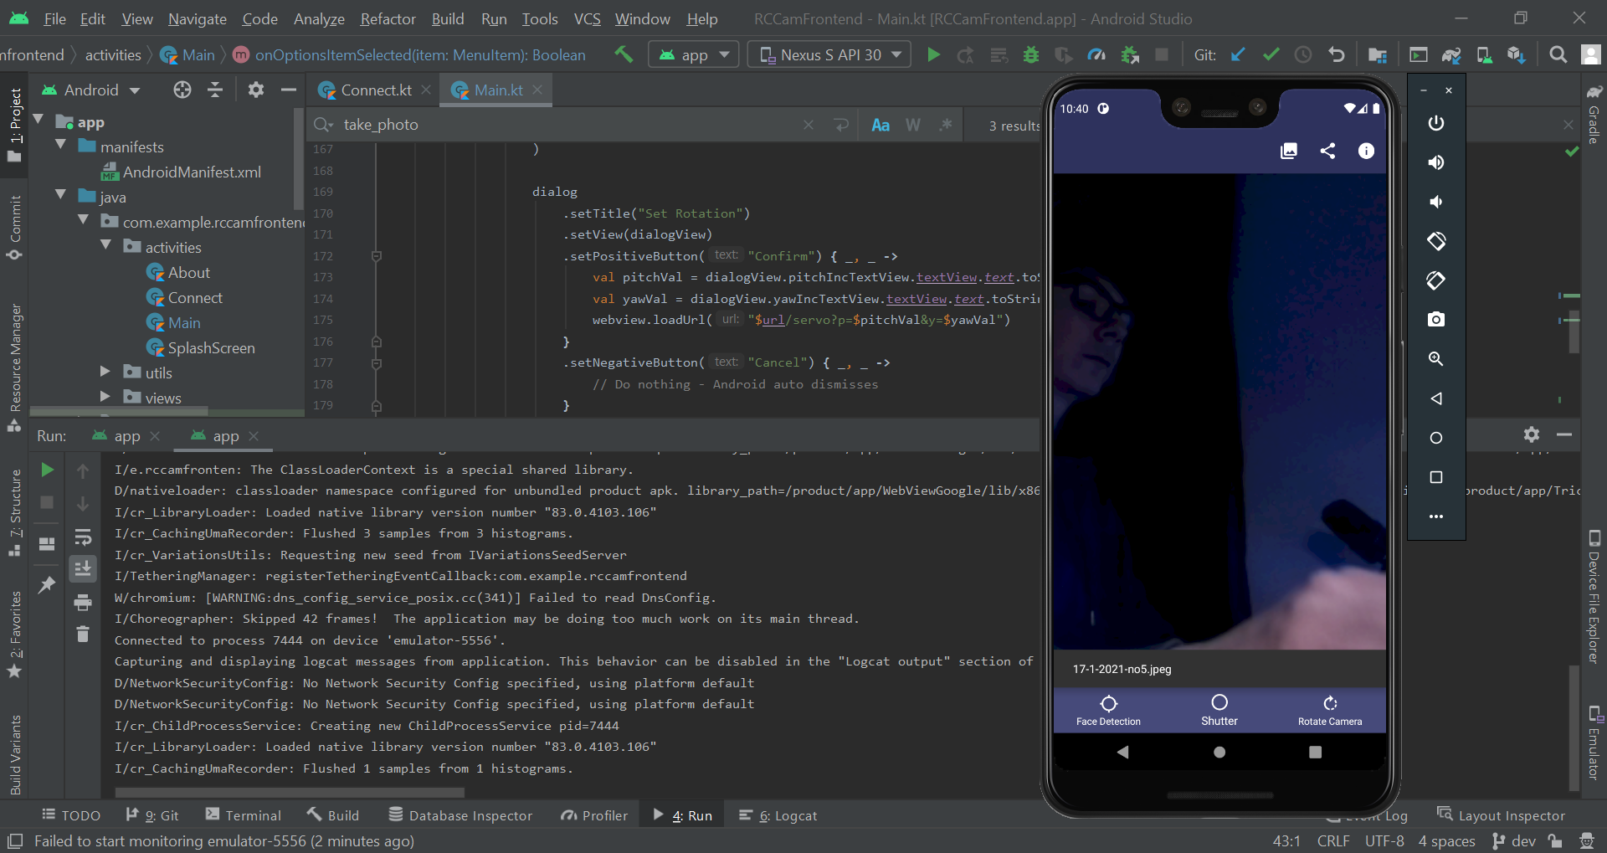

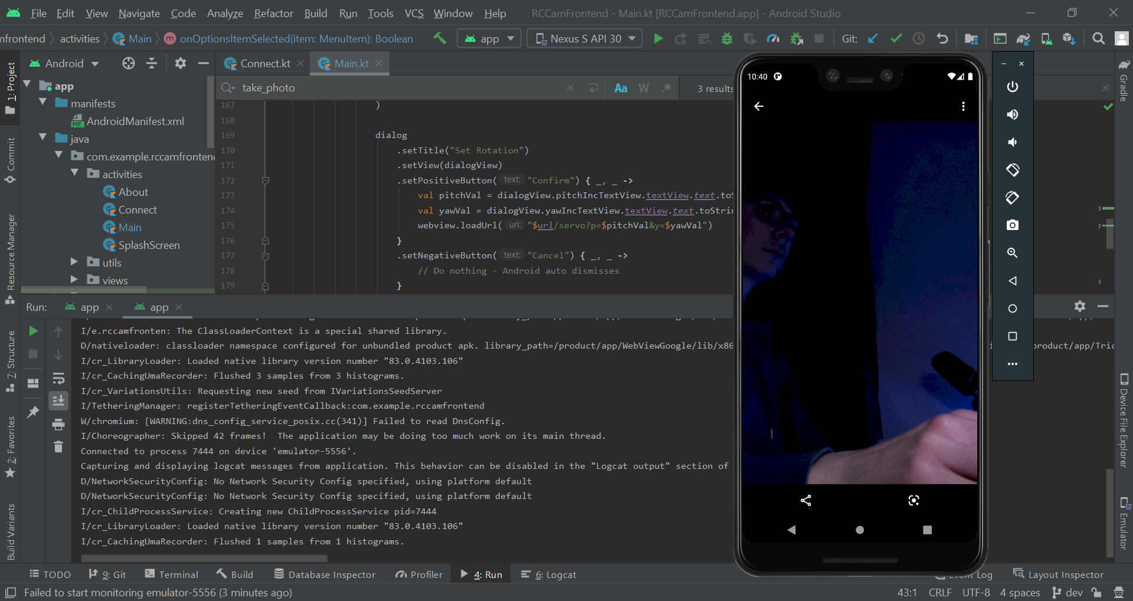

With that I checked off this feedback as done.

##### Feedback 3

Feedback 3 mentions something I remember working on a bit back in module 1. After reading through module 1, I found android:imeOptions under 1.3. I changed this attribute in the EditText textfieldPort.

|  |
| --- |
| android:imeOptions="actionDone" |

This fixed the issue.

### Module 2

#### Test Scenarios and Cases

|  |  |  |
| --- | --- | --- |
| **Test Scenario ID** | **Test Scenario Description** | **Test Steps** |
| 2.2.1 | Check pitch and yaw textfield functionality with a range of combinations of data. | 1. Navigate to Main GUI  2. Press rotation button  3. Input pitch and yaw values  4. Press confirm button |
| 2.2.2 | Check the functionality of the increment and decrement buttons with a combination of yaw and pitch data. | 1. Navigate to Main GUI  2. Press rotation button  3. Input pitch value  4. Press increment/decrement buttons for pitch textfield the appropriate amount of times |

|  |  |  |  |  |  |  |
| --- | --- | --- | --- | --- | --- | --- |
| **Test Case ID** | **Test Scenario ID** | **Test Case Description** | **Test Data** | **Expected Result** | **Actual Result** | **Pass/Fail** |
| 1 | 2.2.1 | Valid Pitch and valid Yaw | pitch = 7  yaw = 7 | Dialog closes and the servo rotates appropriately | Worked as expected | Pass |
| 2 | 2.2.1 | Invalid Pitch and valid Yaw | pitch = 1000  yaw = 7 | Dialog closes and the servo rotates to maximum pitch and appropriate yaw | Cannot enter more than 2 digits for pitch | Fail |
| 3 | 2.2.1 | Valid Pitch and invalid Yaw | pitch = 7  yaw = 1000 | Dialog closes and the servo rotates to maximum yaw and appropriate pitch | Cannot enter more than 2 digits for yaw | Fail |
| 4 | 2.2.1 | Invalid Pitch and invalid Yaw | pitch = -1000  yaw = -1000 | Dialog closes and the servo rotates to minimum pitch and minimum yaw | Cannot enter negative numbers | Fail |
| 5 | 2.2.1 | Absent Pitch and valid Yaw | pitch = **No data**  yaw = 7 | Dialog closes and the servo rotates to the appropriate yaw | Worked as expected | Pass |
| 6 | 2.2.1 | Valid Pitch and absent Yaw | pitch = 7  yaw = **No data** | Dialog closes and the servo rotates to the appropriate pitch | Worked as expected | Pass |
| 7 | 2.2.1 | Invalid alphabetical Pitch and valid Yaw | pitch = hello  yaw = 7 | None of the characters in the pitch textfield should be shown when inputted, the dialog closes and the servo rotates to the appropriate yaw | Cannot enter letters, yaw adjusted accordingly | Pass |
| 8 | 2.2.1 | Valid Pitch and invalid alphabetical Yaw | pitch = 7  yaw = test | None of the characters in the yaw textfield should be shown when inputted, the dialog closes and the servo rotates to the appropriate pitch | Cannot enter letters, pitch adjusted accordingly | Pass |
| 9 | 2.2.1 | Boundary Pitch and valid Yaw | pitch = 12  yaw = 7 | Dialog closes and the servo rotates to maximum pitch and appropriate yaw | Worked as expected | Pass |
| 10 | 2.2.1 | Boundary Pitch and valid Yaw | pitch = 13  yaw = 7 | Dialog closes and the servo rotates to maximum pitch and appropriate yaw | Worked as expected, but pitch did not change | Pass |
| 11 | 2.2.1 | Valid Pitch and boundary Yaw | pitch = 7  yaw = 12 | Dialog closes and the servo rotates to maximum yaw and appropriate pitch | Worked as expected | Pass |
| 12 | 2.2.1 | Valid Pitch and boundary Yaw | pitch = 7  yaw = 13 | Dialog closes and the servo rotates to maximum yaw and appropriate pitch | Worked as expected, but yaw did not change | Pass |
| 13 | 2.2.1 | Boundary Pitch and boundary Yaw | pitch = 2  yaw = 2 | Dialog closes and the servo rotates to minimum pitch and minimum yaw | Worked as expected | Pass |
| 14 | 2.2.1 | Boundary Pitch and boundary Yaw | pitch = 1  yaw = 1 | Dialog closes and the servo rotates to minimum pitch and minimum yaw | Worked as expected, but neither pitch or yaw changed | Pass |
| 15 | 2.2.2 | Valid Pitch followed by two increment presses and two decrement presses | pitch = 5  Increment presses: 2  Decrement presses: 2 | The value within the text field should follow: 5, 6, 7, 6, 5. | Worked as expected | Pass |
| 16 | 2.2.2 | Maximum boundary Pitch followed by two increment presses and one decrement press | pitch = 12  Increment presses: 2  Decrement presses: 1 | The value within the text field should follow: 12, 12, 12, 11. | Values were 12, 13, 13, 12 | Fail |
| 17 | 2.2.2 | Minimum boundary Pitch followed by two decrement presses and one increment press | pitch = 2  Decrement presses: 2  Increment presses: 1 | The value within the text field should follow: 2, 2, 2, 3 | Values were 2, 1, 0, 1 | Fail |
| 18 | 2.2.2 | Absent Pitch followed by two increment presses and two decrement press | pitch = **No data**  Increment presses: 2  Decrement presses: 2 | Nothing will happen to the text field when the increment or decrement buttons are pressed | Worked as expected | Pass |
| 19 | 2.2.2 | Invalid alphabetical Pitch followed by two increment presses and two decrement press | pitch = hello  Increment presses: 2  Decrement presses: 2 | No characters should appear in the text input resulting in an empty input - should be the same as test case 18 | Worked as expected | Pass |
| 20 | 2.2.2 | Valid Yaw followed by two increment presses and two decrement presses | yaw = 5  Increment presses: 2  Decrement presses: 2 | The value within the text field should follow: 5, 6, 7, 6, 5. | Worked as expected | Pass |
| 21 | 2.2.2 | Maximum boundary Yaw followed by two increment presses and one decrement press | yaw = 12  Increment presses: 2  Decrement presses: 1 | The value within the text field should follow: 12, 12, 12, 11. | Values were 12, 13, 13, 12 | Fail |
| 22 | 2.2.2 | Minimum boundary Yaw followed by two decrement presses and one increment press | yaw = 2  Decrement presses: 2  Increment presses: 1 | The value within the text field should follow: 2, 2, 2, 3 | Values were 2, 1, 0, 1 | Fail |
| 23 | 2.2.2 | Absent Yaw followed by two increment presses and two decrement press | yaw = **No data**  Increment presses: 2  Decrement presses: 2 | Nothing will happen to the text field when the increment or decrement buttons are pressed | Worked as expected | Pass |
| 24 | 2.2.2 | Invalid alphabetical Yaw followed by two increment presses and two decrement press | yaw = hello  Increment presses: 2  Decrement presses: 2 | No characters should appear in the text input resulting in an empty input - should be the same as test case 18 | Worked as expected | Pass |

#### Identified Issues

|  |  |  |
| --- | --- | --- |
| **Issue ID** | **Encompassed Test Cases** | **Issue Description** |
| 1 | 2, 3, 4 | Entering certain values in that should yield a max and min don’t. E.g trying to enter 1000 results in 10 instead of 12. |
| 2 | 16, 17, 21, 22 | Frontend max and min are not the correct values |

#### Feedback

|  |  |
| --- | --- |
| **Feedback ID** | **Issue Description** |
| 1 | Previous keyboard issue present when rotating camera |
| 2 | Length Mismatch error when rotating, video feed frozen |
| 3 | Range should be intuitive rather than random numbers |
| 4 | It would be nice to have the face detection button working |
| 5 | Decimal values for pitch and yaw |
| 6 | Stop the video feed flickering when rotating |

#### Remedial Action

##### Issue 1, Issue 2, Feedback 3

I decided to combine the two issues and the feedback since I can solve them all fairly easily and they’re relatively similar.

My solution to this would be to have the range of 0-10 allowed for the range of values. This is a lot better than 2-12 and is really easy to implement. Also, you won’t have the issue of trying to enter 1000 for example and it not rotating to the max value.

I started by setting the max and min values of my incrementable view to 0 and 10.

|  |
| --- |
| <com.example.rccamfrontend.views.IncrementableTextView  android:id="@+id/pitchIncTextView"  android:layout_width="match_parent"  android:layout_height="wrap_content"  android:layout_marginLeft="20dp"  android:layout_marginTop="30dp"  android:layout_marginRight="20dp"  android:layout_marginBottom="5dp"  custom:maxVal="10"  custom:minVal="0"  custom:text="Pitch" />  <com.example.rccamfrontend.views.IncrementableTextView  android:id="@+id/yawIncTextView"  android:layout_width="match_parent"  android:layout_height="wrap_content"  android:layout_marginLeft="20dp"  android:layout_marginTop="30dp"  android:layout_marginRight="20dp"  android:layout_marginBottom="5dp"  custom:maxVal="10"  custom:minVal="0"  custom:text="Yaw" /> |

I then modified the rotation dialogue confirm to add 2 to the pitch and yaw values to get the working range of 2-12.

|  |
| --- |
| .setPositiveButton("Confirm") { _, _ ->  var pitchVal = dialogView.pitchIncTextView.textView.text.toString().toIntOrNull()  var yawVal = dialogView.yawIncTextView.textView.text.toString().toIntOrNull()  if (pitchVal != null){  pitchVal += 2  }  if (yawVal != null){  yawVal += 2  }  webview.loadUrl("$url/servo?p=$pitchVal&y=$yawVal") } |

For consistency I realised it might be better to just have the backend work with the values 0-10 instead. So, I removed the Kotlin code above and performed the calculation on the backend.

|  |
| --- |
| # Acceptable value range for servos smin = 0.0 smax = 10.0  # Servo pitch modification logic for char, servo_name, ref in (("p", "Pitch", ser_app.pitch), ("y", "Yaw", ser_app.yaw)):  if char in arg_keys and is_number(request.args[char]):  val = float(request.args[char])  if val < smin:  print(f"{servo_name} value '{val}' exceeded range ({smin} -> {smax})\n{servo_name} value set to {smin}")  val = smin  elif val > smax:  print(f"{servo_name} value '{val}' exceeded range ({smin} -> {smax})\n{servo_name} value set to {smax}")  val = smax   ser_app.change_servo(ref, val+2)  print(f"{servo_name} rotation set to {val}") |

I also increased the delay for the servo since it seemed to be having some issues.

|  |
| --- |
| @staticmethod def change_servo(servo, amount, tm=0.3): |

I then began working through all of the test cases without my stakeholder.

|  |  |  |  |  |  |  |
| --- | --- | --- | --- | --- | --- | --- |
| **Test Case ID** | **Test Scenario ID** | **Test Case Description** | **Test Data** | **Expected Result** | **Actual Result** | **Pass/Fail** |
| 1 | 2.2.1 | Valid Pitch and valid Yaw | pitch = 7  yaw = 7 | Dialog closes and the servo rotates appropriately | As expected | Pass |
| 2 | 2.2.1 | Invalid Pitch and valid Yaw | pitch = 1000  yaw = 7 | Dialog closes and the servo rotates to maximum pitch and appropriate yaw | As expected | Pass |
| 3 | 2.2.1 | Valid Pitch and invalid Yaw | pitch = 7  yaw = 1000 | Dialog closes and the servo rotates to maximum yaw and appropriate pitch | As expected | Pass |
| 4 | 2.2.1 | Invalid Pitch and invalid Yaw | pitch = -1000  yaw = -1000 | Dialog closes and the servo rotates to minimum pitch and minimum yaw | Can’t input negative values so it goes to max. However, I don’t consider this a failure as they can see that they don’t input a negative value. | Pass |
| 5 | 2.2.1 | Absent Pitch and valid Yaw | pitch = **No data**  yaw = 7 | Dialog closes and the servo rotates to the appropriate yaw | As expected | Pass |
| 6 | 2.2.1 | Valid Pitch and absent Yaw | pitch = 7  yaw = **No data** | Dialog closes and the servo rotates to the appropriate pitch | As expected | Pass |
| 7 | 2.2.1 | Invalid alphabetical Pitch and valid Yaw | pitch = hello  yaw = 7 | None of the characters in the pitch textfield should be shown when inputted, the dialog closes and the servo rotates to the appropriate yaw | As expected | Pass |
| 8 | 2.2.1 | Valid Pitch and invalid alphabetical Yaw | pitch = 7  yaw = test | None of the characters in the yaw textfield should be shown when inputted, the dialog closes and the servo rotates to the appropriate pitch | As expected | Pass |
| 9 | 2.2.1 | Boundary Pitch and valid Yaw | pitch = 10  yaw = 7 | Dialog closes and the servo rotates to maximum pitch and appropriate yaw | As expected | Pass |
| 10 | 2.2.1 | Boundary Pitch and valid Yaw | pitch = 11  yaw = 7 | Dialog closes and the servo rotates to maximum pitch and appropriate yaw | As expected | Pass |
| 11 | 2.2.1 | Valid Pitch and boundary Yaw | pitch = 7  yaw = 10 | Dialog closes and the servo rotates to maximum yaw and appropriate pitch | As expected | Pass |
| 12 | 2.2.1 | Valid Pitch and boundary Yaw | pitch = 7  yaw = 11 | Dialog closes and the servo rotates to maximum yaw and appropriate pitch | As expected | Pass |
| 13 | 2.2.1 | Boundary Pitch and boundary Yaw | pitch = 0  yaw = 0 | Dialog closes and the servo rotates to minimum pitch and minimum yaw | As expected | Pass |
| 14 | 2.2.1 | Boundary Pitch and boundary Yaw | pitch = -1  yaw = -1 | Dialog closes and the servo rotates to minimum pitch and minimum yaw | Same logic as the result of test case 4 | Pass |
| 15 | 2.2.2 | Valid Pitch followed by two increment presses and two decrement presses | pitch = 5  Increment presses: 2  Decrement presses: 2 | The value within the text field should follow: 5, 6, 7, 6, 5. | Values: 5, 6, 7, 6, 5 | Pass |
| 16 | 2.2.2 | Maximum boundary Pitch followed by two increment presses and one decrement press | pitch = 10  Increment presses: 2  Decrement presses: 1 | The value within the text field should follow: 10, 10, 10, 9. | Values: 10, 10, 10, 9 | Pass |
| 17 | 2.2.2 | Minimum boundary Pitch followed by two decrement presses and one increment press | pitch = 0  Decrement presses: 2  Increment presses: 1 | The value within the text field should follow: 0, 0, 0, 1 | Values: 0, 0, 0, 1 | Pass |
| 18 | 2.2.2 | Absent Pitch followed by two increment presses and two decrement press | pitch = **No data**  Increment presses: 2  Decrement presses: 2 | Nothing will happen to the text field when the increment or decrement buttons are pressed | As expected | Pass |
| 19 | 2.2.2 | Invalid alphabetical Pitch followed by two increment presses and two decrement press | pitch = hello  Increment presses: 2  Decrement presses: 2 | No characters should appear in the text input resulting in an empty input - should be the same as test case 18 | As expected | Pass |
| 20 | 2.2.2 | Valid Yaw followed by two increment presses and two decrement presses | yaw = 5  Increment presses: 2  Decrement presses: 2 | The value within the text field should follow: 5, 6, 7, 6, 5. | Values: 5, 6, 7, 6, 5 | Pass |
| 21 | 2.2.2 | Maximum boundary Yaw followed by two increment presses and one decrement press | yaw = 10  Increment presses: 2  Decrement presses: 1 | The value within the text field should follow: 10, 10, 10, 9. | Values: 10, 10, 10, 9 | Pass |
| 22 | 2.2.2 | Minimum boundary Yaw followed by two decrement presses and one increment press | yaw = 0  Decrement presses: 2  Increment presses: 1 | The value within the text field should follow: 0, 0, 0, 1 | Values: 0, 0, 0, 1 | Pass |
| 23 | 2.2.2 | Absent Yaw followed by two increment presses and two decrement press | yaw = **No data**  Increment presses: 2  Decrement presses: 2 | Nothing will happen to the text field when the increment or decrement buttons are pressed | As expected | Pass |
| 24 | 2.2.2 | Invalid alphabetical Yaw followed by two increment presses and two decrement press | yaw = hello  Increment presses: 2  Decrement presses: 2 | No characters should appear in the text input resulting in an empty input - should be the same as test case 18 | As expected | Pass |

##### Feedback 1

After testing this myself, I found that it only occurred when the user presses the tab button to go between text fields. When using the Android keyboard, this issue doesn’t occur. Due to this I believe it is an emulator issue and not one to do with my app.

##### Feedback 2

In order to fix this issue, I had the simple idea of just reloading the video feed whenever it occurred. This seemed to be happening on the length mismatch and another error. I first changed the toast to show the error code so that I could use that to check if it was either of these errors.

|  |
| --- |
| generateToast(  this@Main,"${error.errorCode}# ${error.description}",  dur = Toast.LENGTH_LONG ) |

After testing for a bit both of the errors were under unknown errors, the code being -1. This could cause issues but for the time being I had only ever seen these errors come up. I could use their descriptions for checking if it was those errors however these could be altered.

So, I decided to just use the code.

|  |
| --- |
| // Error handling kinda webview.webViewClient = object : WebViewClient() {  override fun onReceivedError(  view: WebView,  request: WebResourceRequest,  error: WebResourceError  ) {  if (error.errorCode == -1){  webview.reload()  } else {  generateToast(  this@Main,  "${error.errorCode}# ${error.description}",  dur = Toast.LENGTH_LONG)  }  } } |

After testing with various rotation values, it seemed to have fixed the issue.

##### Feedback 5

My current code already has the implementation of decimalised values being accepted so it was only a matter of setting up the frontend to allow those values to be entered.

I started by changing the attribute from an integer to a float

|  |
| --- |
| <attr name="incVal" format="float" /> <attr name="decVal" format="float" /> |

I then changed the increment and decrement values to 0.5 to show to the user that decimals are acceptable.

|  |
| --- |
| <com.example.rccamfrontend.views.IncrementableTextView  android:id="@+id/pitchIncTextView"  android:layout_width="match_parent"  android:layout_height="wrap_content"  android:layout_marginLeft="20dp"  android:layout_marginTop="30dp"  android:layout_marginRight="20dp"  android:layout_marginBottom="5dp"  custom:maxVal="10"  custom:minVal="0"  custom:incVal="0.5"  custom:decVal="0.5"  custom:text="Pitch" />  <com.example.rccamfrontend.views.IncrementableTextView  android:id="@+id/yawIncTextView"  android:layout_width="match_parent"  android:layout_height="wrap_content"  android:layout_marginLeft="20dp"  android:layout_marginTop="30dp"  android:layout_marginRight="20dp"  android:layout_marginBottom="5dp"  custom:maxVal="10"  custom:minVal="0"  custom:incVal="0.5"  custom:decVal="0.5"  custom:text="Yaw" /> |

I then changed the casts to an integer to a float (excluding the length)

|  |
| --- |
| // Setting value limit for Text View val max = attrGetter.getString(R.styleable.IncrementableTextView_maxVal)?.toFloatOrNull() val min = attrGetter.getString(R.styleable.IncrementableTextView_minVal)?.toFloatOrNull()  textView.doOnTextChanged { text, _, _, _ ->  val textInt = text.toString().toFloatOrNull() |

Then I changed the incrementTextView function to work with floats.

|  |
| --- |
| fun incrementTextView(view: TextView, amount: Float){  if (view.text.toString() != ""){  // val intText = Integer.parseInt(view.text.toString())  val numText = view.text.toString().toFloat()  view.text = (numText + amount).toString()  } } |

Finally I modified where this value was called within the incrementable text view

|  |
| --- |
| // Modifying Minus Button val dec = attrGetter.getFloat(R.styleable.IncrementableTextView_decVal, -1F) button_minus.setOnClickListener { // Decrement btnYaw  incrementTextView(textView, dec) }   // Modifying Plus Button val inc = attrGetter.getFloat(R.styleable.IncrementableTextView_incVal, 1F) button_plus.setOnClickListener { // Decrement btnYaw  incrementTextView(textView, inc) } |

I ran the program and when I tried to input 5.9, the decimal value didn’t work. In order to fix this, I added a new attribute to my incrementable text view.

|  |
| --- |
| <attr name="inputType" format="enum" >  <enum name="integer" value="0"/>  <enum name="real" value="1"/> </attr> |

In order for this to work, I would need to change the input type to allow for a float. I found this [Stack overflow thread](https://stackoverflow.com/questions/7300490/set-edittext-digits-programmatically) detailing how to.

|  |
| --- |
| if (attrGetter.getString(R.styleable.IncrementableTextView_inputType) == "1"){  textView.inputType = InputType.TYPE_CLASS_NUMBER  textView.inputType = InputType.TYPE_NUMBER_FLAG_DECIMAL  textView.keyListener = DigitsKeyListener(Locale.getDefault(), false, true) } |

I then went back and added the following attribute to the XML calls.

|  |
| --- |
| custom:inputType="real" |

I added the following to the timed shot incrementable text view.

|  |
| --- |
| custom:inputType="integer" |

When I ran the program I could now enter a decimal but due to the max length I couldn’t enter another value. So, I changed the max length to 3 for the entire view.

|  |
| --- |
| <EditText  android:id="@+id/textfield"  android:layout_width="0dp"  android:layout_height="wrap_content"  android:textColor="@color/white"  android:layout_weight="4"  android:fontFamily="sans-serif"  android:hint="@string/add_text_attribute"  android:importantForAutofill="no"  android:inputType="number"  android:maxLength="3" /> |

Everything seemed to work now except when I typed in 50 it would correct it to “10.” instead of “10”. To fix this I just increased the max length to 4 to display the decimal value after the point.

|  |
| --- |
| android:maxLength="3" |

This seemed to work for all values except for where it was “5.” for example. This seemed to be an issue with the backend. After some testing it seemed to be an issue with the function is_number. I modified the regex to allow for 0 or more occurrences of a digit after the decimal point.

|  |
| --- |
| def is_number(num):  """  Determines whether a given input is a number or not. Valid for num∈ℚ   :param num: string, int, float  :return: true if the given value is a number, false if not.  """  return True if type(num) in [int, float] or re.match(r"^-?\d+(?:\.\d*)?$", num) is not None else False |

This fixed the issue entirely. I then ran through some new test cases to double check whether it worked appropriately.

|  |  |  |  |  |  |  |
| --- | --- | --- | --- | --- | --- | --- |
| **Test Case ID** | **Test Scenario ID** | **Test Case Description** | **Test Data** | **Expected Result** | **Actual Result** | **Pass/Fail** |
| 1 | 2.2.1 | Valid Pitch and valid Yaw | pitch = 7  yaw = 7 | Dialog closes and the servo rotates appropriately | As expected | Pass |
| 2 | 2.2.1 | Invalid Pitch and valid Yaw | pitch = 1000  yaw = 7.5 | Dialog closes and the servo rotates to maximum pitch and appropriate yaw | As expected | Pass |
| 3 | 2.2.1 | Valid Pitch and invalid Yaw | pitch = 7.5  yaw = 1000 | Dialog closes and the servo rotates to maximum yaw and appropriate pitch | As expected | Pass |
| 4 | 2.2.1 | Invalid Pitch and invalid Yaw | pitch = -1000  yaw = -1000 | Dialog closes and the servo rotates to maximum pitch and maximum yaw | As expected | Pass |
| 5 | 2.2.1 | Absent Pitch and valid Yaw | pitch = **No data**  yaw = 8.6 | Dialog closes and the servo rotates to the appropriate yaw | As expected | Pass |
| 6 | 2.2.1 | Valid Pitch and absent Yaw | pitch = 8.6  yaw = **No data** | Dialog closes and the servo rotates to the appropriate pitch | As expected | Pass |
| 7 | 2.2.1 | Invalid alphabetical Pitch and valid Yaw | pitch = hello  yaw = 7 | None of the characters in the pitch textfield should be shown when inputted, the dialog closes and the servo rotates to the appropriate yaw | As expected | Pass |
| 8 | 2.2.1 | Valid Pitch and invalid alphabetical Yaw | pitch = 7  yaw = test | None of the characters in the yaw textfield should be shown when inputted, the dialog closes and the servo rotates to the appropriate pitch | As expected | Pass |
| 9 | 2.2.1 | Boundary Pitch and valid Yaw | pitch = 10  yaw = 7 | Dialog closes and the servo rotates to maximum pitch and appropriate yaw | As expected | Pass |
| 10 | 2.2.1 | Boundary Pitch and valid Yaw | pitch = 10.1  yaw = 5 | Dialog closes and the servo rotates to maximum pitch and appropriate yaw | As expected | Pass |
| 11 | 2.2.1 | Valid Pitch and boundary Yaw | pitch = 7  yaw = 10 | Dialog closes and the servo rotates to maximum yaw and appropriate pitch | As expected | Pass |
| 12 | 2.2.1 | Valid Pitch and boundary Yaw | pitch = 5  yaw = 10.1 | Dialog closes and the servo rotates to maximum yaw and appropriate pitch | As expected | Pass |
| 13 | 2.2.1 | Boundary Pitch and boundary Yaw | pitch = 0.1  yaw = 0.1 | Dialog closes and the servo rotates to minimum pitch and minimum yaw | As expected | Pass |
| 14 | 2.2.1 | Boundary Pitch and boundary Yaw | pitch = 0  yaw = 0 | Dialog closes and the servo rotates to minimum pitch and minimum yaw | As expected | Pass |
| 15 | 2.2.2 | Valid Pitch followed by two increment presses and two decrement presses | pitch = 5  Increment presses: 2  Decrement presses: 2 | The value within the text field should follow: 5, 5.5, 6, 5.5, 5. | Values: 5, 5.5, 6, 6.5, 7 | Fail |
| 16 | 2.2.2 | Maximum boundary Pitch followed by two increment presses and one decrement press | pitch = 10  Increment presses: 2  Decrement presses: 1 | The value within the text field should follow: 10, 10, 10, 9.5. | 10, 10, 10, 10 | Fail |
| 17 | 2.2.2 | Minimum boundary Pitch followed by two decrement presses and one increment press | pitch = 0  Decrement presses: 2  Increment presses: 1 | The value within the text field should follow: 0, 0, 0, 0.5 | 0, 0.5, 1, 1.5 | Fail |
| 18 | 2.2.2 | Absent Pitch followed by two increment presses and two decrement press | pitch = **No data**  Increment presses: 2  Decrement presses: 2 | Nothing will happen to the text field when the increment or decrement buttons are pressed | As expected | Pass |
| 19 | 2.2.2 | Invalid alphabetical Pitch followed by two increment presses and two decrement press | pitch = hello  Increment presses: 2  Decrement presses: 2 | No characters should appear in the text input resulting in an empty input - should be the same as test case 18 | As expected | Pass |
| 20 | 2.2.2 | Valid Yaw followed by two increment presses and two decrement presses | yaw = 5  Increment presses: 2  Decrement presses: 2 | The value within the text field should follow: 5, 5.5, 6, 5.5, 5. | Values: 5, 5.5, 6, 6.5, 7 | Fail |
| 21 | 2.2.2 | Maximum boundary Yaw followed by two increment presses and one decrement press | yaw = 10  Increment presses: 2  Decrement presses: 1 | The value within the text field should follow: 10, 10, 10, 9.5. | 10, 10, 10, 10 | Fail |
| 22 | 2.2.2 | Minimum boundary Yaw followed by two decrement presses and one increment press | yaw = 0  Decrement presses: 2  Increment presses: 1 | The value within the text field should follow: 0, 0, 0, 0.5 | 0, 0.5, 1, 1.5 | Fail |
| 23 | 2.2.2 | Absent Yaw followed by two increment presses and two decrement press | yaw = **No data**  Increment presses: 2  Decrement presses: 2 | Nothing will happen to the text field when the increment or decrement buttons are pressed | As expected | Pass |
| 24 | 2.2.2 | Invalid alphabetical Yaw followed by two increment presses and two decrement press | yaw = hello  Increment presses: 2  Decrement presses: 2 | No characters should appear in the text input resulting in an empty input - should be the same as test case 18 | As expected | Pass |

From my tests it seemed like my decrement value wasn’t functioning as expected. I changed the default value and multiplied the value by -1 to fix this.

|  |
| --- |
| // Modifying Minus Button val dec = attrGetter.getFloat(R.styleable.IncrementableTextView_decVal, 1F) button_minus.setOnClickListener { // Decrement btnYaw  incrementTextView(textView, dec*-1) } |

I then ran through the 2.2.2 test cases again.

|  |  |  |  |  |  |  |
| --- | --- | --- | --- | --- | --- | --- |
| **Test Case ID** | **Test Scenario ID** | **Test Case Description** | **Test Data** | **Expected Result** | **Actual Result** | **Pass/Fail** |
| 15 | 2.2.2 | Valid Pitch followed by two increment presses and two decrement presses | pitch = 5  Increment presses: 2  Decrement presses: 2 | The value within the text field should follow: 5, 5.5, 6, 5.5, 5. | Values: 5, 5.5, 6.0, 5.5, 5.0 | Pass |
| 16 | 2.2.2 | Maximum boundary Pitch followed by two increment presses and one decrement press | pitch = 10  Increment presses: 2  Decrement presses: 1 | The value within the text field should follow: 10, 10, 10, 9.5. | Values: 10, 10.0, 10.0, 9.5 | Pass |
| 17 | 2.2.2 | Minimum boundary Pitch followed by two decrement presses and one increment press | pitch = 0  Decrement presses: 2  Increment presses: 1 | The value within the text field should follow: 0, 0, 0, 0.5 | Values: 0, 0.0, 0.0, 0.5 | Pass |
| 18 | 2.2.2 | Absent Pitch followed by two increment presses and two decrement press | pitch = **No data**  Increment presses: 2  Decrement presses: 2 | Nothing will happen to the text field when the increment or decrement buttons are pressed | As expected | Pass |
| 19 | 2.2.2 | Invalid alphabetical Pitch followed by two increment presses and two decrement press | pitch = hello  Increment presses: 2  Decrement presses: 2 | No characters should appear in the text input resulting in an empty input - should be the same as test case 18 | As expected | Pass |
| 20 | 2.2.2 | Valid Yaw followed by two increment presses and two decrement presses | yaw = 5  Increment presses: 2  Decrement presses: 2 | The value within the text field should follow: 5, 5.5, 6, 5.5, 5. | Values: 5, 5.5, 6.0, 5.5, 5.0 | Pass |
| 21 | 2.2.2 | Maximum boundary Yaw followed by two increment presses and one decrement press | yaw = 10  Increment presses: 2  Decrement presses: 1 | The value within the text field should follow: 10, 10, 10, 9.5. | Values: 10, 10.0, 10.0, 9.5 | Pass |
| 22 | 2.2.2 | Minimum boundary Yaw followed by two decrement presses and one increment press | yaw = 0  Decrement presses: 2  Increment presses: 1 | The value within the text field should follow: 0, 0, 0, 0.5 | Values: 0, 0.0, 0.0, 0.5 | Pass |
| 23 | 2.2.2 | Absent Yaw followed by two increment presses and two decrement press | yaw = **No data**  Increment presses: 2  Decrement presses: 2 | Nothing will happen to the text field when the increment or decrement buttons are pressed | As expected | Pass |
| 24 | 2.2.2 | Invalid alphabetical Yaw followed by two increment presses and two decrement press | yaw = hello  Increment presses: 2  Decrement presses: 2 | No characters should appear in the text input resulting in an empty input - should be the same as test case 18 | As expected | Pass |

This fixed the issue and the only slight problem was values being changed to “x.0”. Since this wasn’t a big issue I decided to leave it.

##### Feedback 6

To stop the screen flickering when rotating the servo via the app, I would need to change how the app interacts with the web server. Instead of relying on the webview to send HTTP requests, I would need to send one outside of this.

I would need to use a POST HTTP request in order to send the data. I found a [guide](https://developer.android.com/training/volley) for the HTTP library Volley in the documentation.

I first set up my project to work with Volley. Then, after reading the lacking documentation and some articles on Volley I created the following function.

|  |
| --- |
| fun requestPOST(ctx: Context, url: String, data: String){  // Instantiate the RequestQueue  val queue = Volley.newRequestQueue(ctx)   // String request for the provided URL with given data  val strReq: StringRequest = object : StringRequest(Method.POST, url, { }, { }){  override fun getBody(): ByteArray{  return data.toByteArray(Charset.defaultCharset())  }  }   // Add the request to the RequestQueue.  queue.add(strReq) } |

Then, where I originally loaded the URL for servo rotation, I used this instead.

|  |
| --- |
| dialog  .setTitle("Set Rotation")  .setView(dialogView)  .setPositiveButton("Confirm") { _, _ ->  val pitchVal = dialogView.pitchIncTextView.textView.text  val yawVal = dialogView.yawIncTextView.textView.text  requestPOST(this, "$url/servo", "p=$pitchVal&y=$yawVal")  }  .setNegativeButton("Cancel") { _, _ ->  // Do nothing - Android auto dismisses  }  .show() |

I then tried running the app and entering values for rotation to see if it would work. On my server, I saw it recognise the POST request but respond with a code 405. After googling it appeared that my server rejected the request.

I realised that my current web server script was only built to respond to GET requests and not POST. I also added to my requestPOST function to show errors.

|  |
| --- |
| // String request for the provided URL with given data val strReq: StringRequest = object : StringRequest(Method.POST, url,  { },  { error ->  Log.d("Volley:", error)  } ){  override fun getBody(): ByteArray{  return data.toByteArray(Charset.defaultCharset())  } } |

I then began changing the Flask server to accept POST requests. I started by enabling them for the servo directory and outputting request.values to see what they would give me.

|  |
| --- |
| @web_app.route("/servo", methods=["POST", "GET"]) def servo():  print(request.values)   ...   if request.method == "GET":  return redirect(url_for("main_page")) |

It worked when I tried to access the servo directory through Chrome but not through the app. According to the server, I needed to have a return statement for POST. So, I removed the if statement. I also tried adding a get method to request.values to see how it would work.

|  |
| --- |
| @web_app.route("/servo", methods=["POST", "GET"]) def servo():  print(f"Pitch {request.values.get('p', 'No Pitch')}")  print(f"Yaw {request.values.get('y', 'No Yaw')}") |

Again, the servo worked through Chrome but not through the app. However, the server did output both values I entered when using the app. So, it was a matter of implementing this through request.values rather than request.args as it seemingly encompassed both.

|  |
| --- |
| @web_app.route("/servo", methods=["POST", "GET"]) def servo():  # Acceptable value range for servos  smin = 0.0  smax = 10.0   # Servo pitch modification logic  for char, servo_name, ref in (("p", "Pitch", ser_app.pitch), ("y", "Yaw", ser_app.yaw)):  val = request.values.get(char, "a")  if is_number(val):  val = float(val)  if val < smin:  print(f"{servo_name} value '{val}' exceeded range ({smin} -> {smax})\n{servo_name} value set to {smin}")  val = smin  elif val > smax:  print(f"{servo_name} value '{val}' exceeded range ({smin} -> {smax})\n{servo_name} value set to {smax}")  val = smax   ser_app.change_servo(ref, val + 2)  print(f"{servo_name} rotation set to {val}")   return redirect(url_for("main_page")) |

As expected, Chrome worked without fault. The app also worked this time round. This was a success as the flickering was gone. Later on I should make sure to fix this for taking photos as well.

##### Feedback 4

Face detection. This was the only part of the success criteria I failed to meet. I had been researching alternatives after failing to produce the result using alwaysAI and did find Google Vision - an API with what looked like an easy face detection system.

I found the [guide for face detection](https://cloud.google.com/vision/docs/detecting-faces) and after looking a bit more into it, I discovered that I would have to set up payment information with Google.

Due to this, I decided to instead look into OpenCV again. It turned out that OpenCV already provides a dataset for face detection according to this [guide](https://towardsdatascience.com/simple-face-detection-in-python-1fcda0ea648e) and the OpenCV [repo](https://github.com/opencv/opencv). Also, the RPI should be able to handle performing face detection on a low resolution image fairly quickly - it would be a different case for a video stream with face recognition for example.

After reading some articles, the sample face detection Python file for OpenCV and downloading haarcascade_frontalface_default.xml, I created the following:

|  |
| --- |
| import cv2 as cv  # Initialise face detection cascade = cv.CascadeClassifier("face_detect.xml")  # Load image img = cv.imread("image.jpeg")  # Recolour image to grey img_grey = cv.cvtColor(img, cv.COLOR_BGR2GRAY) img_grey = cv.equalizeHist(img_grey)  # Run face detection faces = cascade.detectMultiScale(img_grey, scaleFactor=1.1, minNeighbors=7, flags=cv.CASCADE_SCALE_IMAGE)  # Apply bounding boxes for (x, y, w, h) in faces:  cv.rectangle(img, (x, y), (x + w, y + h), (255, 0, 0), 2)  # Write image with bounding box cv.imwrite("bounding_box.png", img) print("Done!") |

I changed the minNeighbors value to try to get the most accurate without being unrealistic. The main issue with the Haar Cascade face detection algorithm is that it isn’t always very accurate though it is very fast. Since accuracy isn’t necessarily a major issue however, it is the perfect algorithm for my low power RPI.

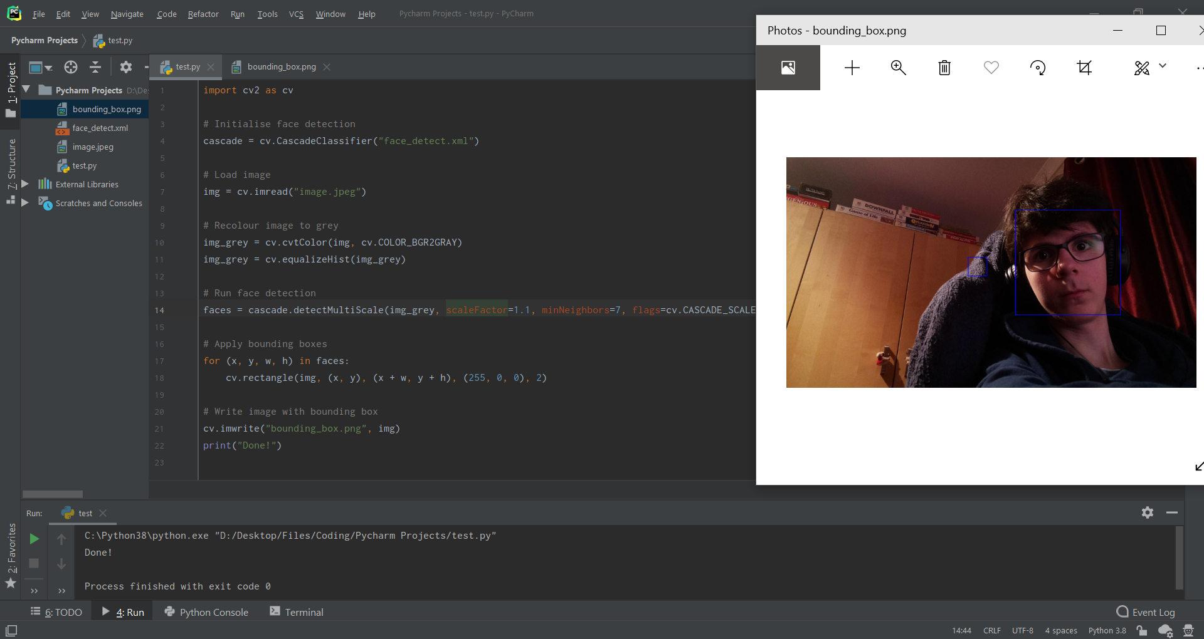

In order to implement this effectively, I would need to have the image stored in a stream in memory rather than working off an image captured. To do this I need to rework the capture_image function.

|  |
| --- |
| def capture_image(self, filename="", format="png", res=None):  # Changing resolution  maxRes = (1920, 1080)  if res is None:  res = maxRes  elif res[0] > maxRes[0] or res[1] > maxRes[1]:  res = reduceResolution(res, maxRes)   # Stopping video feed  Camera.curCapture = True  while Camera.curStream is True:  pass   # Changing to higher resolution for capturing image  while True:  try:  self.camera.resolution = res  break  except picamera.exc.PiCameraMMALError:  pass   self.camera.capture(filename, format=ext)   # Reverting to live stream resolution  while True:  try:  self.camera.resolution = (320, 240)  break  except picamera.exc.PiCameraMMALError:  pass   Camera.curCapture = False |

I also modified the call. This way I have to pass a filename into the function and could also pass a stream instead.

|  |
| --- |
| # Capture image as PNG image_ext = "png" image_name = gen_filename(image_ext, path=image_paths[0]) camera.capture_image(filename=image_name, format=image_ext, res=res) |

Then I created a quick test with a new route and OpenCV for this. I used the [documentation](http://bgr) for the picamera to help achieve this.

|  |
| --- |
| @web_app.route("/face_detection", methods=["POST", "GET"]) def face_detection():  # Image stream capture and decode for OpenCV  stream = io.BytesIO()  camera.capture_image(stream, format="jpeg")  data = np.fromstring(stream.getvalue(), dtype=np.uint8)  img = cv.imdecode(data, 1)   # Image manipulation and saving  img_grey = cv.cvtColor(img, cv.COLOR_BGR2GRAY)  img_grey = cv.equalizeHist(img_grey)  cv.imwrite("result.png", img_grey)   return redirect(url_for("main_page")) |

After installing dependencies for the RPI, I ran the script and - despite the warning about the binary mode of “fromstring” being deprecated - it worked.

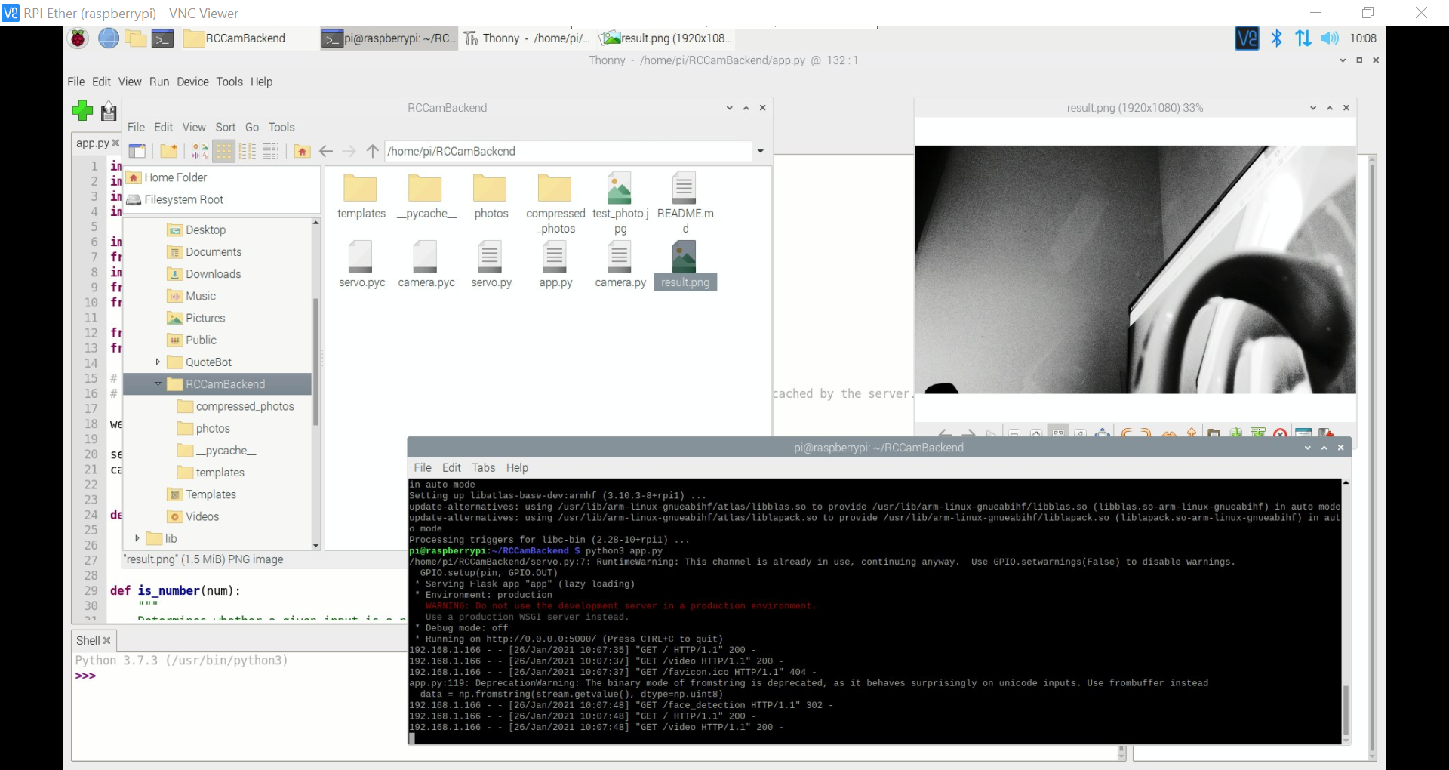

I decided to change to frombuffer to remove the warning as well.

|  |
| --- |
| data = np.frombuffer(stream.getvalue(), dtype=np.uint8) |

I then decided to see how the RPI would handle the current face detection system so I implemented my original test code into this route.

|  |
| --- |
| @web_app.route("/face_detection", methods=["POST", "GET"]) def face_detection():  # Image stream capture and decode for OpenCV  stream = io.BytesIO()  camera.capture_image(stream, format="jpeg")  data = np.frombuffer(stream.getvalue(), dtype=np.uint8)  img = cv.imdecode(data, 1)   # Image manipulation and saving  img_grey = cv.cvtColor(img, cv.COLOR_BGR2GRAY)  img_grey = cv.equalizeHist(img_grey)    # Run face detection  cascade = cv.CascadeClassifier("face_detect.xml")  faces = cascade.detectMultiScale(img_grey, scaleFactor=1.1, minNeighbors=7, flags=cv.CASCADE_SCALE_IMAGE)   # Apply bounding boxes  for (x, y, w, h) in faces:  cv.rectangle(img, (x, y), (x + w, y + h), (255, 0, 0), 2)   # Write image with bounding box  cv.imwrite("result.png", img)   return redirect(url_for("main_page")) |

It worked occasionally when I was testing it which is to be expected. I changed the minNeighbours parameter to 5 to see if it would help and it did a small amount.

I then further modified the parameters to the following:

|  |
| --- |
| # Run face detection cascade = cv.CascadeClassifier("face_detect.xml") faces = cascade.detectMultiScale(img_grey,  scaleFactor=1.05,  minNeighbors=3,  minSize=(70, 70),  flags=cv.CASCADE_SCALE_IMAGE) |

I then started to think about how I would calculate the angle to move to. After an hour of thinking and writing I came up with the following equation to calculate the angle for a single servo.

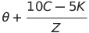

Where:

**θ** = Current angle

**C** = Average face location relative to image

**K** = Size of image

**Z** = Arc length for Camera

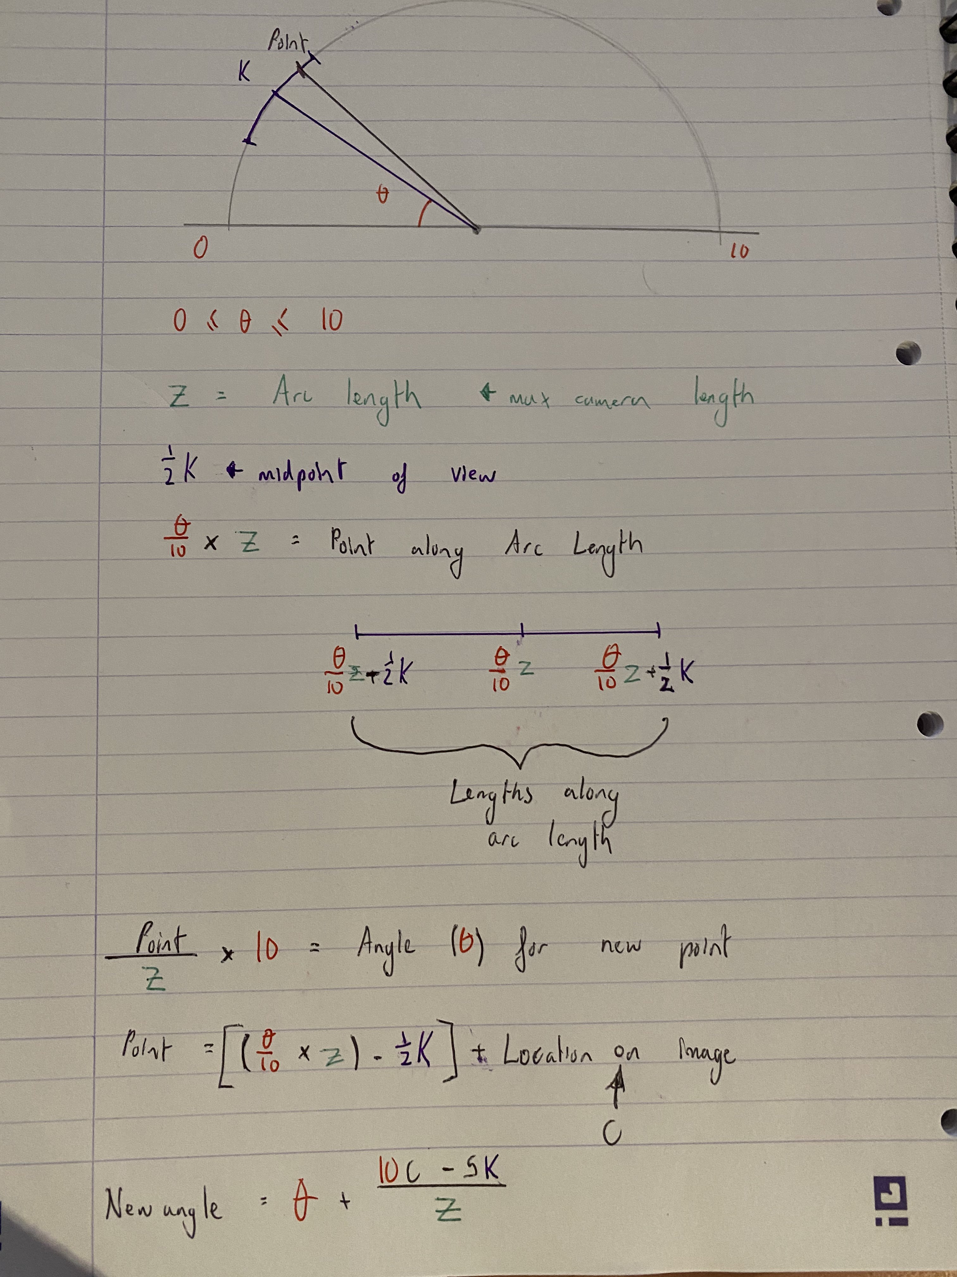

With my current system, **θ**, **C** and **K** are easy to obtain. **Z** however isn’t as easy. For **Z** I would need to calculate the total resolution for the camera if it were to rotate in its entirety.

The simplest way I can think of doing this is to modify some existing code to take a panorama and then to take the resolution values from that.

In order to take a panorama however, the camera mount would need to be able to rotate to take photos. As it currently stands, the mount isn’t attached to anything so changing the yaw hasn’t been very accurate. I would need to have the camera mount attached to something first. A modified RPI 3B case would work as it would attach the mount to the RPI itself.

I started by finding a case on Thingiverse which had space for the video cable and GPIO cables. [This case](https://www.thingiverse.com/thing:685074) seemed perfect so I downloaded the files for it. I then installed FreeCAD so that I could modify the model to fit my camera mount.

I added cylinder extrusions to the case using the measurements from the [pan-tilt product page](https://www.adafruit.com/product/1967). I then saved it to a microSD card to print later. While waiting for the 3D printer to be in use, I added functionality to the Face Detection button on the frontend.

I added a call to the face detection button and then modified the requestPOST function to have its data default to “”.

|  |
| --- |
| fun requestPOST(ctx: Context, url: String, data: String = ""){  ~~  R.id.action_face_detection -> {  requestPOST(this, "$url/face_detection") } |

This initiated the face detection function on my backend and was therefore functioning correctly. I found while doing this that the take photo button was throwing an exception. Since I was still waiting on the 3D printer, I decided to work on a fix.

It seemed as if it was an issue with the backend since it threw the same error when I tried going to <ip>:<port>/take_photo on Chrome. It apparently couldn’t find the photo PNG with the given path. After checking the code, I found that the image path being used to check was incorrect. To fix this I decided to change how “gen_filename” worked so that it would return the path.

I then modified the calls to it to work properly.

|  |
| --- |
| def gen_filename(ext, path=""):  counter = 1  date = datetime.today()  filename = f"{date.day}-{date.month}-{date.year}-no{counter}"   if path[-1] != "/":  path += "/"   while True:  if os.path.isfile(f"{path}{filename}.{ext}"): # Increment counter if filename already exists  counter += 1  filename = f"{date.day}-{date.month}-{date.year}-no{counter}"  else: # Filename doesn't already exist, end loop  break   return f"{path}{filename}"  ~~  @web_app.route("/take_photo/") def take_photo():   ...   # Capture image as PNG  image_ext = "png"  image_name = gen_filename(image_ext, path=image_paths[0])  camera.capture_image(filename=image_name, format=image_ext, res=res)   # Convert and save image as JPEG  im = Image.open(f"{image_name}.{image_ext}").convert("RGB")  image_ext = "jpeg"  image_name = f"{gen_filename(image_ext, path=image_paths[1])}.{image_ext}"  im.save(image_name) # JPEG   return send_from_directory(image_paths[1], image_name, as_attachment=True) |

This still didn’t work - I noticed that the image was saved with the PNG format but not with the extension in the name. I changed the code and ran it again.

|  |
| --- |
| # Capture image as PNG image_ext = "png" image_name = gen_filename(image_ext, path=image_paths[0]) camera.capture_image(filename=f"{image_name}.{image_ext}", res=res) |

This took the photo however, when it redirected me to download the image, it showed an error. I modified them again to not return the path and to implement the path properly again. After a lot of changes I ended up with the following fix:

|  |
| --- |
| # Capture image as PNG image_ext = "png" image_location = f"{image_paths[0]}{gen_filename(image_ext, path=image_paths[0])}.{image_ext}" camera.capture_image(filename=image_location, res=res)  # Convert and save image as JPEG im = Image.open(image_location).convert("RGB") image_ext = "jpeg" image_name = f"{gen_filename(image_ext, path=image_paths[1])}.{image_ext}" im.save(f"{image_paths[1]}{image_name}") # JPEG print(f"Took photo: {image_paths[1]}{image_name}")  return send_from_directory(image_paths[1], image_name, as_attachment=True)  ~~  def gen_filename(ext, path=""):  counter = 1  date = datetime.today()  filename = f"{date.day}-{date.month}-{date.year}-no{counter}"   if path[-1] != "/":  path += "/"   while True:  if os.path.isfile(f"{path}{filename}.{ext}"): # Increment counter if filename already exists  counter += 1  filename = f"{date.day}-{date.month}-{date.year}-no{counter}"  else: # Filename doesn't already exist, end loop  break   return f"{filename}"  ~~  def capture_image(self, filename="", format="png", res=None):   ...   self.camera.capture(filename, format=format)  print(f"Took photo: {filename}") |

After a lot of hours and printing off 3 failed designs - the printer wasn’t co-operating - I ended up with the final case and stand. I changed the ribbon cable back to the shorter version as it fit a lot nicer but had to flip the camera to make the ribbon cable fit appropriately. Due to this I set vflip to True in the code to flip the resulting video feed. I also added some black tape to stick the GPIO wires down behind the camera so that it wouldn’t see them.

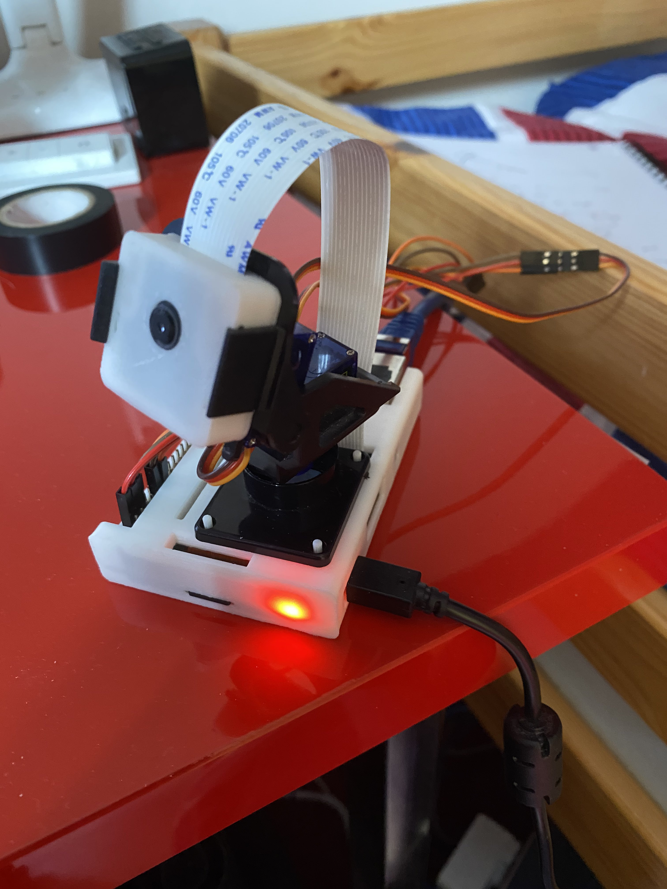

When rotating the yaw to 10 I noticed that the mount began to slightly detach from the pins holding it in place but it didn’t seem like it was going to fall out.

Now that I had a better stand for the mount - I could create panorama to get the max width and max height values to plug into my formula.

I found a [GitHub repository](https://github.com/kushalvyas/Python-Multiple-Image-Stitching) for stitching together images into a panorama. To save time, I decided to use this so that I could get my max width and height values. In order to use this, I needed to have images ready to stitch together. So, I created the following code:

|  |
| --- |
| import os import time  from camera import Camera, gen_filename from servo import ServoController  servo = ServoController() camera = Camera()  ext = "jpeg" res = [1920, 1080]  for path, s in zip(("panorama/pitch/", "panorama/yaw/"), (servo.pitch, servo.yaw)):   if not os.path.exists(path):  os.mkdir(path)   for i in range(0, 105, 5):  servo.change_servo(s, i/10)  time.sleep(0.1)  camera.capture_image(filename=f"{path}{gen_filename(ext, path=path)}.{ext}", res=res) |

There were a few issues that occurred so I fixed those and ended up with the final code:

|  |
| --- |
| import os import time  from camera import Camera, gen_filename from servo import ServoController  servo = ServoController() camera = Camera()  ext = "jpeg" res = [1920, 1080]  servo.change_servo(servo.yaw, 6) time.sleep(0.5)  for path, s in zip(("panorama/pitch/", "panorama/yaw/"), (servo.pitch, servo.yaw)):   if not os.path.exists(path):  os.makedirs(path)   for i in range(0, 105, 5):  servo.change_servo(s, 2 + i/10)  print(f"Changed servo to: {i/10}")  time.sleep(1)  camera.capture_image(filename=f"{path}{gen_filename(ext, path=path)}.{ext}", res=res)  time.sleep(0.5)   servo.change_servo(servo.pitch, 6)  time.sleep(0.5) |

Then I tried to get the [Image Stitcher](https://github.com/kushalvyas/Python-Multiple-Image-Stitching) to work - it was built in Py2. After a lot of work I found that a major algorithm used by the image stitcher (SURF) wasn’t enabled with opencv-python and that I would need to build from source. This looked like a lot of hassle so I found another [image stitcher](https://github.com/WillBrennan/ImageStitching) which used SIFT instead.

After setting up that image stitcher, upon running the program and getting to around image 18 it would run out of memory and crash (somehow using 10GB alone). So instead, I decided to just estimate a value.

After a lot of trial and error trying to get the rotation calculation to work properly, I ended up with the following code. It seemed to work as intended and only had issues when the face detection calculated faces wrong.

|  |
| --- |
| @web_app.route("/face_detection", methods=["POST", "GET"]) def face_detection():  # Image stream capture and decode for OpenCV  stream = io.BytesIO()  camera.capture_image(stream, format="jpeg")  data = np.frombuffer(stream.getvalue(), dtype=np.uint8)  img = cv.imdecode(data, 1)   # Image manipulation and saving  img_grey = cv.cvtColor(img, cv.COLOR_BGR2GRAY)  img_grey = cv.equalizeHist(img_grey)   # Run face detection  cascade = cv.CascadeClassifier("face_detect.xml")  faces = cascade.detectMultiScale(img_grey,  scaleFactor=1.05,  minNeighbors=3,  minSize=(70, 70),  flags=cv.CASCADE_SCALE_IMAGE)   # Apply bounding boxes  for (x, y, w, h) in faces:  cv.rectangle(img, (x, y), (x + w, y + h), (255, 0, 0), 2)   # Calculating servo rotation  height, width, channel = img.shape   print(width, height)   # Calculating average co-ord  mid_coords = [(x + (w / 2), y + (h / 2)) for (x, y, w, h) in faces]   if len(mid_coords) != 0:  total = [sum(i) for i in zip(*mid_coords)]  average = (round(total[0] / len(mid_coords)), round(height - total[1] / len(mid_coords)))  print(f"Average: {average}")   vals = [(10 * loc - 5 * dim) / arc for arc, loc, dim in zip((1920*3, 1080*3), average, (width, height))]   yaw = round(ser_app.yaw.current + vals[0], 1)  if yaw < 0:  yaw = 0  elif yaw > 10:  yaw = 10  ser_app.change_servo(ser_app.yaw, yaw)  print(f"Yaw rotation set to {yaw}")   pitch = round(ser_app.pitch.current - vals[1], 1)  if pitch < 0:  pitch = 0  elif pitch > 10:  pitch = 10  ser_app.change_servo(ser_app.pitch, pitch)  print(f"Pitch rotation set to {pitch}")   # Write image with bounding box  cv.imwrite("result.png", img)   return redirect(url_for("main_page")) |

To reduce the chance of invalid faces being detected and to improve the user experience I decided to add in a width and height parameter that would be used when capturing an image - similar to how taking a photo uses your screen size.

|  |
| --- |
| @web_app.route("/face_detection", methods=["POST", "GET"]) def face_detection():  # Width and Height  resWidth = request.args.get("w", "")  resHeight = request.args.get("h", "")   if (resHeight != "" or resWidth != "") and is_number(resWidth) and is_number(resHeight):  res = [int(resWidth), int(resHeight)]  else:  res = [1920, 1080]   # Image stream capture and decode for OpenCV  stream = io.BytesIO()  camera.capture_image(stream, format="jpeg", res=res) |

I then changed one small issue where the face detection was off. This was a result of the servos having an incorrect current rotation stored; where they haven’t been rotated as of the time when the program started. A simple fix was to make both change to 5 when the program starts.

|  |
| --- |
| if __name__ == "__main__":  ser_app.change_servo(ser_app.pitch, 7)  ser_app.change_servo(ser_app.yaw, 7)  web_app.run("0.0.0.0", threaded=True) |

The servo had some timing issues causing it to stutter so I fixed those.

|  |
| --- |
| @staticmethod def change_servo(servo, amount, tm=0.3):  if servo.current != amount:  servo.ChangeDutyCycle(amount)  servo.current = amount   time.sleep(tm)  servo.ChangeDutyCycle(0) |

Now I had to add in functionality to the frontend app.

|  |
| --- |
| bottomNavigationBar.setOnNavigationItemSelectedListener{ item ->  when(item.itemId) {  R.id.action_face_detection -> {  val args = "w=${webview.width}&h=${webview.height}"  requestPOST(this, "$url/face_detection", args)  } |

This worked but for some reason Volley was sending two requests. After searching I found this [GitHub issue and response](https://github.com/google/volley/issues/316). I also found this Stack Overflow thread and then made the following code.

|  |
| --- |
| @web_app.after_request def add_header(response):  response.headers["Cache-Control"] = "must-revalidate; stale-while-revalidate=True"  response.headers["Pragma"] = "must-revalidate"  return response |

However, this seemed to have no effect. Instead I tried the following code.

|  |
| --- |
| @web_app.after_request def add_header(response):  response.cache_control.max_age = 0  response.cache_control.no_cache = True  response.cache_control.no_store = True  response.cache_control.must_revalidate = True  response.cache_control.proxy_revalidate = True  return response |

This also seemed to have no effect and I couldn’t find a way to make Flask send back a stale-while-revalidate value. I then found the following [group post](https://groups.google.com/g/volley-users/c/8PE9dBbD6iA/m/-UvlMZOHEAAJ) from 2014 for Volley. I implemented the changes mentioned in one of the posts into my code.

|  |
| --- |
| fun requestPOST(ctx: Context, url: String, data: String = ""){   ...   // Add the request to the RequestQueue  strReq.retryPolicy = DefaultRetryPolicy(0, -1, DefaultRetryPolicy.DEFAULT_BACKOFF_MULT)  queue.add(strReq) } |

This meant that now Volley would only ever send one attempt; I believe the reason it sent two was it was expecting a specific response header during a time frame and, since face detection takes longer than the other methods, it sent another request.

### Module 3

#### Test Scenarios and Cases

|  |  |  |
| --- | --- | --- |
| **Test Scenario ID** | **Test Scenario Description** | **Test Steps** |
| 3.2.1 | Check if the shutter button takes a photo via the RPI and saves it to the users phone. | 1. Navigate to Main GUI  2. Press shutter button the specified amount of times |
| 3.2.2 | Check if timed shots wait the held amount of time before taking a photo. | 1. Navigate to Main GUI  2. Press and hold the shutter button until the timed shot GUI appears  3. Input time value and press confirm |

|  |  |  |  |  |  |  |
| --- | --- | --- | --- | --- | --- | --- |
| **Test Case ID** | **Test Scenario ID** | **Test Case Description** | **Test Data** | **Expected Result** | **Actual Result** | **Pass/Fail** |
| 1 | 3.2.1 | Pressing the shutter button once |  | A photo is downloaded onto the users phone with the filename as “<date>-no1” | Downloaded a file named 3-2-2021-no1.jpeg | Pass |
| 2 | 3.2.1 | Pressing the shutter button twice |  | Two photos are downloaded onto the users phone. The file names should be “<date>-no2” and “<date>-no3” | App froze | Fail |
| 3 | 3.2.2 | 5 second timed shot | Time: 5 seconds | The app waits 5 seconds before a photo is taken | Error 404 | Fail |
| 4 | 3.2.2 | 10 second timed shot | Time: 10 seconds | The app waits 10 seconds before a photo is taken | Error 404 | Fail |

#### Identified Issues

|  |  |  |
| --- | --- | --- |
| **Issue ID** | **Encompassed Test Cases** | **Issue Description** |
| 1 | 2 | App froze when the take photo button was pressed twice |
| 2 | 3, 4 | An error 404 was returned when the timed shot was attempted |

#### Remedial Action

##### Issue 2

I decided to start with issue 2 as it seemed to be a lot easier to fix. I checked the output of the server terminal after the user had attempted to run a timed shot and found that the URL they were attempting to access had the arguments as a directory location. This of course threw an error 404. I decided that when I was going to fix this I would also implement the HTTP POST request function as currently this relies on the webview loading a URL.

|  |
| --- |
| dialog  .setTitle("Choose Time to Wait")  .setView(dialogView)  .setPositiveButton("Confirm") { _, _ ->  val textfieldTimeData = dialogView.secIncTextView.textView.text   // <ip>/take_photo?dur=float&w=width&h=height  val args = "dur=$textfieldTimeData&w=${webview.width}&h=${webview.height}"  requestPOST(this, "$url/take_photo", args)  }  .setNegativeButton("Cancel") { _, _ ->  // Do nothing - Android auto dismisses  }  .show() |

This didn’t work however as the image wasn’t downloaded. So, I resorted to using the webview.

|  |
| --- |
| dialog  .setTitle("Choose Time to Wait")  .setView(dialogView)  .setPositiveButton("Confirm") { _, _ ->  val textfieldTimeData = dialogView.secIncTextView.textView.text   // <ip>/take_photo?dur=float&w=width&h=height  webview.loadUrl("$url/take_photo?dur=$textfieldTimeData&w=${webview.width}&h=${webview.height}")  }  .setNegativeButton("Cancel") { _, _ ->  // Do nothing - Android auto dismisses  }  .show() |

I then ran the appropriate test cases.

|  |  |  |  |  |  |  |
| --- | --- | --- | --- | --- | --- | --- |
| **Test Case ID** | **Test Scenario ID** | **Test Case Description** | **Test Data** | **Expected Result** | **Actual Result** | **Pass/Fail** |
| 3 | 3.2.2 | 5 second timed shot | Time: 5 seconds | The app waits 5 seconds before a photo is taken | Expected result | Pass |
| 4 | 3.2.2 | 10 second timed shot | Time: 10 seconds | The app waits 10 seconds before a photo is taken | Expected result | Pass |

##### Issue 1

This seemed to be an issue with multiple requests for taking a picture occurring. My theory was that while the first request was attempting to take a photo, the other tried to manipulate the resolution of the camera during this which caused issues.

In order to fix this issue I first considered adding a lock using Camera.curCapture however I realised that there would be an issue with three requests. One request would get through and the other two locked. Then when the first finished the other two would both be unlocked and the same issue would occur. Then I considered changing the server to be single threaded but when I tried that I couldn’t get two clients to see the video feed which was undesirable.

Instead I thought a request queue would be the best course of action as all requests would be fulfilled and each would wait. I then realised that there was a chance that if a request for face_detection also came through there would be another issue. The best place to put this request queue would be inside the capture_image function as a result.

|  |
| --- |
| class Camera:  capQueue = []   ...   def capture_image(self, filename="", format="png", res=None):  # Request queue  id = 1 if len(Camera.capQueue) == 0 else Camera.capQueue[-1] + 1  Camera.capQueue.append(id)  while Camera.capQueue[0] != id:  pass   ...   # Reverting to live stream resolution if no requests in queue  if len(Camera.capQueue) != 0:  while True:  try:  self.camera.resolution = (320, 240)  break  except picamera.exc.PiCameraMMALError:  pass   Camera.curCapture = False   # Removing this request from the queue  del Camera.capQueue[0] |

This seemed to work perfectly and I decided to add in some prints for more clarity on the backend.

|  |
| --- |
| # Request queue id = 1 if len(Camera.capQueue) == 0 else Camera.capQueue[-1] + 1 Camera.capQueue.append(id) while Camera.capQueue[0] != id:  pass  print(f"CI: Now serving request '{id}'")  ...  # Removing this request from the queue del Camera.capQueue[0] print(f"CI: Finished serving request '{id}'") |

It seemed to always output that it was serving “1” when I sent three requests. I outputted the queue and it appeared empty before each new request was added. I checked on my app as well. I realised it was because I had forgotten to enable threading from before. I fixed this and tried again. This seemed to work fine except when I tried on my app; it only downloaded the final image. This seemed to be because the webview was loading a new page each time - makes sense but doesn’t work how I need it to.

To fix this the best cause of action seemed to be using either POST or GET requests. I enabled POST requests for the take photo route first.

|  |
| --- |
| @web_app.route("/take_photo/", methods=["POST", "GET"]) def take_photo(): |

I then tried again with the POST request to see if it would work; I doubt it would however since the download manager itself is tied to the webview.

|  |
| --- |
| R.id.action_shutter -> {  val args = "w=${webview.width}&h=${webview.height}\""  requestPOST(this, "$url/take_photo", args) } |

As expected, no file was downloaded. I then changed the requestPOST function to return response data.

|  |
| --- |
| fun requestPOST(ctx: Context, url: String, data: String = ""): String {  // Instantiate the RequestQueue  val queue = Volley.newRequestQueue(ctx)  // String request for the provided URL with given data  var responseData = ""  val strReq: StringRequest = object : StringRequest(Method.POST, url,  { response ->  responseData = response  },  { error ->  Log.d("Volley", "$error")  }  ){  override fun getBody(): ByteArray{  return data.toByteArray(Charset.defaultCharset())  }  }   // Add the request to the RequestQueue  strReq.retryPolicy = DefaultRetryPolicy(0, -1, DefaultRetryPolicy.DEFAULT_BACKOFF_MULT)  queue.add(strReq)   return responseData } |

I then changed the backend to return the filename if a POST request is sent; this way I can use POST requests for the frontend to pull the filename to download or GET requests from my browser.

|  |
| --- |
| if request.method == "GET":  return send_from_directory(image_paths[1], image_name, as_attachment=True) return Response(image_name) |

However this didn’t work. I tried some other things on the frontend and got the following to output a load of random characters.

|  |
| --- |
| fun requestPOST(ctx: Context, url: String, data: String = ""){  // Instantiate the RequestQueue  val queue = Volley.newRequestQueue(ctx)  // String request for the provided URL with given data  val strReq: StringRequest = object : StringRequest(Method.POST, url,  Response.Listener { response ->  Log.d("Volley", response)  },  Response.ErrorListener { error ->  Log.d("Volley", "$error")  }  ){  override fun getBody(): ByteArray{  return data.toByteArray(Charset.defaultCharset())  }  }   // Add the request to the RequestQueue  strReq.retryPolicy = DefaultRetryPolicy(0, -1, DefaultRetryPolicy.DEFAULT_BACKOFF_MULT)  queue.add(strReq)  } |

Since I seemed to be getting nowhere, I decided to scrap this and instead just prevent the user from requesting another photo on the frontend. I added the following to the take photo and timed shot functions.

|  |
| --- |
| bottomNavigationBar.menu.findItem(R.id.action_shutter).isEnabled = false |

I also added the following to the download receiver to re-enable the button after the file has been downloaded.

|  |
| --- |
| bottomNavigationBar.menu.findItem(R.id.action_shutter).isEnabled = true |

However, I realised that the functionality was essentially the same with the advantage of sending less requests. If a file fails to download, that means that the button will stay disabled. Due to this, I have decided to scrap these changes.

I then noticed when stress testing the web servers new request queue that a few images caused a truncated image error. I found this [Stack Overflow thread](https://stackoverflow.com/questions/60584155/oserror-image-file-is-truncated) and implemented the code into my web server.

|  |
| --- |
| ImageFile.LOAD_TRUNCATED_IMAGES = True |

After stress testing with this running it seemed to have fixed the issue.

I then ran the specific test cases again.

|  |  |  |  |  |  |  |
| --- | --- | --- | --- | --- | --- | --- |
| **Test Case ID** | **Test Scenario ID** | **Test Case Description** | **Test Data** | **Expected Result** | **Actual Result** | **Pass/Fail** |
| 1 | 3.2.1 | Pressing the shutter button once |  | A photo is downloaded onto the users phone with the filename as “<date>-no1” | Expected result | Pass |
| 2 | 3.2.1 | Pressing the shutter button twice |  | Two photos are downloaded onto the users phone. The file names should be “<date>-no2” and “<date>-no3” | Only the third photo was taken | Fail |

After the changes made, the fail for test case 2 is technically a pass now.

### Module 4

#### Test Scenarios and Cases

|  |  |  |
| --- | --- | --- |
| **Test Scenario ID** | **Test Scenario Description** | **Test Steps** |
| 4.2.1 | Check whether a button shows an animation for when it is pressed. | 1. Navigate to button location  2. Press the button  3. Observe the button |
| 4.2.2 | Check if each of the sub menu buttons function as intended | 1. Navigate to button location  2. Press the button |
| 4.2.3 | Check if Photo gallery works as intended | 1. Follow test data  2. Press the photo gallery button |

|  |  |  |  |  |  |  |
| --- | --- | --- | --- | --- | --- | --- |
| **Test Case ID** | **Test Scenario ID** | **Test Case Description** | **Test Data** | **Expected Result** | **Actual Result** | **Pass/Fail** |
| 5 | 4.2.1 | Share Media button |  | Colour change animation on the button plays | Expected result | Pass |
| 6 | 4.2.1 | Open photo gallery button |  | Colour change animation on the button plays | Expected result | Pass |
| 7 | 4.2.1 | About page button |  | Colour change animation on the button plays | Expected result | Pass |
| 8 | 4.2.2 | Pressing the Share Media button without taking a photo |  | A prompt should be displayed to the user telling them they haven’t taken a photo yet | Expected result | Pass |
| 9 | 4.2.2 | Pressing the Share Media button after taking a photo | Take photo beforehand | A share media prompt for the most recent photo taken should be displayed | Expected result | Pass |
| 10 | 4.2.2 | Open photo gallery button |  | This should open the photo gallery app | Expected result | Pass |
| 11 | 4.2.2 | About page button |  | The app goes to the about page and it displays the relevant information | Expected result | Pass |
| 12 | 4.2.3 | Photo gallery already open | Open photo gallery. | Photo gallery is opened as if the user switched tabs - if they were originally viewing a photo, it would show that part when apps switch | Expected result | Pass |
| 13 | 4.2.3 | Photo gallery closed |  | A new photo gallery instance is opened - as if the user went to the home page and clicked the photo gallery icon | Expected result | Pass |

### Black Box Evaluation

|  |  |  |  |  |
| --- | --- | --- | --- | --- |
| **Module** | **Issue No.** | **Issue Summary** | **Fixed?** | **Further Comments** |
| **1** | 1 | An invalid IP and Port only stated that the IP was invalid. | Yes | Shows a combination of validation issues in one snackbar. |
| 2 | An error was shown for trying to connect to a specific IP and Port. | Partially | In order to fix this, the error detection system was removed. This means that the app can still try to connect to a site which isn’t valid. |
| 3 | No colour changes for buttons on the bottom of the main GUI. | No | The solution I use means it would show the colour change until another button is pressed. Using another alternate solution would take too long to implement. |
| **2** | 1 | Trying to enter values larger than max/min should result in max/min appearing in the textfields. | Yes | Fixed in tandem with issue 2 and feedback 3. Essentially, the servo values were changed to 0-10 which meant that the existing solution worked for this issue. |
| 2 | Frontend max and min are not the correct values. | Yes | Fixed in tandem with issue 1 and feedback 3. The values on the frontend were changed to 0-10. |
| **3** | 1 | The RPI crashed when the take photo button was pressed multiple times. | Yes | The RPI now has a request queue built in for any calls of “capture_image”. This means that the RPI won’t crash when the camera attempts to change resolution X amount of times per second. |
| 2 | An error 404 was returned when the timed shot was attempted. | Yes | The URL on the frontend had a / instead of a ? before the arguments. |

|  |  |  |  |  |
| --- | --- | --- | --- | --- |
| **Module** | **FeedbackNo.** | **Feedback Summary** | **Fixed?** | **Further Comments** |
| **1** | 1 | The shutter button should be more noticeable than the other two buttons. | No | Similar to issue 3, with the current implementation this isn’t possible and an alternate solution would take too long. |
| 2 | The size of the video feed doesn’t seem right, the black spaces above and below are odd. | Yes | The size of the video on the frontend was changed to take up the entire space and the backend was modified to support taking photos with given resolutions. This allows for photos taken that look extremely close to the video feed. |
| 3 | When on the port textfield, if you press enter it goes to the connect button but keeps the keyboard up. | Yes | The keyboard now is lowered when pressing the enter button while on the port textfield. |
| **2** | 1 | On the rotation menu, pressing tab would result in the keyboard staying up on cancel. | No | This didn’t need fixing as it was an emulator related issue. When pressing enter on the on screen keyboard, this didn’t happen. |
| 2 | Length Mismatch error when rotating, video feed frozen. | Yes | Any errors with error code -1 cause the video feed to be reloading; this seems to fix this issue entirely. |
| 3 | Range should be intuitive rather than seemingly random numbers. | Yes | Fixed in tandem with issue 1 and issue 2. The range was changed to 0-10. |
| 4 | Face Detection should be implemented. | Partially | Face detection was implemented onto the backend with the RPI running a fast face detection algorithm. This isn’t always accurate but it provides a fast detection without the need for web API calls. |
| 5 | Decimal values for pitch and yaw. | Yes | These were implemented alongside fixed validation and sanitisation for the text inputs. |
| 6 | Stop the video feed flickering when rotating. | Yes | A POST HTTP request was used rather than relying on the webview with GET requests. |

When performing black box testing alongside my stakeholder, we uncovered a lot of general and usability issues that needed to be addressed. Most of these issues and feedback were addressed and solved completely.

Module 1 issue 3 and module 1 feedback 1 were not fixed due to the time requirement behind overhauling the bottom navigation bar to another component. Material IO seemed to have the best alternative, however, implementation of Material IO seemed extremely time consuming. Module 2 issue 1 wasn’t fixed as it wasn’t an issue that would be encountered on the actual app as the stakeholder was using the emulator.

Module 1 issue 2 was fixed and the webview would connect to all IP and Ports on the users end, however, this came at the cost of removing the web page error detection. This means that for some IPs and Ports, the user will connect on the Main GUI and will have to navigate back to the Connect GUI manually. Module 2 feedback 4 was regarding the face detection feature not being implemented. This was implemented into the app but the face detection algorithm used, while fast, wasn’t very accurate and frequently detected objects that weren’t faces.

Despite the shutter button’s size not being increased, a lack of indication a button on the Main GUI had been pressed, the removal of the error detection for web pages and the inaccuracy of the face detection, I would conclude that black box testing was successful. The vast majority of the issues and feedback given were taken into consideration and resulted in changes to the project for the better.

# Project Evaluation

## Success Criteria

|  |  |  |  |
| --- | --- | --- | --- |
| **Module** | **Criteria** | **Justification** | **Priority** |
| **Main Interface** | 1.1 - Connect GUI | The interface provides an easy way for the user to connect to the RPI without having to set up the software to only be able to connect to a single RPI. | **High** |
| 1.2 - Connect to RPI | Allows the user to connect to the RPI so that the app can send requests and receive data such as the live video feed and images. | **High** |
| 1.3 - Main GUI | This interface appears after the Connect GUI screen and will allow the user to interact with the camera. It will have buttons for taking photos, rotating the camera, centring the camera on a face and accessing the submenu. | **High** |
| 1.4 - Live Camera Feed | The main portion of the screen will display a live camera feed from the RPIs camera. | **High** |
| **Camera Rotation** | 2.1 - Rotate Camera | This brings up a menu which allows the user to input values which will increment or decrement the rotation of the camera mount by sending a request to the RPI. The menu will be accessed via a button to the right of the ‘Take Photo’ button. | **High** |
| 2.2 - Modify Servo Rotation | For the camera device to be rotated from a distance, the RPI needs to be able to change the rotation of the servos. In turn, this will change the rotation the camera is facing as the servos control the camera mount. | **High** |
| 2.3 - Detect Faces | Facial recognition will be a minor feature on the app. The RPI will detect faces and then modify the servo rotation to centre the camera on any detected faces. | **Medium** |
| 2.4 - Centre on Face | The button sends a request to the RPI to centre the camera on a face or the average position using the location of multiple faces. | **Medium** |
| **Take Photo** | 3.1 - Regular Photo | When the user presses the take photo button, it will request for the RPI to take a photo. | **High** |
| 3.2 - Timed Shot | By pressing and holding the take photo button, you can take a timed shot. The number of seconds you hold the button down for will be counted after releasing and then a photo will be taken. | **Low** |
| 3.3 - RPI Take Photo | The user needs to be able to request for the RPI to take a photo. This is vital as the majority of the project relies on this feature to function. | **High** |
| 3.4 - RPI Send Photo | Once the RPI has taken the photo, it will be sent to the user’s phone. This will be a high priority as is vital to the project. | **High** |
| 3.5 - Autosave Image | If the RPI fails to send the user the photo through either connection means, full storage or another factor - the image should still be persistent somewhere. The RPI will save the images taken to local storage. This way the user can access any and all images taken from the RPI. | **Medium** |
| **Submenu** | 4.1 - Sub menu interface | The button to access the submenu will be located in the top left. This will avoid interference with the main interface that will be used more often | **Medium** |
| 4.2 - Share Media | This brings up the generic share menu built into a lot of android apps. Using this will share the most recent photo taken. | **Low** |
| 4.3 - Open Photo Gallery | Opens the Android photo gallery on the user’s phone; means that I don’t have to implement a custom-built photo gallery into the app. | **Medium** |
| 4.4 - About page | Brings up a page which shows information ranging from the connection information to the RPI to my contact details for feedback. | **Low** |

Above is the original success criteria from the analysis phase of the project; I will be going through each criteria within each and discussing whether it was completely met, partially met or not met. This can be used to dictate whether the final product was successful in meeting its final goal. I will also be linking back to previous testing per criteria.

### Module 1 References

White Box test cases

Black Box test cases

Feedback

### 1.1 - Connect GUI

The Connect GUI was the first interface the user would be interacting with. This criteria was originally aimed at the frontend design and functionality. The functionality of the Connect GUI works perfectly fine and allows the user to easily connect to the RPI alongside some validation checks and sanitisation to help with the IP and Port inputs.

Before White Box testing, the validation checks had some issues with the port value “65536” being accepted despite the maximum port value being “65535”. This was fixed however under Remedial Action for Issue 1.

Additionally, for Black Box testing, the usability feature for telling the user whether a validation failed had some issues which were fixed under Remedial Action for Issue 1. Additionally, there was another usability issue with the keyboard not going down after hitting the enter button on it which was fixed under Remedial Action for Feedback 3.

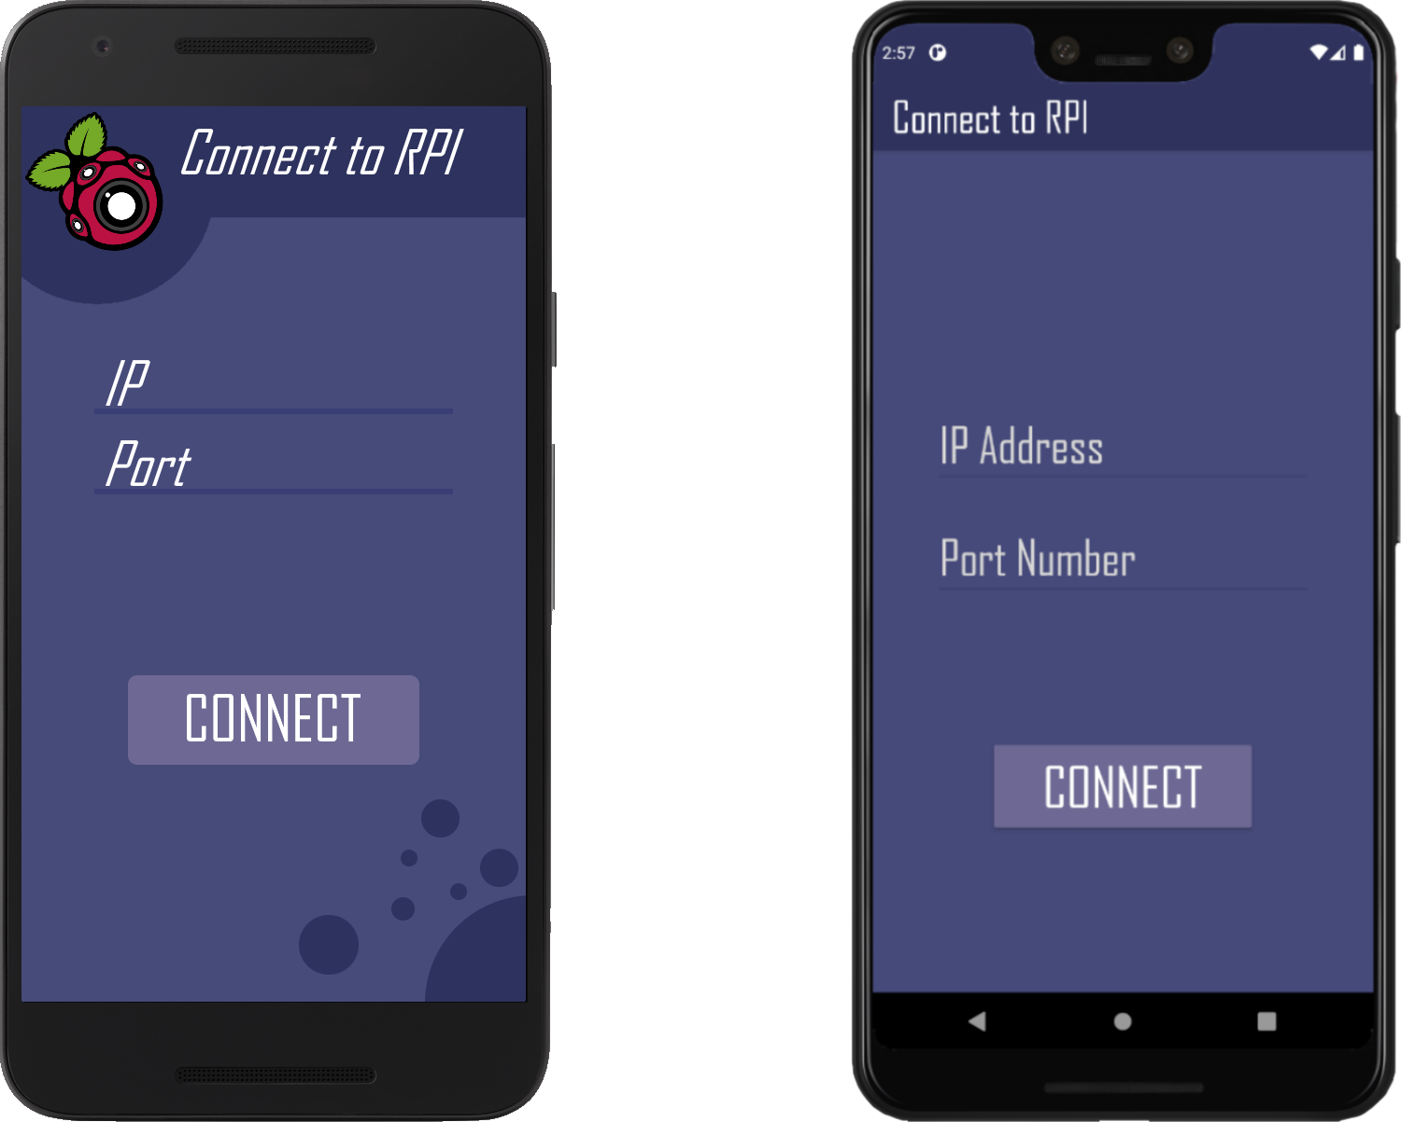

The GUIs design on the other hand, while looking alright, didn’t achieve the same level of quality as the original mockup. The Connect GUI is missing the top banner portion with the logo which helps break up the colours a bit more as well as the more sophisticated background.

Due to this, I consider the criteria to be partially met. The Connect GUI provides all the correct functionality and more but the design is lacking in comparison with the mockup.

In the future, the background could be modified to look better and instead of the logo appearing in the top banner, the logo could appear centered, directly above the IP Address text field.

### 1.2 - Connect to RPI

This criteria focused more on the logic behind connecting to the RPI via the frontend. This is to allow the user to send requests and receive data. It would occur after the user presses the connect button on the Connect GUI - after validation checks were performed on the IP address and port number.

Originally, an error detection system was put into place so that the app wouldn’t move on to the Main GUI if there was an error when trying to connect to a web server. However, during black box testing, an issue was encountered with this system and so it was removed under Remedial Action for Issue 2.

The other issue during black box testing that was brought up by a stakeholder was the keyboard staying up after pressing the enter button on the final text field. This was quickly resolved under Remedial Action for Feedback 3.

This criteria was definitely a success as it functioned as intended and it was only an additional feature which didn’t make the final product; it would have been better if it was reworked to be functional and this could be addressed in later development.

### 1.3 - Main GUI

This criteria involved the Main GUI - from the frontend design to the live video feed integration. The final version didn’t differ too far from the original design in terms of layout but the icons were vastly different. Functionality wise, the video feed works well but can be slow sometimes. This may be the result of the emulator but it is currently unknown.

Within the remedial action on issues that appeared during development, there was the issue of the Connect Button not functioning as intended on the first press. This was fixed by changing how the server handled sending the live video feed across however during the Connect GUI Bug.

During black box testing, there was the issue of the buttons on the bottom bar not changing colour. This issue however wasn’t fixed. I found, during Remedial Action for Issue 3, that it would require an overhaul of the bottom bar as the component didn’t support changing individual icon colours in the way I needed. This was the same for Remedial Action for Feedback 1 as it would require the same overhaul. Additionally, the video feed size was brought into question by a stakeholder and was modified to fill the space alongside a modification to the server side so that a resolution could be passed for the photo to be taken. This was fixed under Remedial Action for Feedback 2.

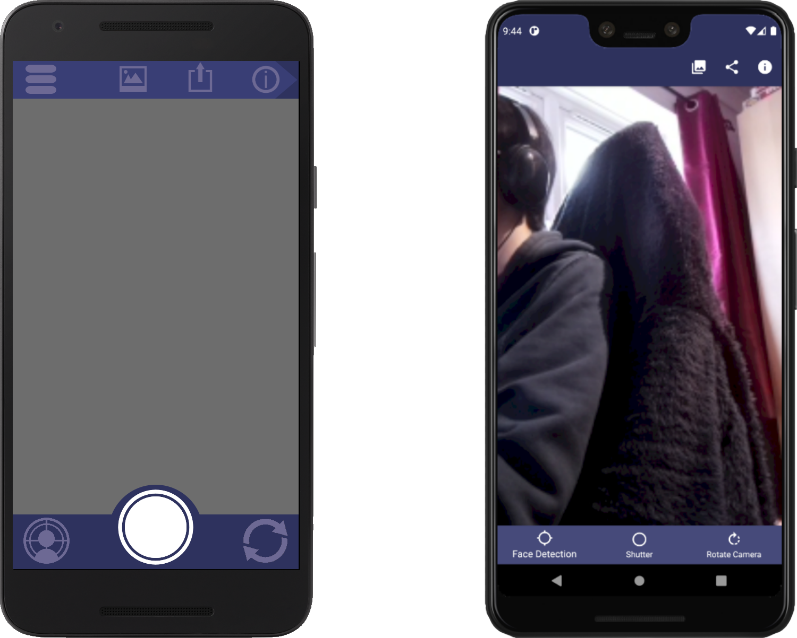.

Similar to 1.1, the GUI was also simplified. The idea for an animated top menu was changed to static icons, the larger shutter button and the icons themselves were all modified. In my opinion, the mockup looks a lot better than the final design as the shutter button is a lot clearer but I do prefer the icons in the final product

As such, I consider the Main GUI a partial success - the functionality is completely fine but, similar to 1.1, the final criteria fails to meet the higher quality of the mockup design. If just the bottom bar was modified to have a larger shutter button then I would classify this as a complete success.

In future development, the bottom bar being modified to work with colours on presses and a larger shutter button should be addressed; potentially with integration of the [Bottom App Bar from Material design](https://material.io/components/app-bars-bottom#usage).

### 1.4 - Live Camera Feed

This criteria was mainly focussed around the backend implementation of the live video feed. The criteria originally surrounded the frontend design a bit more but, due to the order I tackled the module 1 criteria, ended up only being for the backend.

The video feed worked very well - all things considered. Due to this, I consider this criteria a complete success.

### Module 2 References

White Box test cases

Black Box test cases

Feedback

### 2.1 - Rotate Camera

This criteria encompassed the frontend logic for rotating the servos manually. The final version of this was a dialog window with the option to input both a yaw and pitch value and buttons to increment/decrement each value by 0.5.

During white box testing, it turned out that the text field hints for “Pitch” and “Yaw” had been swapped. This was fixed and they were swapped back during Remedial Action for Issue 2.

There were two more issues found in black box testing that were also fixed. The first being that when trying to enter a value larger than the max, it didn’t correct that value and set it as the max value. The other issue was that the maximum and minimum values for “Yaw” and “Pitch” were incorrect. These were fixed alongside Feedback 3 where the range, originally 2 to 12, was changed to 0 to 10 instead. This was all done under Remedial Action for Issue 1, Issue 2 and Feedback 3.

There were three other given pieces of feedback that were acted on. The first one, Feedback 1, revolved around the keyboard staying up after pressing tab. However, this was an issue with the emulator and wasn’t fixed; it can be seen discussed under Remedial Action for Feedback 1. The second one, Feedback 5, was regarding how decimal values should be acceptable rotation values. This was agreed upon and implemented under Remedial Action for Feedback 5. Another one was Feedback 6. The video feed seemed to flicker every time a rotation was made. This was fixed under Remedial Action for Feedback 6 where POST requests were used rather than relying on loading a URL via the webview. The final one was Feedback 2 where an error appeared at seemingly random when trying to rotate the camera. This was fixed under Remedial Action for Feedback 2.

As all of the feedback and issues were fixed, outside of one feedback outside of my control, I determined that this criteria was a complete success.

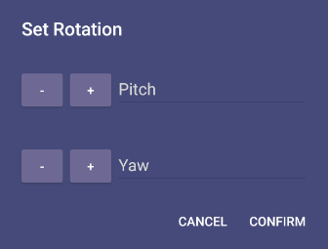

In the future, the one thing that could be improved on for this would be the GUI design itself. While it isn’t necessarily bad, it could do with some improvements colour wise.

### 2.2 - Modify Servo Rotation

This criteria encompassed the backend logic for servo rotation. This didn’t happen during the correct stage in development however. This was the result of testing out the rotation logic previously alongside the Flask server itself - as seen in Servo Flask Server Test Script.

In white box testing, two main issues arose. Issue 1 was that there was no validation for the servo rotation. This meant that certain values could be entered outside of the app to the web server and could potentially break the servo. This was fixed under Remedial Action for Issue 1. Issue 1.1 was around the fact that the servo, if sent the same rotation value twice, would make an irritating noise on the second request but wouldn’t move due to the fact it’s already in the right position. This was fixed under Remedial Action for Issue 1.1 and involved storing the current rotation value in memory to be checked against the requested servo rotation value.

After all the appropriate validation checks were added, there wasn’t much more to this outside of rotating the servos which in itself was a small function. There weren't any other issues and therefore I will conclude that this criteria was successful.

### 2.3 - Detect Faces

After attempting to set up alwaysAI and having major issues with it outside of my control, this was going to be scrapped during development. However, after feedback from a stakeholder, I decided to give it another go using an alternative to alwaysAI - a simple haar cascade algorithm. This turned out to work extremely quickly on my RPI but was somewhat inaccurate depending on the environment. The majority of this code was done under Remedial Action for Feedback 4. Due to this there weren't a lot of test cases I had recorded.

Due to the algorithm being somewhat inaccurate and the overall lack of recorded test cases, I would determine this to be a partial success.

In future development, a better face detection algorithm could be implemented instead of the haar cascade one which would make the face detection a lot better. I wouldn’t recommend that an API should be used as sending requests to a server uses up bandwidth and would cost more to use.

### 2.4 - Centre on Face

This criteria is similar to the previous one with the only difference being this section focussing on the rotation calculation algorithm for determining how much to rotate the servos by. This ended up being a fairly accurate formula that I created and was only limited by the issues with the face detection. Again, like the previous criteria, there weren’t any recorded test cases for this.

Due to this, I would determine that this is a partial success. The algorithm itself works very well but my lack of test data isn’t enough to back that up.

### Module 3 References

White Box test cases

Black Box test cases

### 3.1 - Regular Photo

This criteria was focussed on the frontend logic for sending a photo request to the RPI. This worked mostly around the shutter buttons onclick listener and was a small criteria during development.

There was only one issue which, from a user perspective, would seem like this criteria would have been the cause of. In black box testing, upon pressing the shutter button twice within a short period of time, the video feed would freeze and the RPI would shutdown. However, after checking the logic behind it, it turned out that it was an issue with how the RPI captured photos.

The lack of issues and simplicity means that this criteria was a complete success.

### 3.2 - Timed Shot

The timed shot criteria was entirely dedicated to the frontend logic for timed shots rather than the backend. This involved a dialog being created when the user pressed and held on the shutter button. This allowed the user to enter a duration to wait before the photo would be taken. Like the rotation dialog, this also has buttons to increment/decrement the time to wait.

During black box testing, an issue arose whereby the timed shot didn’t work and an Error 404 was returned. This was a small issue due to me trying out a POST request and missing a character when reverting - there was a “/“ instead of a “?”. This was fixed under Remedial Action for Issue 2.

The only issue found was resolved and the menu works perfectly fine so this criteria was a complete success.

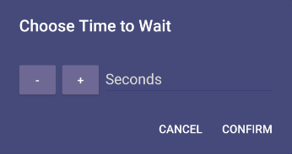

The only thing in future that could be improved, similar to “2.1 - Rotate Camera”, would be the GUI design itself. It isn’t necessarily bad, but it could do with some improvements to make it look nicer.

### 3.3 - RPI Take Photo

Compared to the previous two criteria, this one took a lot more time and effort. It involved the logic behind receiving requests, taking a photo and generating a filename. However, due to the issues of my decomposition diagram, it was a lot easier to bundle this with the next two criteria during development.

In white box testing, there was a lack of validation on the backend for the time to wait. If a negative number was sent then the code would output an error message and wouldn’t take a photo. This was fixed with a range check under Remedial Action for Issue 2.

The final issue with the criteria found during black box testing was where the RPI would crash if multiple photo requests were sent before the previous had finished taking a photo. In order to remedy this, I implemented a request queue to handle each request at a time. This happened under Remedial Action for Issue 1.

All of the issues surrounding this criteria were fixed and it was met completely. As a result, I would determine that this criteria was a complete success.

### 3.4 - RPI Send Photo

This criteria focussed on the RPI sending the photo to the Android app. This was supposed to be an easy integration into the previous criteria but the Android app sent two requests. In order to fix this I had to send a request to take a photo and then another to get the photo.

There weren’t any issues found during testing for this criteria and it works perfectly fine in the end product so I would determine that this is a complete success.

### 3.5 - Autosave Image

The autosave image criteria was built for the backend so that the RPI would automatically save any photos taken to its local storage. This way, if there was an issue with sending the photo to the user, they could retrieve the photo off the RPI. In the final product, this evolved to save both the higher quality PNG photo alongside a compressed JPEG version. Even though I discovered how POST requests worked, I unfortunately relied on the webview for this part as it was easy to bind a download manager to it for photos to be downloaded to the phone.

Within white box testing one issue emerged. This was around the filename generation. Originally, the code generated 1 filename and used this for saving the PNG and JPEG images in separate directories. However, if there was a desync in filenames, say a user deleted file 1 in only one directory, the issue of images being overwritten occurred. This was fixed under Remedial Action for Issue 1 and simply involved generating two filenames independent of each other.

The criteria was working properly and the one issue that emerged was fixed entirely so I’d determine that this criteria was a complete success.

### Module 4 References

White Box test cases

Black Box test cases

### 4.1 - Sub menu interface

This criteria was originally intended for an animated drawer containing the top icons - share media, open photo gallery and about page. However, this deviated and instead I opted for a top navigation drawer. The original idea was technically still visible for smaller devices albeit without the animation.

No issues were found for this during black box and white box testing. However, since the final product deviated from this criteria in terms of design, I would determine that this criteria was a partial success.

If development on the project continued, the idea of an animated drawer could be revisited. It would look a lot better than the current implemented method and would be a lot cleaner.

### 4.2 - Share Media

The share media criteria centred around the proposition of sharing the most recently taken photo from directly within the app. This ended up using the built in Android share widget as it meant that I would be relying on the OS itself rather than having to update it myself.

During white box testing the issue of Android still attempting to share a photo after it has been deleted cropped up. I attempted to fix this under Remedial Action for Issue 2 but was unsuccessful. I concluded that, since this issue didn’t break anything, that it wasn’t as big of a deal.

The share media functioned well, however, due to this outstanding issue, I would only consider this to be a partial success.

In future development, the share media should be fixed to not try to share a missing photo.

### 4.3 - Open Photo Gallery

This was focussed around the implementation of a button that would open the photo gallery. This way, the user can quickly access the photos they had just taken without having to find the gallery on their home screen.

There weren’t any issues found during testing and the functionality worked perfectly so I’d determine that this was a complete success.

### 4.4 - About page

The about page criteria surrounded the implementation of an about page on the frontend. It included information such as the current app build and the connection information.

When undergoing white box testing, an issue appeared with “null” showing instead of default values; I had forgotten to implement these during development. This was fixed under Remedial Action for Issue 1.

This criteria was a complete success; it worked as intended and the only issue found for it was fixed.

### Overview

|  |  |  |
| --- | --- | --- |
| **Module** | **Criteria** | **Success** |
| **Main Interface** | 1.1 - Connect GUI | Partial |
| 1.2 - Connect to RPI | Complete |
| 1.3 - Main GUI | Partial |
| 1.4 - Live Camera Feed | Complete |
| **Camera Rotation** | 2.1 - Rotate Camera | Complete |
| 2.2 - Modify Servo Rotation | Complete |
| 2.3 - Detect Faces | Partial |
| 2.4 - Centre on Face | Partial |
| **Take Photo** | 3.1 - Regular Photo | Complete |
| 3.2 - Timed Shot | Complete |
| 3.3 - RPI Take Photo | Complete |
| 3.4 - RPI Send Photo | Complete |
| 3.5 - Autosave Image | Complete |
| **Submenu** | 4.1 - Sub menu interface | Partial |
| 4.2 - Share Media | Partial |
| 4.3 - Open Photo Gallery | Complete |
| 4.4 - About page | Complete |

## Usability

### Simplistic GUI

When developing the final product, I had simplicity in mind for the original flow of the GUIs. This way, any user can easily start interacting with the product and get a grasp on how it works relatively quickly. In the design phase I tried to make the flow of the app and the features on each screen as simple and logical as possible.

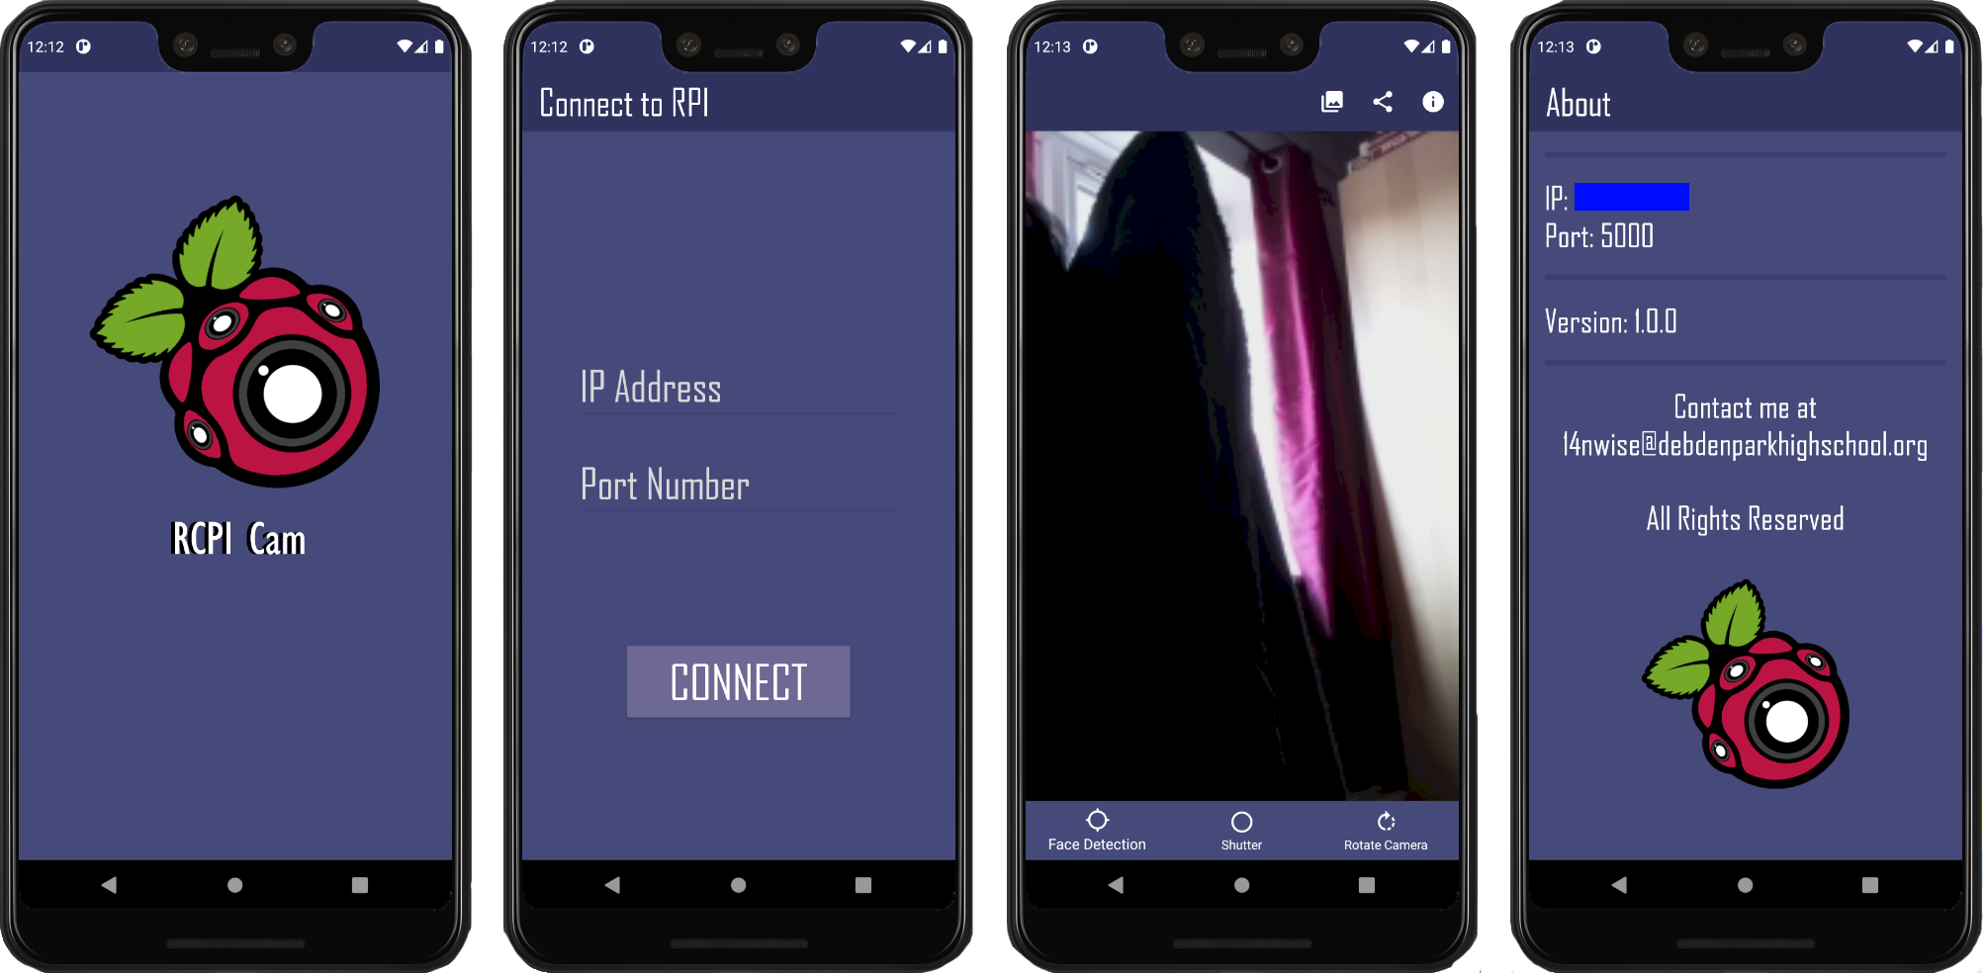

This wasn’t necessarily implemented in a single module or criteria, rather the entire stage of development. I do believe that I wholly achieved this as it seems relatively easy to navigate and use personally. I will however be able to comment further on this when I get round to questioning the stakeholders.

### Button icons

Within the frontend GUI, most of the buttons did use icons. This does exclude the connect button, although, in that instance it is more logical to have the word “CONNECT” as there isn’t a global icon that would be used to symbolise connecting/logging in.

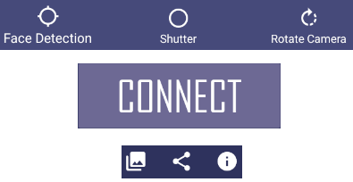

The main issue for this however stems from the bottom icons on the Main GUI. While they do have icons, two of the buttons are obscure and I felt it was necessary to add text underneath. This is undesirable but the feature of holding a button to display it’s meaning isn’t widely known for Android apps.

Therefore, I believe that this is a partial success.

In future development, the following could be done to solve this:

* Investigation into more recognisable icons
* Development of an introductory tutorial
* Development of a help menu that highlights what each button does

### Text

As far as I’m aware, the text within the app follows grammatical correctness and is short. The styling for text shows consistency between groupings of text types - for example logo text, button text and title text.

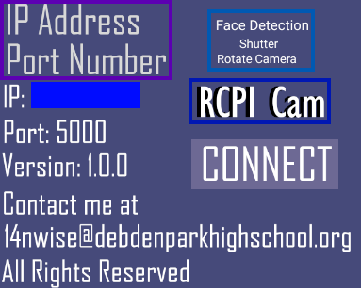

Above is a sample of the majority of the text within the app and they have been grouped by purpose.

* **Purple bound** - text entry group
* **Blue bound** - icon text group
* **Dark Blue bound** - logo text group
* No bound - info text group

I believe, due to this, that the text based usability is a complete success.

### Error Tolerance

When developing the product, I made sure to keep Error Tolerance in mind wherever possible. This has been in the form validation for specific inputs, sanitisation of said inputs and communicating unexpected errors to the user.

For example, if the user tried to input “abc'' into the IP textfield, none of the characters would appear entered in the text field as they are invalid. For more complex validity logic such as determining whether an IP address is appropriate, regex was used and the user was informed if there was an issue.

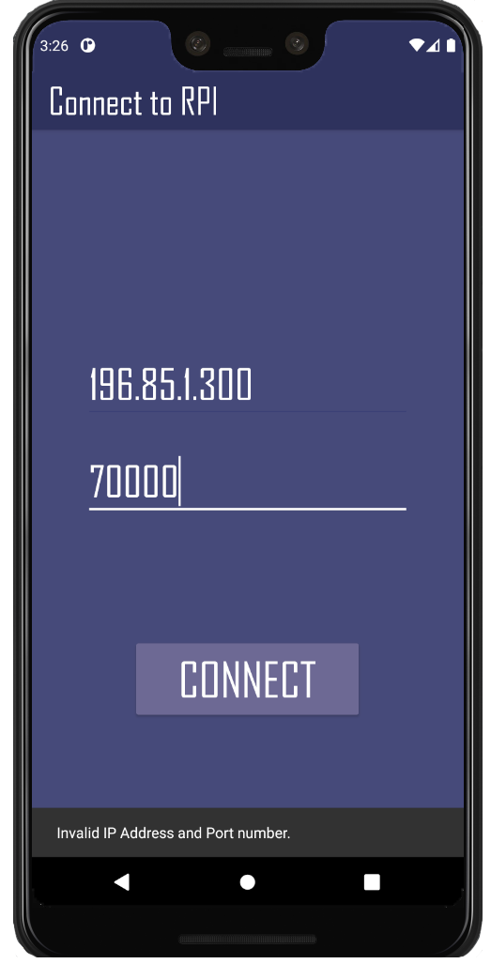

If there was an unexpected error on the video feeds end, a snackbar would display showing the error code and error message. This is a lot harder to give an example for as I’m not sure how to trigger one of these as most that have been encountered have been accounted for.

Due to the above evidence, I believe that this has been a complete success.

Further on in development, this practice should be continued to the same level of quality as currently in place.

### GUI Styling

The GUI styling was very important consistency wise. I chose to have the app follow a certain colour scheme, text style and layout in order to maintain this. This means that parts of the app that are initially new to the user aren’t overwhelming and should be a lot easier to comprehend.



While the UI isn’t terrible, I do believe that some changes should be made to make it feel more modern. As I’m not the greatest UI designer however, I don’t necessarily know what these should be outside of potentially changing up the colour scheme and reducing the size of the bars on the about page.

Therefore, I do consider this to be a partial success as it definitely has room for improvement.

### Overview

|  |  |
| --- | --- |
| **Usability Feature** | **Success** |
| Simplistic GUI | Complete |
| Button Icons | Partial |
| Text | Complete |
| Error Tolerance | Complete |
| GUI Styling | Partial |

## Stakeholders

I then asked all of my stakeholders to test out my final product, fill in a survey and provide any feedback. Since this is hardware based and due to current events, I will be utilising Parsec so that my stakeholders can connect to my PC to test out the final product.

Mr Davies had latency issues when using Parsec so he wasn’t included in the feedback below.

### Questionnaire

|  |  |  |  |  |  |  |
| --- | --- | --- | --- | --- | --- | --- |
| **Q. ID** | **Question** | **Levels of Agreement** | | | | |
| **Strongly Agree** | **Agree** | **Neutral** | **Disagree** | **Strongly Disagree** |
| 1 | The user interface was easy to navigate | **MH, ND** | **JM, DZ** |  |  |  |
| 2 | The user interface was easy to understand | **MH, ND** | **DZ** | **JM** |  |  |
| 3 | The app was responsive to your inputs | **MH, JM** | **DZ, ND** |  |  |  |
| 4 | The app features all worked as you'd expect | **DZ, ND** |  | **MH** | **JM** |  |
| 5 | Connecting to the RPI was easy | **MH, ND** | **JM** | **DZ** |  |  |
| 6 | The user interface looked aesthetically pleasing | **JM** | **MH, DZ, ND** |  |  |  |

### Individual Feedback

|  |  |  |
| --- | --- | --- |
| **Stakeholder** | **Initials** | **Feedback** |
|
| Mr Zerouala | **DZ** | The timed shutter option was quite hidden and I don’t think I’d have found it without being told about it, so I think a help section would have been nice. Otherwise, the app worked just fine. |
| Mr Martin | **JM** | Would have liked a UI displaying simple + / - for yaw + pitch available at all times on the screen to be adjusted on the fly rather than having to input 0-10 values (perhaps an arrow pad). Also would like to see a button saying timed shot rather than having to play with the app to find it. |
| Mr Davies | **CD** | ~~ |
| Mr Dorrell | **ND** | Would be nice if you could wait for decimal times. If you spam face detection, it slowly processes every single request and takes a long time to fix itself. |
| Mr Horn | **MH** | The interface was simple and easy to understand, the app was very responsive and worked as expected though repeated clicking of buttons caused the app to slow, the face recognition was not very reliable. |

### Feedback Overview

|  |  |  |
| --- | --- | --- |
| **Feedback ID** | **Issue Description** | **Potential Resolution** |
| 1 | The Timed Shot feature seemed somewhat difficult to find for most stakeholders and I had to inform them of it in every situation. | Help section or a dedicated Timed Shot button |
| 2 | The rotation dialog seemed to be a slight annoyance for Mr Martin. He would have preferred if you had the option of pressing a button on an arrow-pad like design to change the rotation rather than set the rotation. | D-pad for incrementing/decrementing current rotation |
| 3 | Mr Dorrell pointed out that wait times should also have a decimal option - similar to how the rotation system currently works. | Integration of decimal sanitisation/validation for Timed Shot dialog |
| 4 | Repeatedly pressing the face detection would slow the app. This is due to the RPI trying to process each request one by one. | Limit face detection requests on the frontend; wait for a response from the server before enabling them again? |
| 5 | The face detection wasn’t very accurate and detected things that weren’t faces. | Find a better face detection algorithm (potentially train one) or modify argos for the current face detection to be more strict. |

## Future Improvements

### Limitations

There are currently a fair few limitations of the current solution. These will be discussed below and some will have explanations of how to resolve them during further development.

#### Power

As of right now, the solution relies heavily on the mains power supply which, for the purpose of the solution, isn’t as portable as I’d like it to be. This means that, if you want to use it, it needs to be within the range of a plug socket.

A better solution going forward would be a rechargeable battery pack connected to the main product. This would allow the product to have a lot more freedom of movement and with it being rechargeable would allow for convenience of powering it back up.

#### Connecting to RPI

There are a few limitations with this as it stands. In order to connect, you need to know the private IP of the RPI beforehand which means booting up the RPI, plugging in relevant peripherals and then typing “ifconfig” to find the private IP.

Additionally, the RPI has to be connected to a WiFi or Ethernet network which means potentially booting into the RPI and setting that up.

To solve this a script could be autorun where the RPI tries to connect to any passwordless WiFi and then shows the private IP address of the RPI on an attached LCD screen.

#### App Request Retries

An issue existed where the app sent two POST requests when using Volley as it required a header response to be sent within a specific time frame from the server. Since resource intensive actions like taking a photo or running face detection extended past this time, Volley sends another request. To fix this, I disabled the request retries. As a result, if a request doesn’t actually reach the RPI, another request won’t be sent.

A better look into networking, specifically response headers, could provide a solution to this. However, due to my limited networking knowledge, I’m not entirely sure how to progress with this.

#### Frontend Photo Requests

As it stands, if you repeatedly press the shutter button, the RPI will take every photo but only the last photo will be downloaded by the app. This is due to how the Download Manager currently functions on the app.

To fix this, a better solution than a Download Manager attached to the webview would be ideal. This way POST requests can be used rather than relying on a webview which should help solve the issue.

#### Public Access

A major security concern is that anybody who knows the RPIs private IP and Port can connect to the RPI and, if they know the directories, can send requests to it. This is a massive problem and should be resolved in future development.

To address this, authentication could be introduced to verify whether a user can access it. A token could be assigned to users via the app with a checksum and this could be sent with every request. Every request on the RPI could have their token checked and authenticated.

#### One user

As it currently stands, the backend has only been tested with one user at a time. This could mean there are issues if two or more users with the app try to interact with the same RPI.

In order to remedy this, extensive testing should be done with multiple users on the same RPI and amendments made where necessary.

#### Frontend

The frontend currently heavily relies on activities rather than the more recent and favoured fragments. Fragments should reduce loading times between screens; this should be noticeable on slower devices. Fragments are also more closely tied with the newer Android development system and generally would be a good idea to implement. This should also reduce the amount of code with fragment views.

Also, the app hasn’t been fully integrated with the new Android Jetpack which aims at faster development speeds. With this integrated, future features would be a lot quicker to implement. This could be combined with Material themes in order to make animations and components look a lot more appealing.

#### GPIO Wires

The existing solution for the GPIO wires is the magic of black tape holding them between an ethernet port and two USB 3 ports. This right now isn’t a good solution as they can be accidentally pulled out of their corresponding GPIO pins.

A better solution could be a compartment for holding the pins and a covering for the GPIO pins so that they aren’t accidentally interfered with.

#### Icon

In the project, I never designed and produced an app icon so it is still using the default icon. In future development, a unique app icon should be created - including the logo I created a while back.

#### Web Server

Currently, the project still uses the development server built into Flask. This can come with massive risks with security and maintenance issues and, if possible, should be changed to a better solution. For example, nginx or Apache.

### Maintenance

For maintenance of the product going forward, a fair few things need to be considered.

#### Software Updates

This includes, but is not limited to:

* Raspbian OS
* Python
* Kotlin
* Android
* Dependencies

If the product is going to continue being supported, then the most recent versions of each should be considered and ensured functionality continues. Without this, the product will become dated and unused.

#### Hardware

Over extended use, hardware may become less accurate and in the worst case stop functioning. The hardware should be checked every so often to ensure it works as intended.

Replacements to specific parts may be required and have been prioritised from most likely to fail to least:

* Micro Servos
* Pi Camera V2
* Video Ribbon Cable
* GPIO Pins
* RPI
* 3D printed parts

#### Dependencies

Over time, the dependencies for the project may be altered in a way that renders aspects of the product unusable. To combat this, the dependencies need to be checked and updated when necessary; if major changes have been made to any then this needs to be mirrored in a code update. Additionally, the amount of dependencies should aim to be as low as possible to avoid this issue in the future.

The main dependencies are:

* Android Std Lib
* Android Volley
* Python Std Lib
* Flask
* RPi.GPIO
* Numpy
* cv2 (OpenCV)
* PIL (Pillow)
* Picamera

#### Modularity

When developing new features, modularity needs to continue. Currently, for the backend, there are three Python files. Two for classes (Camera and Servo) and the main file that wraps everything together. For the frontend it is more complicated but for the Kotlin code, the files are split into these categories: activities, utils and views.

To maintain readability, it is vital this is continued forward.

#### Styling

The final aspect to consider is the way code is styled/structured. For Python code, PEP8 needs to be utilised to ensure that variable names, class names, indentation, etc. is consistent across all files. The Kotlin style guide also needs to be followed for any Kotlin code and any other guidelines written for other languages that are implemented.

## Product Photos

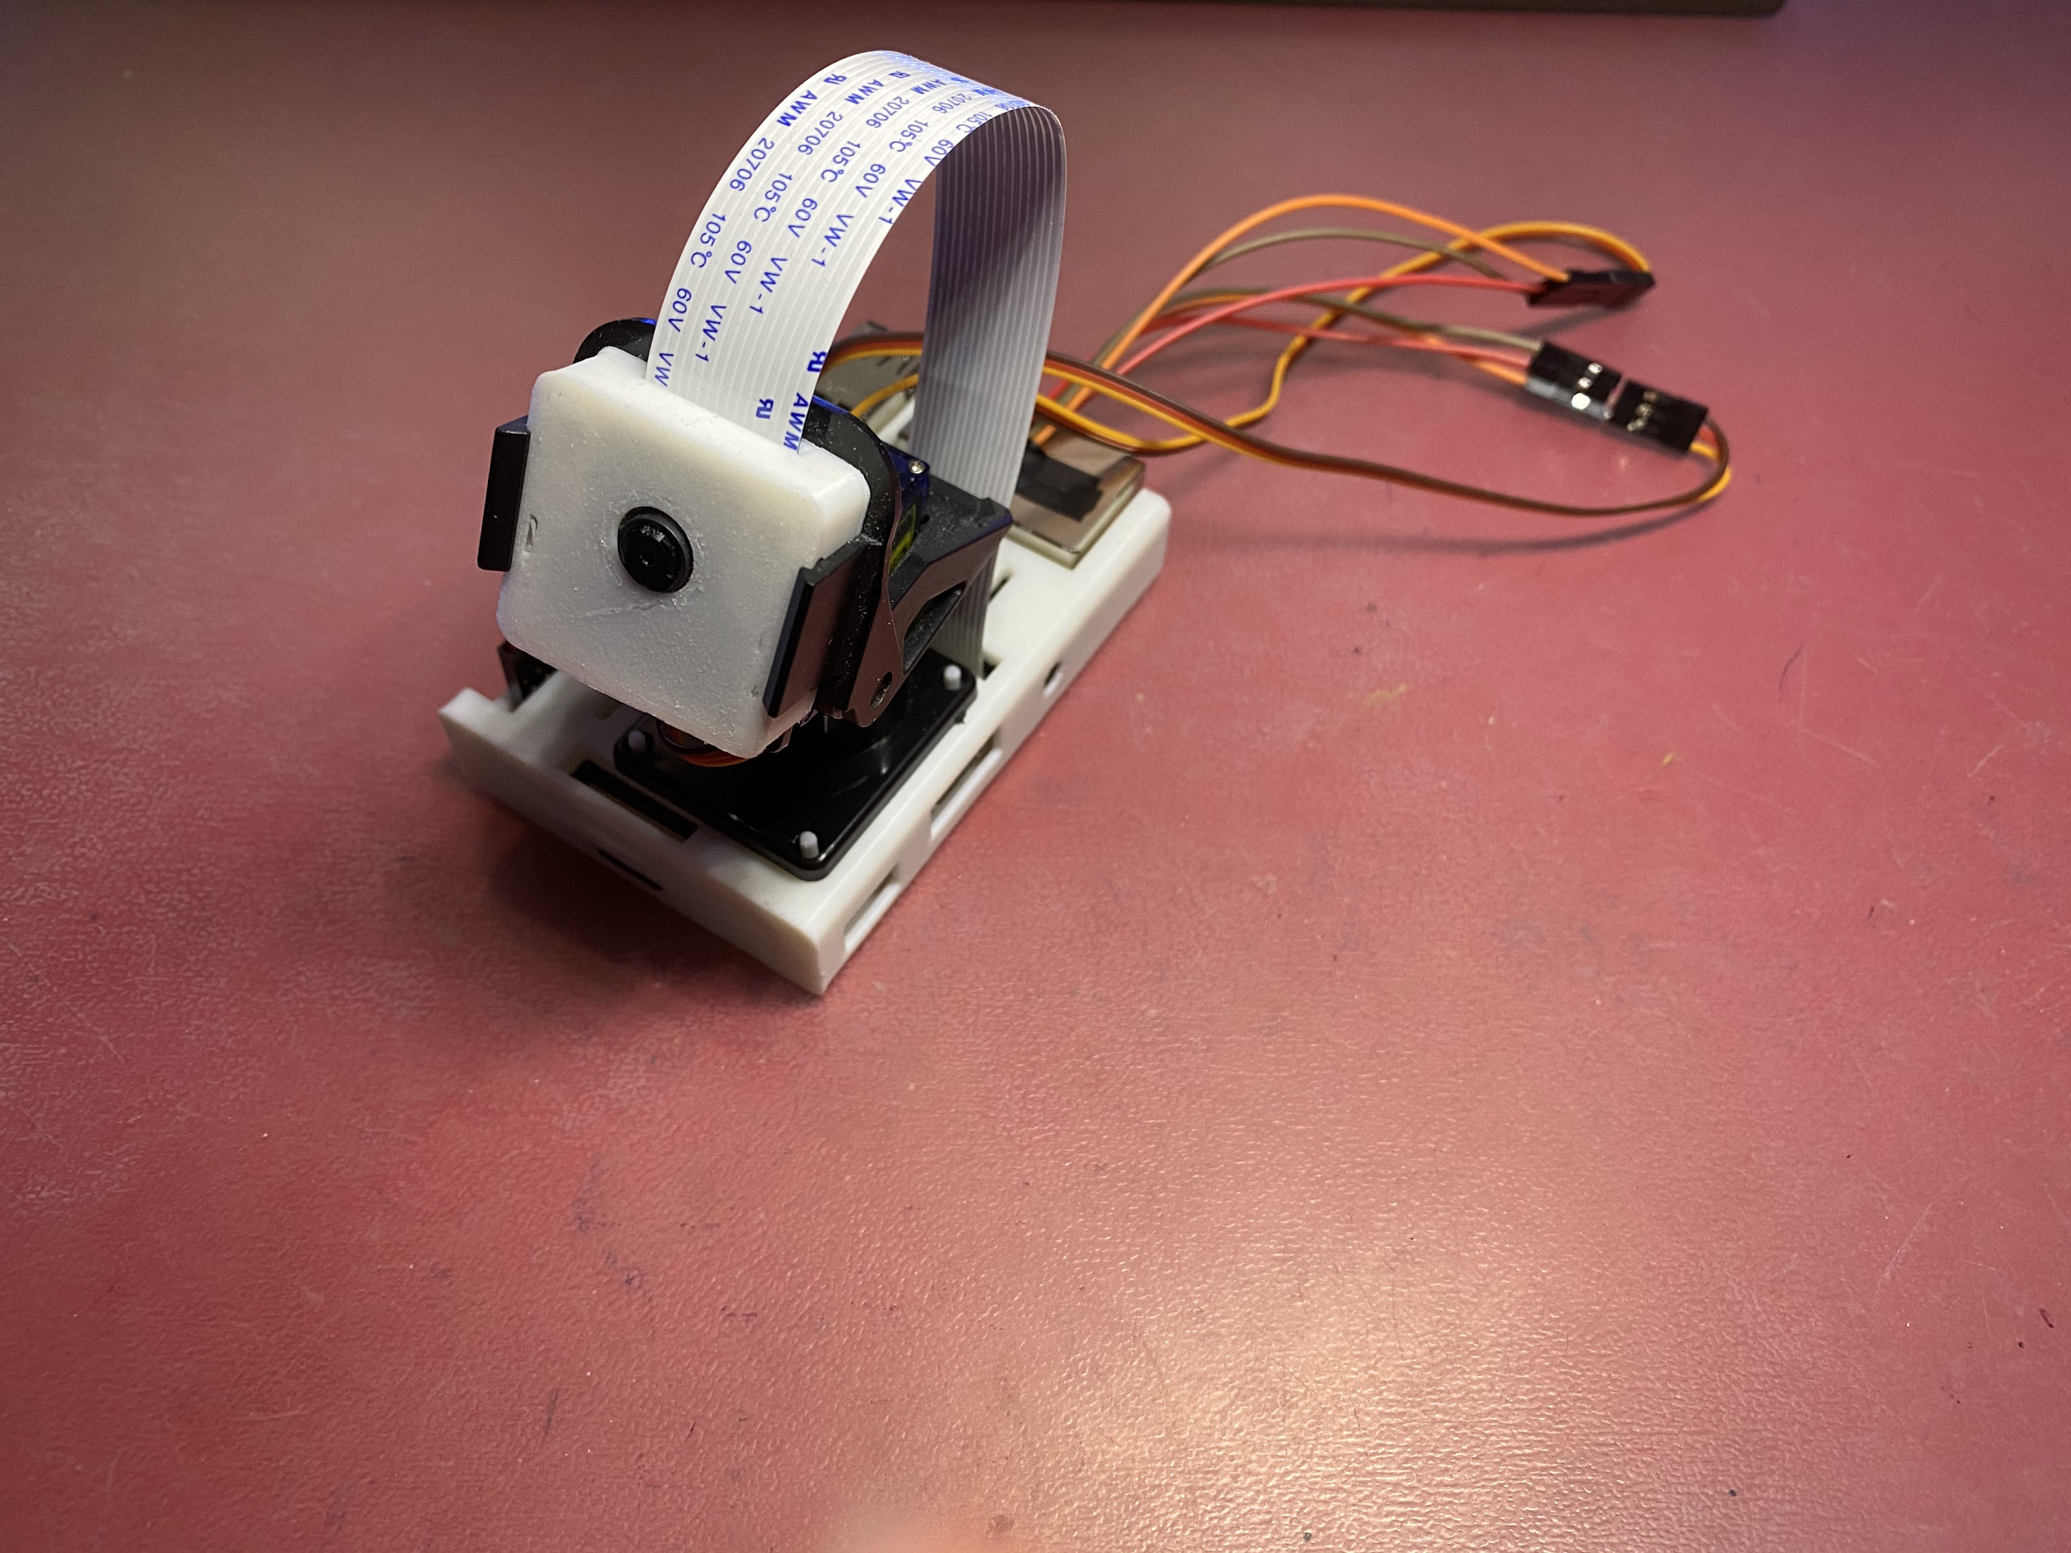

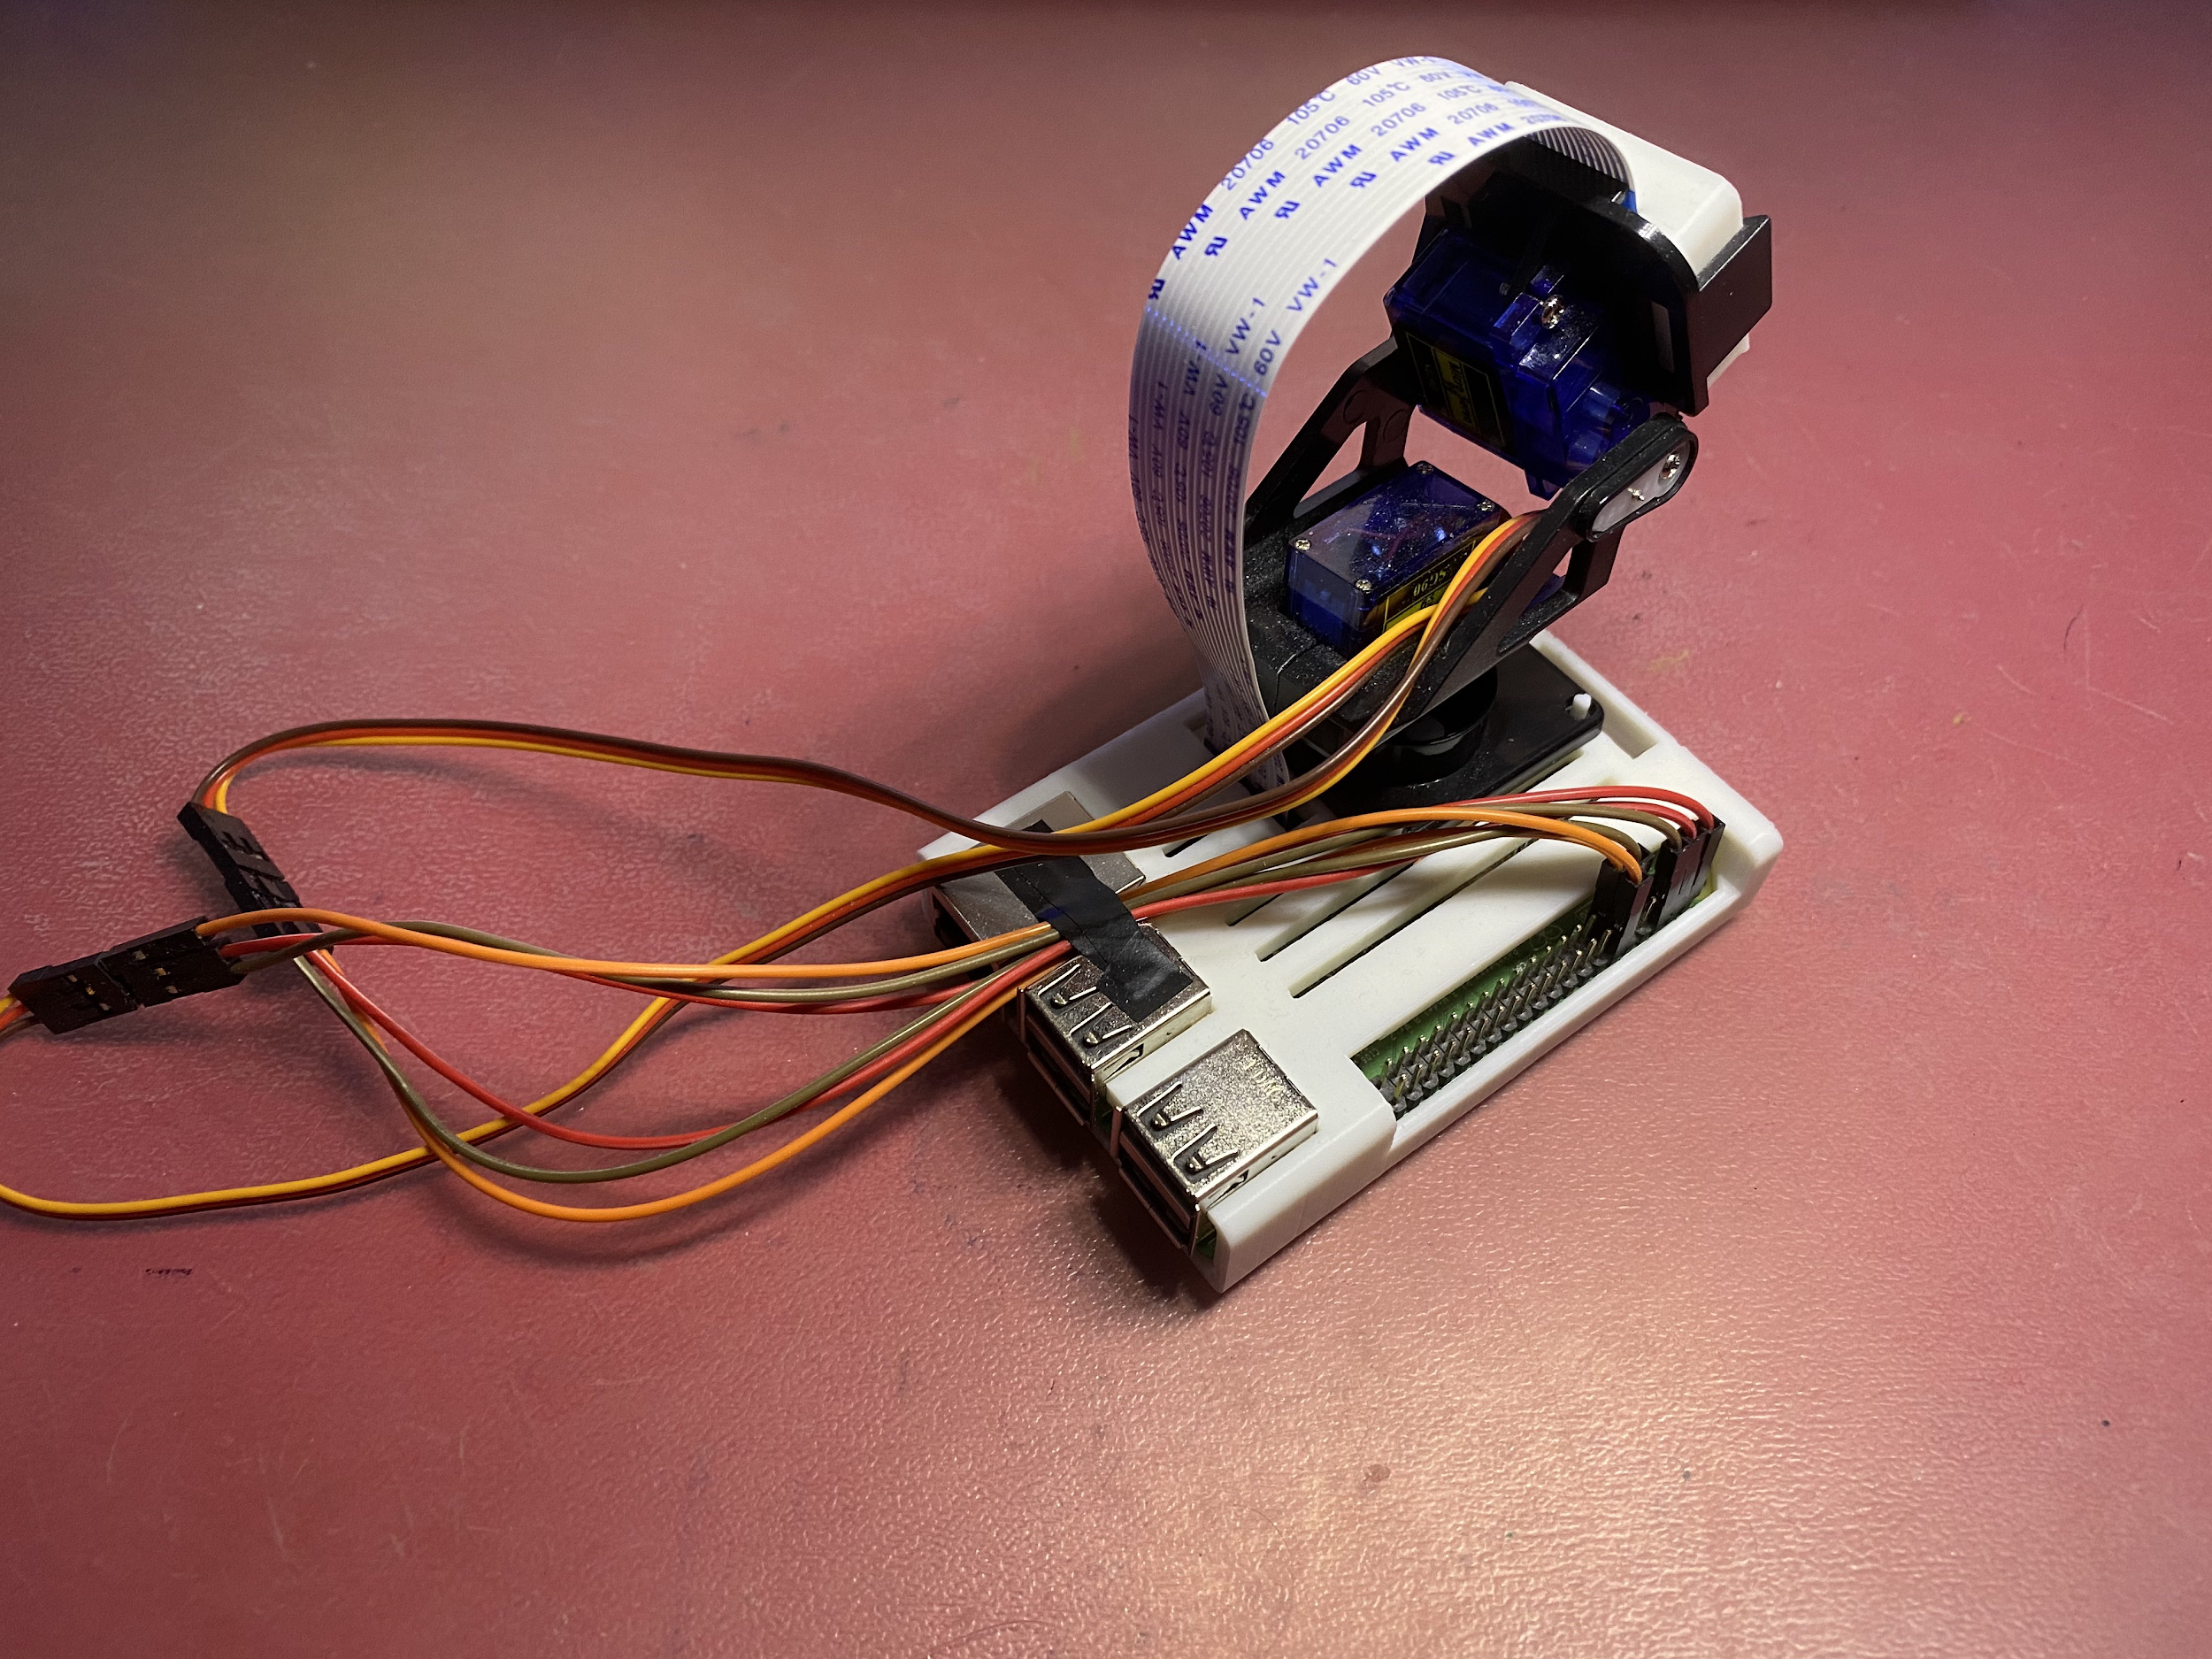



# Final code

## Backend - RCCamBackend

|  |
| --- |
| D:.  │ .gitignore  │ app.py  │ camera.py  │ face_detect.xml  │ README.md  │ servo.py  │  ├───.idea  │ │ misc.xml  │ │ modules.xml  │ │ other.xml  │ │ RCCamBackend.iml  │ │ vcs.xml  │ │ workspace.xml  │ │  │ └───inspectionProfiles  │ profiles_settings.xml  │ Project_Default.xml  │  ├───templates  │ base.html  │  └───__pycache__  app.cpython-38.pyc  camera.cpython-38.pyc |

### app.py

|  |
| --- |
| import io import os import re import time  import numpy as np from PIL import Image, ImageFile import cv2 as cv from flask import Flask, send_from_directory, url_for, redirect, render_template, Response from flask import request  from camera import Camera, gen_filename from servo import ServoController  # GET ~ GET message is send, and the server returns data # POST ~ Used to send HTML form data to the server. The data received by the POST method is not cached by the server.  web_app = Flask(__name__)  ser_app = ServoController() camera = Camera()  ImageFile.LOAD_TRUNCATED_IMAGES = True   def generator(cam):  while True:  yield b"--frame\r\nContent-Type: image/jpeg\r\n\r\n" + cam.get_frame() + b"\r\n"   def is_number(num):  """  Determines whether a given input is a number or not. Valid for num∈ℚ   :param num: string, int, float  :return: true if the given value is a number, false if not.  """  return True if type(num) in [int, float] or re.match(r"^-?\d+(?:\.\d*)?$", num) is not None else False   @web_app.route("/") def main_page():  return render_template("base.html")   @web_app.route("/video") def video_feed():  return Response(generator(camera), mimetype="multipart/x-mixed-replace; boundary=frame")   @web_app.route("/servo", methods=["POST", "GET"]) def servo():  # Acceptable value range for servos  smin = 0.0  smax = 10.0   # Servo pitch modification logic  for char, servo_name, ref in (("p", "Pitch", ser_app.pitch), ("y", "Yaw", ser_app.yaw)):  val = request.values.get(char, "a")  if is_number(val):  val = float(val)  if val < smin:  print(f"{servo_name} value '{val}' exceeded range ({smin} -> {smax})\n{servo_name} value set to {smin}")  val = smin  elif val > smax:  print(f"{servo_name} value '{val}' exceeded range ({smin} -> {smax})\n{servo_name} value set to {smax}")  val = smax   ser_app.change_servo(ref, val + 2)  print(f"{servo_name} rotation set to {val}")   return redirect(url_for("main_page"))   @web_app.route("/take_photo/") def take_photo():  # Get args and declare if missing  dur = request.args.get("dur", "")  resWidth = request.args.get("w", "")  resHeight = request.args.get("h", "")   if (resHeight != "" or resWidth != "") and is_number(resWidth) and is_number(resHeight):  res = [int(resWidth), int(resHeight)]  else:  res = [1920, 1080]   if dur != "" and is_number(dur) and float(dur) > 0:  time.sleep(float(dur))   image_paths = ("photos/", "compressed_photos/")   # Make image paths if they don't exist  for path in image_paths:  if not os.path.exists(path):  os.mkdir(path)   # Capture image as PNG  image_ext = "png"  image_location = f"{image_paths[0]}{gen_filename(image_ext, path=image_paths[0])}.{image_ext}"  camera.capture_image(filename=image_location, res=res)   # Convert and save image as JPEG  im = Image.open(image_location).convert("RGB")  image_ext = "jpeg"  image_name = f"{gen_filename(image_ext, path=image_paths[1])}.{image_ext}"  im.save(f"{image_paths[1]}{image_name}") # JPEG  print(f"Took photo: {image_paths[1]}{image_name}")   return send_from_directory(image_paths[1], image_name, as_attachment=True)   @web_app.route("/get_photo/<path:filename>") def get_photo(filename):  return send_from_directory("compressed_photos/", filename, as_attachment=True)   @web_app.route("/face_detection", methods=["POST", "GET"]) def face_detection():  # Width and Height  resWidth = request.args.get("w", "")  resHeight = request.args.get("h", "")   if (resHeight != "" or resWidth != "") and is_number(resWidth) and is_number(resHeight):  res = [int(resWidth), int(resHeight)]  else:  res = [1920, 1080]   # Image stream capture and decode for OpenCV  stream = io.BytesIO()  camera.capture_image(stream, format="jpeg", res=res)  data = np.frombuffer(stream.getvalue(), dtype=np.uint8)  img = cv.imdecode(data, 1)   # Image manipulation and saving  img_grey = cv.cvtColor(img, cv.COLOR_BGR2GRAY)  img_grey = cv.equalizeHist(img_grey)   # Run face detection  cascade = cv.CascadeClassifier("face_detect.xml")  faces = cascade.detectMultiScale(img_grey,  scaleFactor=1.05,  minNeighbors=3,  minSize=(70, 70),  flags=cv.CASCADE_SCALE_IMAGE)   # Apply bounding boxes  for (x, y, w, h) in faces:  cv.rectangle(img, (x, y), (x + w, y + h), (255, 0, 0), 2)   # Calculating servo rotation  height, width, channel = img.shape   print(width, height)   # Calculating average co-ord  mid_coords = [(x + (w / 2), y + (h / 2)) for (x, y, w, h) in faces]   if len(mid_coords) != 0:  total = [sum(i) for i in zip(*mid_coords)]  average = (round(total[0] / len(mid_coords)), round(height - total[1] / len(mid_coords)))  print(f"Average: {average}")   vals = [(10 * loc - 5 * dim) / arc for arc, loc, dim in zip((1920 * 3, 1080 * 3), average, (width, height))]   yaw = round(ser_app.yaw.current + vals[0], 1)  if yaw < 0:  yaw = 0  elif yaw > 10:  yaw = 10  ser_app.change_servo(ser_app.yaw, yaw)  print(f"Yaw rotation set to {yaw}")   pitch = round(ser_app.pitch.current - vals[1], 1)  if pitch < 0:  pitch = 0  elif pitch > 10:  pitch = 10  ser_app.change_servo(ser_app.pitch, pitch)  print(f"Pitch rotation set to {pitch}")   # Write image with bounding box  cv.imwrite("result.png", img)   return redirect(url_for("main_page"))   @web_app.after_request def add_header(response):  response.cache_control.max_age = 0  response.cache_control.no_cache = True  response.cache_control.no_store = True  response.cache_control.must_revalidate = True  response.cache_control.proxy_revalidate = True  return response   if __name__ == "__main__":  ser_app.change_servo(ser_app.pitch, 7)  ser_app.change_servo(ser_app.yaw, 7)  web_app.run("0.0.0.0", threaded=True) |

### camera.py

|  |
| --- |
| import io import os import threading import time from datetime import datetime  import picamera   def gen_filename(ext, path=""):  counter = 1  date = datetime.today()  filename = f"{date.day}-{date.month}-{date.year}-no{counter}"   if path[-1] != "/":  path += "/"   while True:  if os.path.isfile(f"{path}{filename}.{ext}"): # Increment counter if filename already exists  counter += 1  filename = f"{date.day}-{date.month}-{date.year}-no{counter}"  else: # Filename doesn't already exist, end loop  break   return f"{filename}"   def reduceResolution(cur_res, max_res):  divisor = max(cur_res[0] / max_res[0], cur_res[1] / max_res[1])  cur_res[0] //= divisor  cur_res[1] //= divisor   return list(map(int, cur_res))   class Camera:  thread = None # Background thread that reads frames from camera  frame = None # Current frame is stored here by background thread  last_access = 0 # Time of last client access to the camera   curCapture = False  curStream = False  capQueue = []   camera = picamera.PiCamera()   # camera.hflip = True  camera.vflip = True   def initialise(self):  if Camera.thread is None:  # Start background frame thread  Camera.thread = threading.Thread(target=self._thread)  Camera.thread.start()   # Wait until frames start to be available  while self.frame is None:  time.sleep(0)   def get_frame(self):  Camera.last_access = time.time()  self.initialise()  return self.frame   def capture_image(self, filename="", format="png", res=None):  # Request queue  id = 1 if len(Camera.capQueue) == 0 else Camera.capQueue[-1] + 1  Camera.capQueue.append(id)  while Camera.capQueue[0] != id:  pass   print(f"CI: Now serving request '{id}'")   # Changing resolution  maxRes = (1920, 1080)  if res is None:  res = maxRes  elif res[0] > maxRes[0] or res[1] > maxRes[1]:  res = reduceResolution(res, maxRes)   # Stopping video feed  Camera.curCapture = True  while Camera.curStream is True:  pass   # Changing to higher resolution for capturing image  while True:  try:  self.camera.resolution = res  break  except picamera.exc.PiCameraMMALError:  pass   self.camera.capture(filename, format=format)  print(f"Took photo: {filename}")   # Reverting to live stream resolution if no requests in queue  if len(Camera.capQueue) != 0:  while True:  try:  self.camera.resolution = (320, 240)  break  except picamera.exc.PiCameraMMALError:  pass   Camera.curCapture = False   # Removing this request from the queue  del Camera.capQueue[0]  print(f"CI: Finished serving request '{id}'")   @classmethod  def _thread(cls):  # Setting currently streaming flag to true  Camera.curStream = True   # Giving time for the camera to warm up  cls.camera.resolution = (320, 240)   cls.camera.start_preview()  time.sleep(2)   stream = io.BytesIO()  for foo in cls.camera.capture_continuous(stream, "jpeg", use_video_port=True):  # Store current frame  stream.seek(0)  cls.frame = stream.read()   # Reset stream for next frame  stream.seek(0)  stream.truncate()   # Stop thread if no clients have asked for a stream for 10 seconds  if time.time() - cls.last_access > 10:  cls.camera.stop_preview()  break   # Wait here for Capture camera process to finish if it requests to be run  if Camera.curCapture is True:  Camera.curStream = False   while Camera.curCapture is True:  pass   Camera.curStream = True   cls.thread = None |

### servo.py

|  |
| --- |
| import RPi.GPIO as GPIO import time   class Servo(GPIO.PWM):  def __init__(self, pin, hz):  GPIO.setup(pin, GPIO.OUT)  super().__init__(pin, hz)  super().start(0)   self.current = 0   class ServoController:  def __init__(self):  GPIO.setmode(GPIO.BOARD)   # GPIO 12 initialisation, 50hz  self.yaw = Servo(pin=12, hz=50)   # GPIO 11 initialisation, 50hz  self.pitch = Servo(pin=11, hz=50)   @staticmethod  def change_servo(servo, amount, tm=0.3):  if servo.current != amount:  servo.ChangeDutyCycle(amount)  servo.current = amount   time.sleep(tm)  servo.ChangeDutyCycle(0) |

### face_detect.xml

File is too large.

[GitHub link](https://github.com/opencv/opencv/blob/master/data/haarcascades/haarcascade_frontalface_default.xml)

## Frontend - RCCamFrontend

|  |
| --- |
| D:.  │ .gitattributes  │ .gitignore  │ build.gradle  │ gradle.properties  │ gradlew  │ gradlew.bat  │ local.properties  │ README.md  │ settings.gradle  │  ├───.gradle  │ ├───6.5  │ │ │ gc.properties  │ │ │  │ │ ├───executionHistory  │ │ │ executionHistory.bin  │ │ │ executionHistory.lock  │ │ │  │ │ ├───fileChanges  │ │ │ last-build.bin  │ │ │  │ │ ├───fileContent  │ │ │ fileContent.lock  │ │ │  │ │ ├───fileHashes  │ │ │ fileHashes.bin  │ │ │ fileHashes.lock  │ │ │ resourceHashesCache.bin  │ │ │  │ │ ├───javaCompile  │ │ │ classAnalysis.bin  │ │ │ jarAnalysis.bin  │ │ │ javaCompile.lock  │ │ │ taskHistory.bin  │ │ │  │ │ └───vcsMetadata-1  │ ├───buildOutputCleanup  │ │ buildOutputCleanup.lock  │ │ cache.properties  │ │ outputFiles.bin  │ │  │ ├───checksums  │ │ checksums.lock  │ │ md5-checksums.bin  │ │ sha1-checksums.bin  │ │  │ └───vcs-1  │ gc.properties  │  ├───.idea  │ │ compiler.xml  │ │ discord.xml  │ │ gradle.xml  │ │ jarRepositories.xml  │ │ misc.xml  │ │ modules.xml  │ │ RCCamFrontend.iml  │ │ runConfigurations.xml  │ │ vcs.xml  │ │ workspace.xml  │ │  │ ├───caches  │ │ build_file_checksums.ser  │ │  │ ├───codeStyles  │ │ codeStyleConfig.xml  │ │ Project.xml  │ │  │ ├───dictionaries  │ │ natha.xml  │ │  │ ├───libraries  │ │ Gradle__androidx_activity_activity_1_0_0_aar.xml  │ │ Gradle__androidx_annotation_annotation_1_1_0.xml  │ │ Gradle__androidx_annotation_annotation_experimental_1_0_0_aar.xml  │ │ Gradle__androidx_appcompat_appcompat_1_2_0_aar.xml  │ │ Gradle__androidx_appcompat_appcompat_resources_1_2_0_aar.xml  │ │ Gradle__androidx_arch_core_core_common_2_1_0.xml  │ │ Gradle__androidx_arch_core_core_runtime_2_0_0_aar.xml  │ │ Gradle__androidx_cardview_cardview_1_0_0_aar.xml  │ │ Gradle__androidx_collection_collection_1_1_0.xml  │ │ Gradle__androidx_constraintlayout_constraintlayout_2_0_4_aar.xml  │ │ Gradle__androidx_constraintlayout_constraintlayout_solver_2_0_4.xml  │ │ Gradle__androidx_coordinatorlayout_coordinatorlayout_1_1_0_aar.xml  │ │ Gradle__androidx_core_core_1_3_2_aar.xml  │ │ Gradle__androidx_core_core_ktx_1_3_2_aar.xml  │ │ Gradle__androidx_cursoradapter_cursoradapter_1_0_0_aar.xml  │ │ Gradle__androidx_customview_customview_1_0_0_aar.xml  │ │ Gradle__androidx_drawerlayout_drawerlayout_1_0_0_aar.xml  │ │ Gradle__androidx_fragment_fragment_1_1_0_aar.xml  │ │ Gradle__androidx_interpolator_interpolator_1_0_0_aar.xml  │ │ Gradle__androidx_lifecycle_lifecycle_common_2_1_0.xml  │ │ Gradle__androidx_lifecycle_lifecycle_livedata_2_0_0_aar.xml  │ │ Gradle__androidx_lifecycle_lifecycle_livedata_core_2_0_0_aar.xml  │ │ Gradle__androidx_lifecycle_lifecycle_runtime_2_1_0_aar.xml  │ │ Gradle__androidx_lifecycle_lifecycle_viewmodel_2_1_0_aar.xml  │ │ Gradle__androidx_loader_loader_1_0_0_aar.xml  │ │ Gradle__androidx_recyclerview_recyclerview_1_1_0_aar.xml  │ │ Gradle__androidx_savedstate_savedstate_1_0_0_aar.xml  │ │ Gradle__androidx_test_core_1_3_0_aar.xml  │ │ Gradle__androidx_test_espresso_espresso_core_3_3_0_aar.xml  │ │ Gradle__androidx_test_espresso_espresso_idling_resource_3_3_0_aar.xml  │ │ Gradle__androidx_test_ext_junit_1_1_2_aar.xml  │ │ Gradle__androidx_test_monitor_1_3_0_aar.xml  │ │ Gradle__androidx_test_runner_1_3_0_aar.xml  │ │ Gradle__androidx_transition_transition_1_2_0_aar.xml  │ │ Gradle__androidx_vectordrawable_vectordrawable_1_1_0_aar.xml  │ │ Gradle__androidx_vectordrawable_vectordrawable_animated_1_1_0_aar.xml  │ │ Gradle__androidx_versionedparcelable_versionedparcelable_1_1_0_aar.xml  │ │ Gradle__androidx_viewpager2_viewpager2_1_0_0_aar.xml  │ │ Gradle__androidx_viewpager_viewpager_1_0_0_aar.xml  │ │ Gradle__com_android_volley_volley_1_1_1_aar.xml  │ │ Gradle__com_google_android_material_material_1_2_1_aar.xml  │ │ Gradle__com_google_code_findbugs_jsr305_2_0_1.xml  │ │ Gradle__com_squareup_javawriter_2_1_1.xml  │ │ Gradle__javax_inject_javax_inject_1.xml  │ │ Gradle__junit_junit_4_12.xml  │ │ Gradle__junit_junit_4_13_1.xml  │ │ Gradle__org_hamcrest_hamcrest_core_1_3.xml  │ │ Gradle__org_hamcrest_hamcrest_integration_1_3.xml  │ │ Gradle__org_hamcrest_hamcrest_library_1_3.xml  │ │ Gradle__org_jetbrains_annotations_13_0.xml  │ │ Gradle__org_jetbrains_kotlin_kotlin_android_extensions_runtime_1_4_21.xml  │ │ Gradle__org_jetbrains_kotlin_kotlin_stdlib_1_4_21.xml  │ │ Gradle__org_jetbrains_kotlin_kotlin_stdlib_common_1_4_21.xml  │ │  │ └───modules  │ └───app  │ RCCamFrontend.app.iml  │  ├───app  │ │ .gitignore  │ │ build.gradle  │ │ proguard-rules.pro  │ │  │ ├───build  │ │ ├───generated  │ │ │ ├───ap_generated_sources  │ │ │ │ └───debug  │ │ │ │ └───out  │ │ │ ├───res  │ │ │ │ ├───pngs  │ │ │ │ │ └───debug  │ │ │ │ └───resValues  │ │ │ │ └───debug  │ │ │ └───source  │ │ │ └───buildConfig  │ │ │ └───debug  │ │ │ └───com  │ │ │ └───example  │ │ │ └───rccamfrontend  │ │ │ BuildConfig.java  │ │ │  │ │ ├───intermediates  │ │ │ ├───aar_metadata_check  │ │ │ │ └───debug  │ │ │ ├───annotation_processor_list  │ │ │ │ └───debug  │ │ │ │ annotationProcessors.json  │ │ │ │  │ │ │ ├───compatible_screen_manifest  │ │ │ │ └───debug  │ │ │ │ output-metadata.json  │ │ │ │  │ │ │ ├───compile_and_runtime_not_namespaced_r_class_jar  │ │ │ │ └───debug  │ │ │ │ R.jar  │ │ │ │  │ │ │ ├───compressed_assets  │ │ │ │ └───debug  │ │ │ │ └───out  │ │ │ ├───data_binding_layout_info_type_merge  │ │ │ │ └───debug  │ │ │ │ └───out  │ │ │ ├───dex  │ │ │ │ └───debug  │ │ │ │ ├───mergeExtDexDebug  │ │ │ │ │ classes.dex  │ │ │ │ │  │ │ │ │ ├───mergeLibDexDebug  │ │ │ │ └───mergeProjectDexDebug  │ │ │ │ classes.dex  │ │ │ │  │ │ │ ├───dex_archive_input_jar_hashes  │ │ │ │ └───debug  │ │ │ │ out  │ │ │ │  │ │ │ ├───dex_number_of_buckets_file  │ │ │ │ └───debug  │ │ │ │ out  │ │ │ │  │ │ │ ├───duplicate_classes_check  │ │ │ │ └───debug  │ │ │ ├───external_file_lib_dex_archives  │ │ │ │ └───debug  │ │ │ ├───external_libs_dex_archive  │ │ │ │ └───debug  │ │ │ │ └───out  │ │ │ ├───external_libs_dex_archive_with_artifact_transforms  │ │ │ │ └───debug  │ │ │ │ └───out  │ │ │ ├───incremental  │ │ │ │ ├───debug-mergeJavaRes  │ │ │ │ │ │ merge-state  │ │ │ │ │ │  │ │ │ │ │ └───zip-cache  │ │ │ │ │ 07F3qMLJKygVH_VOy5jq43mTnEU=  │ │ │ │ │ 0ystBZ8Jdioml3k97ut_SiarcUI=  │ │ │ │ │ 1HDF5avSsF+Ssb9_f33I_FoiHOU=  │ │ │ │ │ 1TXb81XvaK801wie8i0bqG3Ng1M=  │ │ │ │ │ 26JEY6nqlcdQBfy6jblyaRBpsiA=  │ │ │ │ │ 6y82yA9lQppkh9iv7x1EEs6fR04=  │ │ │ │ │ 6_C7N9JOpO2vNRbfsWEtj2F6Kzo=  │ │ │ │ │ 94rzHL7ergNQuMeici3KtaSvDgU=  │ │ │ │ │ 9E0Y0YwO8GHx3df846L862W43i4=  │ │ │ │ │ 9E6oh9Zfo0aXWyDYy5IM7uCxIo4=  │ │ │ │ │ A5_4T2b_9gvk_3qH8ZR2NF8g0Oo=  │ │ │ │ │ AnbqJiW2DIUzUOxFr3q1tEvWHV4=  │ │ │ │ │ b2wpHn9Z1vSwCiDY4gW3liETkAk=  │ │ │ │ │ eXXgiC_OnyKdDXEA70K4wISdfco=  │ │ │ │ │ hcwBwv_kVb9p6LzzVANuFkFiIaQ=  │ │ │ │ │ Hx6bNIdXLRsrqryeZEvnJKJF+Js=  │ │ │ │ │ iPgWK7Wzti3NkhhxN0UL9iU66BI=  │ │ │ │ │ JGikYCs1KLVOwZet8nM44LErH_8=  │ │ │ │ │ kQHG8SkJNrX6XYDda8UFLN8tdwM=  │ │ │ │ │ lMhDcegIAaH5YNQrAi4II2Dyd9M=  │ │ │ │ │ MAVSnaS4_ZzL3cwWd8e+7ur_Wj0=  │ │ │ │ │ N1F9Z4ed5jb_MqJ4OxyRlK6u6k4=  │ │ │ │ │ OVSHFwP9Ih2UGtBTBcVRuTyXOr8=  │ │ │ │ │ OwezmOHclVNNrooXqIAstOUjaZM=  │ │ │ │ │ oYGDhvxV56GaHzhEBlxJqA4qV5c=  │ │ │ │ │ P5DZKy5DSE4qT9B+cx4IbS8GqBE=  │ │ │ │ │ pj+QUboNlrQ5c_wAWzHGJQc1Yuk=  │ │ │ │ │ Pmzq728S4IsVwYQCYsxN892mPLk=  │ │ │ │ │ rNbKrjfuaVDuJn2juaYiKaXPmwA=  │ │ │ │ │ rTE9WDJaDDSGWtrckrVmfvcOOvk=  │ │ │ │ │ UiZ7mPbleaCzPrrivTOoghC1qd0=  │ │ │ │ │ V0UqCUaiAIZ_rar_xmDAv7wyZP8=  │ │ │ │ │ V6EaZ4PJ47kZLqhIbo8n9ePQlJY=  │ │ │ │ │ VZdaoERjgX8NDQLFD70hU++BzwI=  │ │ │ │ │ WzIKRNMzyB8Y4jvAG5MkfVpwGXs=  │ │ │ │ │ yJunOMlsp6WoLgk6Tvhvx3NxSoo=  │ │ │ │ │ yMj87LaK9zhH19E6oUx4CgoMDek=  │ │ │ │ │ _sD_HVNCyVNJ0m5AHoiy1QUz0F4=  │ │ │ │ │ _XC_S7XHWVpmKTsNvw4HFnzA5qg=  │ │ │ │ │  │ │ │ │ ├───debug-mergeNativeLibs  │ │ │ │ │ │ merge-state  │ │ │ │ │ │  │ │ │ │ │ └───zip-cache  │ │ │ │ │ 07F3qMLJKygVH_VOy5jq43mTnEU=  │ │ │ │ │ 0ystBZ8Jdioml3k97ut_SiarcUI=  │ │ │ │ │ 1HDF5avSsF+Ssb9_f33I_FoiHOU=  │ │ │ │ │ 1TXb81XvaK801wie8i0bqG3Ng1M=  │ │ │ │ │ 26JEY6nqlcdQBfy6jblyaRBpsiA=  │ │ │ │ │ 6y82yA9lQppkh9iv7x1EEs6fR04=  │ │ │ │ │ 6_C7N9JOpO2vNRbfsWEtj2F6Kzo=  │ │ │ │ │ 94rzHL7ergNQuMeici3KtaSvDgU=  │ │ │ │ │ 9E0Y0YwO8GHx3df846L862W43i4=  │ │ │ │ │ 9E6oh9Zfo0aXWyDYy5IM7uCxIo4=  │ │ │ │ │ A5_4T2b_9gvk_3qH8ZR2NF8g0Oo=  │ │ │ │ │ AnbqJiW2DIUzUOxFr3q1tEvWHV4=  │ │ │ │ │ b2wpHn9Z1vSwCiDY4gW3liETkAk=  │ │ │ │ │ eXXgiC_OnyKdDXEA70K4wISdfco=  │ │ │ │ │ hcwBwv_kVb9p6LzzVANuFkFiIaQ=  │ │ │ │ │ Hx6bNIdXLRsrqryeZEvnJKJF+Js=  │ │ │ │ │ iPgWK7Wzti3NkhhxN0UL9iU66BI=  │ │ │ │ │ JGikYCs1KLVOwZet8nM44LErH_8=  │ │ │ │ │ kQHG8SkJNrX6XYDda8UFLN8tdwM=  │ │ │ │ │ lMhDcegIAaH5YNQrAi4II2Dyd9M=  │ │ │ │ │ MAVSnaS4_ZzL3cwWd8e+7ur_Wj0=  │ │ │ │ │ N1F9Z4ed5jb_MqJ4OxyRlK6u6k4=  │ │ │ │ │ OVSHFwP9Ih2UGtBTBcVRuTyXOr8=  │ │ │ │ │ OwezmOHclVNNrooXqIAstOUjaZM=  │ │ │ │ │ oYGDhvxV56GaHzhEBlxJqA4qV5c=  │ │ │ │ │ P5DZKy5DSE4qT9B+cx4IbS8GqBE=  │ │ │ │ │ pj+QUboNlrQ5c_wAWzHGJQc1Yuk=  │ │ │ │ │ Pmzq728S4IsVwYQCYsxN892mPLk=  │ │ │ │ │ rNbKrjfuaVDuJn2juaYiKaXPmwA=  │ │ │ │ │ rTE9WDJaDDSGWtrckrVmfvcOOvk=  │ │ │ │ │ UiZ7mPbleaCzPrrivTOoghC1qd0=  │ │ │ │ │ V0UqCUaiAIZ_rar_xmDAv7wyZP8=  │ │ │ │ │ V6EaZ4PJ47kZLqhIbo8n9ePQlJY=  │ │ │ │ │ VZdaoERjgX8NDQLFD70hU++BzwI=  │ │ │ │ │ WzIKRNMzyB8Y4jvAG5MkfVpwGXs=  │ │ │ │ │ yJunOMlsp6WoLgk6Tvhvx3NxSoo=  │ │ │ │ │ yMj87LaK9zhH19E6oUx4CgoMDek=  │ │ │ │ │ _sD_HVNCyVNJ0m5AHoiy1QUz0F4=  │ │ │ │ │ _XC_S7XHWVpmKTsNvw4HFnzA5qg=  │ │ │ │ │  │ │ │ │ ├───mergeDebugAssets  │ │ │ │ │ merger.xml  │ │ │ │ │  │ │ │ │ ├───mergeDebugJniLibFolders  │ │ │ │ │ merger.xml  │ │ │ │ │  │ │ │ │ ├───mergeDebugResources  │ │ │ │ │ │ compile-file-map.properties  │ │ │ │ │ │ merger.xml  │ │ │ │ │ │  │ │ │ │ │ ├───merged.dir  │ │ │ │ │ │ ├───values  │ │ │ │ │ │ │ values.xml  │ │ │ │ │ │ │  │ │ │ │ │ │ ├───values-af  │ │ │ │ │ │ │ values-af.xml  │ │ │ │ │ │ │  │ │ │ │ │ │ ├───values-am  │ │ │ │ │ │ │ values-am.xml  │ │ │ │ │ │ │  │ │ │ │ │ │ ├───values-ar  │ │ │ │ │ │ │ values-ar.xml  │ │ │ │ │ │ │  │ │ │ │ │ │ ├───values-as  │ │ │ │ │ │ │ values-as.xml  │ │ │ │ │ │ │  │ │ │ │ │ │ ├───values-az  │ │ │ │ │ │ │ values-az.xml  │ │ │ │ │ │ │  │ │ │ │ │ │ ├───values-b+sr+Latn  │ │ │ │ │ │ │ values-b+sr+Latn.xml  │ │ │ │ │ │ │  │ │ │ │ │ │ ├───values-be  │ │ │ │ │ │ │ values-be.xml  │ │ │ │ │ │ │  │ │ │ │ │ │ ├───values-bg  │ │ │ │ │ │ │ values-bg.xml  │ │ │ │ │ │ │  │ │ │ │ │ │ ├───values-bn  │ │ │ │ │ │ │ values-bn.xml  │ │ │ │ │ │ │  │ │ │ │ │ │ ├───values-bs  │ │ │ │ │ │ │ values-bs.xml  │ │ │ │ │ │ │  │ │ │ │ │ │ ├───values-ca  │ │ │ │ │ │ │ values-ca.xml  │ │ │ │ │ │ │  │ │ │ │ │ │ ├───values-cs  │ │ │ │ │ │ │ values-cs.xml  │ │ │ │ │ │ │  │ │ │ │ │ │ ├───values-da  │ │ │ │ │ │ │ values-da.xml  │ │ │ │ │ │ │  │ │ │ │ │ │ ├───values-de  │ │ │ │ │ │ │ values-de.xml  │ │ │ │ │ │ │  │ │ │ │ │ │ ├───values-el  │ │ │ │ │ │ │ values-el.xml  │ │ │ │ │ │ │  │ │ │ │ │ │ ├───values-en-rAU  │ │ │ │ │ │ │ values-en-rAU.xml  │ │ │ │ │ │ │  │ │ │ │ │ │ ├───values-en-rCA  │ │ │ │ │ │ │ values-en-rCA.xml  │ │ │ │ │ │ │  │ │ │ │ │ │ ├───values-en-rGB  │ │ │ │ │ │ │ values-en-rGB.xml  │ │ │ │ │ │ │  │ │ │ │ │ │ ├───values-en-rIN  │ │ │ │ │ │ │ values-en-rIN.xml  │ │ │ │ │ │ │  │ │ │ │ │ │ ├───values-en-rXC  │ │ │ │ │ │ │ values-en-rXC.xml  │ │ │ │ │ │ │  │ │ │ │ │ │ ├───values-es  │ │ │ │ │ │ │ values-es.xml  │ │ │ │ │ │ │  │ │ │ │ │ │ ├───values-es-rUS  │ │ │ │ │ │ │ values-es-rUS.xml  │ │ │ │ │ │ │  │ │ │ │ │ │ ├───values-et  │ │ │ │ │ │ │ values-et.xml  │ │ │ │ │ │ │  │ │ │ │ │ │ ├───values-eu  │ │ │ │ │ │ │ values-eu.xml  │ │ │ │ │ │ │  │ │ │ │ │ │ ├───values-fa  │ │ │ │ │ │ │ values-fa.xml  │ │ │ │ │ │ │  │ │ │ │ │ │ ├───values-fi  │ │ │ │ │ │ │ values-fi.xml  │ │ │ │ │ │ │  │ │ │ │ │ │ ├───values-fr  │ │ │ │ │ │ │ values-fr.xml  │ │ │ │ │ │ │  │ │ │ │ │ │ ├───values-fr-rCA  │ │ │ │ │ │ │ values-fr-rCA.xml  │ │ │ │ │ │ │  │ │ │ │ │ │ ├───values-gl  │ │ │ │ │ │ │ values-gl.xml  │ │ │ │ │ │ │  │ │ │ │ │ │ ├───values-gu  │ │ │ │ │ │ │ values-gu.xml  │ │ │ │ │ │ │  │ │ │ │ │ │ ├───values-h360dp-land-v13  │ │ │ │ │ │ │ values-h360dp-land-v13.xml  │ │ │ │ │ │ │  │ │ │ │ │ │ ├───values-h480dp-land-v13  │ │ │ │ │ │ │ values-h480dp-land-v13.xml  │ │ │ │ │ │ │  │ │ │ │ │ │ ├───values-h720dp-v13  │ │ │ │ │ │ │ values-h720dp-v13.xml  │ │ │ │ │ │ │  │ │ │ │ │ │ ├───values-hdpi-v4  │ │ │ │ │ │ │ values-hdpi-v4.xml  │ │ │ │ │ │ │  │ │ │ │ │ │ ├───values-hi  │ │ │ │ │ │ │ values-hi.xml  │ │ │ │ │ │ │  │ │ │ │ │ │ ├───values-hr  │ │ │ │ │ │ │ values-hr.xml  │ │ │ │ │ │ │  │ │ │ │ │ │ ├───values-hu  │ │ │ │ │ │ │ values-hu.xml  │ │ │ │ │ │ │  │ │ │ │ │ │ ├───values-hy  │ │ │ │ │ │ │ values-hy.xml  │ │ │ │ │ │ │  │ │ │ │ │ │ ├───values-in  │ │ │ │ │ │ │ values-in.xml  │ │ │ │ │ │ │  │ │ │ │ │ │ ├───values-is  │ │ │ │ │ │ │ values-is.xml  │ │ │ │ │ │ │  │ │ │ │ │ │ ├───values-it  │ │ │ │ │ │ │ values-it.xml  │ │ │ │ │ │ │  │ │ │ │ │ │ ├───values-iw  │ │ │ │ │ │ │ values-iw.xml  │ │ │ │ │ │ │  │ │ │ │ │ │ ├───values-ja  │ │ │ │ │ │ │ values-ja.xml  │ │ │ │ │ │ │  │ │ │ │ │ │ ├───values-ka  │ │ │ │ │ │ │ values-ka.xml  │ │ │ │ │ │ │  │ │ │ │ │ │ ├───values-kk  │ │ │ │ │ │ │ values-kk.xml  │ │ │ │ │ │ │  │ │ │ │ │ │ ├───values-km  │ │ │ │ │ │ │ values-km.xml  │ │ │ │ │ │ │  │ │ │ │ │ │ ├───values-kn  │ │ │ │ │ │ │ values-kn.xml  │ │ │ │ │ │ │  │ │ │ │ │ │ ├───values-ko  │ │ │ │ │ │ │ values-ko.xml  │ │ │ │ │ │ │  │ │ │ │ │ │ ├───values-ky  │ │ │ │ │ │ │ values-ky.xml  │ │ │ │ │ │ │  │ │ │ │ │ │ ├───values-land  │ │ │ │ │ │ │ values-land.xml  │ │ │ │ │ │ │  │ │ │ │ │ │ ├───values-large-v4  │ │ │ │ │ │ │ values-large-v4.xml  │ │ │ │ │ │ │  │ │ │ │ │ │ ├───values-ldltr-v21  │ │ │ │ │ │ │ values-ldltr-v21.xml  │ │ │ │ │ │ │  │ │ │ │ │ │ ├───values-lo  │ │ │ │ │ │ │ values-lo.xml  │ │ │ │ │ │ │  │ │ │ │ │ │ ├───values-lt  │ │ │ │ │ │ │ values-lt.xml  │ │ │ │ │ │ │  │ │ │ │ │ │ ├───values-lv  │ │ │ │ │ │ │ values-lv.xml  │ │ │ │ │ │ │  │ │ │ │ │ │ ├───values-mk  │ │ │ │ │ │ │ values-mk.xml  │ │ │ │ │ │ │  │ │ │ │ │ │ ├───values-ml  │ │ │ │ │ │ │ values-ml.xml  │ │ │ │ │ │ │  │ │ │ │ │ │ ├───values-mn  │ │ │ │ │ │ │ values-mn.xml  │ │ │ │ │ │ │  │ │ │ │ │ │ ├───values-mr  │ │ │ │ │ │ │ values-mr.xml  │ │ │ │ │ │ │  │ │ │ │ │ │ ├───values-ms  │ │ │ │ │ │ │ values-ms.xml  │ │ │ │ │ │ │  │ │ │ │ │ │ ├───values-my  │ │ │ │ │ │ │ values-my.xml  │ │ │ │ │ │ │  │ │ │ │ │ │ ├───values-nb  │ │ │ │ │ │ │ values-nb.xml  │ │ │ │ │ │ │  │ │ │ │ │ │ ├───values-ne  │ │ │ │ │ │ │ values-ne.xml  │ │ │ │ │ │ │  │ │ │ │ │ │ ├───values-night-v8  │ │ │ │ │ │ │ values-night-v8.xml  │ │ │ │ │ │ │  │ │ │ │ │ │ ├───values-nl  │ │ │ │ │ │ │ values-nl.xml  │ │ │ │ │ │ │  │ │ │ │ │ │ ├───values-or  │ │ │ │ │ │ │ values-or.xml  │ │ │ │ │ │ │  │ │ │ │ │ │ ├───values-pa  │ │ │ │ │ │ │ values-pa.xml  │ │ │ │ │ │ │  │ │ │ │ │ │ ├───values-pl  │ │ │ │ │ │ │ values-pl.xml  │ │ │ │ │ │ │  │ │ │ │ │ │ ├───values-port  │ │ │ │ │ │ │ values-port.xml  │ │ │ │ │ │ │  │ │ │ │ │ │ ├───values-pt  │ │ │ │ │ │ │ values-pt.xml  │ │ │ │ │ │ │  │ │ │ │ │ │ ├───values-pt-rBR  │ │ │ │ │ │ │ values-pt-rBR.xml  │ │ │ │ │ │ │  │ │ │ │ │ │ ├───values-pt-rPT  │ │ │ │ │ │ │ values-pt-rPT.xml  │ │ │ │ │ │ │  │ │ │ │ │ │ ├───values-ro  │ │ │ │ │ │ │ values-ro.xml  │ │ │ │ │ │ │  │ │ │ │ │ │ ├───values-ru  │ │ │ │ │ │ │ values-ru.xml  │ │ │ │ │ │ │  │ │ │ │ │ │ ├───values-si  │ │ │ │ │ │ │ values-si.xml  │ │ │ │ │ │ │  │ │ │ │ │ │ ├───values-sk  │ │ │ │ │ │ │ values-sk.xml  │ │ │ │ │ │ │  │ │ │ │ │ │ ├───values-sl  │ │ │ │ │ │ │ values-sl.xml  │ │ │ │ │ │ │  │ │ │ │ │ │ ├───values-small-v4  │ │ │ │ │ │ │ values-small-v4.xml  │ │ │ │ │ │ │  │ │ │ │ │ │ ├───values-sq  │ │ │ │ │ │ │ values-sq.xml  │ │ │ │ │ │ │  │ │ │ │ │ │ ├───values-sr  │ │ │ │ │ │ │ values-sr.xml  │ │ │ │ │ │ │  │ │ │ │ │ │ ├───values-sv  │ │ │ │ │ │ │ values-sv.xml  │ │ │ │ │ │ │  │ │ │ │ │ │ ├───values-sw  │ │ │ │ │ │ │ values-sw.xml  │ │ │ │ │ │ │  │ │ │ │ │ │ ├───values-sw600dp-v13  │ │ │ │ │ │ │ values-sw600dp-v13.xml  │ │ │ │ │ │ │  │ │ │ │ │ │ ├───values-ta  │ │ │ │ │ │ │ values-ta.xml  │ │ │ │ │ │ │  │ │ │ │ │ │ ├───values-te  │ │ │ │ │ │ │ values-te.xml  │ │ │ │ │ │ │  │ │ │ │ │ │ ├───values-th  │ │ │ │ │ │ │ values-th.xml  │ │ │ │ │ │ │  │ │ │ │ │ │ ├───values-tl  │ │ │ │ │ │ │ values-tl.xml  │ │ │ │ │ │ │  │ │ │ │ │ │ ├───values-tr  │ │ │ │ │ │ │ values-tr.xml  │ │ │ │ │ │ │  │ │ │ │ │ │ ├───values-uk  │ │ │ │ │ │ │ values-uk.xml  │ │ │ │ │ │ │  │ │ │ │ │ │ ├───values-ur  │ │ │ │ │ │ │ values-ur.xml  │ │ │ │ │ │ │  │ │ │ │ │ │ ├───values-uz  │ │ │ │ │ │ │ values-uz.xml  │ │ │ │ │ │ │  │ │ │ │ │ │ ├───values-v16  │ │ │ │ │ │ │ values-v16.xml  │ │ │ │ │ │ │  │ │ │ │ │ │ ├───values-v17  │ │ │ │ │ │ │ values-v17.xml  │ │ │ │ │ │ │  │ │ │ │ │ │ ├───values-v18  │ │ │ │ │ │ │ values-v18.xml  │ │ │ │ │ │ │  │ │ │ │ │ │ ├───values-v21  │ │ │ │ │ │ │ values-v21.xml  │ │ │ │ │ │ │  │ │ │ │ │ │ ├───values-v22  │ │ │ │ │ │ │ values-v22.xml  │ │ │ │ │ │ │  │ │ │ │ │ │ ├───values-v23  │ │ │ │ │ │ │ values-v23.xml  │ │ │ │ │ │ │  │ │ │ │ │ │ ├───values-v24  │ │ │ │ │ │ │ values-v24.xml  │ │ │ │ │ │ │  │ │ │ │ │ │ ├───values-v25  │ │ │ │ │ │ │ values-v25.xml  │ │ │ │ │ │ │  │ │ │ │ │ │ ├───values-v26  │ │ │ │ │ │ │ values-v26.xml  │ │ │ │ │ │ │  │ │ │ │ │ │ ├───values-v28  │ │ │ │ │ │ │ values-v28.xml  │ │ │ │ │ │ │  │ │ │ │ │ │ ├───values-vi  │ │ │ │ │ │ │ values-vi.xml  │ │ │ │ │ │ │  │ │ │ │ │ │ ├───values-w360dp-port-v13  │ │ │ │ │ │ │ values-w360dp-port-v13.xml  │ │ │ │ │ │ │  │ │ │ │ │ │ ├───values-w480dp-port-v13  │ │ │ │ │ │ │ values-w480dp-port-v13.xml  │ │ │ │ │ │ │  │ │ │ │ │ │ ├───values-watch-v20  │ │ │ │ │ │ │ values-watch-v20.xml  │ │ │ │ │ │ │  │ │ │ │ │ │ ├───values-watch-v21  │ │ │ │ │ │ │ values-watch-v21.xml  │ │ │ │ │ │ │  │ │ │ │ │ │ ├───values-xlarge-v4  │ │ │ │ │ │ │ values-xlarge-v4.xml  │ │ │ │ │ │ │  │ │ │ │ │ │ ├───values-zh-rCN  │ │ │ │ │ │ │ values-zh-rCN.xml  │ │ │ │ │ │ │  │ │ │ │ │ │ ├───values-zh-rHK  │ │ │ │ │ │ │ values-zh-rHK.xml  │ │ │ │ │ │ │  │ │ │ │ │ │ ├───values-zh-rTW  │ │ │ │ │ │ │ values-zh-rTW.xml  │ │ │ │ │ │ │  │ │ │ │ │ │ └───values-zu  │ │ │ │ │ │ values-zu.xml  │ │ │ │ │ │  │ │ │ │ │ └───stripped.dir  │ │ │ │ ├───mergeDebugShaders  │ │ │ │ │ merger.xml  │ │ │ │ │  │ │ │ │ ├───packageDebug  │ │ │ │ │ └───tmp  │ │ │ │ │ └───debug  │ │ │ │ │ │ dex-renamer-state.txt  │ │ │ │ │ │  │ │ │ │ │ └───zip-cache  │ │ │ │ │ androidResources  │ │ │ │ │ javaResources0  │ │ │ │ │  │ │ │ │ └───processDebugResources  │ │ │ ├───javac  │ │ │ │ └───debug  │ │ │ │ └───classes  │ │ │ │ └───com  │ │ │ │ └───example  │ │ │ │ └───rccamfrontend  │ │ │ │ BuildConfig.class  │ │ │ │  │ │ │ ├───manifest_merge_blame_file  │ │ │ │ └───debug  │ │ │ │ manifest-merger-blame-debug-report.txt  │ │ │ │  │ │ │ ├───merged_assets  │ │ │ │ └───debug  │ │ │ │ └───out  │ │ │ ├───merged_java_res  │ │ │ │ └───debug  │ │ │ │ out.jar  │ │ │ │  │ │ │ ├───merged_jni_libs  │ │ │ │ └───debug  │ │ │ │ └───out  │ │ │ ├───merged_manifest  │ │ │ │ └───debug  │ │ │ │ └───out  │ │ │ │ AndroidManifest.xml  │ │ │ │  │ │ │ ├───merged_manifests  │ │ │ │ └───debug  │ │ │ │ AndroidManifest.xml  │ │ │ │ output-metadata.json  │ │ │ │  │ │ │ ├───merged_native_libs  │ │ │ │ └───debug  │ │ │ │ └───out  │ │ │ ├───merged_res_blame_folder  │ │ │ │ └───debug  │ │ │ │ └───out  │ │ │ │ ├───multi-v2  │ │ │ │ │ debug.json  │ │ │ │ │ values-af.json  │ │ │ │ │ values-am.json  │ │ │ │ │ values-ar.json  │ │ │ │ │ values-as.json  │ │ │ │ │ values-az.json  │ │ │ │ │ values-b+sr+Latn.json  │ │ │ │ │ values-be.json  │ │ │ │ │ values-bg.json  │ │ │ │ │ values-bn.json  │ │ │ │ │ values-bs.json  │ │ │ │ │ values-ca.json  │ │ │ │ │ values-cs.json  │ │ │ │ │ values-da.json  │ │ │ │ │ values-de.json  │ │ │ │ │ values-el.json  │ │ │ │ │ values-en-rAU.json  │ │ │ │ │ values-en-rCA.json  │ │ │ │ │ values-en-rGB.json  │ │ │ │ │ values-en-rIN.json  │ │ │ │ │ values-en-rXC.json  │ │ │ │ │ values-es-rUS.json  │ │ │ │ │ values-es.json  │ │ │ │ │ values-et.json  │ │ │ │ │ values-eu.json  │ │ │ │ │ values-fa.json  │ │ │ │ │ values-fi.json  │ │ │ │ │ values-fr-rCA.json  │ │ │ │ │ values-fr.json  │ │ │ │ │ values-gl.json  │ │ │ │ │ values-gu.json  │ │ │ │ │ values-h360dp-land-v13.json  │ │ │ │ │ values-h480dp-land-v13.json  │ │ │ │ │ values-h720dp-v13.json  │ │ │ │ │ values-hdpi-v4.json  │ │ │ │ │ values-hi.json  │ │ │ │ │ values-hr.json  │ │ │ │ │ values-hu.json  │ │ │ │ │ values-hy.json  │ │ │ │ │ values-in.json  │ │ │ │ │ values-is.json  │ │ │ │ │ values-it.json  │ │ │ │ │ values-iw.json  │ │ │ │ │ values-ja.json  │ │ │ │ │ values-ka.json  │ │ │ │ │ values-kk.json  │ │ │ │ │ values-km.json  │ │ │ │ │ values-kn.json  │ │ │ │ │ values-ko.json  │ │ │ │ │ values-ky.json  │ │ │ │ │ values-land.json  │ │ │ │ │ values-large-v4.json  │ │ │ │ │ values-ldltr-v21.json  │ │ │ │ │ values-lo.json  │ │ │ │ │ values-lt.json  │ │ │ │ │ values-lv.json  │ │ │ │ │ values-mk.json  │ │ │ │ │ values-ml.json  │ │ │ │ │ values-mn.json  │ │ │ │ │ values-mr.json  │ │ │ │ │ values-ms.json  │ │ │ │ │ values-my.json  │ │ │ │ │ values-nb.json  │ │ │ │ │ values-ne.json  │ │ │ │ │ values-night-v8.json  │ │ │ │ │ values-nl.json  │ │ │ │ │ values-or.json  │ │ │ │ │ values-pa.json  │ │ │ │ │ values-pl.json  │ │ │ │ │ values-port.json  │ │ │ │ │ values-pt-rBR.json  │ │ │ │ │ values-pt-rPT.json  │ │ │ │ │ values-pt.json  │ │ │ │ │ values-ro.json  │ │ │ │ │ values-ru.json  │ │ │ │ │ values-si.json  │ │ │ │ │ values-sk.json  │ │ │ │ │ values-sl.json  │ │ │ │ │ values-small-v4.json  │ │ │ │ │ values-sq.json  │ │ │ │ │ values-sr.json  │ │ │ │ │ values-sv.json  │ │ │ │ │ values-sw.json  │ │ │ │ │ values-sw600dp-v13.json  │ │ │ │ │ values-ta.json  │ │ │ │ │ values-te.json  │ │ │ │ │ values-th.json  │ │ │ │ │ values-tl.json  │ │ │ │ │ values-tr.json  │ │ │ │ │ values-uk.json  │ │ │ │ │ values-ur.json  │ │ │ │ │ values-uz.json  │ │ │ │ │ values-v16.json  │ │ │ │ │ values-v17.json  │ │ │ │ │ values-v18.json  │ │ │ │ │ values-v21.json  │ │ │ │ │ values-v22.json  │ │ │ │ │ values-v23.json  │ │ │ │ │ values-v24.json  │ │ │ │ │ values-v25.json  │ │ │ │ │ values-v26.json  │ │ │ │ │ values-v28.json  │ │ │ │ │ values-vi.json  │ │ │ │ │ values-w360dp-port-v13.json  │ │ │ │ │ values-w480dp-port-v13.json  │ │ │ │ │ values-watch-v20.json  │ │ │ │ │ values-watch-v21.json  │ │ │ │ │ values-xlarge-v4.json  │ │ │ │ │ values-zh-rCN.json  │ │ │ │ │ values-zh-rHK.json  │ │ │ │ │ values-zh-rTW.json  │ │ │ │ │ values-zu.json  │ │ │ │ │ values.json  │ │ │ │ │  │ │ │ │ └───single  │ │ │ │ debug.json  │ │ │ │  │ │ │ ├───merged_shaders  │ │ │ │ └───debug  │ │ │ │ └───out  │ │ │ ├───mixed_scope_dex_archive  │ │ │ │ └───debug  │ │ │ │ └───out  │ │ │ ├───navigation_json  │ │ │ │ └───debug  │ │ │ │ navigation.json  │ │ │ │  │ │ │ ├───packaged_manifests  │ │ │ │ └───debug  │ │ │ │ AndroidManifest.xml  │ │ │ │ output-metadata.json  │ │ │ │  │ │ │ ├───processed_res  │ │ │ │ └───debug  │ │ │ │ └───out  │ │ │ │ output-metadata.json  │ │ │ │ resources-debug.ap_  │ │ │ │  │ │ │ ├───project_dex_archive  │ │ │ │ └───debug  │ │ │ │ └───out  │ │ │ │ │ bed62a11834743c5ec35b138dbf868c9e7ac8fe885f7f90d6b24815080f92897_0.jar  │ │ │ │ │ bed62a11834743c5ec35b138dbf868c9e7ac8fe885f7f90d6b24815080f92897_1.jar  │ │ │ │ │ bed62a11834743c5ec35b138dbf868c9e7ac8fe885f7f90d6b24815080f92897_2.jar  │ │ │ │ │  │ │ │ │ └───com  │ │ │ │ └───example  │ │ │ │ └───rccamfrontend  │ │ │ │ │ BuildConfig.dex  │ │ │ │ │  │ │ │ │ ├───activities  │ │ │ │ │ About.dex  │ │ │ │ │ Connect$onCreate$1$1.dex  │ │ │ │ │ Connect$onCreate$1.dex  │ │ │ │ │ Connect.dex  │ │ │ │ │ Main$onCreate$1$onDownloadComplete$1.dex  │ │ │ │ │ Main$onCreate$1.dex  │ │ │ │ │ Main$onCreate$2.dex  │ │ │ │ │ Main$onCreate$3$1.dex  │ │ │ │ │ Main$onCreate$3$2.dex  │ │ │ │ │ Main$onCreate$3.dex  │ │ │ │ │ Main$onCreate$4$1.dex  │ │ │ │ │ Main$onCreate$4$2.dex  │ │ │ │ │ Main$onCreate$4.dex  │ │ │ │ │ Main.dex  │ │ │ │ │ SplashScreen$onCreate$r$1.dex  │ │ │ │ │ SplashScreen.dex  │ │ │ │ │  │ │ │ │ ├───utils  │ │ │ │ │ Address.dex  │ │ │ │ │ PublicFunctionsKt$requestPOST$strReq$1.dex  │ │ │ │ │ PublicFunctionsKt$requestPOST$strReq$2.dex  │ │ │ │ │ PublicFunctionsKt$requestPOST$strReq$3.dex  │ │ │ │ │ PublicFunctionsKt.dex  │ │ │ │ │  │ │ │ │ └───views  │ │ │ │ IncrementableTextView$$special$$inlined$doOnTextChanged$1.dex  │ │ │ │ IncrementableTextView$2.dex  │ │ │ │ IncrementableTextView$3.dex  │ │ │ │ IncrementableTextView.dex  │ │ │ │  │ │ │ ├───res  │ │ │ │ └───merged  │ │ │ │ └───debug  │ │ │ │ drawable-mdpi_logo.png.flat  │ │ │ │ drawable-v24_ic_launcher_foreground.xml.flat  │ │ │ │ drawable_ic_baseline_info_24.xml.flat  │ │ │ │ drawable_ic_baseline_share_24.xml.flat  │ │ │ │ drawable_ic_face_detection.xml.flat  │ │ │ │ drawable_ic_launcher_background.xml.flat  │ │ │ │ drawable_ic_rotate.xml.flat  │ │ │ │ drawable_ic_round_photo_library_24.xml.flat  │ │ │ │ drawable_ic_shutter.xml.flat  │ │ │ │ font_agencyb.ttf.flat  │ │ │ │ font_agencyr.ttf.flat  │ │ │ │ font_gillsansmtcondensed.TTF.flat  │ │ │ │ layout_activity_about.xml.flat  │ │ │ │ layout_activity_connect.xml.flat  │ │ │ │ layout_activity_main.xml.flat  │ │ │ │ layout_activity_splash_screen.xml.flat  │ │ │ │ layout_dialogue_rotation.xml.flat  │ │ │ │ layout_dialogue_timed.xml.flat  │ │ │ │ layout_textview_incrementable.xml.flat  │ │ │ │ menu_action_bar.xml.flat  │ │ │ │ menu_bottom_navigation.xml.flat  │ │ │ │ mipmap-anydpi-v26_ic_launcher.xml.flat  │ │ │ │ mipmap-anydpi-v26_ic_launcher_round.xml.flat  │ │ │ │ mipmap-hdpi_ic_launcher.png.flat  │ │ │ │ mipmap-hdpi_ic_launcher_round.png.flat  │ │ │ │ mipmap-mdpi_ic_launcher.png.flat  │ │ │ │ mipmap-mdpi_ic_launcher_round.png.flat  │ │ │ │ mipmap-xhdpi_ic_launcher.png.flat  │ │ │ │ mipmap-xhdpi_ic_launcher_round.png.flat  │ │ │ │ mipmap-xxhdpi_ic_launcher.png.flat  │ │ │ │ mipmap-xxhdpi_ic_launcher_round.png.flat  │ │ │ │ mipmap-xxxhdpi_ic_launcher.png.flat  │ │ │ │ mipmap-xxxhdpi_ic_launcher_round.png.flat  │ │ │ │ values-af_values-af.arsc.flat  │ │ │ │ values-am_values-am.arsc.flat  │ │ │ │ values-ar_values-ar.arsc.flat  │ │ │ │ values-as_values-as.arsc.flat  │ │ │ │ values-az_values-az.arsc.flat  │ │ │ │ values-b+sr+Latn_values-b+sr+Latn.arsc.flat  │ │ │ │ values-be_values-be.arsc.flat  │ │ │ │ values-bg_values-bg.arsc.flat  │ │ │ │ values-bn_values-bn.arsc.flat  │ │ │ │ values-bs_values-bs.arsc.flat  │ │ │ │ values-ca_values-ca.arsc.flat  │ │ │ │ values-cs_values-cs.arsc.flat  │ │ │ │ values-da_values-da.arsc.flat  │ │ │ │ values-de_values-de.arsc.flat  │ │ │ │ values-el_values-el.arsc.flat  │ │ │ │ values-en-rAU_values-en-rAU.arsc.flat  │ │ │ │ values-en-rCA_values-en-rCA.arsc.flat  │ │ │ │ values-en-rGB_values-en-rGB.arsc.flat  │ │ │ │ values-en-rIN_values-en-rIN.arsc.flat  │ │ │ │ values-en-rXC_values-en-rXC.arsc.flat  │ │ │ │ values-es-rUS_values-es-rUS.arsc.flat  │ │ │ │ values-es_values-es.arsc.flat  │ │ │ │ values-et_values-et.arsc.flat  │ │ │ │ values-eu_values-eu.arsc.flat  │ │ │ │ values-fa_values-fa.arsc.flat  │ │ │ │ values-fi_values-fi.arsc.flat  │ │ │ │ values-fr-rCA_values-fr-rCA.arsc.flat  │ │ │ │ values-fr_values-fr.arsc.flat  │ │ │ │ values-gl_values-gl.arsc.flat  │ │ │ │ values-gu_values-gu.arsc.flat  │ │ │ │ values-h360dp-land-v13_values-h360dp-land-v13.arsc.flat  │ │ │ │ values-h480dp-land-v13_values-h480dp-land-v13.arsc.flat  │ │ │ │ values-h720dp-v13_values-h720dp-v13.arsc.flat  │ │ │ │ values-hdpi-v4_values-hdpi-v4.arsc.flat  │ │ │ │ values-hi_values-hi.arsc.flat  │ │ │ │ values-hr_values-hr.arsc.flat  │ │ │ │ values-hu_values-hu.arsc.flat  │ │ │ │ values-hy_values-hy.arsc.flat  │ │ │ │ values-in_values-in.arsc.flat  │ │ │ │ values-is_values-is.arsc.flat  │ │ │ │ values-it_values-it.arsc.flat  │ │ │ │ values-iw_values-iw.arsc.flat  │ │ │ │ values-ja_values-ja.arsc.flat  │ │ │ │ values-ka_values-ka.arsc.flat  │ │ │ │ values-kk_values-kk.arsc.flat  │ │ │ │ values-km_values-km.arsc.flat  │ │ │ │ values-kn_values-kn.arsc.flat  │ │ │ │ values-ko_values-ko.arsc.flat  │ │ │ │ values-ky_values-ky.arsc.flat  │ │ │ │ values-land_values-land.arsc.flat  │ │ │ │ values-large-v4_values-large-v4.arsc.flat  │ │ │ │ values-ldltr-v21_values-ldltr-v21.arsc.flat  │ │ │ │ values-lo_values-lo.arsc.flat  │ │ │ │ values-lt_values-lt.arsc.flat  │ │ │ │ values-lv_values-lv.arsc.flat  │ │ │ │ values-mk_values-mk.arsc.flat  │ │ │ │ values-ml_values-ml.arsc.flat  │ │ │ │ values-mn_values-mn.arsc.flat  │ │ │ │ values-mr_values-mr.arsc.flat  │ │ │ │ values-ms_values-ms.arsc.flat  │ │ │ │ values-my_values-my.arsc.flat  │ │ │ │ values-nb_values-nb.arsc.flat  │ │ │ │ values-ne_values-ne.arsc.flat  │ │ │ │ values-night-v8_values-night-v8.arsc.flat  │ │ │ │ values-nl_values-nl.arsc.flat  │ │ │ │ values-or_values-or.arsc.flat  │ │ │ │ values-pa_values-pa.arsc.flat  │ │ │ │ values-pl_values-pl.arsc.flat  │ │ │ │ values-port_values-port.arsc.flat  │ │ │ │ values-pt-rBR_values-pt-rBR.arsc.flat  │ │ │ │ values-pt-rPT_values-pt-rPT.arsc.flat  │ │ │ │ values-pt_values-pt.arsc.flat  │ │ │ │ values-ro_values-ro.arsc.flat  │ │ │ │ values-ru_values-ru.arsc.flat  │ │ │ │ values-si_values-si.arsc.flat  │ │ │ │ values-sk_values-sk.arsc.flat  │ │ │ │ values-sl_values-sl.arsc.flat  │ │ │ │ values-small-v4_values-small-v4.arsc.flat  │ │ │ │ values-sq_values-sq.arsc.flat  │ │ │ │ values-sr_values-sr.arsc.flat  │ │ │ │ values-sv_values-sv.arsc.flat  │ │ │ │ values-sw600dp-v13_values-sw600dp-v13.arsc.flat  │ │ │ │ values-sw_values-sw.arsc.flat  │ │ │ │ values-ta_values-ta.arsc.flat  │ │ │ │ values-te_values-te.arsc.flat  │ │ │ │ values-th_values-th.arsc.flat  │ │ │ │ values-tl_values-tl.arsc.flat  │ │ │ │ values-tr_values-tr.arsc.flat  │ │ │ │ values-uk_values-uk.arsc.flat  │ │ │ │ values-ur_values-ur.arsc.flat  │ │ │ │ values-uz_values-uz.arsc.flat  │ │ │ │ values-v16_values-v16.arsc.flat  │ │ │ │ values-v17_values-v17.arsc.flat  │ │ │ │ values-v18_values-v18.arsc.flat  │ │ │ │ values-v21_values-v21.arsc.flat  │ │ │ │ values-v22_values-v22.arsc.flat  │ │ │ │ values-v23_values-v23.arsc.flat  │ │ │ │ values-v24_values-v24.arsc.flat  │ │ │ │ values-v25_values-v25.arsc.flat  │ │ │ │ values-v26_values-v26.arsc.flat  │ │ │ │ values-v28_values-v28.arsc.flat  │ │ │ │ values-vi_values-vi.arsc.flat  │ │ │ │ values-w360dp-port-v13_values-w360dp-port-v13.arsc.flat  │ │ │ │ values-w480dp-port-v13_values-w480dp-port-v13.arsc.flat  │ │ │ │ values-watch-v20_values-watch-v20.arsc.flat  │ │ │ │ values-watch-v21_values-watch-v21.arsc.flat  │ │ │ │ values-xlarge-v4_values-xlarge-v4.arsc.flat  │ │ │ │ values-zh-rCN_values-zh-rCN.arsc.flat  │ │ │ │ values-zh-rHK_values-zh-rHK.arsc.flat  │ │ │ │ values-zh-rTW_values-zh-rTW.arsc.flat  │ │ │ │ values-zu_values-zu.arsc.flat  │ │ │ │ values_values.arsc.flat  │ │ │ │  │ │ │ ├───runtime_symbol_list  │ │ │ │ └───debug  │ │ │ │ R.txt  │ │ │ │  │ │ │ ├───sub_project_dex_archive  │ │ │ │ └───debug  │ │ │ │ └───out  │ │ │ ├───symbol_list_with_package_name  │ │ │ │ └───debug  │ │ │ │ package-aware-r.txt  │ │ │ │  │ │ │ └───validate_signing_config  │ │ │ └───debug  │ │ ├───kotlin  │ │ │ └───compileDebugKotlin  │ │ │ │ build-history.bin  │ │ │ │ last-build.bin  │ │ │ │  │ │ │ └───caches-jvm  │ │ │ ├───inputs  │ │ │ │ source-to-output.tab  │ │ │ │ source-to-output.tab.keystream  │ │ │ │ source-to-output.tab.keystream.len  │ │ │ │ source-to-output.tab.len  │ │ │ │ source-to-output.tab.values  │ │ │ │ source-to-output.tab.values.at  │ │ │ │ source-to-output.tab.values.s  │ │ │ │ source-to-output.tab_i  │ │ │ │ source-to-output.tab_i.len  │ │ │ │  │ │ │ ├───jvm  │ │ │ │ └───kotlin  │ │ │ │ class-fq-name-to-source.tab  │ │ │ │ class-fq-name-to-source.tab.keystream  │ │ │ │ class-fq-name-to-source.tab.keystream.len  │ │ │ │ class-fq-name-to-source.tab.len  │ │ │ │ class-fq-name-to-source.tab.values.at  │ │ │ │ class-fq-name-to-source.tab_i  │ │ │ │ class-fq-name-to-source.tab_i.len  │ │ │ │ internal-name-to-source.tab  │ │ │ │ internal-name-to-source.tab.keystream  │ │ │ │ internal-name-to-source.tab.keystream.len  │ │ │ │ internal-name-to-source.tab.len  │ │ │ │ internal-name-to-source.tab.values.at  │ │ │ │ internal-name-to-source.tab_i  │ │ │ │ internal-name-to-source.tab_i.len  │ │ │ │ java-sources-proto-map.tab  │ │ │ │ java-sources-proto-map.tab.keystream  │ │ │ │ java-sources-proto-map.tab.keystream.len  │ │ │ │ java-sources-proto-map.tab.len  │ │ │ │ java-sources-proto-map.tab.values.at  │ │ │ │ java-sources-proto-map.tab_i  │ │ │ │ java-sources-proto-map.tab_i.len  │ │ │ │ package-parts.tab  │ │ │ │ package-parts.tab.keystream  │ │ │ │ package-parts.tab.keystream.len  │ │ │ │ package-parts.tab.len  │ │ │ │ package-parts.tab.values.at  │ │ │ │ package-parts.tab_i  │ │ │ │ package-parts.tab_i.len  │ │ │ │ proto.tab  │ │ │ │ proto.tab.keystream  │ │ │ │ proto.tab.keystream.len  │ │ │ │ proto.tab.len  │ │ │ │ proto.tab.values.at  │ │ │ │ proto.tab_i  │ │ │ │ proto.tab_i.len  │ │ │ │ source-to-classes.tab  │ │ │ │ source-to-classes.tab.keystream  │ │ │ │ source-to-classes.tab.keystream.len  │ │ │ │ source-to-classes.tab.len  │ │ │ │ source-to-classes.tab.values.at  │ │ │ │ source-to-classes.tab_i  │ │ │ │ source-to-classes.tab_i.len  │ │ │ │ subtypes.tab  │ │ │ │ subtypes.tab.keystream  │ │ │ │ subtypes.tab.keystream.len  │ │ │ │ subtypes.tab.len  │ │ │ │ subtypes.tab.values.at  │ │ │ │ subtypes.tab_i  │ │ │ │ subtypes.tab_i.len  │ │ │ │ supertypes.tab  │ │ │ │ supertypes.tab.keystream  │ │ │ │ supertypes.tab.keystream.len  │ │ │ │ supertypes.tab.len  │ │ │ │ supertypes.tab.values.at  │ │ │ │ supertypes.tab_i  │ │ │ │ supertypes.tab_i.len  │ │ │ │  │ │ │ └───lookups  │ │ │ counters.tab  │ │ │ file-to-id.tab  │ │ │ file-to-id.tab.keystream  │ │ │ file-to-id.tab.keystream.len  │ │ │ file-to-id.tab.len  │ │ │ file-to-id.tab.values.at  │ │ │ file-to-id.tab_i  │ │ │ file-to-id.tab_i.len  │ │ │ id-to-file.tab  │ │ │ id-to-file.tab.keystream  │ │ │ id-to-file.tab.keystream.len  │ │ │ id-to-file.tab.len  │ │ │ id-to-file.tab.values.at  │ │ │ id-to-file.tab_i  │ │ │ id-to-file.tab_i.len  │ │ │ lookups.tab  │ │ │ lookups.tab.keystream  │ │ │ lookups.tab.keystream.len  │ │ │ lookups.tab.len  │ │ │ lookups.tab.values  │ │ │ lookups.tab.values.at  │ │ │ lookups.tab.values.s  │ │ │ lookups.tab_i  │ │ │ lookups.tab_i.len  │ │ │  │ │ ├───outputs  │ │ │ ├───apk  │ │ │ │ └───debug  │ │ │ │ app-debug.apk  │ │ │ │ output-metadata.json  │ │ │ │  │ │ │ └───logs  │ │ │ manifest-merger-debug-report.txt  │ │ │  │ │ └───tmp  │ │ ├───compileDebugJavaWithJavac  │ │ │ source-classes-mapping.txt  │ │ │  │ │ └───kotlin-classes  │ │ └───debug  │ │ ├───com  │ │ │ └───example  │ │ │ └───rccamfrontend  │ │ │ ├───activities  │ │ │ │ About.class  │ │ │ │ Connect$onCreate$1$1.class  │ │ │ │ Connect$onCreate$1.class  │ │ │ │ Connect.class  │ │ │ │ Main$onCreate$1$onDownloadComplete$1.class  │ │ │ │ Main$onCreate$1.class  │ │ │ │ Main$onCreate$2.class  │ │ │ │ Main$onCreate$3$1.class  │ │ │ │ Main$onCreate$3$2.class  │ │ │ │ Main$onCreate$3.class  │ │ │ │ Main$onCreate$4$1.class  │ │ │ │ Main$onCreate$4$2.class  │ │ │ │ Main$onCreate$4.class  │ │ │ │ Main.class  │ │ │ │ SplashScreen$onCreate$r$1.class  │ │ │ │ SplashScreen.class  │ │ │ │  │ │ │ ├───utils  │ │ │ │ Address.class  │ │ │ │ PublicFunctionsKt$requestPOST$strReq$1.class  │ │ │ │ PublicFunctionsKt$requestPOST$strReq$2.class  │ │ │ │ PublicFunctionsKt$requestPOST$strReq$3.class  │ │ │ │ PublicFunctionsKt.class  │ │ │ │  │ │ │ └───views  │ │ │ IncrementableTextView$$special$$inlined$doOnTextChanged$1.class  │ │ │ IncrementableTextView$2.class  │ │ │ IncrementableTextView$3.class  │ │ │ IncrementableTextView.class  │ │ │  │ │ └───META-INF  │ │ app_debug.kotlin_module  │ │  │ └───src  │ ├───androidTest  │ │ └───java  │ │ └───com  │ │ └───example  │ │ └───rccamfrontend  │ │ ExampleInstrumentedTest.kt  │ │  │ ├───main  │ │ │ AndroidManifest.xml  │ │ │  │ │ ├───java  │ │ │ └───com  │ │ │ └───example  │ │ │ └───rccamfrontend  │ │ │ ├───activities  │ │ │ │ About.kt  │ │ │ │ Connect.kt  │ │ │ │ Main.kt  │ │ │ │ SplashScreen.kt  │ │ │ │  │ │ │ ├───utils  │ │ │ │ Address.kt  │ │ │ │ PublicFunctions.kt  │ │ │ │  │ │ │ └───views  │ │ │ IncrementableTextView.kt  │ │ │  │ │ └───res  │ │ ├───drawable  │ │ │ ic_baseline_info_24.xml  │ │ │ ic_baseline_share_24.xml  │ │ │ ic_face_detection.xml  │ │ │ ic_launcher_background.xml  │ │ │ ic_rotate.xml  │ │ │ ic_round_photo_library_24.xml  │ │ │ ic_shutter.xml  │ │ │  │ │ ├───drawable-mdpi  │ │ │ logo.png  │ │ │  │ │ ├───drawable-v24  │ │ │ ic_launcher_foreground.xml  │ │ │  │ │ ├───font  │ │ │ agencyb.ttf  │ │ │ agencyr.ttf  │ │ │ gillsansmtcondensed.TTF  │ │ │  │ │ ├───layout  │ │ │ activity_about.xml  │ │ │ activity_connect.xml  │ │ │ activity_main.xml  │ │ │ activity_splash_screen.xml  │ │ │ dialogue_rotation.xml  │ │ │ dialogue_timed.xml  │ │ │ textview_incrementable.xml  │ │ │  │ │ ├───menu  │ │ │ action_bar.xml  │ │ │ bottom_navigation.xml  │ │ │  │ │ ├───mipmap-anydpi-v26  │ │ │ ic_launcher.xml  │ │ │ ic_launcher_round.xml  │ │ │  │ │ ├───mipmap-hdpi  │ │ │ ic_launcher.png  │ │ │ ic_launcher_round.png  │ │ │  │ │ ├───mipmap-mdpi  │ │ │ ic_launcher.png  │ │ │ ic_launcher_round.png  │ │ │  │ │ ├───mipmap-xhdpi  │ │ │ ic_launcher.png  │ │ │ ic_launcher_round.png  │ │ │  │ │ ├───mipmap-xxhdpi  │ │ │ ic_launcher.png  │ │ │ ic_launcher_round.png  │ │ │  │ │ ├───mipmap-xxxhdpi  │ │ │ ic_launcher.png  │ │ │ ic_launcher_round.png  │ │ │  │ │ └───values  │ │ attr.xml  │ │ colors.xml  │ │ dimens.xml  │ │ strings.xml  │ │ styles.xml  │ │  │ └───test  │ └───java  │ └───com  │ └───example  │ └───rccamfrontend  │ ExampleUnitTest.kt  │  ├───build  │ └───kotlin  │ └───sessions  └───gradle  └───wrapper  gradle-wrapper.jar  gradle-wrapper.properties |

### activities

#### About.kt

|  |
| --- |
| package com.example.rccamfrontend.activities  import android.os.Bundle import androidx.appcompat.app.AppCompatActivity import com.example.rccamfrontend.BuildConfig import com.example.rccamfrontend.R import kotlinx.android.synthetic.main.activity_about.*   class About : AppCompatActivity() {  override fun onCreate(savedInstanceState: Bundle?) {  super.onCreate(savedInstanceState)  setContentView(R.layout.activity_about)   // Modifying Action Bar title  supportActionBar?.title = "About"   // Getting IP and Port  var ip: String? = intent.getStringExtra("ip")  var port: String? = intent.getStringExtra("port")   if (ip == null){  ip = "Unknown"  }   if (port == null){  port = "Unknown"  }   // Getting Version  var build = BuildConfig.VERSION_NAME   if (build == ""){  build = "XX.XX.XX"  }   // Setting text attribute of text views  textViewNet.text = getString(R.string.ip_port, ip, port)  textViewVer.text = getString(R.string.version, build)  } } |

#### Connect.kt

|  |
| --- |
| package com.example.rccamfrontend.activities  import android.content.Intent import android.os.Bundle import android.webkit.WebView import android.webkit.WebViewClient import androidx.appcompat.app.AppCompatActivity import com.example.rccamfrontend.R import com.example.rccamfrontend.utils.Address import com.example.rccamfrontend.utils.generateSnack import com.google.android.material.snackbar.Snackbar import kotlinx.android.synthetic.main.activity_connect.* import java.util.*  class Connect : AppCompatActivity() {  override fun onCreate(savedInstanceState: Bundle?) {  super.onCreate(savedInstanceState)  setContentView(R.layout.activity_connect)   // Modifying Action Bar title  supportActionBar?.title = "Connect to RPI"   // Getting view  val view = connectConstraint   btnConnect.setOnClickListener{  val ip = textfieldIP.text.toString()  val port = textfieldPort.text.toString()   // Instantiating User Inputted Address  val address = Address(ip, port.toDoubleOrNull())    // IP and Port presence  var textfieldsPresent = false  var message = ""  if (address.emptyIP && address.emptyPort) {  message = "Enter an IP Address and Port number. "  } else if (address.emptyIP) {  message = "Enter an IP Address. "  } else if (address.emptyPort) {  message = "Enter a Port number. "  } else {  textfieldsPresent = true  }   // IP and Port Validity  var textfieldsValid = false  if (!address.validIP && !address.validPort) {  message += "Invalid IP Address and Port number."  } else if (!address.validIP) {  message += "Invalid IP Address."  } else if (!address.validPort) {  message += "Invalid Port."  } else {  textfieldsValid = true  }   if (!textfieldsPresent || !textfieldsValid){ // Invalid textfield entries  generateSnack(view, message, dur = Snackbar.LENGTH_LONG)  } else { // Process for going to Main activity if text view inputs are valid  // Webview instantiating and overriding  hiddenWebview.webViewClient = object : WebViewClient() {  override fun onPageFinished(view: WebView?, url: String?) {  super.onPageFinished(view, url)  val intent = Intent(this@Connect, Main::class.java)  intent.putExtra("ip", textfieldIP.text.toString())  intent.putExtra("port", textfieldPort.text.toString())   startActivity(intent)  }  }  }   hiddenWebview.loadUrl("http://%s:%s/".format(ip, port))  }  } } |

#### Main.kt

|  |
| --- |
| package com.example.rccamfrontend.activities  import android.app.AlertDialog import android.app.DownloadManager import android.content.BroadcastReceiver import android.content.Context import android.content.Intent import android.content.IntentFilter import android.net.Uri import android.os.Bundle import android.os.Environment.DIRECTORY_DOWNLOADS import android.view.Menu import android.view.MenuItem import android.view.View import android.webkit.* import android.widget.Toast import androidx.appcompat.app.AppCompatActivity import com.example.rccamfrontend.R import com.example.rccamfrontend.utils.generateSnack import com.example.rccamfrontend.utils.generateToast import com.example.rccamfrontend.utils.requestPOST import kotlinx.android.synthetic.main.activity_connect.* import kotlinx.android.synthetic.main.activity_main.* import kotlinx.android.synthetic.main.dialogue_rotation.view.* import kotlinx.android.synthetic.main.dialogue_timed.view.*   class Main : AppCompatActivity() {  // Address Values  private lateinit var url: String  private lateinit var ip: String  private lateinit var port: String   // View  private lateinit var view: View   override fun onCreate(savedInstanceState: Bundle?) {  super.onCreate(savedInstanceState)  setContentView(R.layout.activity_main)   // Modifying Action Bar  supportActionBar?.title = ""   // Getting view  view = mainConstraint   //Webview cache control  webview.clearCache(true)  webview.settings.cacheMode = WebSettings.LOAD_NO_CACHE   // Setting Address values and changing URL  if (intent != null) {  ip = intent.getStringExtra("ip").toString()  port = intent.getStringExtra("port").toString()   url = "http://%s:%s".format(ip, port)  webview.loadUrl(url)   generateSnack(view, "Loaded URL: $ip", anch = bottomNavigationBar)  }   // Download Manager  webview.setDownloadListener { thisUrl, _, contentDisposition, mimeType, _ ->  // Getting filename  val filename = URLUtil.guessFileName(thisUrl, contentDisposition, mimeType)   // Setting up Download Request Manager  val request = DownloadManager.Request(Uri.parse("$url/get_photo/$filename"))  request  .setTitle(filename)  .setDescription("Taken from RPI")  .setDestinationInExternalPublicDir(DIRECTORY_DOWNLOADS, filename)   // Setting up Main Download Manager  val manager = getSystemService(DOWNLOAD_SERVICE) as DownloadManager  manager.enqueue(request)   // Saving URI of file for share button  val onDownloadComplete = object : BroadcastReceiver() {  override fun onReceive(context: Context?, intent: Intent?) {  val id = intent!!.getLongExtra(DownloadManager.EXTRA_DOWNLOAD_ID, -1)  // File received  if (id != -1L) {  val uri = manager.getUriForDownloadedFile(id)   if (uri != null){  with(getPreferences(Context.MODE_PRIVATE).edit()){  putString("URI", uri.toString())  apply()  }  }   } else {  generateToast(this@Main, "Failed to get ID, $id")  }  }  }  registerReceiver(  onDownloadComplete,  IntentFilter(DownloadManager.ACTION_DOWNLOAD_COMPLETE)  )   generateSnack(view, filename, anch = bottomNavigationBar)   }   // Error handling kinda  webview.webViewClient = object : WebViewClient() {  override fun onReceivedError(  view: WebView,  request: WebResourceRequest,  error: WebResourceError  ) {  if (error.errorCode == -1){  webview.reload()  } else {  generateToast(  this@Main,  "${error.errorCode}# ${error.description}",  dur = Toast.LENGTH_LONG)  }  }  }   // Timed Shot  bottomNavigationBar.findViewById<View>(R.id.action_shutter).setOnLongClickListener{  val dialog = AlertDialog.Builder(this)  val dialogView = this.layoutInflater.inflate(  R.layout.dialogue_timed,  findViewById(R.id.content),  false  )   dialog  .setTitle("Choose Time to Wait")  .setView(dialogView)  .setPositiveButton("Confirm") { _, _ ->  val textfieldTimeData = dialogView.secIncTextView.textView.text   // <ip>/take_photo?dur=float&w=width&h=height  webview.loadUrl("$url/take_photo?dur=$textfieldTimeData&w=${webview.width}&h=${webview.height}")   }  .setNegativeButton("Cancel") { _, _ ->  // Do nothing - Android auto dismisses  }  .show()  return@setOnLongClickListener true  }   // Bottom Nav Bar  bottomNavigationBar.setOnNavigationItemSelectedListener{ item ->  when(item.itemId) {  R.id.action_face_detection -> {  val args = "w=${webview.width}&h=${webview.height}"  requestPOST(this, "$url/face_detection", args)  }  R.id.action_shutter -> {  // Setting up Download Request Manager  val shutterURL = "$url/take_photo?w=${webview.width}&h=${webview.height}"  webview.loadUrl(shutterURL)  }  R.id.action_rotation -> {  val dialog = AlertDialog.Builder(this)  val dialogView = this.layoutInflater.inflate(  R.layout.dialogue_rotation,  findViewById(R.id.content),  false  )   dialog  .setTitle("Set Rotation")  .setView(dialogView)  .setPositiveButton("Confirm") { _, _ ->  val pitchVal = dialogView.pitchIncTextView.textView.text  val yawVal = dialogView.yawIncTextView.textView.text  requestPOST(this, "$url/servo", "p=$pitchVal&y=$yawVal")  }  .setNegativeButton("Cancel") { _, _ ->  // Do nothing - Android auto dismisses  }  .show()  }  }  return@setOnNavigationItemSelectedListener true  }  }   override fun onCreateOptionsMenu(menu: Menu?): Boolean {  menuInflater.inflate(R.menu.action_bar, menu)  return super.onCreateOptionsMenu(menu)  }   override fun onOptionsItemSelected(item: MenuItem): Boolean {  when(item.itemId){  // Open Photo Gallery Clicked  R.id.open_photo_gallery -> {  val mediaUri = Uri.parse("content://media/internal/images/media")  with(Intent(Intent.ACTION_VIEW, mediaUri)){  addFlags(Intent.FLAG_ACTIVITY_NEW_TASK)  startActivity(this)  }  }   // Share Media Clicked  R.id.share -> {  with(Intent(Intent.ACTION_SEND)) {  val sharedPref = getPreferences(Context.MODE_PRIVATE)  val imagePath = sharedPref.getString("URI", "")   if (imagePath == "") {  generateSnack(  view,  "You haven't got a recent photo to share yet",  anch = bottomNavigationBar  )  } else {  type = "image/*"  flags = Intent.FLAG_GRANT_READ_URI_PERMISSION  putExtra(Intent.EXTRA_STREAM, Uri.parse(imagePath))  startActivity(Intent.createChooser(this, "Share Image Using"))  }  }  }   // About clicked  R.id.about -> {  with(Intent(this, About::class.java)) {  generateSnack(view, "${webview.width} ${webview.height}")  putExtra("ip", ip)  putExtra("port", port)  startActivity(this)  }  }  }  return super.onOptionsItemSelected(item)  } } |

#### Splashscreen.kt

|  |
| --- |
| package com.example.rccamfrontend.activities  import android.app.ActivityOptions import android.content.Intent import android.os.Bundle import android.os.Handler import android.os.Looper import android.transition.Fade import androidx.appcompat.app.AppCompatActivity import com.example.rccamfrontend.R  class SplashScreen : AppCompatActivity() {  override fun onCreate(savedInstanceState: Bundle?) {  super.onCreate(savedInstanceState)  setContentView(R.layout.activity_splash_screen)   // Hiding the Action Bar  supportActionBar?.hide()   // Fade when going to the next activity  window.exitTransition = Fade()   // Runnable for "postDelayed"  val r = Runnable {  val intent = Intent(this, Connect::class.java)  startActivity(  intent,  ActivityOptions.makeSceneTransitionAnimation(this).toBundle()  )  }   // Wait 3 seconds and then go to the "Connect" activity  Handler(Looper.getMainLooper()).postDelayed(r, 3000)  } } |

### utils

#### Address.kt

|  |
| --- |
| package com.example.rccamfrontend.utils  class Address(private var ip: String, private var port: Double?) {  // Attributes  private val ipPat = Regex(  "^([01]?\\d\\d?|2[0-4]\\d|25[0-5])(\\.([01]?\\d\\d?|2[0-4]\\d|25[0-5])){3}\$"  )   val emptyIP = hasEmptyIP()  val emptyPort = hasEmptyPort()  val validIP = hasValidIP()  val validPort = hasValidPort()   // Returns true if the IP arg supplied was empty, else false  private fun hasEmptyIP(): Boolean{  if (ip == ""){  return true  }  return false  }   // Returns true if the Port arg supplied was empty, else false  private fun hasEmptyPort(): Boolean{  if (port == null){  return true  }  return false  }   // Returns true if the IP arg supplied was valid, else false  private fun hasValidIP(): Boolean {  if (emptyIP){  return true  }  return ipPat.matches(ip)  }   // Returns true if the Port arg supplied was valid, else false  private fun hasValidPort(): Boolean {  if (emptyPort){  return true  }  if (port?.let { it > 65535 } == false) {  return true  }  return false  } } |

#### PublicFunctions.kt

|  |
| --- |
| package com.example.rccamfrontend.utils  import android.app.Activity import android.content.Context import android.util.Log import android.view.View import android.widget.TextView import android.widget.Toast import com.android.volley.DefaultRetryPolicy import com.android.volley.toolbox.StringRequest import com.android.volley.toolbox.Volley import com.google.android.material.snackbar.Snackbar import java.nio.charset.Charset   fun generateToast(context: Activity, text: String, dur: Int = Toast.LENGTH_SHORT){  Toast.makeText(context, text, dur).show() }  fun generateSnack(view: View, text: String, dur: Int = Snackbar.LENGTH_SHORT, anch: View? = null){  val snack = Snackbar.make(view, text, dur)  if (anch != null){  snack.anchorView = anch  }  snack.show() }  fun incrementTextView(view: TextView, amount: Float){  if (view.text.toString() != ""){  // val intText = Integer.parseInt(view.text.toString())  val numText = view.text.toString().toFloat()  view.text = (numText + amount).toString()  } }  fun requestPOST(ctx: Context, url: String, data: String = ""){  // Instantiate the RequestQueue  val queue = Volley.newRequestQueue(ctx)  // String request for the provided URL with given data  val strReq: StringRequest = object : StringRequest(Method.POST, url,  { },  { error ->  Log.d("Volley", "$error")  }  ){  override fun getBody(): ByteArray{  return data.toByteArray(Charset.defaultCharset())  }  }   // Add the request to the RequestQueue  strReq.retryPolicy = DefaultRetryPolicy(0, -1, DefaultRetryPolicy.DEFAULT_BACKOFF_MULT)  queue.add(strReq) } |

### views

#### IncrementableTextView.kt

|  |
| --- |
| package com.example.rccamfrontend.views  import android.content.Context import android.text.InputFilter import android.text.InputType import android.text.method.DigitsKeyListener import android.util.AttributeSet import android.widget.* import androidx.core.widget.doOnTextChanged import com.example.rccamfrontend.R import com.example.rccamfrontend.utils.incrementTextView import kotlinx.android.synthetic.main.textview_incrementable.view.* import java.util.*  class IncrementableTextView(ctx: Context, attr: AttributeSet) : LinearLayout(ctx, attr) {   var textView: EditText   init {  inflate(context, R.layout.textview_incrementable, this)  val attrGetter = context.theme.obtainStyledAttributes(  attr,  R.styleable.IncrementableTextView,  0,  0  )   // Modifying Text View  textView = textfield  textView.hint = attrGetter.getString(R.styleable.IncrementableTextView_text)   if (attrGetter.getString(R.styleable.IncrementableTextView_inputType) == "1"){  textView.inputType = InputType.TYPE_CLASS_NUMBER  textView.inputType = InputType.TYPE_NUMBER_FLAG_DECIMAL  textView.keyListener = DigitsKeyListener(Locale.getDefault(), false, true)  }   val maxLength = attrGetter.getString(R.styleable.IncrementableTextView_maxLength)?.toIntOrNull()  if (maxLength != null){ textView.filters = arrayOf(InputFilter.LengthFilter(maxLength)) }   // Setting value limit for Text View  val max = attrGetter.getString(R.styleable.IncrementableTextView_maxVal)?.toFloatOrNull()  val min = attrGetter.getString(R.styleable.IncrementableTextView_minVal)?.toFloatOrNull()   textView.doOnTextChanged { text, _, _, _ ->  val textInt = text.toString().toFloatOrNull()  if (textInt != null) {  if (max != null && textInt > max) {  textView.setText(max.toString())  } else if (min != null && textInt < min) {  textView.setText(min.toString())  }  }  textView.setSelection(textView.text.length)  }    // Modifying Minus Button  val dec = attrGetter.getFloat(R.styleable.IncrementableTextView_decVal, 1F)  button_minus.setOnClickListener { // Decrement btnYaw  incrementTextView(textView, dec*-1)  }    // Modifying Plus Button  val inc = attrGetter.getFloat(R.styleable.IncrementableTextView_incVal, 1F)  button_plus.setOnClickListener { // Decrement btnYaw  incrementTextView(textView, inc)  }  } } |

### drawable

#### ic_baseline_info_24.xml

|  |
| --- |
| <vector android:height="24dp" android:tint="#FFFFFF"  android:viewportHeight="24" android:viewportWidth="24"  android:width="24dp" xmlns:android="http://schemas.android.com/apk/res/android">  <path android:fillColor="@android:color/white" android:pathData="M12,2C6.48,2 2,6.48 2,12s4.48,10 10,10 10,-4.48 10,-10S17.52,2 12,2zM13,17h-2v-6h2v6zM13,9h-2L11,7h2v2z"/> </vector> |

#### ic_baseline_share_24.xml

|  |
| --- |
| <vector android:height="24dp" android:tint="#FFFFFF"  android:viewportHeight="24" android:viewportWidth="24"  android:width="24dp" xmlns:android="http://schemas.android.com/apk/res/android">  <path android:fillColor="@android:color/white" android:pathData="M18,16.08c-0.76,0 -1.44,0.3 -1.96,0.77L8.91,12.7c0.05,-0.23 0.09,-0.46 0.09,-0.7s-0.04,-0.47 -0.09,-0.7l7.05,-4.11c0.54,0.5 1.25,0.81 2.04,0.81 1.66,0 3,-1.34 3,-3s-1.34,-3 -3,-3 -3,1.34 -3,3c0,0.24 0.04,0.47 0.09,0.7L8.04,9.81C7.5,9.31 6.79,9 6,9c-1.66,0 -3,1.34 -3,3s1.34,3 3,3c0.79,0 1.5,-0.31 2.04,-0.81l7.12,4.16c-0.05,0.21 -0.08,0.43 -0.08,0.65 0,1.61 1.31,2.92 2.92,2.92 1.61,0 2.92,-1.31 2.92,-2.92s-1.31,-2.92 -2.92,-2.92z"/> </vector> |

#### ic_face_detection.xml

|  |
| --- |
| <vector xmlns:android="http://schemas.android.com/apk/res/android"  android:width="24dp"  android:height="24dp"  android:viewportWidth="24"  android:viewportHeight="24"  android:tint="?attr/colorControlNormal">  <path  android:fillColor="@android:color/white"  android:pathData="M20.94,11c-0.46,-4.17 -3.77,-7.48 -7.94,-7.94V1h-2v2.06C6.83,3.52 3.52,6.83 3.06,11H1v2h2.06c0.46,4.17 3.77,7.48 7.94,7.94V23h2v-2.06c4.17,-0.46 7.48,-3.77 7.94,-7.94H23v-2h-2.06zM12,19c-3.87,0 -7,-3.13 -7,-7s3.13,-7 7,-7 7,3.13 7,7 -3.13,7 -7,7z"/> </vector> |

#### ic_rotate.xml

|  |
| --- |
| <vector xmlns:android="http://schemas.android.com/apk/res/android"  android:width="24dp"  android:height="24dp"  android:viewportWidth="24"  android:viewportHeight="24"  android:tint="?attr/colorControlNormal">  <path  android:fillColor="@android:color/white"  android:pathData="M15.55,5.55L11,1v3.07C7.06,4.56 4,7.92 4,12s3.05,7.44 7,7.93v-2.02c-2.84,-0.48 -5,-2.94 -5,-5.91s2.16,-5.43 5,-5.91L11,10l4.55,-4.45zM19.93,11c-0.17,-1.39 -0.72,-2.73 -1.62,-3.89l-1.42,1.42c0.54,0.75 0.88,1.6 1.02,2.47h2.02zM13,17.9v2.02c1.39,-0.17 2.74,-0.71 3.9,-1.61l-1.44,-1.44c-0.75,0.54 -1.59,0.89 -2.46,1.03zM16.89,15.48l1.42,1.41c0.9,-1.16 1.45,-2.5 1.62,-3.89h-2.02c-0.14,0.87 -0.48,1.72 -1.02,2.48z"/> </vector> |

#### ic_round_photo_library_24.xml

|  |
| --- |
| <vector android:height="24dp" android:tint="#FFFFFF"  android:viewportHeight="24" android:viewportWidth="24"  android:width="24dp" xmlns:android="http://schemas.android.com/apk/res/android">  <path android:fillColor="@android:color/white" android:pathData="M22,16L22,4c0,-1.1 -0.9,-2 -2,-2L8,2c-1.1,0 -2,0.9 -2,2v12c0,1.1 0.9,2 2,2h12c1.1,0 2,-0.9 2,-2zM11.4,12.53l1.63,2.18 2.58,-3.22c0.2,-0.25 0.58,-0.25 0.78,0l2.96,3.7c0.26,0.33 0.03,0.81 -0.39,0.81L9,16c-0.41,0 -0.65,-0.47 -0.4,-0.8l2,-2.67c0.2,-0.26 0.6,-0.26 0.8,0zM2,7v13c0,1.1 0.9,2 2,2h13c0.55,0 1,-0.45 1,-1s-0.45,-1 -1,-1L5,20c-0.55,0 -1,-0.45 -1,-1L4,7c0,-0.55 -0.45,-1 -1,-1s-1,0.45 -1,1z"/> </vector> |

#### ic_shutter.xml

|  |
| --- |
| <vector xmlns:android="http://schemas.android.com/apk/res/android"  android:width="24dp"  android:height="24dp"  android:viewportWidth="24"  android:viewportHeight="24"  android:tint="?attr/colorControlNormal">  <path  android:fillColor="@android:color/white"  android:pathData="M12,2C6.47,2 2,6.47 2,12s4.47,10 10,10 10,-4.47 10,-10S17.53,2 12,2zM12,20c-4.41,0 -8,-3.59 -8,-8s3.59,-8 8,-8 8,3.59 8,8 -3.59,8 -8,8z"/> </vector> |

### layout

#### activity_about.xml

|  |
| --- |
| <?xml version="1.0" encoding="utf-8"?> <androidx.constraintlayout.widget.ConstraintLayout xmlns:android="http://schemas.android.com/apk/res/android"  xmlns:app="http://schemas.android.com/apk/res-auto"  xmlns:tools="http://schemas.android.com/tools"  android:layout_width="match_parent"  android:layout_height="match_parent"  android:paddingHorizontal="15dp"  tools:context=".activities.About">   <View  android:id="@+id/about_line1"  android:layout_width="match_parent"  android:layout_height="5dp"  android:layout_marginTop="@dimen/about_margin"  android:background="@color/navy"  app:layout_constraintTop_toTopOf="parent" />   <TextView  android:id="@+id/textViewNet"  android:layout_width="match_parent"  android:layout_height="wrap_content"  android:layout_marginTop="@dimen/about_margin"  android:fontFamily="@font/agencyr"  android:text="@string/ip_port"  android:textSize="30sp"  app:layout_constraintTop_toBottomOf="@+id/about_line1" />    <View  android:id="@+id/about_line2"  android:layout_width="match_parent"  android:layout_height="5dp"  android:layout_marginTop="@dimen/about_margin"  android:background="@color/navy"  app:layout_constraintTop_toBottomOf="@+id/textViewNet" />   <TextView  android:id="@+id/textViewVer"  android:layout_width="match_parent"  android:layout_height="wrap_content"  android:layout_marginTop="@dimen/about_margin"  android:text="@string/version"  android:fontFamily="@font/agencyr"  android:textSize="30sp"  app:layout_constraintTop_toBottomOf="@+id/about_line2" />   <View  android:id="@+id/about_line3"  android:layout_width="match_parent"  android:layout_height="5dp"  android:layout_marginTop="@dimen/about_margin"  android:background="@color/navy"  app:layout_constraintTop_toBottomOf="@+id/textViewVer" />   <TextView  android:id="@+id/textViewContact"  android:layout_width="match_parent"  android:layout_height="wrap_content"  android:layout_marginTop="@dimen/about_margin"  android:text="@string/contact"  android:fontFamily="@font/agencyr"  android:textSize="30sp"  android:textAlignment="center"  app:layout_constraintTop_toBottomOf="@+id/about_line3" />   <ImageView  android:layout_width="200dp"  android:layout_height="200dp"  android:layout_marginTop="40dp"  android:src="@drawable/logo"  app:layout_constraintEnd_toEndOf="parent"  app:layout_constraintStart_toStartOf="parent"  app:layout_constraintTop_toBottomOf="@+id/textViewContact"  android:contentDescription="@string/rcpi_logo" />  </androidx.constraintlayout.widget.ConstraintLayout> |

#### activity_connect.xml

|  |
| --- |
| <?xml version="1.0" encoding="utf-8"?> <androidx.constraintlayout.widget.ConstraintLayout xmlns:android="http://schemas.android.com/apk/res/android"  xmlns:app="http://schemas.android.com/apk/res-auto"  xmlns:tools="http://schemas.android.com/tools"  android:id="@+id/connectConstraint"  android:layout_width="match_parent"  android:layout_height="match_parent"  tools:context=".activities.Connect">   <EditText  android:id="@+id/textfieldIP"  android:layout_width="310sp"  android:layout_height="wrap_content"  android:layout_marginTop="208sp"  android:digits="1234567890."  android:ems="10"  android:fontFamily="@font/agencyr"  android:hint="@string/ip_address"  android:imeOptions="actionNext"  android:importantForAutofill="no"  android:inputType="phone"  android:maxLength="15"  android:textSize="40sp"  app:layout_constraintEnd_toEndOf="parent"  app:layout_constraintStart_toStartOf="parent"  app:layout_constraintTop_toTopOf="parent" />   <EditText  android:id="@+id/textfieldPort"  android:layout_width="310sp"  android:layout_height="wrap_content"  android:layout_marginTop="24sp"  android:digits="1234567890"  android:ems="10"  android:fontFamily="@font/agencyr"  android:hint="@string/port_number"  android:imeOptions="actionDone"  android:importantForAutofill="no"  android:inputType="number"  android:maxLength="5"  android:textSize="40sp"  app:layout_constraintEnd_toEndOf="parent"  app:layout_constraintStart_toStartOf="parent"  app:layout_constraintTop_toBottomOf="@+id/textfieldIP" />   <Button  android:id="@+id/btnConnect"  android:layout_width="220sp"  android:layout_height="80sp"  android:fontFamily="@font/agencyr"  android:text="@string/connect"  android:textSize="45sp"  app:layout_constraintBottom_toBottomOf="parent"  app:layout_constraintEnd_toEndOf="parent"  app:layout_constraintStart_toStartOf="parent"  app:layout_constraintTop_toBottomOf="@+id/textfieldPort"  app:layout_constraintVertical_bias="0.468" />   <WebView  android:id="@+id/hiddenWebview"  android:layout_width="166sp"  android:layout_height="77sp"  android:layout_marginTop="120sp"  android:visibility="invisible"  app:layout_constraintBottom_toBottomOf="parent"  app:layout_constraintEnd_toEndOf="parent"  app:layout_constraintStart_toStartOf="parent"  app:layout_constraintTop_toBottomOf="@+id/btnConnect" />   </androidx.constraintlayout.widget.ConstraintLayout> |

#### activity_main.xml

|  |
| --- |
| <?xml version="1.0" encoding="utf-8"?> <androidx.constraintlayout.widget.ConstraintLayout xmlns:android="http://schemas.android.com/apk/res/android"  xmlns:app="http://schemas.android.com/apk/res-auto"  xmlns:tools="http://schemas.android.com/tools"  android:id="@+id/mainConstraint"  android:layout_width="match_parent"  android:layout_height="match_parent"  tools:context=".activities.Main">   <WebView  android:id="@+id/webview"  android:layout_width="0dp"  android:layout_height="0dp"  android:background="@color/spaceBlue"  app:layout_constraintBottom_toTopOf="@+id/bottomNavigationBar"  app:layout_constraintEnd_toEndOf="parent"  app:layout_constraintStart_toStartOf="parent"  app:layout_constraintTop_toTopOf="parent">   </WebView>   <com.google.android.material.bottomnavigation.BottomNavigationView  android:id="@+id/bottomNavigationBar"  android:layout_width="0dp"  android:layout_height="wrap_content"  android:layout_gravity="start"  android:background="@color/spaceBlue"  app:itemBackground="@color/spaceBlue"  app:itemIconTint="@color/white"  app:itemTextColor="@color/white"  app:layout_constraintBottom_toBottomOf="parent"  app:layout_constraintEnd_toEndOf="parent"  app:layout_constraintStart_toStartOf="parent"  app:menu="@menu/bottom_navigation" />  </androidx.constraintlayout.widget.ConstraintLayout> |

#### activity_splash_screen.xml

|  |
| --- |
| <?xml version="1.0" encoding="utf-8"?> <androidx.constraintlayout.widget.ConstraintLayout xmlns:android="http://schemas.android.com/apk/res/android"  xmlns:app="http://schemas.android.com/apk/res-auto"  xmlns:tools="http://schemas.android.com/tools"  android:layout_width="match_parent"  android:layout_height="match_parent"  tools:context=".activities.SplashScreen">   <ImageView  android:id="@+id/imageView"  android:layout_width="276sp"  android:layout_height="289sp"  android:contentDescription="@string/just_the_logo"  android:cropToPadding="false"  app:layout_constraintBottom_toBottomOf="parent"  app:layout_constraintEnd_toEndOf="parent"  app:layout_constraintHorizontal_bias="0.495"  app:layout_constraintStart_toStartOf="parent"  app:layout_constraintTop_toTopOf="parent"  app:layout_constraintVertical_bias="0.242"  app:srcCompat="@drawable/logo" />   <TextView  android:layout_width="wrap_content"  android:layout_height="wrap_content"  android:layout_marginTop="16dp"  android:fontFamily="@font/gillsansmtcondensed"  android:lineSpacingExtra="8sp"  android:paddingHorizontal="10sp"  android:text="@string/rcpi_cam"  android:textColor="@color/black"  android:textSize="45sp"  app:layout_constraintEnd_toEndOf="parent"  app:layout_constraintStart_toStartOf="parent"  app:layout_constraintTop_toBottomOf="@+id/imageView" />   <TextView  android:layout_width="wrap_content"  android:layout_height="wrap_content"  android:layout_marginStart="8dp"  android:layout_marginTop="16dp"  android:fontFamily="@font/gillsansmtcondensed"  android:lineSpacingExtra="8sp"  android:paddingHorizontal="10sp"  android:text="@string/rcpi_cam"  android:textColor="@color/white"  android:textSize="45sp"  app:layout_constraintEnd_toEndOf="parent"  app:layout_constraintStart_toStartOf="parent"  app:layout_constraintTop_toBottomOf="@+id/imageView" />  </androidx.constraintlayout.widget.ConstraintLayout> |

#### dialogue_rotation.xml

|  |
| --- |
| <?xml version="1.0" encoding="utf-8"?> <LinearLayout xmlns:android="http://schemas.android.com/apk/res/android"  xmlns:custom="http://schemas.android.com/apk/res-auto"  android:layout_width="match_parent"  android:layout_height="match_parent"  android:orientation="vertical">   <com.example.rccamfrontend.views.IncrementableTextView  android:id="@+id/pitchIncTextView"  android:layout_width="match_parent"  android:layout_height="wrap_content"  android:layout_marginLeft="20dp"  android:layout_marginTop="30dp"  android:layout_marginRight="20dp"  android:layout_marginBottom="5dp"  custom:maxVal="10"  custom:minVal="0"  custom:incVal="0.5"  custom:decVal="0.5"  custom:inputType="real"  custom:text="Pitch" />   <com.example.rccamfrontend.views.IncrementableTextView  android:id="@+id/yawIncTextView"  android:layout_width="match_parent"  android:layout_height="wrap_content"  android:layout_marginLeft="20dp"  android:layout_marginTop="30dp"  android:layout_marginRight="20dp"  android:layout_marginBottom="5dp"  custom:maxVal="10"  custom:minVal="0"  custom:incVal="0.5"  custom:decVal="0.5"  custom:inputType="real"  custom:text="Yaw" />  </LinearLayout> |

#### dialogue_timed.xml

|  |
| --- |
| <?xml version="1.0" encoding="utf-8"?> <LinearLayout xmlns:android="http://schemas.android.com/apk/res/android"  xmlns:custom="http://schemas.android.com/apk/res-auto"  android:layout_width="wrap_content"  android:layout_height="wrap_content"  android:orientation="horizontal">   <com.example.rccamfrontend.views.IncrementableTextView  android:id="@+id/secIncTextView"  android:layout_width="match_parent"  android:layout_height="wrap_content"  android:layout_marginLeft="20dp"  android:layout_marginTop="30dp"  android:layout_marginRight="20dp"  android:layout_marginBottom="5dp"  custom:minVal="0"  custom:maxLength="8"  custom:inputType="integer"  custom:text="Seconds" />  </LinearLayout> |

#### textview_incrementable.xml

|  |
| --- |
| <?xml version="1.0" encoding="utf-8"?> <merge xmlns:android="http://schemas.android.com/apk/res/android"  xmlns:tools="http://schemas.android.com/tools"  android:layout_width="match_parent"  android:layout_height="wrap_content"  android:orientation="horizontal"  tools:layout_height="match_parent"  tools:layout_width="match_parent"  tools:parentTag="android.widget.LinearLayout">   <Button  android:id="@+id/button_minus"  android:layout_width="0dp"  android:layout_height="wrap_content"  android:layout_weight="1"  android:paddingStart="0dp"  android:paddingEnd="0dp"  android:text="@string/button_minus" />   <Button  android:id="@+id/button_plus"  android:layout_width="0dp"  android:layout_height="wrap_content"  android:layout_weight="1"  android:paddingStart="0dp"  android:paddingEnd="0dp"  android:text="@string/button_plus" />   <EditText  android:id="@+id/textfield"  android:layout_width="0dp"  android:layout_height="wrap_content"  android:textColor="@color/white"  android:layout_weight="4"  android:fontFamily="sans-serif"  android:hint="@string/add_text_attribute"  android:importantForAutofill="no"  android:inputType="number"  android:maxLength="4" />  </merge> |

### menu

#### action_bar.xml

|  |
| --- |
| <?xml version="1.0" encoding="utf-8"?> <menu xmlns:app="http://schemas.android.com/apk/res-auto"  xmlns:android="http://schemas.android.com/apk/res/android">  <item android:title="@string/open_photo_gallery"  android:titleCondensed="Photo Gallery"  android:id="@+id/open_photo_gallery"  android:icon="@drawable/ic_round_photo_library_24"  app:showAsAction="ifRoom" />   <item android:title="@string/share_latest_photo"  android:id="@+id/share"  android:icon="@drawable/ic_baseline_share_24"  app:showAsAction="ifRoom" />   <item android:title="@string/about"  android:id="@+id/about"  android:icon="@drawable/ic_baseline_info_24"  app:showAsAction="ifRoom" />  </menu> |

#### bottom_navigation.xml

|  |
| --- |
| <?xml version="1.0" encoding="utf-8"?> <menu xmlns:android="http://schemas.android.com/apk/res/android">  <item android:title="@string/face_detection"  android:id="@+id/action_face_detection"  android:icon="@drawable/ic_face_detection" />   <item android:title="@string/shutter"  android:id="@+id/action_shutter"  android:icon="@drawable/ic_shutter" />   <item android:title="@string/rotate_camera"  android:id="@+id/action_rotation"  android:icon="@drawable/ic_rotate" /> </menu> |

### values

#### attr.xml

|  |
| --- |
| <?xml version="1.0" encoding="utf-8"?> <resources>  <declare-styleable name="IncrementableTextView">  <attr name="maxVal" format="integer" />  <attr name="minVal" format="integer" />  <attr name="incVal" format="float" />  <attr name="decVal" format="float" />  <attr name="text" format="string" />  <attr name="maxLength" format="integer"/>  <attr name="inputType" format="enum" >  <enum name="integer" value="0"/>  <enum name="real" value="1"/>  </attr>  </declare-styleable> </resources> |

#### colors.xml

|  |
| --- |
| <?xml version="1.0" encoding="utf-8"?> <resources xmlns:tools="http://schemas.android.com/tools">  <color name="midnightBlue">#2E325E</color>  <color name="navy">#393E75</color>  <color name="spaceBlue">#474B7A</color>  <color name="slateBlue">#6D6994</color>  <color name="paleBlue" tools:keep="@color/paleBlue">#7F8AC1</color>  <color name="darkerPaleBlue" tools:keep="@color/darkerPaleBlue">#59628F</color>  <color name="white">#FFFFFF</color>  <color name="raspberryRed" tools:keep="@color/raspberryRed">#BB1142</color>  <color name="leafGreen" tools:keep="@color/leafGreen">#75A928</color>  <color name="black">#000000</color>  <color name="gray" tools:keep="@color/gray">#404040</color>  <color name="lightGray">#D8D8D8</color> </resources> |

#### dimens.xml

|  |
| --- |
| <?xml version="1.0" encoding="utf-8"?> <resources>  <dimen name="about_margin">20dp</dimen> </resources> |

#### strings.xml

|  |
| --- |
| <resources>  <string name="app_name">RCCamFrontend</string>  <string name="port_number">Port Number</string>  <string name="ip_address">IP Address</string>  <string name="connect">CONNECT</string>  <string name="shutter">Shutter</string>  <string name="face_detection">Face Detection</string>  <string name="rotate_camera">Rotate Camera</string>  <string name="rcpi_cam">RCPI Cam</string>  <string name="just_the_logo">Just the logo</string>  <string name="button_plus">+</string>  <string name="button_minus">-</string>  <string name="share_latest_photo">Share Latest Photo</string>  <string name="open_photo_gallery">Open Photo Gallery</string>  <string name="about">About</string>  <string name="contact">Contact me at 14nwise@debdenparkhighschool.org\n\nAll Rights Reserved</string>  <string name="ip_port">IP: %1$s\nPort: %2$s</string>  <string name="version">Version: %1$s</string>  <string name="rcpi_logo">RCPI Logo</string>  <string name="add_text_attribute">Add text attribute</string> </resources> |

#### styles.xml

|  |
| --- |
| <resources xmlns:tools="http://schemas.android.com/tools">  <!-- Base application theme. -->  <style name="AppTheme" parent="Theme.AppCompat.Light.DarkActionBar">  <!-- App Body Colours -->  <item name="colorPrimary">@color/midnightBlue</item>  <item name="colorPrimaryDark">@color/midnightBlue</item>  <item name="colorAccent">@color/white</item>  <item name="android:windowBackground">@color/spaceBlue</item>  <item name="android:alertDialogTheme">@style/Dialog</item>   <!-- Default Control Colours -->  <item name="colorControlNormal">@color/navy</item>  <item name="colorControlActivated">@color/white</item>   <!-- Text Related -->  <item name="android:textColor">@color/white</item>  <item name="android:textColorPrimary">@color/white</item>  <item name="android:textColorHint">@color/lightGray</item>   <!-- Button Related -->  <item name="android:colorButtonNormal">@color/slateBlue</item>  </style>   <!-- Action Bar -->  <style name="TextAppearance.AppCompat.Widget.ActionBar.Title" parent="@android:style/TextAppearance" tools:keep="@style/TextAppearance_AppCompat_Widget_ActionBar_Title">  <item name="android:fontFamily">@font/agencyr</item>  <item name="android:textSize">35sp</item>  </style>   <!-- Action Dialog -->  <style name="Dialog" parent="Theme.AppCompat.Light.Dialog.Alert">  <item name="android:background">@color/spaceBlue</item>  <item name="colorAccent">@color/white</item>  <item name="android:textColor">@color/white</item>  <item name="android:editTextColor">@color/lightGray</item>  </style> </resources> |

# References

Image references below are ordered based on the order in which they appear within the coursework documentation.

*[#Num] Company[Link to URL]. Description of image.*

*Retrieval date.*

## Analysis

[1] - [HobbyTron](https://www.hobbytron.com/BladeChromaGoProReady3AxisGimbalRCDrone.html#). Blade Chroma GoPro Ready 3-Axis Gimbal RC Drone.

Retrieved 25/03/2020.

[2] - [Amazon](https://www.amazon.com/DJI-CP-BX-000166-Inspire-2-Drone/dp/B01MY2YDW9/ref=sr_1_1?dchild=1&keywords=dji+inspire+2&qid=1587552719&sr=8-1). Customer ratings of DJI Inspire 2.

Retrieved 20/04/2020

[3] - [Amazon](https://www.amazon.co.uk/DJI-Mavic-Mini-Transmission-Lightweight/dp/B07RRMPZ4L). Customer ratings of DJI Mavic Mini.

Retrieved 20/04/2020

[4] - [GadgetFlow](https://thegadgetflow.com/portfolio/noshow-gopro-extension-pole-by-polarpro/). GoPro Extension Pole By PolarPro.

Retrieved 25/03/2020.

[5] - [Amazon](https://www.amazon.co.uk/GoPro-HERO8-Black-Hypersmooth-Stabilisation/product-reviews/B07YGSXVB8/ref=cm_cr_unknown?ie=UTF8&reviewerType=all_reviews&pageNumber=1&filterByStar=one_star). Customer ratings of GoPro HERO8.

Retrieved 20/04/2020

[6] - [Amazon](https://www.amazon.co.uk/GoPro-Grande-Extension-Official-Accessory/dp/B06XHJZLXG/ref=sr_1_3?dchild=1&keywords=gopro+extension+pole&qid=1587375621&sr=8-3). Customer ratings of El Grande Extension pole.

Retrieved 20/04/2020

[7] - [AppAdvice](https://appadvice.com/appnn/2015/07/top-10-iphone-6-camera-accessories). Hapurs Bluetooth Remote Control Camera Shutter.

Retrieved 25/03/2020.

[8] - [Amazon](https://www.amazon.co.uk/Ailun-Bluetooth-Smartphone-Compatible-Included-Black/dp/B06XD9GZ3T/ref=sr_1_3?crid=A4E63P31VC9J&dchild=1&keywords=bluetooth+remote+control+camera+shutter&qid=1587553229&sprefix=Bluetooth+Remote+Control+came%2Caps%2C146&sr=8-3). Customer ratings of Ailun Bluetooth Remote Shutter.

Retrieved 22/04/2020

[8] - [Wikipedia](https://en.wikipedia.org/wiki/JetBrains). Android Studio icon, Pycharm icon and the Jetbrains icon all grouped into a single image.

Retrieved 19/04/2020

[9] - [GitKraken](https://www.gitkraken.com/store). Dark GitKraken icon.

Retrieved 19/04/2020

[10] - [Wikipedia](https://en.wikipedia.org/wiki/React_Native). React Native icon.

Retrieved 13/05/2020

[11] - [Wikipedia](https://en.wikipedia.org/wiki/OpenCV). OpenCV icon.

Retrieved 07/05/2020

[12] - [Codebind](http://www.codebind.com/android-tutorials-and-examples/android-studio-android-webview-example/). Modified version of emulator output.

Retrieved 07/05/2020

[13] - [element14](https://www.element14.com/community/servlet/JiveServlet/previewBody/73950-102-10-339300/pi3_gpio.png). Raspberry Pi 3 GPIO Header legend.

Retrieved 07/05/2020

[14] - [Raspberrypi](http://www.raspberrypi.org/products/raspberry-pi-3-model-b/). Raspberry Pi 3 Model B.

Retrieved 22/04/2020

[15] - [Amazon](https://www.amazon.co.uk/Shiwaki-Plastic-Pan-tilt-Assembled-MG-90s/dp/B07T9XYWRS/ref=sr_1_1?dchild=1&keywords=Shiwaki%2BPT%2BMini%2BPlastic%2BPan-tilt%2BAssembled%2BWith%2BSG-90%2FMG-90s%2BServo%2BFor%2BRobot%2B-%2BPackage%2BA&qid=1584450362&sr=8-1&th=1). Shiwaki PT Mini.

Retrieved 07/05/2020